Effet on the shallow ground of BHE commonly assessed by modelling in-situ thermal conditions but with little attention on the transient heat flux regime stimulated by BHEs. The authors here characterize these heat fluxes / quantify vertical fluxes using analytical approach, with long-term monitoring of the ground temperature development around a BHE. Offers a new perspective for judging renewability and sustainability of low-enthalpy geothermal technologies. Conclusions:

* advective transport shapes vertical heat fluxes and the power provided to the system from groundwater and from storage substantially varies over time.
* Examination of power sources reveals that during early operation phase, energy is extracted mainly from the storage. Then, local depletion enhances the vertical fluxes with the relative contribution from the bottom reaching a limit of 24% of the total power demand, whereas that from the ground surface becomes dominant for Fo > 0.13.
* Long-term energetic analysis, including the time after system shutdown, highlights that recovery may take much longer than the operation time. However, axial heat fluxes accelerate recovery and the ground surface then becomes even more dominant providing about two thirds of the power over the full life-cycle of the studied standard system.

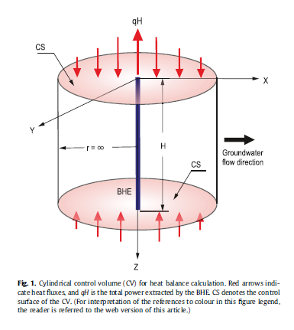

* FLS: semi-analytical expression that solve the conduction-advection transport problem
* Semi-infinite homogenous and fully saturated media with uniform horizontal groundwater flow assumed
* Low computational cost, suitable for studying long term effects / Good for understanding long-term energy balances during and after life cycle of BHE
* Incorporate heat exchange with atm at top BC with constant temperature (XXX has shown that not very good and using a source term is more appropriate).

Computation of heat flux essential to quantify ground energy balance but standard formulation of FLS model cannot account for vertical fluxes, so standard formula has been modified.

However:

* Moving MFLS suited for scenarios without heat input from lateral boundaries so arriving GW flow is thermally unaffected.
* Advection transport instantaneous heat flux induced by BHE & advancing thermal plume delineate the domain where reservoir exhaustion takes place.
* Extracted energy rate qH is independent of velocity v so overall power balance is unaffected by GW flow (not representative of reality where drawdown of temperature in solid matrix around the BHE creates thermal gradients that stimulate net heat influx from advection = qcdT/dx) so here not possible to differentiate power contribution from GW or reservoir storage/exhaustion.

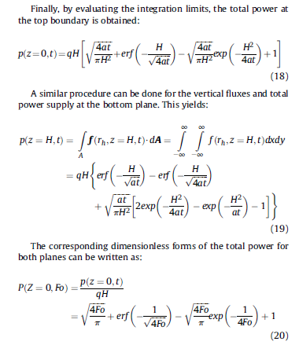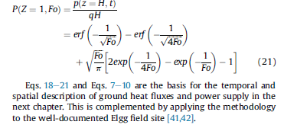

In this study:

* N = 0.2
* Λ = 2.1 (sandy aquifer)
* C = 4.2 MJ/K.m3 for water and 2.2 for solid
* BHE length = 50 m and extraction rate = 40 W/m
* Darcy flux = 9.4 m/yr (Pe = 30), so GW seepage velocity = 47 m/yr

Use of dimensionless parameter to better characterize heat fluxes (processes and drivers of the heat fluxes): H=characteristic length, so for a same thermal diffusivity, Fo=0.1 means 10/39 years of operation for H=50/100m. Pe=60 means qDarcy=18.8m or 9.4 /yr for H=50 or 100m, respectively.

Results :

* heat fluxes increased close to the borehole compared to natural geothermal flux (
* Groundwater influences vertical heat flux at top boundary (asymmetric deformation of the heat flux field with max value at BH location). Advection enhances heat input in the downstream side while notoriously decreases it upstream. The moving water washes out the diffusive fluxes yielding systematically lower fluxes for higher Pe values on the direction perpendicular to GW flow. Fixed temperature BC attenuate the effect of advective heat transport on the temperature distribution close to the boundary and thus lead to more pronounced vertical gradient. Comparing the fluxes in X and Y directions reveals a compensation in the heat flux distribution. Higher fluxes downstream are compensated with lesser heat input upstream and in transversal direction
* Length of the borehole affect vertical flux. The observed lower heat fluxes for longer BHEs, in both horizontal planes and in both axes, indicate that thermal depletion around the borehole is more relevant in the energy balance.
* Lowester vertical flux at top boundary upstream the BHE. Vertical heat fluxes reach a steady state faster under higher effective thermal velocities
* At the bottom plane, the fluxes at enough distance from the BHE and after a certain time are downward directed (due to fixed top BC effects that reach bottom of the well).
* Contribution from top and bottom planes are 35 and 18% so exhaustion medium is 47% 🡪 **but constant temperature might not be representative !!!**
* After long term, total energy demand supplied by fluxed from the top (but fixed BC so can’t be exhausted…)

Numerical simulation could be compared to the analytical solutions (that gives vertical flux at z=0 and z=H) + total power contribution of both boundaries and transversal flux.

Need to modify equation to account for an absorption term by the matrix

What proportion comes from GW, from solar and from rock matrix?

Look at rivera et al (15). They simulated the temporal and spatial distribution of the thermal anomaly induced by the system using analytical solutions. The BHE was approximated as a finite line source with unbalanced heat extraction rate. the variable load was incorporated within the MFLS via temporal superposition of a stepwise function representing the transient rate + vertical heat fluxes and the total power supply have been calculated.

Signorelli et al. [27] and Eugster and Rybach [51] used numerical simulations and field measurements to demonstrate that the system reaches a sustainable operation level after 12 years in an obs well located 1 m distant from the BHE.

Here, the authors show that the system is far from being in a quasiequilibrium after 12 years - (quasi-) steady power states occur in a different time scale since energy, contrary to temperature, is an extensive (and aggregated) property in the system.

+ they studied time for recovery after temporary shutdown: In terms of power, recovery period is much longer than the one of production.

Rybach et al. [26] and Rybach and Eugster [52] estimated a similar time for these two periods using numerical models but focused on the change of temperature at a fixed position. However, changes in local temperature are lower in time when the heat extraction rate is kept constant (or in a quasi-steady state). This is due the higher input from the top boundary and the increasing thermally affected volume around the BHE.

Thermal recovery is faster at the BHE toe due to the continuity of the porous medium. At the end of the 30th year, heat fluxes at both planes provide around 900 W out of the demanded 1666 W. Afterwards, the storage around the BHE is replenished at a rate equal to the sum of the power supply from both planes. The top boundary becomes the main contributor to the storage recovery since its heat input remains higher during the entire time window. Immediately after the shutdown, this boundary retrieves around 60% of the current reservoir gain, whereas after 60 years of recovery period it contributes with approximately 80%

Conclusion:

* heat fluxes from the ground surface are the double of those estimated at the basal plane.
* increasing horizontal advection (expressed by higher Peclet numbers) enhances vertical conductive heat flux in the downstream in both horizontal planes.
* At early stages, energy is extracted mainly from the storage. Then, mostly from ground surface for Fo > 0.13. At the basal plane, power contribution reaches a limit of around 24% of the total power demand at Fo = 0.41 but in reality as temperature increases with depth heat extraction (but not accounted for in line source model that assumes a uniform specific heat extraction rate )
* For a BHE of 100 m, even after several decades, the energetic source is mainly the reservoir exhaustion whereas the ground surface supplies up to 35% of the demanded power.
* When the heat fluxes after system shutdown are included in the analysis, the vertical heat fluxes replenish the reservoir. 🡪 the origin of shallow geothermal energy is by two thirds from the atmosphere, and one third from the earth's interior. This means, the main source of shallow geothermal energy ultimately is not the ground, independent of the length of the borehole.
* in absence of groundwater flow, the declining thermal gradients around the borehole decelerate recovery on the long run. For the typical field case selected in our study, after the same time of recovery as of operation, only 55% of the energy deficit is replenished. It is also shown that the vertical heat fluxes are crucial for this analysis and their neglect would yield wrong

**Need to account for heat flux on surface plus geothermal gradient that affect specific heat extraction rate (valid for deep borehole even if not important in that case where shallow borehole are considered)**