* Investigate thermal interferences under seasonal effects and dynamic exchanged heat flux for a vertical coaxial BHE.
* Seasonal effects treated doing a physical balance between convective heat transfer between ambient air and soil surface and solar radiations (source term)
* Transient 2D ground FVM model accounting for accurate axial and seasonal effect – coupled to a fluid model (analytical solution of Beier et al.) to introduce dynamic behaviour of heat flux (=function of depth and time)
* Extended to 3D model to evaluate interferences between neighbouring BH
* Axial and seasonal effects only relevant for short borehole depth and long operation periods
* Dynamic heat flux along the depth is more considerable for long borehole depth
* Good agreement with T Line Source analytical model (Beier et al)
* Result 3D model: soil resistance increases with time; outlet temperature and withdrawn energy decreases over time thus decreasing performances of heat pump. Recommended to couple system with solar thermal recharging system or couple with energy storage system.

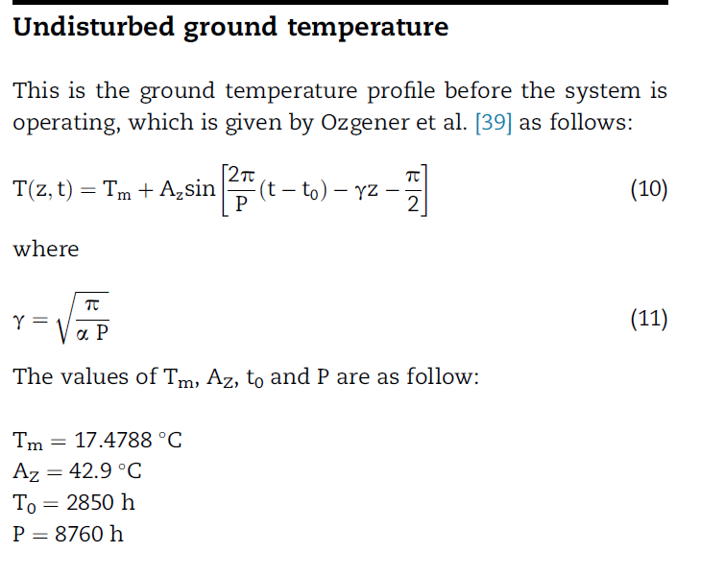

This is the temperature profile (with depth = initial condition), different from seasonal variation (to use as BC)

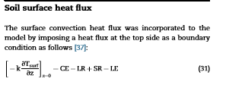

CE and LE are given by Mihalakakou et al. [37], LR and SR are given by Thiers and Peuportier [41].

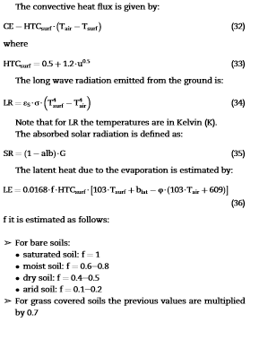

Equation for LE differs slightly from MIHALAKAKOU et al (1997), where blat = t = 609 Pa

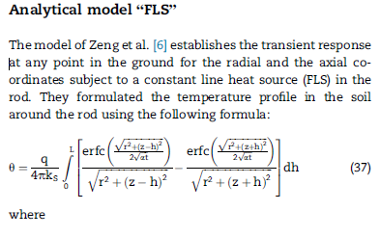

Model the impact of axial effects and the way of their consideration on the temperature distribution in the surrounding ground. Discrepancy between analytical and FVM due to the fact that analytical line source model only consider the initial distribution of the undisturbed ground temperature (soil surface temperature remains constant and equal to the initial temperature over the operation period vs numerical solution has the ability to consider a time dependant surface temperature 🡪 differences in solution down to 10 m deep).

As during operation the temperature distribution is not equal to the undisturbed ground temperature from the surface to the bottom, it is more accurate to consider a HF BC instead of an imposed undisturbed temperature at the surface (=resultant of solar radiation + convection heat flux that has a non-uniform radial distribution [variation of radial temperature distribution in the vicinity of borehole induced by the operation of the heat pump].

1. Prediction of the undisturbed ground surface temperature numerically over the operation period by treating the surface heat flux detailed in Ref. [37] + analytical prediction [39] to better account for seasonal effects (solar radiation, ambient air temperature and velocity values are given for each hour over a year) for 8760h
2. Prediction of the surroundings vertical temperature distribution for an operating heat pump

The difference between imposed natural heat flux and imposed ambient temperature affected soil temperature up to 1.4 m from the surface. This effect is expected to be greater for longer operation of heat pump.

surface heat flux rather than the undisturbed ground surface temperature in the soil region lead to a closer to the reality thermal analysis in the soil.

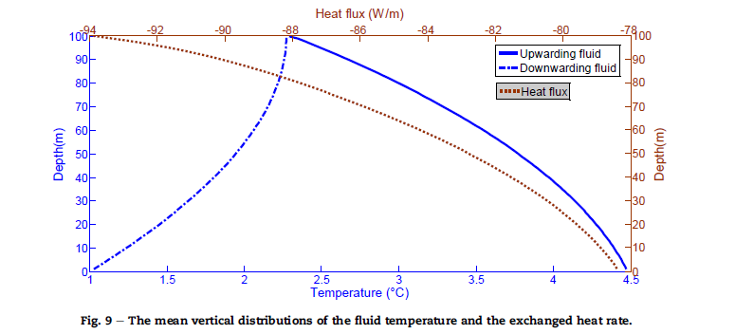

* Non linear distribution due to circulating fluid (dynamic behavior of the BHE, which cannot be seen away from the BHE: )

