Stylianou et al., 2017 : we know here again that heat load / exchange rate improved when high ground conductivity.

* Heat exchange rate larger when lithology with high thermal conductivity and presence of groundwater.
* Development of a tool to measure and analyse the thermal properties of lithologies encountered in an area used to predict heat injection rate of a GHE (depending on its characteristics, GW flow and ground properties)
* Tool can be used to size GHE and calculate heat injection rate in any areas

Performances measured in term of Heat exchange load values of GHEs for different areas (W/m) range

The performance of the GHEs was calculated using a validated model in FlexPDE software (numerical solving tool that can combine parameters e i.e. equations and boundary conditions e entered by the user and obtain numerical solutions of 3D differential equations, based on the Finite Element Method). Heat distribution over time is described by the general heat transfer equation based on the energy balance. The rate of energy accumulated in the system is equal to the flow of energy entering the system, plus the rate of energy generated within the system, minus the flow of energy leaving the system. The 3D conservation of the transient heat equation is used and applied in FlexPDE software

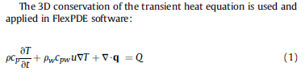

where T is the temperature, t is time, r is the density of the borehole/surrounding soil and rock material, cp is the heat capacity of the borehole/surrounding soil and rock material at constant pressure, rw is the density of the heat transferred fluid, cpw is the heat capacity of the heat transferred fluid at constant pressure u is the velocity of the groundwater, Q is the heat source and q is Fourier's law heat conduction that describes the relationship between the heat flux vector field and the temperature gradient: q = -λ

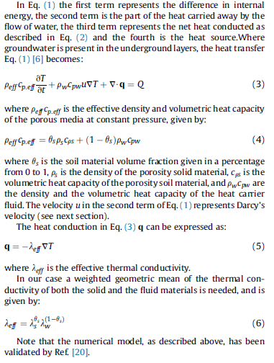

Heat load : Q = m c (Tf-Ti)

where Q is the amount of heat energy lost by the circulating water in the tubes, m the mass ofwater that was circulated, c the specific heat capacity of water, Tf the final (output) temperature of circulating water and Ti the initial (input, entering) temperature of circulating water.

Water level was also considered in calculations, as the flow of underground water has an important effect on the cooling of the vertical heat columns of the heat exchangers. Heat load values that can be transferred to the ground through GHEs are proportionally related

* (a) to the level of groundwater, and
* (b) to the density of the underground where the borehole is located.

As the level of water and the density of the soil/rock increases, heat exchange rate increases too.

Upon reviewing similar studies and GIS applications referring to other countries, heat exchange load values of GHEs vary from 22 to 63 W m-1. The magnitude of the values is a major factor for deciding the depth of the GHE. these values can only be considered as indicative, since the place site-specific conditions may vary in each case.