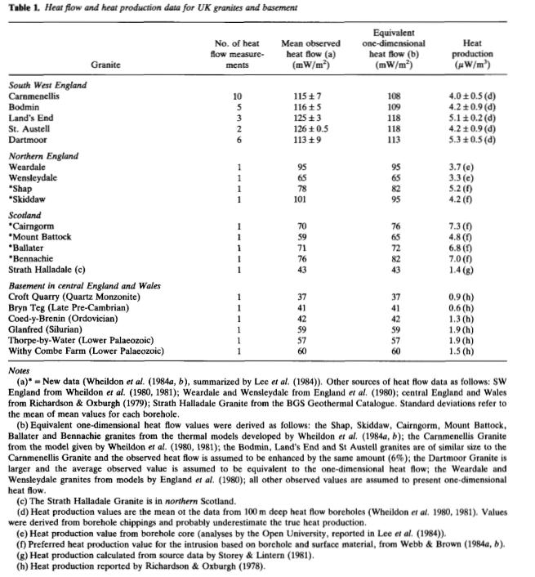

New heat flow data from four Caledonian-age granites, which are part of the Eastern Highlands batholith, are in the range 59-76mW/m2 (Table 1). These values define a zone of higher than average heat flow in Scotland which is closely related spatially to the Eastern Highlands batholith.