Investigating the key controls on mine-water heat in abandonned flooded coal mine workings in the UK: what is the thermal footprint of past mining activities?

Mylene Receveur\*, Christopher McDermott\*, Andrew Fraser-Harris\*, Stuart Gilfillan\*, Ian Watson\*\*

\*School of Geosciences, University of Edinburgh, Grant Institute, The King's Buildings, James Hutton Road, Edinburgh EH9 3FE, United Kingdom (M.Receveur@sms.ed.ac.uk)

\*\*The Coal Authority, 200 Lichfield Lane, Mansfield, United Kingdom

Heat demand for space heating represents ~1/3 of the energy consumption in the UK. In 2017, most of this energy is supplied by natural gas, contributing to 19% of the carbon footprint of the country. Among new low-carbon heat sources required to decarbonize heating, mine-water heat recovery from abandoned collieries available across the UK has been of growing interest.

Although the temperature of mine-water is expected follow the local geothermal gradient, recent studies revealed the lack of correlation between the temperature measured in mine shafts and the measurement depth. The aim of this study is to investigate the impact of past mining activities on the temperature distribution in coal mines after closure and flooding of the mine.

We use the finite-element modelling software OpenGeoSys to simulate groundwater flow and heat transfers in 2D porous media representing mines of simple geometry. Based on the geology of the Coal Measures in UK Coalfields, we examine the perturbations of the geothermal gradient induced by long-term pumping through highly permeable layers and the time to return to equilibrium. A thorough analysis is made on the impact of the mine geometry, rock properties, production period and hydraulic boundary conditions on the extent of the perturbations.

Using temperature time-series and temperature profiles in shafts, we show the existence of permanent temperature perturbations around the mined seams and shafts. Preliminary results suggest that the thermal footprint of mining is mainly controlled by the hydraulic conductivity of the seams, their interconnectivity and the hydraulic recharge to the mine. For scenario with constant head boundaries, temperature profiles around the pumping shaft display higher and lower temperatures above and below the mined seams after flooding, respectively, in accordance with the observations made in UK mine shafts. This suggests the importance of considering the mining history when evaluating the initial heat potential of flooded mines.

Keywords: Mine-Water Heat, Numerical Modelling, OpenGeoSys, Thermal footprint

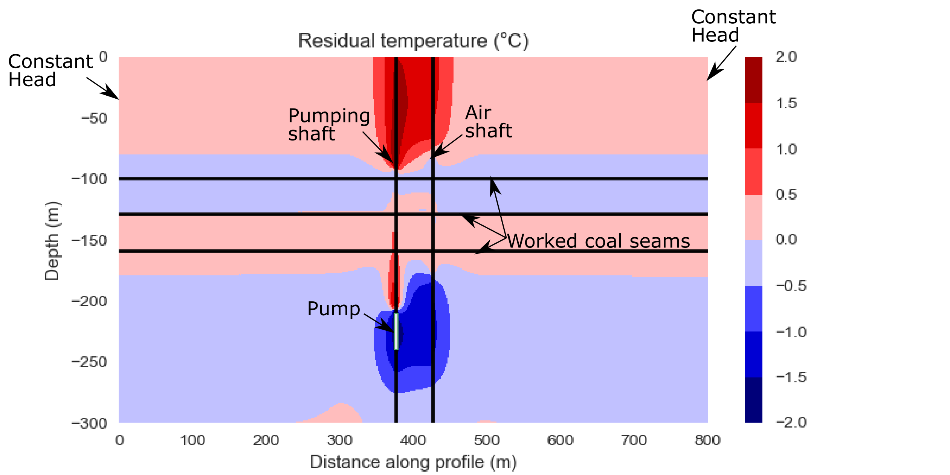

Figure 1: Example of 2D profile of temperature change in the model after a 10-year production period at a rate of 0.05 m3/s and a subsequent 10-year recovery period with constant hydraulic head lateral boundaries.