**Key Controls on Mine-water Temperature in Flooded Mine Shafts: Insights from Temperature Profiles and Numerical Modelling**

Mylène RECEVEUR, Christopher MCDERMOTT, Andrew FRASER-HARRIS, Stuart GILFILLAN and Ian WATSON

University of Edinburgh, Grant Institute, James Hutton Road, EH9 3FE Edinburgh

M.Receveur@sms.ed.ac.uk

**Keywords:** Mine-Water Heat, Coal Mines, Temperature Profiles, Numerical Modelling, OpenGeoSys

# Abstract

# Heat demand for domestic and industrial space heating represents more than 30% of the energy consumption in the UK. Most of this energy is currently supplied by natural gas, contributing up to 19% of the carbon footprint of the country in 2017. To reach Net-Zero carbon emissions by 2050, the UK Government is looking at new approaches to decarbonize residential heating. Among them, using mine-water from abandoned legacy mine workings as a new low-carbon heat source has been of growing interests. Using open-loop ground-source heat pump systems, heat energy can be harnessed from the 12-20°C water stored in the large underground voids inherited from past mining activities. Although the temperature of the water is expected to increase with depth according to local geothermal gradient, temperature measurements in former mine shafts in the UK revealed the lack of correlation between the depth of the measurements and the mine-water temperature. The aim of this study is therefore to assess the key parameters controlling the temperature profiles in mine-shafts to understand if those can be used to calibrate mine models aiming at assessing their long-term geothermal potential. We use the finite-element modelling software OpenGeoSys to simulate groundwater flow and heat transfers in a 2D porous media representing a mine of simple geometry. We first analyse the effects of a 500-day pumping period followed by mine-water recovery on the temperature distribution in a pumping shaft for different hydraulic boundary conditions, assuming a constant geothermal flux of 0.085 W/m². We then investigate the effects of the material properties, the mine geometry and pumping scenario on the modelled temperature profiles. Time-series of energy change in the system are also calculated to get insights into the relationships between the observed mine-water temperature and the actual heat potential of the mine. Preliminary results indicate that the hydraulic conductivity of the worked coal seams intersected by the shaft and the nature of the hydraulic recharge governs the observed temperature profile. During pumping, the average temperature in the shaft depends on the pumping depth and on the temperature of the mine-water flowing into the shaft at the seam insets, as predicted by the undisturbed geothermal gradient. Heat convection in the highly-permeable mining voids during prolonged dewatering periods is however suggested to disturb the rock temperature and alter the initial geothermal gradient around the shaft over the long-term. Although mine-water in the shaft re-equilibrates with the surrounding rock within ~20 years following the cessation of pumping, the nature of the hydraulic recharge during water rebound also tend to control the mechanisms of heat recovery and the residual temperature anomaly in the shaft. Further analysis is being undertaken to assess the thermal footprint of long-term mining on the observed temperature distribution in flooded coal mines, considering more realistic mine geometry and dewatering history.

# 1. Introduction

# Mine-water from abandoned legacy coal mines constitute a low-temperature geothermal heat source that can be used for hot water or space heating. This low-carbon resource largely available across the UK has been of growing interest as it could contribute to reach the Net-Zero carbon emission target set by the 2019 UK's Climate Change Act by 2050 (House of Commons Energy and Climate Committee, 2016). In Scotland, Todd *et al*. (2019) showed that about 7% of the heat requirement could be sustainably sourced from abandoned flooded mine workings lying just below populated areas without the need for artificial heat storage.

Underground coal mines have been described as highly permeable ‘anthropogenic aquifers’ (Adams and Younger, 2001), from which important volume of water can be stored and extracted at relatively high rates (Banks *et al.,* 2004). These characteristics are the result of a long mining history during which different mining approaches have been employed. In the early times of mining (16-17th Century), coal was mostly extracted from shallow mines using the pillar-and-stall method. In the early 18th Century, the invention of the Newcomen steam engine enabled pumping water more efficiently, allowing access to deeper coal seams. From the 1950’s, longwall mining was the main method of extraction of coal in deep mines, and many mined areas were reworked using this method (Younger *et al.,* 2002). The decline in demand for coal led to the progressive closure of the underground mines from the 1960’s. In 1992, only 50 collieries were left opened in the UK and the last one closed in 2015. Following their abandonment and the cessation of dewatering, most of the underground collieries were left to progressively flood as water rebounded back to natural levels, filling the complex network of voids inherited from the mining activities (Younger and Adams, 1999). A compilation of mine-water temperatures in the UK showed that mine-waters are generally hotter than natural groundwater, ranging from 12°C to 30°C (Gillespie, 2013). Using open-loop ground source heat pump systems, mine-water can be pumped from the mine and used for hot water or space heating, with the cooled water disposed of either through treatment and surface disposal or re-injection to another coal seam through boreholes or shafts (Banks *et al.*, 2004). Such a system has been implemented in Dawdon, North-East England, where a 20°C water is abstracted from the mine before being discharged to the sea (Bailey, 2013).

To promote the development of heat extraction schemes, the Coal Authority (i.e. the authority responsible for the legacy of coal mines in the UK) wish to get a better understanding of the geothermal resources in mines. To that end, Farr *et al.* (2020) provided a mapping and synthesis of the temperature of Britain’s coalfields at the scale of the Mine-Water Block (MWB) by comparing equilibrium temperatures to recent mine-water temperatures measured by the Coal Authority. Their results indicated a good correlation between historic in-situ coal strata temperatures acquired during mining and more recent mine-water temperatures from un-pumped shafts, collected in the BGS UK Geothermal Catalogue (Burley *et al.*, 1984; Rollin, 1987). This was suggested to indicate that mine-water from flooded workings has reached an approximate temperature equilibrium with the surroundings (Farr *et al.,* 2020). A comparison between the equilibrium temperatures and temperature data from pumping shafts/boreholes moreover showed that pumping tends to significantly alter the calculated geothermal gradient. Although pumped temperatures tend to be higher than equilibrium temperature at shallow depth in most MWB, deeper data (300-500 m) in pumped coalfields indicates cooler temperature than in the equilibrium coalfields. This was interpreted to result from the mixing between deep warm water and colder surface water in the shaft.

The lack of data in mine galleries however makes it difficult to know whether such effects are localized in the shaft or spread within the hydraulically connected parts of a mine or network of mine (Farr *et al.*, 2020). Being able to extrapolate the measured data from shafts and boreholes is critical to be able to estimate the heat potential of mines. The aim of this study is therefore to investigate the key controls on the temperature profiles measured in shafts and to get a better understanding of the relationship between equilibrium and pumped mine-water temperatures. Using numerical modeling, we analyze the effects of different host rock thermal and hydraulic properties, the geometry of the mine galleries, the hydraulic recharge and the pumping scenario on the observed temperature profiles during pumping activities and recovery/flooding. In addition, we investigate the relationship between the temperature profiles and the energy change in the mine system to get a better understanding of how measured temperatures in shafts can be used to gain insights into the mine heat potential. We finally discuss the potential effect of past mining activities on the observed temperature in shafts and in the galleries to assess if historical in-situ strata temperatures can be used to estimate post closure temperatures in coal mines (Farr *et al*., 2020). This study does not aim at matching modeling results with real data, which will be the aim of a future work.

# 2. Methods

We use the finite-element modelling software OpenGeoSys to simulate groundwater flow and heat transfers in a 2D porous medium representing a mine of simple geometry. The reference mine consists of three worked coal seams located at 100, 130 and 160 m depth. They are interconnected via two open shafts separated by a distance of 100 m and embedded in a homogeneous host rock, whose properties have been attributed accordingly to the geology of the Coal Measures in UK Coalfields.

**Table 1: Petro-physical, thermal and hydraulic properties for the 2D reference mine model**

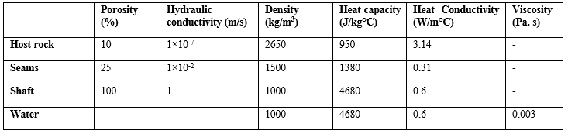

We first analyze the effects of pumping and recovery under different hydraulic conditions on the temperature profile in the production shaft. The impact of a westward regional hydraulic gradient is assessed using constant heads of 0 m on the eastern boundary and of 10, 20, 50 and 80 m on the western boundary. Additionally, we study the effects of a westward hydraulic flow of -1.3×10-8 m3/s using Neumann lateral boundary conditions. This hydraulic flow corresponds to the flow required to maintain a hydraulic gradient of ~10 m between the lateral boundaries of the model. For each scenario, we assume a geothermal flux of 0.085 W/m², calculated for a temperature gradient of 30°C/km and a mean effective heat conductivity of 2.82 W/m°C. We investigate the effects of the geothermal gradient, the host rock properties (i.e. heat conductivity, heat capacity, hydraulic conductivity), the seam properties (i.e. porosity, hydraulic conductivity), the mine geometry (see Fig. 1), the volume of mined rock and the pumping scenario (i.e. production rate, pumping depth) on the temperature profile. For each scenario, the overall change in energy content of the system is moreover calculated to gain insights into the relationships between the observed mine-water temperature and the heat potential of the mine. Initial steady-state conditions are calculated for each of them before simulating dewatering in order to account for possible shifts in the initial energy content of the flooded mine.

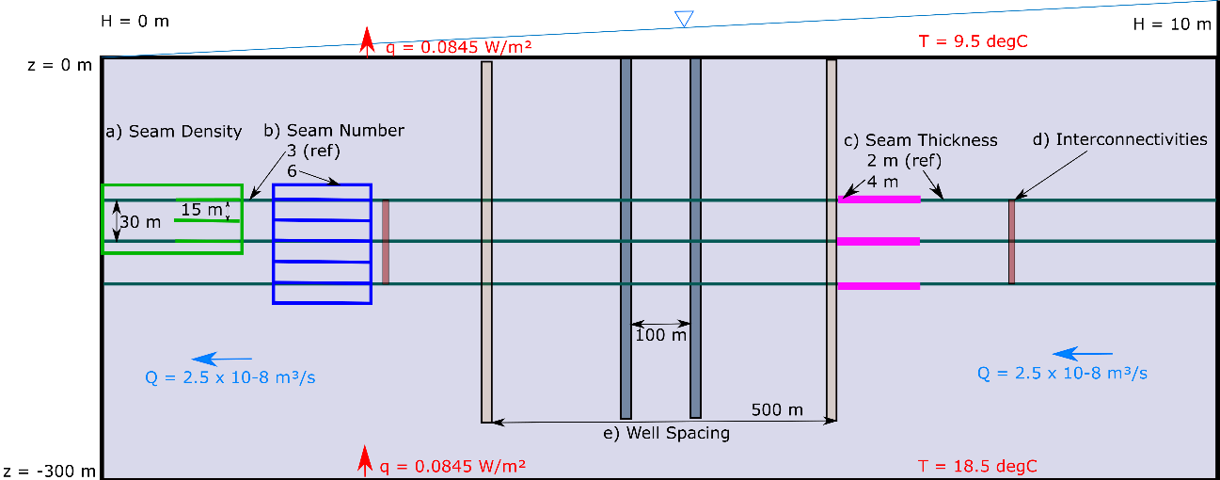

Figure 1: Sketch of the 2D mine model with different geometrical features and boundary conditions.

# 3. RESULTS

Fig. 2 shows temperature data extracted from a vertical profile in the pumping shaft, after 500 days of pumping/dewatering at a rate of 0.05 m3/s. This production period was chosen in accordance with the time required for thermal and hydraulic steady-state to be reached in the shaft in the reference model (Table 1). In the scenarios with constant head boundaries and a seam productivity of 1 x 10-2 m/s, pumping results in a decline in head down to the depth of the lowest seam (i.e. about -160 m) at the shaft location. Scenarios with a lower seam permeability induced a greater drawdown at the shaft location due to lower hydraulic recharge (i.e. up to -1600 m for a hydraulic conductivity of 1 x 10-5 m/s). Similar observation was made for models with hydraulic flux boundaries, where the head was lowered down to -800 m due to the reduced availability of water recharge. In all the production scenario (Fig. 2a-e), temperature offsets are visible in the profiles where the shaft intersects the mined seams. This suggests that the high permeability of the worked seams creates zones of higher productivity from where inflows of water into the shaft are enhanced. Profiles for the host rock heat conductivity, heat capacity and hydraulic conductivity, the hydraulic gradient, the seam and host rock porosity and the pumping rate are not displayed here due to their limited or absence of impact on the temperature profile.

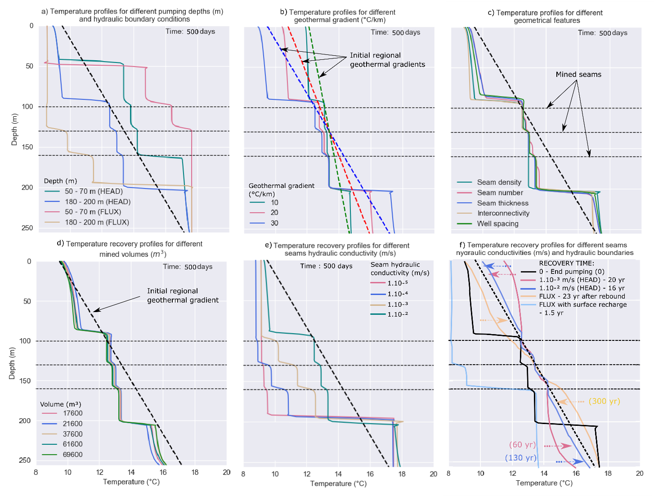

Figure 2: Temperature profiles obtained after 500 days of pumping for a) pumping depths of 60 m and 190 m under constant head and hydraulic flux boundary conditions, with different b) geothermal gradients, c) geometrical features, d) mined volume and e) seams hydraulic conductivity under constant head boundaries. f) Temperature profile obtained after flooding and heat recovery. The arrows indicate the direction of temperature recovery for each scenario.

**3.1 Boundary Conditions**

3.1.1 Hydraulic Flux and Head Gradients

Temperature profiles displayed in Fig. 2a suggest that the choice of a Dirichlet or Neumann hydraulic boundaries tend to considerably impact the temperature profiles during pumping activities. In models with constant head boundaries, the average temperature in the shaft is highly controlled by the temperature at the shallowest seam when water is pumped from below the mined area, resulting in cooling in the mined interval. Conversely, the temperature in the shaft increases relative to the initial temperature gradient when pumping is performed from above the mined seam, as the average temperature is controlled by the inflow at the deepest seam. A flow rate of -1.3×10-8 m3/s chosen to maintain the head gradient of 10 m across the model tends to favor cooling at the well location when the pump is located below the seams, and favor warming when the pump is located above the worked seams. The nature and extent of hydraulic recharge could therefore explain a large range of temperature observed at a same depth interval (Farr et al., 2020).

Further analysis on the effect of the regional hydraulic gradient on the measured temperature profile is performed, based on hydraulic heads of 10, 20, 50 and 80 m at the eastern boundary. For each scenario, new initial steady state conditions are calculated before starting pumping simulations. Results (not displayed here) after 500 days of pumping indicate that an increase in the hydraulic gradients only slightly decreases the temperature in the mined area, suggesting that high regional hydraulic flow rate through the highly conductive seams tends to reduce the amount of heat recharge to the well during pumping.

3.1.2 Geothermal Gradient

We then assess the effect of the geothermal gradient on the temperature profiles resulting from a 500-day long pumping period. Geothermal gradients of 10, 20 and 30°C/km are set so that the temperature at 130 m depth (i.e. mid-seam depth) is 13.15°C. Results displayed in Fig. 2b shows that for a pumping depth of 180 – 200 m, an increase in the geothermal gradient increases the amplitude of the temperature drops at the seams insets, so that the temperature at the shallowest seam matches the temperature predicted by the initial gradient. In those scenarios, the average temperature in the mined interval is linearly correlated to the surface temperature, which decreases as the geothermal gradient increases. This shows that the shallow part of the geothermal gradient can highly affect the observed temperature in the shaft.

**3.2 Geometry**

Fig. 2c shows the temperature profiles for models with different geometries (Fig. 1). These include a) a decrease in the seam spacing from 30 m to 15 m, b) an increase in the number of seams from 3 to 6, c) an increase in the seam thickness from 2 to 4 m, d) the addition of two staple shafts connecting the seams and e) an increase in the well spacing from 100 to 500 m. In those scenarios, the relatively high hydraulic conductivity of the mined seams (of 1×10-2 m/s,) relative to the surrounding rock (of 1×10-7 m/s,) allows ‘steps’ to be visible at each intersection with the shaft. Results suggest that the depth range spanned by the mined seams (i.e. seam density, number of seam) has the largest influence on the average temperature in the mined area, in accordance with Banks et al. (2004). The deeper the seams, the higher the temperature of the water available for mixing in the shaft.

We also investigate the impact of the volume of the mine on the temperature profiles. In this series of models, we assume six areas of intensive mining or collapsed material with 25% porosity. The effective density, conductivity and heat capacity have been attributed accordingly to the relative proportion of mined seam/host rock in those areas (Table 1) in order to maintain a geothermal flux of 0.085 W/m². Results displayed in Fig. 2d suggest that the volume of mined rock controls the average temperature in the shaft. Above the pump location, the average temperature decreases with increasing mined volume while below the deepest seam, the temperature increases with increasing mined volume, with a temperature difference of up to 0.5°C between the two end-members scenarios. One of the possible reasons for the observed decrease in the average temperature with increasing void volume could be explained by the lower heat conductivity of the water that fills the pores. This has been observed to a much smaller extend when performing a sensitivity analysis for the host rock heat conductivity (see section 3.3.1).

**3.3 Intrinsic rock Properties**

3.3.1 Host rock hydraulic Conductivity Kr

We investigate the effect of different host rock permeability Kr = 1×10-8 m/s, 1×10-7 m/s (reference model), 1×10-6 m/s and 1×10-5 m/s) on the temperature profile after 500 days of pumping for a seam hydraulic conductivity Ks = 1×10-2 m/s. Results (not displayed here) indicate that the permeability of the host rock does not affect the observed temperature in the mined interval. The greatest perturbations are observed above the shallowest seam, where the higher the host rock permeability and the higher the temperature. This suggests that higher rock permeability enhances hydraulic recharge throughout the whole depth range of the well/shaft, allowing an inflow of heat that restricts the temperature drop away from the geothermal gradient. This improved recharge is confirmed by a slight reduction in the drop in head from -160 to -155 m at the pump location when increasing the permeability from 1 x 10-7 to 1 x 10-5 m/s. Although casings in the shafts/wells would prevent this hydraulic recharge to occur, further analysis (see section 4.1) confirms that increasing the rock permeability favors heat recharge to the system.

3.3.2 Seam hydraulic conductivity Ks

Several authors suggested the importance of the effects of permeability contrasts between the mining voids and the host rock on the temperature distribution in mines (i.e. Renz *et al.*, 2009). To verify this hypothesis, we here perform a sensitivity analysis on the effect of the hydraulic conductivity of the coal seams on the temperature profiles. Using hydraulic conductivities Ks of 1×10-5 m/s, 1×10-4 m/s, 1×10-3 m/s and 1×10-2 m/s (reference model) for Kr 1×10-7 m/s, we show that the productivity of the seams largely impact the measured temperature profile in the mined interval, where the higher the permeability the higher the average shaft temperature (Fig. 2e). Those moreover highly control the drop in head at the pump location, ranging from -160 m for Ks = 1×10-2 m/s to –1600 m for Ks = 1×10-5 m/s, for a pumping rate of 0.05 m3/s. Further analysis showed that for the same contrasts in hydraulic conductivity evaluated (i.e. 103, 104, 105), the temperature profiles can be highly different depending in the absolute seam permeability. The temperature profiles measured in shafts therefore mostly depend on the absolute permeability of the host rock and the seams rather than on the permeability contrasts. Both tend to control the hydraulic flux and the extent of convective heat recharge that governs the pattern of the temperature profile during pumping.

3.3.3 Seam Porosity

In mines, the amount of void space is expected to depend on the mining approach (i.e. pillar-and-stall or longwall mining) and on the volume of coal extracted. However, following the closure of a mine, subsidence, collapse and fracturing of the roof together with the backfilling of the galleries often tend to alter the initial void volume (Younger and Adams, 1999). Several methods have been deployed in the past to derive estimates of the residual porosity in mine workings (see Table 2). The reference model presented in this study considers the seams and the shafts as porous medium of porosity = 25% (i.e. amount of residual void in a fully mined coal panel) and 100% (i.e. open voids), respectively. To account for the uncertainty in the residual volume of void in mine galleries, we investigate the impact of different seam porosity (i.e. 15%, 25%, 50%, 55% and 75%) on the temperature profile. Results (not displayed here) show that the seams porosity does not affect the observed temperatures in the shaft. In opposition to the seam permeability, the porosity does not improve the seam-shaft interconnectivity nor control the hydraulic flow rate in the galleries, but only informs on the volume of water stored in the mine. The relatively small change in void volume induced by a change in seam porosity at the scale of the mine (in opposition to the mined volume presented in section 3.2) would explain the limited impact on the heat flow in mines and on the measured temperature profiles. Further analysis discussed in section 4.1 (Fig. 3) however show that the volume of water does affect the energy content in the mine system.

**Table 2: Summary of the characteristics and expected residual void volume in coal mines following their closure, depending on the mining approach.**

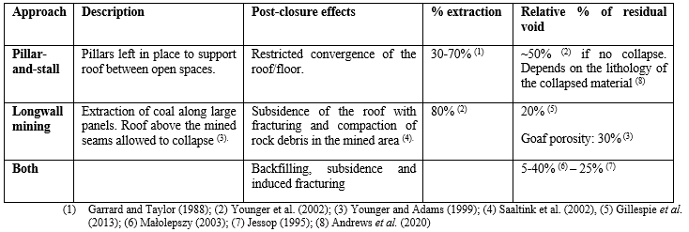

**3.4 Production Scenario**

3.4.1 Pumping rate

Farr et al. (2020) suggested that variations in the average profile temperature observed at Horden over time might be caused by changes in pumping rate. To verify this hypothesis, we simulate the temperature profile in the pumping shaft after 500 days of pumping at rates of 0.01, 0.05 (reference model), 0.1, 0.2 and 0.5 m3/s. Results (not displayed here) show that the pumping rate does not affect the temperature in the mining area. Above and below the mined seams, slightly cooler and warmer temperatures are modelled for higher pumping rates. This suggests that as the production rate increases, colder water is dragged from above and warmer water is accessed from depth, without significantly changing the average temperature. However, a more detailed time-series analysis would be necessary to evaluate the rate of change in temperature along the profile following a change in the production rate.

3.4.2 Pumping depth

We finally look at the impact of the pumping depth on the temperature profiles. Pumps located at 50-70 and 180-200 m depth are set in a series of two models with constant head and constant flux boundary conditions. The resulting profiles are shown in Fig. 2a and indicate that the location of the pump defines the boundary between a zone of cooler temperature above it and a zone of warm temperature below. This has been predicted by i.e. Banks et al. (2004) and Nuttall and Younger (2004) as a result of cold water dragged from above and warmer water pulled from below (see section 3.1.1).

**4. DISCUSSION**

**4.1 Temperature Profiles and Energy Content**

In the previous section, we analyzed the effects of pumping from a flooded mine with highly permeable layers on the temperature profile observed in the pumping shaft. We showed that in addition to the geothermal heat flow, the advection of heat via highly conductive mined seams tend to control the mine-water temperature (i.e. Burnside *et al.,* 2016). In parallel, we calculated time-series of energy change in the mine for each scenario in order to get better insights on the effects of the rock properties, the production scenario and the hydraulic/geothermal conditions on the energy content of the mine and on its relationship to the observed temperature. Results displayed in Fig. 3 indicate the followings:

**Hydraulic gradient**: The initial energy content in the mine decreases linearly with an increasing hydraulic gradient (Fig. 3a), in accordance with the temperature observations. Time-series of energy change during pumping indicate a rapid drop and a subsequent increase in energy in the initial stage of production, mostly observed for high hydraulic gradients (i.e. H = 50 m and H = 80 m). After ~500 days of pumping, where the energy reaches a constant rate of decline, the higher the regional head gradient and the higher the energy losses in the system. This could suggest that although convective heat flow is essential to recharge a mine system in heat, high regional flow rates tend to ‘wash away’ the geothermal heat arriving from depth, decreasing the initial heat potential of the mine and its recharge rate during production.

**Geothermal gradient.** In the modelled scenarios, an increase in the geothermal gradient causes the upper part of the temperature profile to shift toward lower temperatures (Fig. 2b) and both the surface and the average temperature in the shaft decreases. Energy time-series (not displayed here) show that both the initial energy content and the energy drop after 500 days of pumping are linearly correlated to the temperature gradient. This suggests that although a higher geothermal gradient increases the heat potential of the mine, the geothermal flux is not sufficient to recharge the system during pumping. The absence of heat recharge at the surface, especially for high temperature gradients where the surface temperature is lower, favors faster temperature decline.

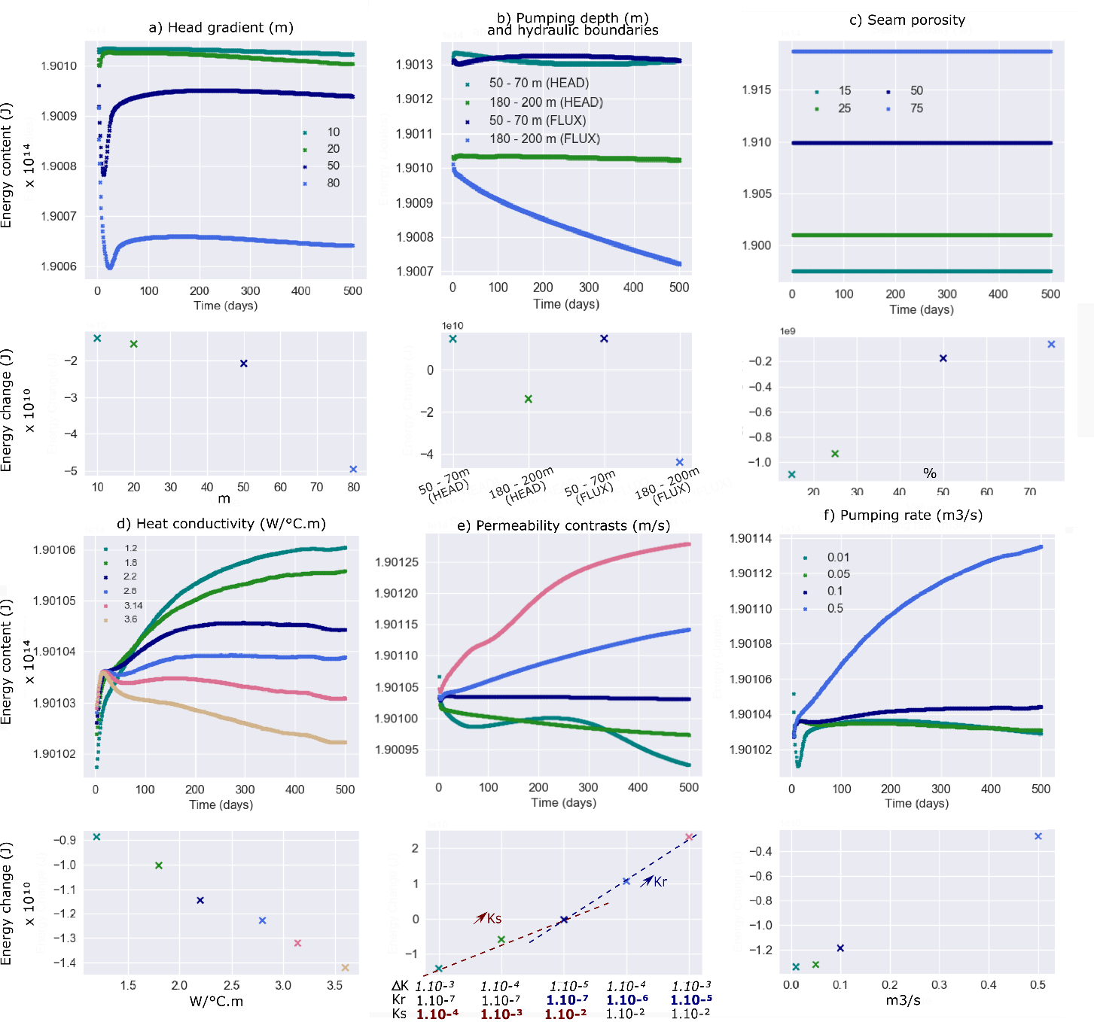

Figure 3: Time-series of energy change and overall energy change observed for the different parameters of the sensitivity analysis, with a) the head gradient, b) the pumping depth (m) and hydraulic boundaries, e) the seam porosity, d) the host rock heat conductivity, e) the seam and host rock hydraulic conductivity (see labels of x-axis on the lower panel for conductivity values, using the corresponding colors of the dots) and e) the pumping rate.

**Pumping depth and hydraulic boundaries:** Pumping from shallow depths (i.e. ~ -60 m, above the seams) drags hot water from depth and increase the temperature in the shaft up to the near-surface (Fig. 2a). This permits to the system to maintain a high energy content relative to deeper production, independently of the hydraulic boundary (Fig. 3b). While a quasi-steady-state situation is reached after about 200 days following the start of pumping in a system with constant head boundaries, the use of Neumann lateral boundary conditions causes the energy in the system to drop linearly after 50 days when pumping is at 180 – 200 m depth. In opposition to constant head boundaries that force water recharge into the system, deep pumping with hydraulic flux boundaries prevent from the convection of heat into the system, which might explain the faster energy drop. This effect is also observed in the temperature profiles (Fig. 2a), where the average temperature for scenario with head boundaries is higher than for scenario with hydraulic flux boundaries at the corresponding pumping depth.

**Seam porosity and mined volume**: An increase in the seams porosity increases linearly the initial energy content in the mine and tend to reduce the overall energy drop in the system after 500 days of pumping (Fig. 3c). Similar observations are made for the mined volume, for which the initial energy content also increases linearly with the volume of mined rock. This can be the higher specific heat capacity of water contained in higher quantity in both scenarios, relative to the host rock (Table 1). Although the temperature above the pump decreases with increasing mined volume (Fig. 2d), high void volumes (> 4 x 104 m3/s) also tend to favor heat recharge compared to lower void volumes. We suggest this reduction in energy drop to be linked to the low heat conductivity of the water, whose effect is described in the followings.

**Host rock heat conductivity:** Although the rock heat conductivity does not have any influence on the temperature profile in the shaft, the higher the host rock heat conductivity the quicker the energy drop in the system (Fig. 3d). This happens in spite of the higher geothermal flux set to maintain the geothermal gradient of 0.03°C/km through the model. A high effective thermal conductivity would therefore favor heat depletion in the mine system under pumping condition while maintaining a constant temperature at the shaft. This is in accordance with the heat diffusion equation, where an increase in heat conductivity λ for a same temperature gradient ΔT/Δx generates a higher heat flux q (Fig. 4).

**Host rock and seam hydraulic conductivity**: The initial energy content of the mine increases exponentially relative to permeability of the seams and of the host rock, suggesting that promoting water flow through the rock improves the heat potential of the mine reservoir. Moreover, both tend to reduce the energy drop after 500 years of pumping, showing that enhanced fluid-rock interactions also favor heat recharge into the system. Although the seam productivity highly affects the temperature profiles in the shaft, a higher host rock permeability promotes quicker heat recharge to the mine system, as suggested by the slopes of the trends presented in Fig. 3e. This effect is also likely to be responsible for the warmer temperatures observed above and below the mined area for higher rock permeability. Heat recharge in mines during pumping is therefore highly promoted by the combined effect of the seams and host rock permeability on heat convection (Fig. 4).

**Pumping rate**: Although the pumping rate does not significantly alter the steady-state temperature in the shaft, increasing the production rate increases linearly the energy in the mine after 500 days of pumping (Fig. 3f). This phenomenon might be explained by the effects of abstracting warm water from deeper seams as the head is lowered (i.e. -150 m for 0.05 m3/s to -1500 m for 0.5 m3/s after 500 days). However, the effect of upwelling of warm water into the model might be overestimated in cases where hydraulic recharge is limited and the medium becomes unsaturated with water.

**Specific heat capacity *c* and density ρ:** Those parameters tend to increase the initial heat capacity of the mine without impacting the temperature profile in the shaft (see Fig. 4).

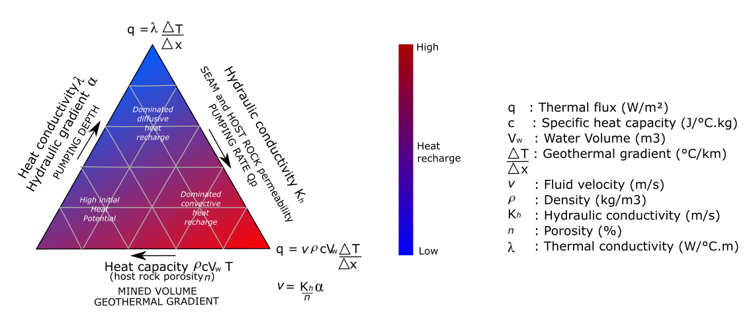

Figure 4: Conceptual diagram showing the relationship between the parameters evaluated in this study and the expected amount of heat recharge within the mine system. Parameters in capital letters corresponds to those having an impact on the temperature profiles (Fig. 2).

**4.2 Long-Term Perturbations of the Geothermal Gradient**

Previous studies of the heat potential of flooded coal mines often considered the undisturbed geothermal gradient as the main contributor to the thermal state of the mine. However, Gillespie et al. (2013) pointed out the lack of correlation between the temperature of the mine-water measured in abandoned un-pumped mine shafts in the UK and the depth of the measurements. To explain those discrepancies, some authors suggested the existence of other sources of heat controlling the mine water temperature, such as heat production from pyrite oxidation (Farr et al., 2016) or the effects free density-related water convection within the large open mining voids (i.e. Nuttall and Younger, 2004; Renz et al., 2009; Hamm and Bazargan Sabet, 2010). Beamish and Busby (2016) interpreted those observations as the effect of heat advection through the artificial large-scale transmissive pathways that would indicate that the geothermal gradients in mines may not represent purely conductive heat flows (Bailey et al., 2016). However, only a few authors recognized the potential effect of extensive periods of mining with deep pumping and air-cooling on the virgin rock temperature in flooded mines (i.e. Malolepszy, 2003).

We simulate water rebound and heat recovery under different hydraulic boundary conditions and seam productivity, based on the modeling outputs for a 500-day pumping period. Although those models underestimate the mining periods and the effect of air-cooling in the galleries before flooding, the objective is to get insight into the relative time necessary for the temperature in the mine to return to equilibrium. Scenarios with hydraulic flux boundary conditions assume a total recharge of 2.5 x 10-5 m3/s from both lateral boundaries. This was done to ensure a water rebound in the same time scale as for a scenario with constant head boundaries. Table 3 summarizes for each model the time for water rebound to be completed (i.e. head measured at the pump location) and the time for temperature in the shaft to reach a new equilibrium. Those were estimated based on a graphic analysis of the head and temperature time-series measured at -50 m and -180 m depth at the shaft location.

Recovery profiles displayed in Fig. 2f represent the temperature in the production shaft after water rebound is completed and as thermal equilibrium approaches. Results show that in a case with constant head boundaries, the geothermal gradient remains lower than the pre-pumping steady-state temperature gradient. When pumping stops, the mixing of warm deep water and colder surface water in the shaft fixes the temperature in the shaft around the average temperature in the mined area. Once the flooding is completed, the temperature profile in the shaft slowly re-equilibrates with the temperature of the surrounding rock. However, the effects of convective heat flux at the intersection between the shafts and the mined seams together with the perturbations of the rock temperature induced by earlier pumping activities maintain a temperature anomaly in the shaft. Above the mined area, temperatures tend to be higher than the initial steady-state temperatures after recovery, while they remain lower than the pre-pumping temperatures below the deepest seam. The presence of productive seams favors a quicker water rebound and steady rate of heat recovery, although the projected time to return to the initial undisturbed temperatures is extended.

Table 3: Water rebound and heat recovery time obtained for different seam permeability and boundary conditions. Times are given relative to the cessation of pumping (t0) unless otherwise specified.

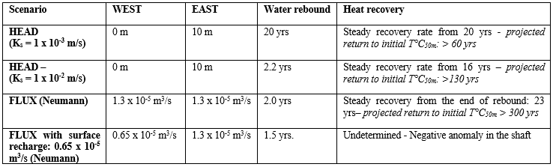

In a scenario with hydraulic flow, the reversed effect is observed. After water rebound and heat recovery, the temperature profile in the shaft displays lower temperatures in the upper part of the profile while temperatures remain higher than the pre-pumping geothermal gradient in the lower part. Time-series analysis show that this effect results from the nature of the hydraulic recharge during flooding. In opposition to water rebound in models with constant head boundaries that tend to promote diffusive heat recovery, the high hydraulic flow induced during water rebound in this case reproduces the offsets at the seams location similar to those observed during pumping. Instead of mixing water into the shaft, the upwelling of warm thermal waters from below the mine will heat up the base while the recharging water from shallower and colder seams will cool the upper part of the model. Heat convection will tend to superimpose onto the diffusive heat gradient during flooding. As the rebound is completed, the temperature profile is smoothed but conserves the temperature anomalies induced during recovery. Water recharge at the top of the model (light blue profile in Fig. 2f) finally shows that infiltration of cold surface rainwater can highly reduce the temperature in the shaft.

**5. CONCLUSION**

### We have performed a sensitivity analysis on the controls on the temperature profiles observed in mine-shafts under pumping conditions and during recovery. Results indicated that the hydraulic conductivity of the worked coal seams intersected by the pumping shaft and the nature of the hydraulic recharge governs the temperature distribution in the shaft. During pumping, the temperature offsets created at the seams insets also highly depends on the pumping depth and on the temperature of the mine-water predicted by the undisturbed geothermal gradient. Simulation of water rebound and heat recovery moreover suggested that although the mine-water temperature tends to re-equilibrate with the surrounding rocks within ~20 years following the cessation of pumping, the observed temperature gradient remains affected by the past dewatering activities. Modelling results indeed showed that extensive periods of pumping tend to disturb the virgin rock temperature around the mining area and create new thermal equilibrium conditions in the shaft. Those long-term perturbations were suggested to result from the superimposition of the effects of vertical/horizontal convective heat flow in highly permeable mining voids during dewatering onto the initial purely diffusive geothermal gradient. However, comparison of modeling results obtained for different hydraulic conditions also suggested that the residual temperature anomaly in the shaft highly depends on the nature and the extent of hydraulic recharge during water rebound. Following the cessation of pumping, the hydraulic recharge conditions would indeed control the mechanisms of heat recovery. While constant head boundaries favor mixing in the shaft and diffusive heat transfers, hydraulic flow through the galleries promotes the advection of cold water at shallow depths and warmer water in the deeper parts of the mine. This would result in a near-surface warming and cooling relative to the initial undisturbed geothermal gradient. By comparing temperature profiles to energy time-series during pumping activities, we finally showed that the observed steady-state temperatures in the shaft cannot always give insights into the heat potential of the mine over the long-term.

### Although the models presented in this study might overestimate the advective flow in unmined parts of the collieries during mining activities, the short dewatering period (500 days) might underestimate the extent of the perturbations away from the shaft. Considering a real mining history, more time could be required for flooded mines to reach thermal equilibrium after flooding is completed, suggesting that some mines in the UK might not have reached equilibrium yet. Moreover, additional cooling of the rock might be induced by prolonged periods of air-ventilation in the galleries and has not been considered in this study. Further modeling work accounting for more realistic geometry and dewatering history is therefore currently undertaken in order to assess the extent of the perturbations caused by past mining activities on the temperature distribution within mines. This is essential to get a better understanding of the heat potential of flooded mines.

6. ACKNOWLEDGMENTS

This work was funded by NERC through an E4 DTP studentship (NE/S007407/1).

# References

Adams, R. and Younger, P. A Strategy For Modeling Ground Water Rebound In Abandoned Deep Mine Systems, Groundwater, 39(2), (2001), 249-261. doi: 10.1111/j.1745-6584.2001.tb02306.x.

Andrews, B.J., Cumberpatch, Z.A., Shipton, Z.K. and Lord,R.: Collapse processes in abandoned pillar and stall coal mines: Implications for shallow mine geothermal energy. Geothermics, 88, (2020). doi: 10.1016/j.geothermics.2020.101904.

Bailey, M.T, Moorhouse, A.M.L and Watson, I.A., Heat extraction from hypersaline mine water at the Dawdon mine water treatment site’, In Tibbett, M., Fourie, A.B., and Digby, C. (eds), Proceedings, 18th International Seminar on Mine Closure, Australian Centre for Geomechanics, Cornwall (2013), 559-570. doi: 10.36487/ACG_rep/1352_47_Bailey

Bailey, M.T, Gandy, C.J., Watson, I.A., Wyatt, L.M., and Jarvis, A.P.: Heat recovery potential of mine water treatment systems in Great Britain, International Journal of Coal Geology, 164, (2016) 77–84. doi: 10.1016/j.coal.2016.03.007.

Banks, D., Skarphagen, H., Wiltshire, R. and Jessop, C.: Heat pumps as a tool for energy recovery from mining wastes, Energy, Waste and the Environment: a Geochemical Perspective, R. Gieré, P. Stille. Geological Society London Special Publications, 236, (2004), 499-513. doi:10.1144/GSL.SP.2004.236.01.27.

Beamish, D. and Busby, J., The Cornubian geothermal province: heat production and flow in SW England: estimates from boreholes and airborne gamma-ray measurements, Geothermal Energy, 4(1), (2016), 4 pp. doi: 10.1186/s40517-016-0046-8

Burley, A.J., Edmunds, W.M., and Gale, I.N., Catalogue of geothermal data for the land area of the United Kingdom, Second Revision (1984), Investigation of the geothermal potential of the UK, British Geological Survey, Keyworth.

Burnside, N.M., Banks, D., Boyce, A.J., Sustainability of thermal energy production at the flooded mine workings of the former Caphouse Colliery, Yorkshire, United Kingdom, International Journal of Coal Geology, 164, (2016), 85-91.

Farr, G., Sadasivam, S., Manju, Watson, I.A., Thomas, H. R. and Tucker, D., Low enthalpy heat recovery potential from coal mine discharges in the South Wales Coalfield, International Journal of Coal Geology, 164, (2016), 92-103.

Farr, G., Busby, J., Wyatt, L.,Crooks, J., Schofield, D.I. and Holden, A.: The temperature of Britain’s coalfields, Quarterly Journal of Engineering Geology and Hydrogeology, (2020). Geological Society of London. doi:10.1144/qjegh2020-109.

Garrard, G.F., Taylor, R.K.: Collapse mechanisms of shallow coal-mine workings from field measurements, Engineering Geology of Underground Movements, 5, (1988), 181-192. Geological Society London, Engineering Geology Special Publications.

Gillespie, M., Crane, E., and Barron, H.: Study into the Potential for Deep Geothermal Energy in Scotland, British Geological Survey Commissioned Report, CR/12/131, 2, (2013), 129 pp.

Hamm, V., and Bazargan Sabet, Modelling of fluid flow and heat transfer to assess the geothermal potential of a flooded coal mine in Lorraine, France, Geothermics, 39, (2010), 177-186.

House of Commons Energy and Climate Committee, 2020 Renewable Heat and Transport Targets, 2(55), (2016). doi: 10.1016/j.vetpar.2006.11.008.

Jessop, A.: Geothermal energy from old mines at Springhill, Nova Scotia, Canada, (1995), 6 pp.

Małolepszy, Z.: Low Temperature, Man-Made Geothermal Reservoirs in Abandoned Workings of Underground Mines, Proceedings, 28th Workshop on Geothermal Reservoir Engineering, Stanford University, Stanford, CA (2003).

Nuttall, C.A., Adams, R., and Younger,P.L., Integrated hydraulic-hydrogeochemical assessment of flooded deep mine voids by test pumping at the Deerplay (Lancashire) and Frances (Fife) Collieries, Mine Water Hydrogeology and Geochemistry, 198, (2004), 315-326

Renz, A., Rühaak, W., Schätzl, P., Diersch, H.J.G., Numerical Modeling of Geothermal Use of Mine Water: Challenges and Examples, Mine Water and the Environment, 28, (2009), 2-14.

Rollin, K.E., Catalogue of geothermal data for the land area of the United Kingdom, Third Revision (1987), Investigation of the Geothermal Potential of the UK, British Geological Survey, Keyworth.

Saaltink, M.W., Domenech,C., Ayora,C. and Carrera,J.: Modelling the oxidation of sulphides in an unsaturated soil, Mine Water Hydrogeology and Geochemistry, 198, (2002), 187-204. Geological Society, London, Special Publications.

Todd, F., McDermott, C., Harris, A. F., Bond, A., and Gilfillan, S.: Coupled hydraulic and mechanical model of surface uplift due to mine water rebound: implications for mine water heating and cooling schemes, Scottish Journal of Geology, 55, (2019), 124-133. doi: 10.1144/sjg2018-028.

Younger, P.L. and Adams, R. Predicting Mine Water Rebound, Environmental Agency Research and development Technical report W179 (1999). United Kingdom. 109 pp.

Younger, P. L., Banwart, S. A., and Hedin, R. S.: Mine water: hydrology, pollution, remediation, Environmental Pollution, 5, (2002), 442 pp.