Good day everyone, I am Mylene Receveur, a 2-year PhD student at the university of Edinburgh. I am looking at the geothermal potential of flooded coal mines in the UK.

In the UK, 50% of the energy consumption is used for domestic heating, and most of this energy is sourced from natural gas. The UK has a long mining history and today, 11% of the population lives in former mining areas. All the underground coal mines are now closed, but as dewatering stopped after the end of the mining activities, water rebounded in filled all the large voids created from mining activities. Those include the former galleries, roadways, tunnels or shafts. The water temperature ranges between 12-20°C, so using gshp systems, it would be possible to harness the heat from the mine water and use it as energy source to provide heating/cooling to local populations.

The most famous and successful mine-water based district heating network are located in Herleen in The Netherlands. Other district heating schemes have been implemented in flooded mines in Spain. In the UK, only one small cheme has been operating in Glasgow, Scotland since 1999, to heat 17 properties. The coal authority is currently developing the heat resource from 16 existing mine-water treatment schemes and these are at various stages of development. Pilot heat pump schemes have also been installed in two former collieries in England (Caphouse and Markham) and are used to provide energy to the water treatment plant or to provide heating to a local museum. The first large-scale district heating network in the UK, the Seaham Garden Village, in NE England has been inaugurated in 2020. The plan is to use the 20°C water already pumped at the treatment plant in Dawdon to provide heating/cooling to 1500 homes, a school, shops, and medical and innovation centres. Other projects conductive by private companies are also located in Dollar, Scotland and Elsecar, England.

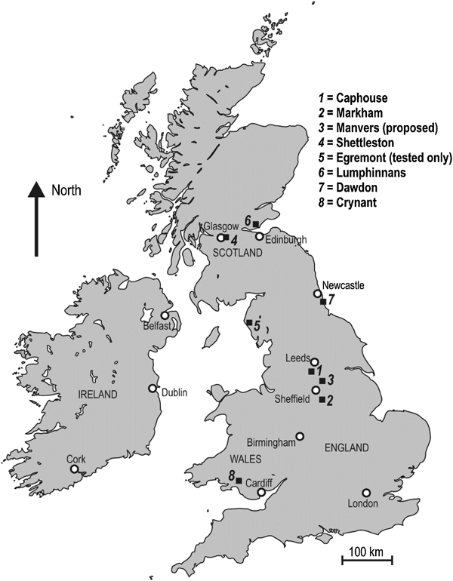

One of the main questions to understand the geothermal potential of flooded coal mines is to understand the temperature distribution in the mine, the key controls on the mine water temperature and recharge mechanisms. This can give insights into how fast heat is replenished into a mine system. This differs from conventional system in terms of the high permeability of such system, and with he risk of short-circuiting. Here in this profile is displayed the average rock strata temperature equilibrium measured in UK coalfield, and the mine water temperature measured in flooded shafts, above 800 m. They indicate that there is not clear correlation between the mine-water temperature and the equilibrium temperature profile.

Here are examples of 2 mine networks on which I will focus further during my PhD. The Bilston Glen mine in Scotland, which consists of a syncline and whose rebound was completed in 2020. The profile was taken before rebound was completed and displays isotheral distribution. In the Dawdon-Horden mine in NE England, pumping is performed since 2004 to prevent water discharge at the surface. The profiles indicate some shifts at the seam intersection, and shifts in temperature during pumping.

Temperature in flooded mine shaft is the only input data available from mines and therefore it is essential to understand what controls the observed temperature and how this can give insights into the heat potential of mines.

However, mines are very complex and for the purpose of this study, I use a conceptual model of a mine of simple geometry. The model consists of 3 horizontal seams intersected by two shafts. We perform a sensitivity analysis on the effect of diverse rock properties, mine geometry and production scenario on the observed temperature profile. The various geometrical features include …

Simulation is performed for 500 days, duration necessary for the pumped temperature profile and hydraulic conditions to reach a steady-state conditions in the reference model.

This first set of profiles indicate the parameters that do impact the observed temperature profile in the pumped shaft as a result of fluid extraction. They also impact the **rate of temperature change** at the well location

* The pumping depth: shallow pumping drags water from depth, increasing the heat capacity of the mine over time. Deep pumping reduces the average temperature at the shaft location. The energy drop after 500 days if even more pronounced with hydraulic flux boundaries (no forced recharge).

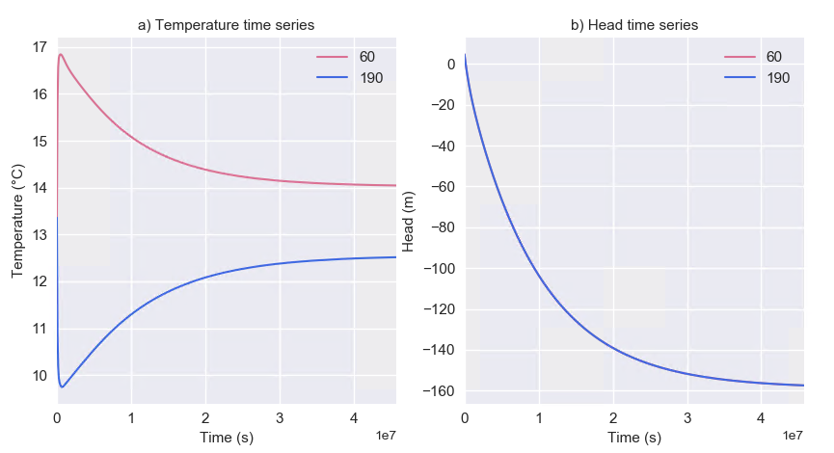

* The type of boundary also controls the drawdown around the well. When hydraulic flux boundaries are used, drawdown is up to -800m and not recharge is possible. The model considers saturated porous medium and does not account for the dewatering of the pore volumes.

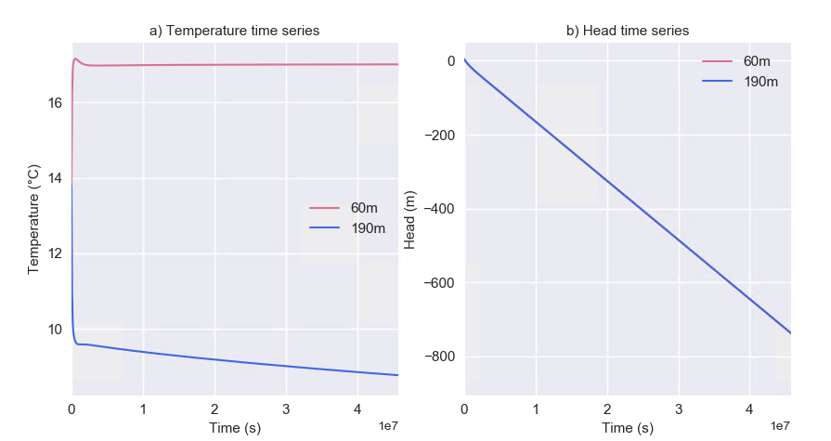

* The geothermal gradient: The lower the gradient and the lower the temperature inflow at the seam’s insets. The temperature at the pump location is equal to the mean profile temperature.

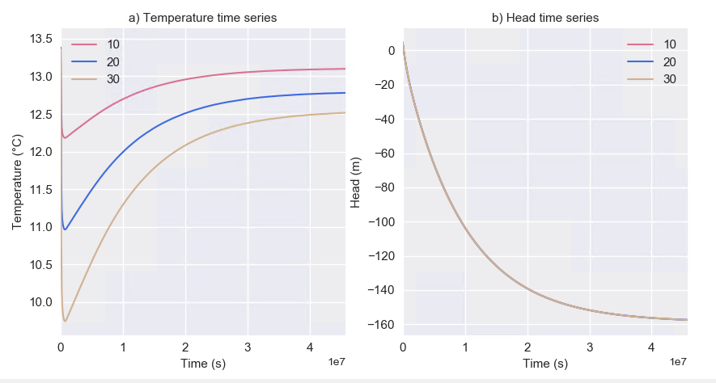

* The seam hydraulic conductivity: increasing seam conductivity favours recharge from different level. For low seam productivity (k < 1e-2 m/s), drawdown is higher and does not reach steady state within 500 days, so is the temperature in the mined interval.

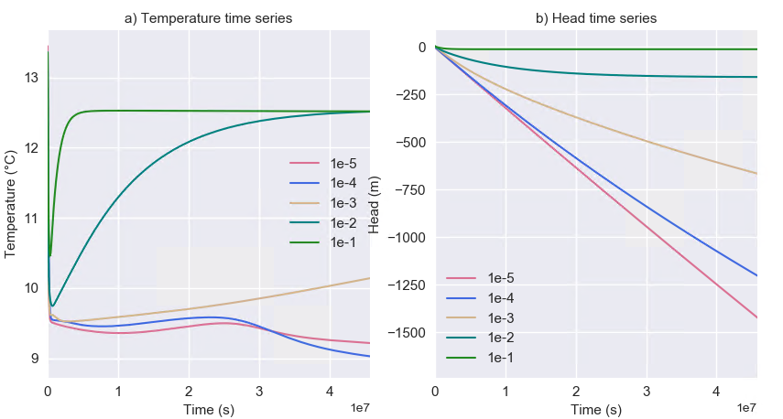

* And to a lower extent, the host rock hydraulic conductivity, although it does not impact the offsets in the mine interval (it only slightly modifies the temperature and head time series), high rock permeability reduced the temperature decline in the upper part of the profile.

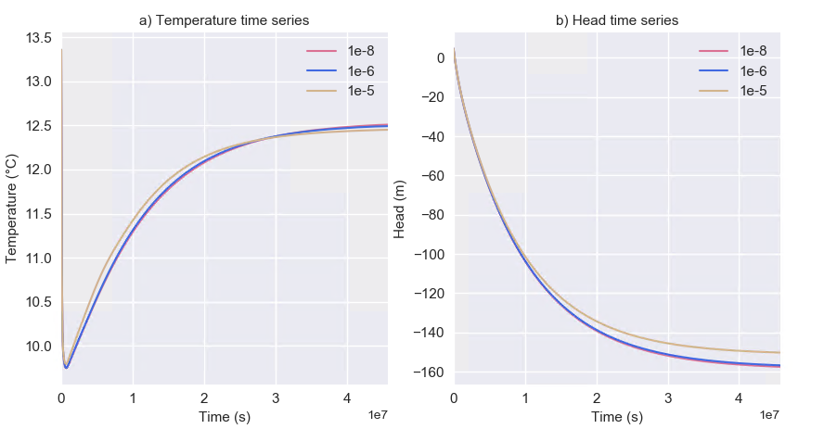

Both rock and seam productivity reduced the energy drop in the system, suggesting that convection of heat is the main recharge mechanisms

Some of the parameters only have a slight impact the observed temperature profile and temperature time-series at the well location. Although they impact the initial head in the system, the rate of change is not impacted and **steady-state is reached after the same time period**. This includes:

* The head gradient/regional flow velocity (offset in initial head only, but same rate of T/H decrease)

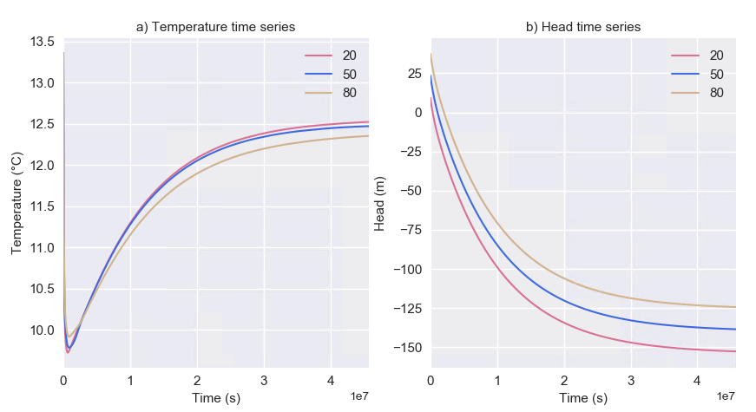

* The heat conductivity (no impact on time series)

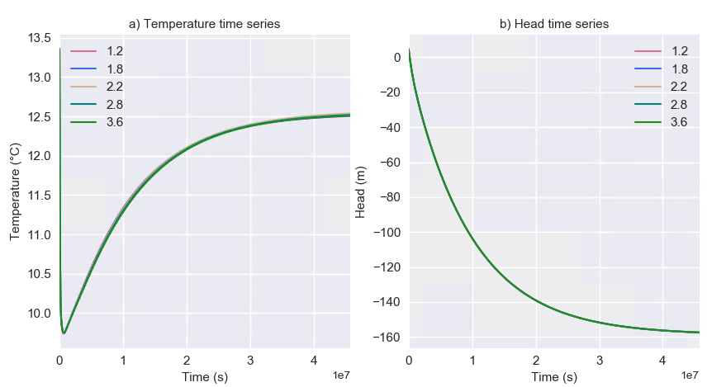

* and the pumping rate 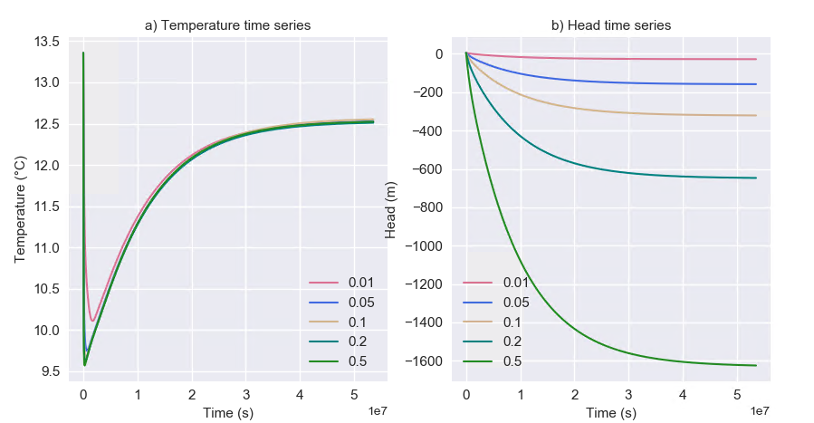

The host rock density, heat capacity, porosity have no impact on the observed timeseries and temperature profile. However, they do control the rate of energy change in the model.

Preliminary analysis on the effect of mine geometry has also been conducted. The results show that the profile in the mine interval depends on the location of the seams intersected and, on the relative location of the pump relative to the mined seams

Those results suggest that although temperature equilibrium in shafts reached after 500 days, it cannot give insight on the long tern heat potential of the mine (i.e. on the long-term energy content, i.e. temperature change away from the shaft). Therefore, further analysis needs to be done to understand the impact of a larger mined volume away from the shaft, but also on the impact of pumping on the temperature profile observed in another neighbouring shaft. Further investigation will aim at looking at temperatures away from the shaft to provide a mapping of temperature change in the mine, to better predict the long-term energy change.

11- Rebound

The previous models show results for scenario with pumping. However, not all coalfields are currently pumped, and some are still rebounding. We therefore model water rebound and heat recovery for a few scenarios previously presented, that is for different boundary conditions, pumping depth and seams hydraulic conductivities. Results first suggest that heat recovery is completed after different time periods depending on the hydraulic recharge rate, that is smaller for lower seam permeability and hydraulic flux boundaries.

When water is rebounding, there is a isothermal profile in the shaft, accordingly to the observations in UK coalfields showed in the beginning of this presentation.

After rebound is completed, temperature tends to re-equilibrate toward the initial undisturbed temperature gradient. The profiles here were extracted about 20 years after water rebound and heat recovery processes, but they display a positive temperature anomaly at the sub-surface and a negative one when hydraulic flux boundaries are used, suggesting that return to equilibrium is not completed yet. Extrapolation of temperature time series suggest that it would take more that 60 yrs at the minimum to return to pre-mining conditions, although perturbations of the gradient will remain at the seam’s intersection due to the superimposition effects of heat convection (advection of mine water).

The advection of water in highly permeable voids during mining and rebound is therefore suggested to create long-term perturbations of the geothermal gradient around mine shafts, as hot water is dragged from below and cold water from above the pump location. As the last mine in the UK was closed in the 1990’ and some of them are still rebounding, this would explain the lack of correlation between the mine-water temperature measured in shaft and the predicted undisturbed rock strata temperature. Those long-term perturbations are displayed here as 2D profiles of residual temperature anomaly, taken as the difference between the post-recovery and pre-pumping temperature distribution.

To conclude…

More work… Further work is now aiming at providing a more detailed mapping of temperature distribution in coal mines using the knowledge acquired from this sensitivity analysis. The aim will be to use a realistic mine geometry and mining/dewatering and rebound history to get more understanding on the importance of considering detailed mine features when assessing the large-scale potential of coal mines.