A benchmark for diffusive and advective heat transport in a 2D plane homogeneous incompressible porous media is currently being develop to assess the effect of different parameters on the evolution of the temperature profile. In this model, a line source located on the left boundary is injected a pulse of a constant amount of heat over time, and heat is transferred through the saturated porous media. A head gradient is introduced, allowing groundwater to flow at a velocity of XXX. Numerical results are validated against the corresponding analytical solution.

First a pulse and continuous heat injection solutions are solved numerically for a 1D line model. For each heat source type, we evaluate the impact of the mesh size (1 and 8 mm line elements) and of the porosity (0.1 and 0.5). Results are then compared for a 2D domain composed of quadratic elements (480 elements for the 8mm mesh and 34560 elements for the 1 mm mesh).

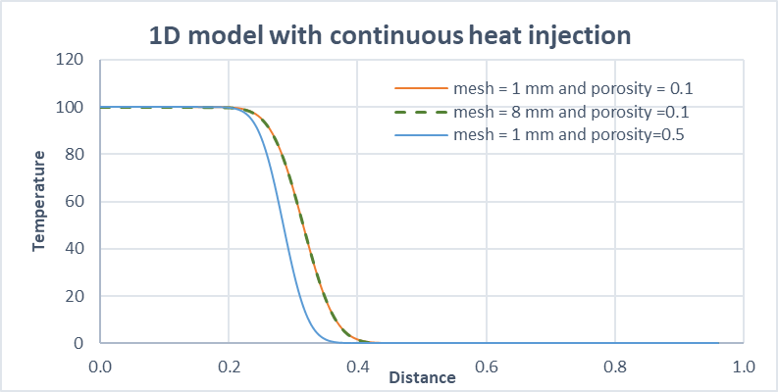

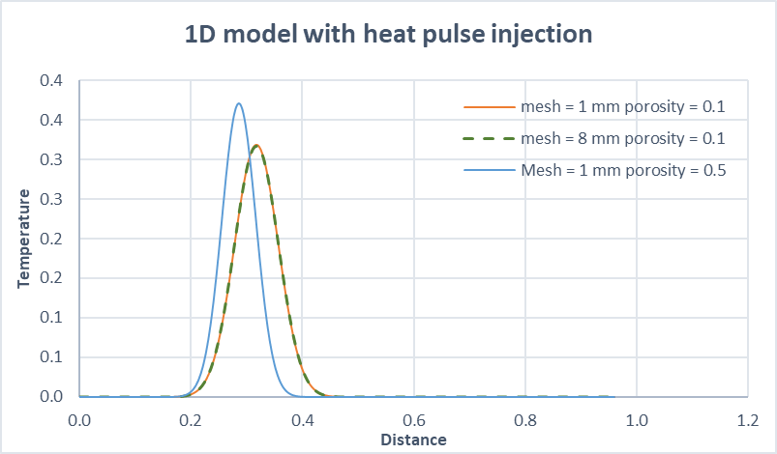

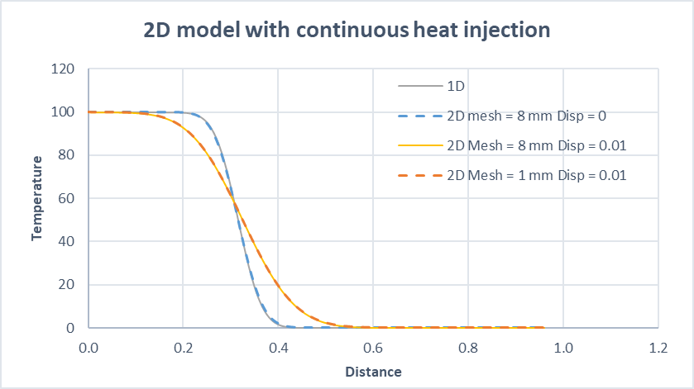

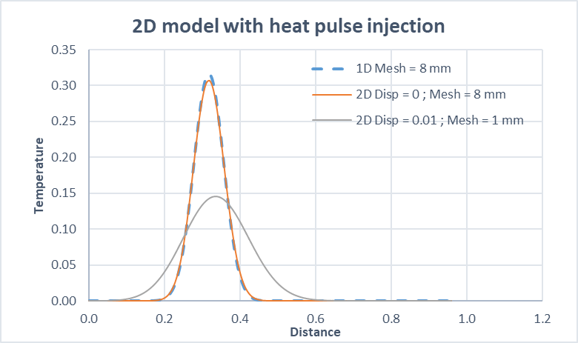

The material property is defined by a density of 2500 kg/m3, a thermal expansion of 1e-5, thermal capacity of 1280 and conductivity of 2.78 W/°C.m, and a porosity of 0.1. The permeability if set to 2.184e-13 and the fluid viscosity is 1.8e-5. The specific heat capacity of the water is set at 4068 and the heat conductivity is 0.63. In addition, the effect of an isotropic dispersion factor of 0.1 is finally assessed for both model size.

The analytical solution used here is based on the solution described in Barends et al. (2010), based on the Lauwerier concept (1955). This solution allows exploring the complete heat storage and transfer processes allowing convection by pore fluid flow, conduction, dispersion and thermal bleeding. The Lauwerier’s concept deals with heat transport in a homogeneous reservoir with thickness H(m) and initial uniform temperature T0 in a plane uniform steady groundwater flow. Water of temperature T1 in injected at x=0 and t=0 at a reate Q(m3/s). In this model, the lower boundary is set no flow (both hydraulic and thermal) and the upper boundary in impermeable but can conduct heat through thermal bleeding. The solution derived for z=0 (no heat diffusion in the overburden) represents the temperature distribution in the reservoir (Abramowits and Stegun, 1968; Ogata and Banks, 1961):

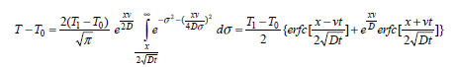

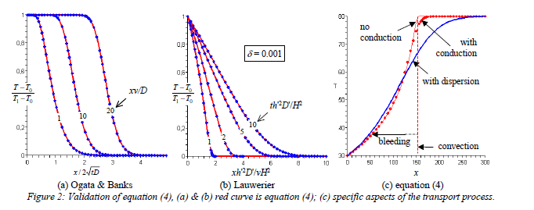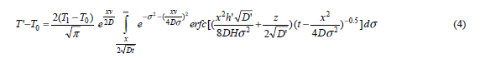

In Eq (4), the effects of thermal convection, conduction, dispersion and bleeding are described, from the injection of water at a temperature of 30°C in a reservoir of initial temperature T0 = 80°C. The curves represent the temperature of the saturated medium while heat is instantaneously distributed over the porous fluid and solid matrix.

Result from their analysis showed that despite the effected zone in the overburden is rather limited, thermal bleeding (i.e. heat conduction in the overburden) has a large effect on the temperature pattern in a reservoir. In a plane symmetry, the true water velocity is rho c / n (rho c)f is 2 times higher than the heat front velocity. Evaluating the relative contribution of different processes requires the use of normalized parameters. The Peclet number can for example be used to study the relative contribution of conduction or convection for heat transport in a reservoir, using a characteristic length Lc for conduction-dispersion phenomenon, and L = vt the length effect of convection, as: (L/Lc)² = L²/(4tD) = L²/(4(L/v)D=Lv/4D=0.25Pe. A thermal bleeding numer Bl has also been developed to study thermal bleeding in the overburden relative to convection. Thermal bleeding halfway is also described by T-T0=(T1-T0)erfc(z/sqrt(tD’)), with D’ the diffusion coefficient in the overburden, resulting in a average heat flux at the interface q=2/sqrt(pi)\*(λ’/sqrt(tD’)). Using those parameter, an equation for a specific Darcy velocity q has been developed, with L the location of a production well, t)L/v, m=e-Bl the relative temperature change:



Similar solutions have been developed for axi-symmetric heat transport in stationary flow and radial solutions.

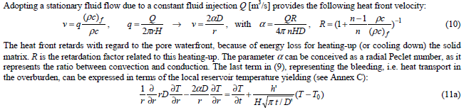

The time t0 required for the temperature at the boundary reach T1 under injection of heat before the heat front actually start has been defined as t0 = rw² / (4D (α+1) \* F(α)

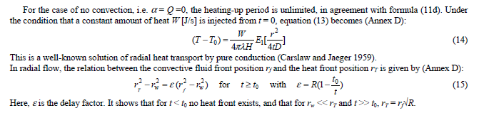

Bauer et al (2015)

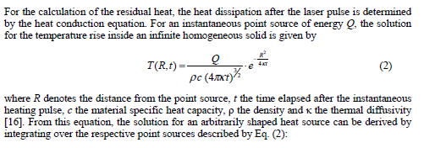

Pastore et al. (2018)

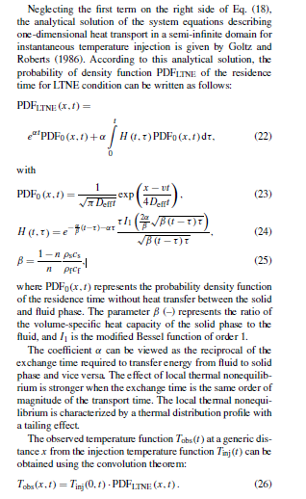

Ref for “Normalization used to see relative contribution of processes” + characteristic length used in Biglarian et al 2017. Rivera et al. (2016) based her study on dimensionless parameters (i.e. independent of temperature, borehole length and/or time) to faithfully study the contribution of different heat transfer processes (i.e. using Pe, Fo and H numbers).

Tye-Gingras, L. Gosselin (2014)

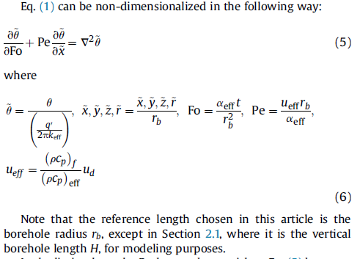

Molina Giraldo, 2011

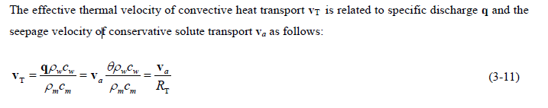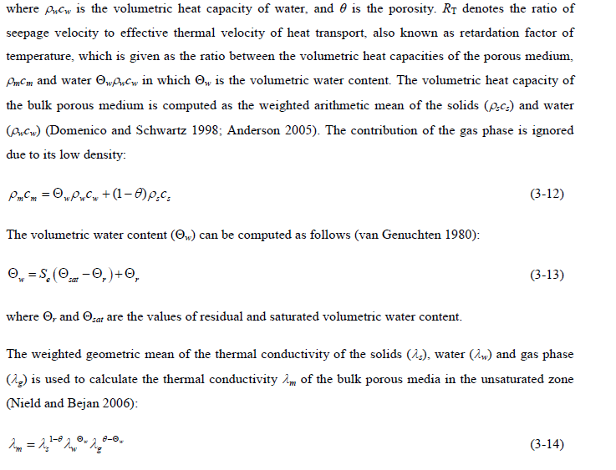

LM2 : layer above / below with t = 0.01

M0 = Ref : k=2e-13 and K=2.78 zith GZ floz 2e-4

M1 : lower k-layer above/below but same Kth as reservoir

M2 : lower k and low Kth in layer above/below

M3 : same as ref but lower Kth (0.41)

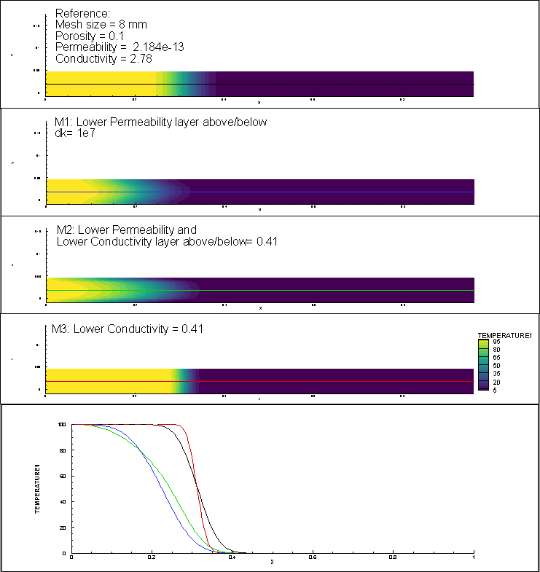

M4 : lower permeability (2e-20)

M5 : higher porosity (0.5)

M6 : no gradient (pure conduction)

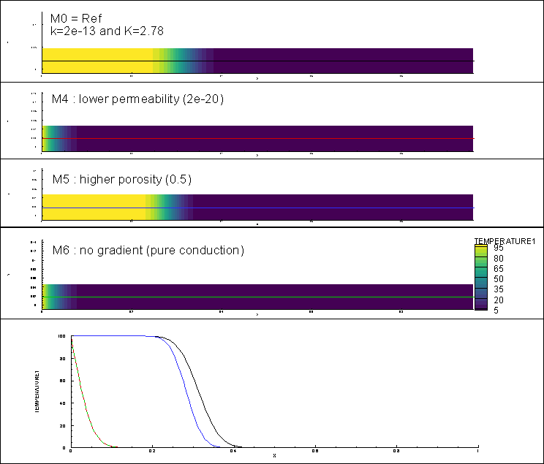

LM3 : layer above / below with t = 0.02

same as M2

- for structured mesh

- for unstructured mesh

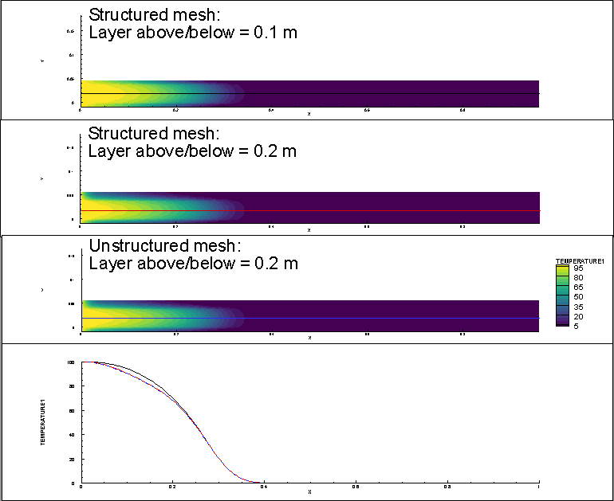

LM4 : Model complex and sandwich

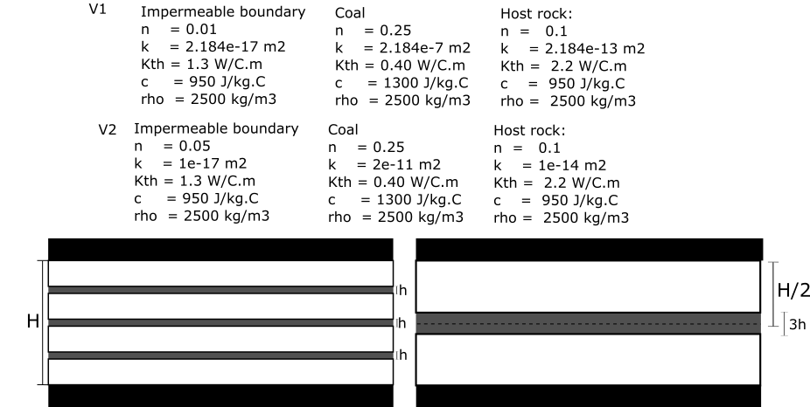



k=Kµ/rho g



- v1: material properties based on M2

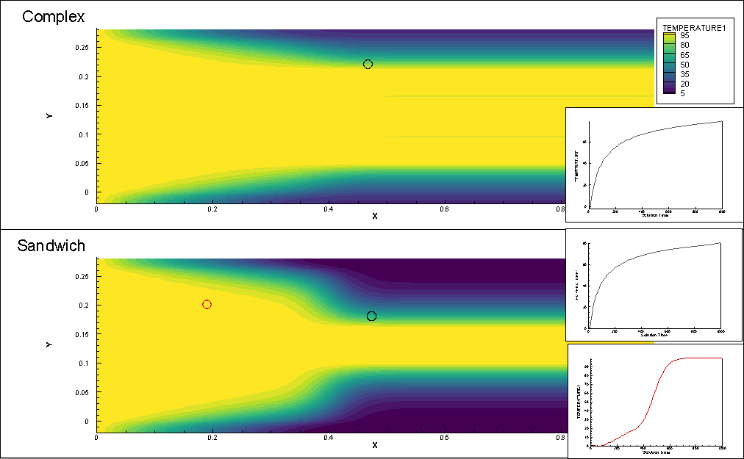

- v2: more realistic material properties



