Scanned Mine Plans request (Academic data license)

# Dawdon-Horden area (NE England)

**Mine plans** of the Dawdon-Horden Minewater Block.

Include all the **Undersea mine Plans** for the Durham coastal collieries (i.e. extending undersea from Vane Tempest – Ryhope to the North, to Blackhall to the South).

In order of priority:

* Dawdon, Murton collieries (inland / undersea)
* Easington, Horden collieries (inland / undersea)
* Hawthorn, South Hetton, Shotton collieries (inland)
* Seaham, Vane Tempest collieries (inland / undersea)
* Blackhall colliery (inland / undersea)
* Others…

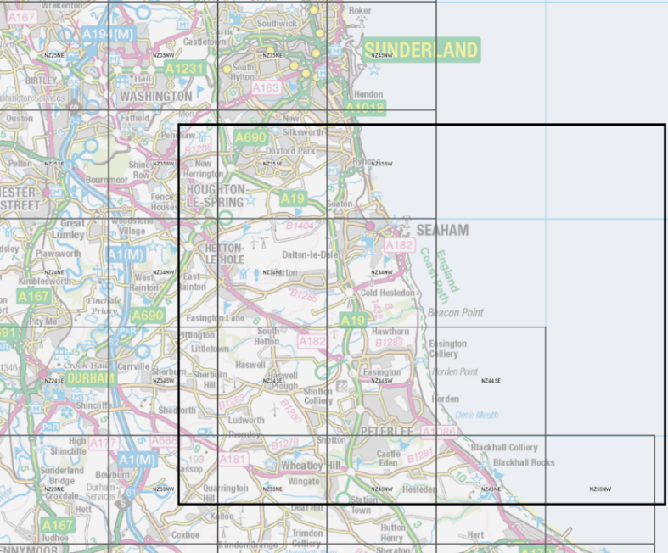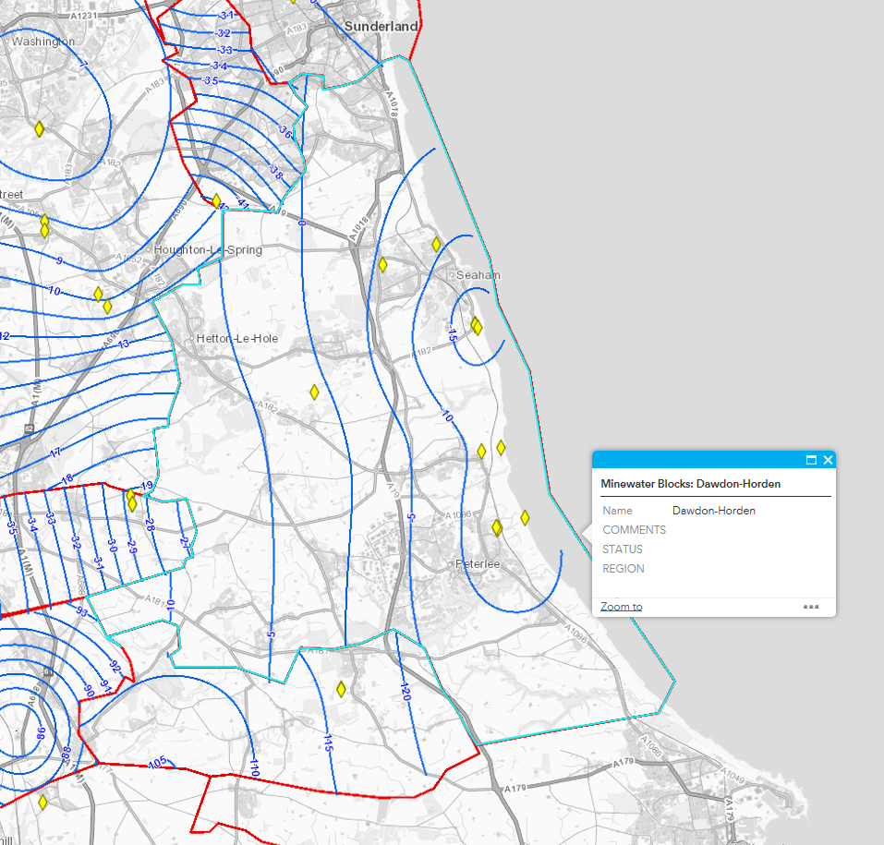

# Bilston Glen-Easthouses area, Midlothian, Scotland

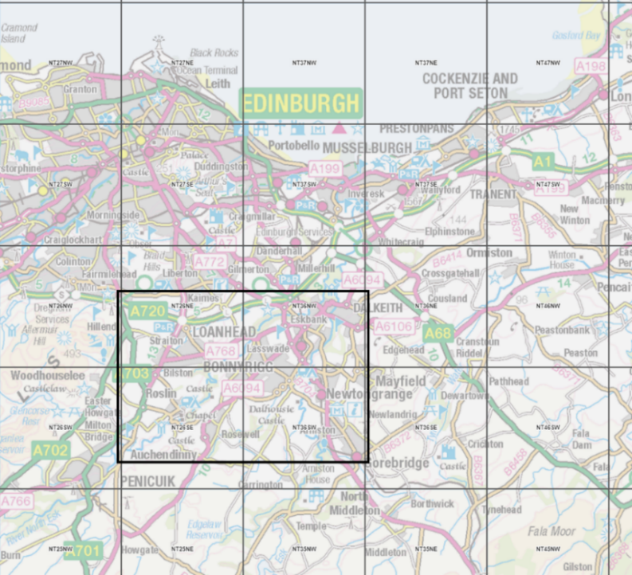

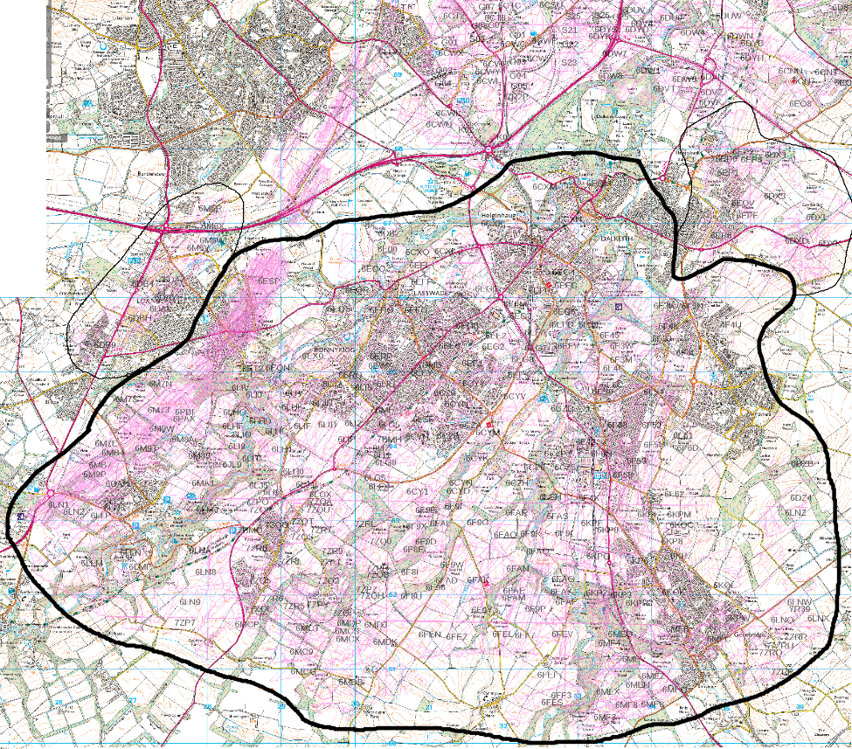

**Mine plans** requested for the area outlined by bold line. In order of priority:

* + Bilston Glen, Easthouses, Lady Victoria, Lingerwood
  + Arniston, Newton Grange, Newbattle
  + Burghlee, Roslin, Ramsay
  + Whitehill, Polton
  + Others…

Areas outlined by the thin lines will be considered later if connected with main study area.

For both area, please include any scanned copies of:

* seam summary
* key plans (scale of 6 inches to 1 mile)

Thanks,

Mylene