<https://assets.publishing.service.gov.uk/government/uploads/system/uploads/attachment_data/file/208097/10043_R66141HouseholdElectricitySurveyFinalReportissue4.pdf>

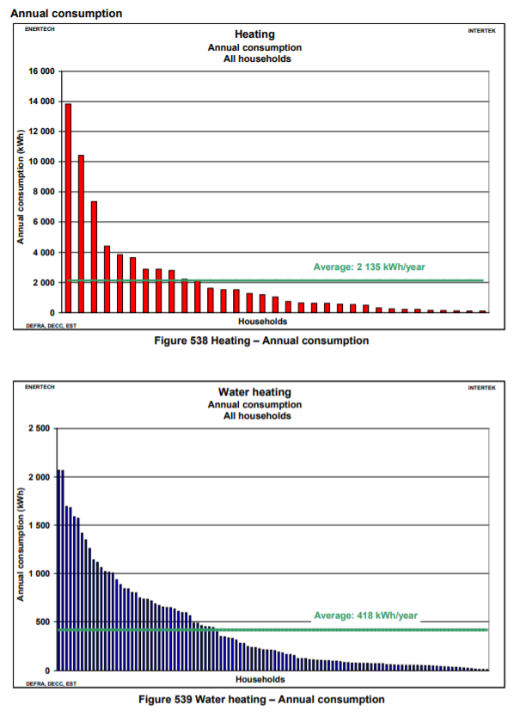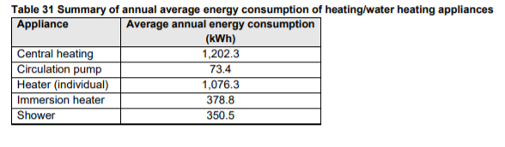

<https://www.thegreenage.co.uk/how-much-energy-does-my-home-use/>

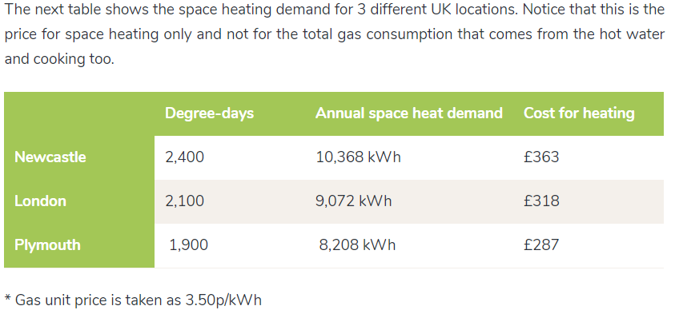

<https://www.ovoenergy.com/guides/energy-guides/how-much-heating-energy-do-you-use.html>

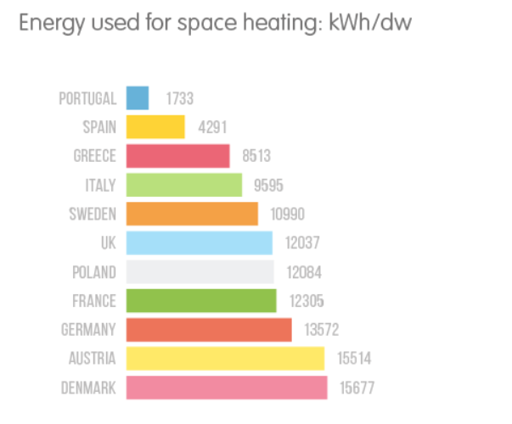





Total: 410,439,007,930 kWh (<https://www.unitjuggler.com/convert-energy-from-ktoe-to-kWh.html>)

Nb households = 27424058 (source: Final Energy Consumption Tables – Table C9)

Average heat consumption per household = 14966 kWh