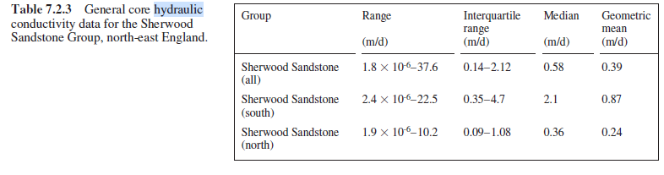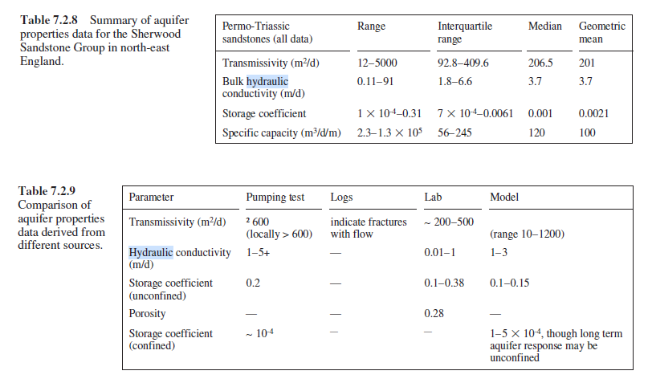

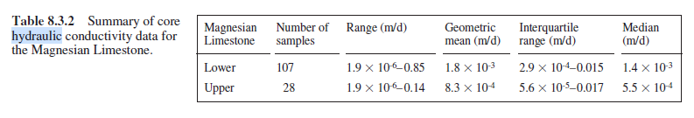

The matrix of the Carboniferous Limestone has very low

values of porosity and permeability. Drew (1968) obtained

a porosity value of 0.18%, and Gunn (1992) suggested

intergranular hydraulic conductivity values in the range

0.001–0.01 m/d. Recent work on Carboniferous Limestone

core from north-east England indicates porosity values of

0.2% to 5.9% (median 1.2%) and a median hydraulic conductivity

value of 3  10-6 m/d (Nirex, 1993). Such values

are unlikely to contribute to the water-bearing properties of

the aquifer

Slug Bailer tests were carried out on 30 boreholes in the

Beacon Hill Carboniferous Limestone (Hobbs, 1988). The

average hydraulic conductivity values obtained from each

site varied between 0.00074 m/d and 110 m/d, with an arithmetic

mean of 8.5 m/d and a geometric mean of 0.3 m/d.

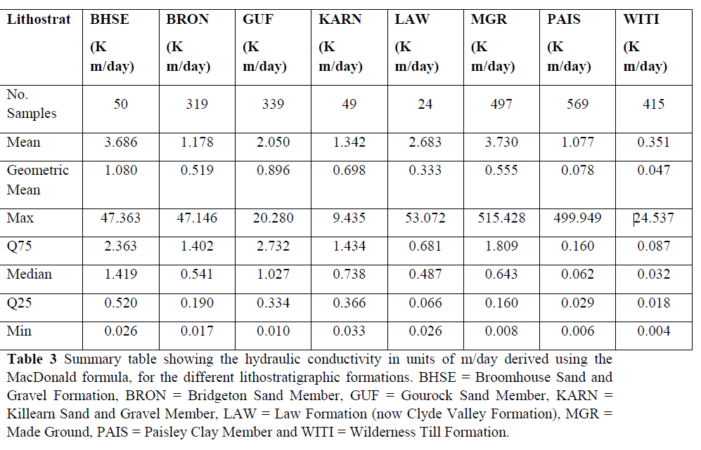

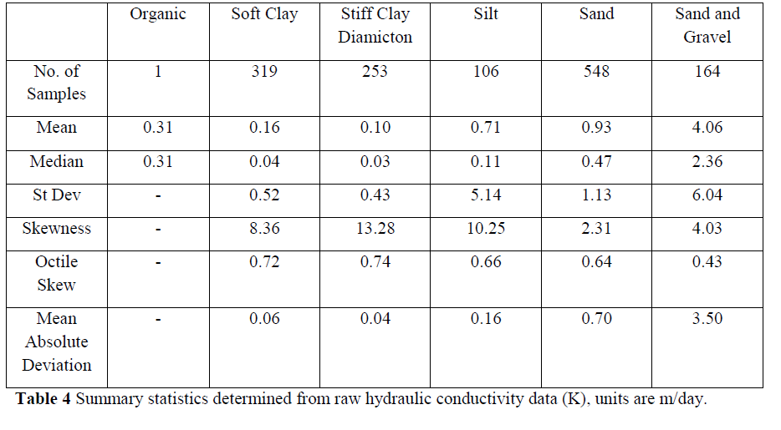

Carboniferous sedimentary rocks in the Central Belt typically form multi-layered and vertically segmented aquifers. The typically fine-grained, well-cemented rocks have low intergranular porosity and permeability, and groundwater flow and storage dominantly occur in fractures in the rock. Hydraulic aquifer properties therefore depend largely on the local nature of fracturing in the rock (Ó Dochartaigh et al., 2015). The rocks tend to form moderately productive aquifers (Ó Dochartaigh et al., 2015). Measured matrix porosity values are in the range 12–17%; hydraulic conductivity (permeability) values are in the range 0.003–0.1 m/d; and transmissivity values are in the range of 10–1000 m2/d (Table 9).

