1. 2D steady state model

Simulate heat extraction from a single seam with no net inflow / outflow to determine the new steady state heat flow pattern from the surface, together with the lateral extent of the zone influences by mine water extraction.

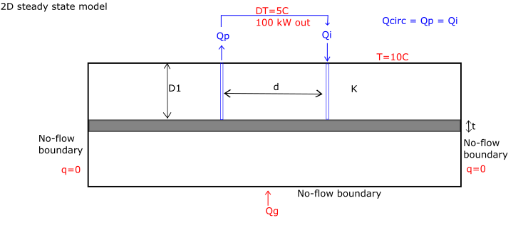

Geometry

* Sensitivity analysis on the model width necessary to determine the minimum lateral extent required to minimize edge effects of the no flow/flux boundaries on the model temperature
* D =100 m [100 – 500 m?]
* d =100 m [100 - 1000 m?]
* t = 2m
* n (seam porosity) = 50%

Boundary conditions:

* Borehole abstraction/reinjection modelled as from one cell or as lines

Properties

* K (thermal conductivity of sandstone/mudstone)

Expected results:

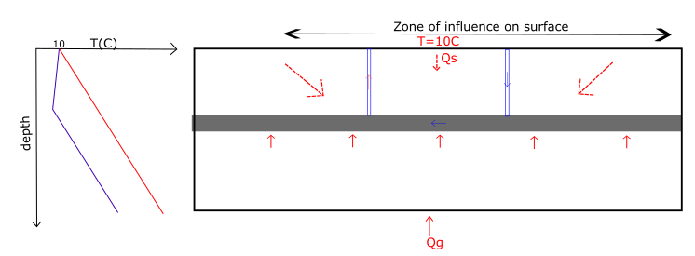

* Decrease in seam temperature due to the reinjection of colder mine water
* Increase in conductive heat exchanges between the host rock (geothermal heat recharge from below) and the coal seam
* Possible negative gradient formed above the coal seam leading to solar heat flux flowing down from the surface
* New steady state reached between solar/geothermal heat recharge and colder water injection (balance + location of solar/geothermal fluxes is of interest)
* The difference between the undisturbed thermal profile (in red) and the new steady state (in blue) represents the heat energy extracted prior to sustainable steady state being reaches (heat mining)

1. 2D steady state model with flow in seam

Regional head gradient is set across width of the model.

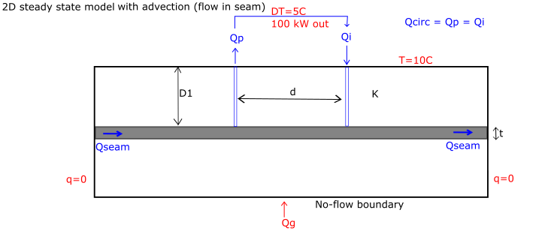

Simulate what happens for:

$Q_{circ}=Q_{seam}$

* $Q_{circ}>Q_{seam}$ (e.g. $Q_{circ}=\frac{1}{2}Q_{seam}$)
* $Q_{circ}<Q_{seam}$ (e.g. $Q_{circ}=2 Q_{seam}$)
* If abstraction and injection wells are swapped
* If injection is stopped (i.e. $Q_{p}>Q_{i}$)

Constraints:

* Modelled regional gradient needs to remain close to what is typically observed ([1:500 – 1:1000]
* Abstraction/injection rates: [10-40 L/s]

1. 2D steady state model with flow in seam and uniform recharge

Flow is induced both along the seam (horizontal flow mainly) and the host rock / strata (vertical flow mainly).

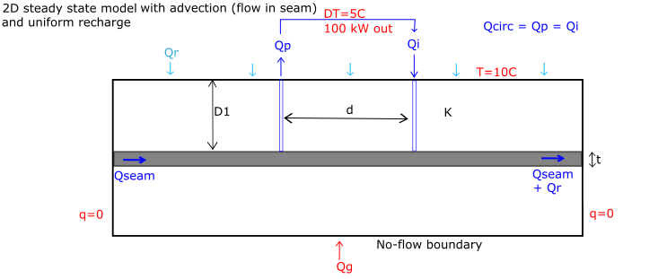

Question: Does the adjective heat flow from surface in the recharge make a significant difference?

1. 2D steady state model with flow in seam and uniform recharge + other features
   1. Seam below (+ reinjection)

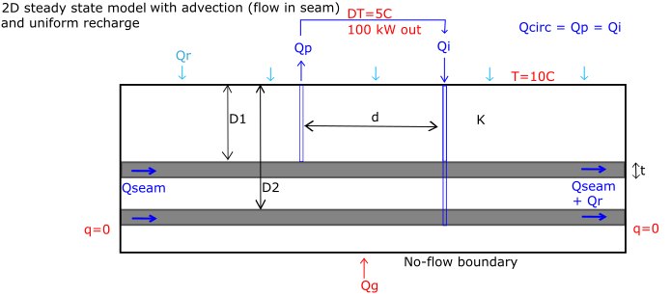

* 1. Seam above (+reinjection)

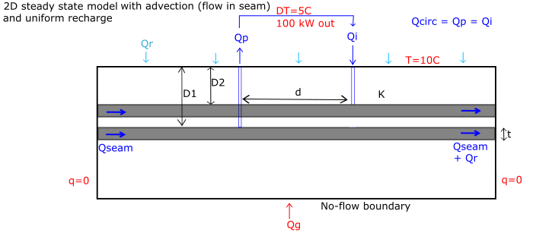

* 1. Interconnection between seams?
  2. Infilled mine shaft close to the boreholes
  3. Solar seasonal fluctuations?
  4. Different mined seam geometries (e.g. goaf / open voids)

1. Transient model

Objective: determine the time to reach the new steady state or breakthrough time.

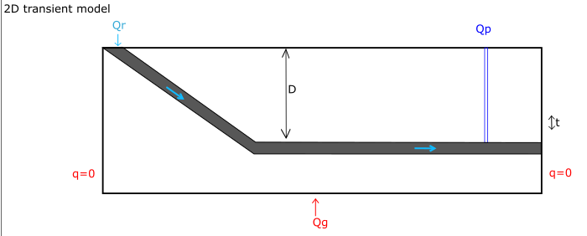

Geometry: include more realistic geometry such as a dipping layer / seam from outcrop (i.e. Bilston glen, Dawdon and Hawthorne areas) allowing recharge to flow down.

Question: can the temperature of Q be predicted by modelling <