# Introduction

Heat demand for domestic and industrial space heating account for about 50% of the energy consumption in the UK. Currently, around 70% of this energy is supplied by natural gas, contributing to about 34% of the Grenhouses Gas Emissions of the country. Through the 2019 UK’s Climate Change Act, the UK Government and Scotland both agreed to reach neutral carbon emissions by 2050 and 2045, respectively. To achieve this goal, attentions have been raised on the need to decarbonize residential heat and to find new low-carbon energy sources, such as low temperature geothermal energy.

Borehole heat exchanger (BHE) coupled ground source heat pump (GSHP) systems have increasingly used from the 80’s to extract heat from the ground for domestic space heating and cooling purposes (Chen et al., 2019). In situations where no groundwater is available, closed-loop technologies have been developed to access heat at different depth range in the subsurface. Some examples include horizontal heat exchangers, generally situated at depth below 10s meters, where the ground temperature is mainly controlled by solar recharge, or deep vertical borehole heat exchangers. Where the temperature extracted is too low, such as in the former example, heat pumps are generally used to raise it to sufficient levels. In opposition, deep BHE can be drilled down to 2 km depth and can access higher temperatures, depending on the local geothermal gradient. Despite deep BHE have been proven to be more performant (i.e. increased borehole length that reduce the specific heat absorption (Banks, 2008) and increased energy content due to higher temperature), the high investments costs of such technology represents an important barrier for individuals. Here, we focus our attention on shallow vertical BHE systems. Such system, are generally situated between 40 – 200 m and can be used for hot water and space heating of individual houses. At that depth interval, the temperature is assumed to be relatively constant as a result of complex interactions between the solar heat flow at the ground surface and the deep geothermal flux, and tends to equal the average yearly air temperature.

To date, the performances and the sustainability aspects of BHE have been well studied. Many authors used both analytical and numerical models, ranging from one-dimensional BHE model to full 3D subsurface numerical models to assess the long-term performances of such system (i.e. Rybach and Eugster, 2010; Signorelli et al., 2005; Lyu et al., 2017; Zhang et al., 2016; Stylianou et al., 2017; Zanchini et al., 2010; Lazzari et al., 2010). While XXX and XXX, for example, showed that steady state production temperature can be reached after a few years of heat extraction, XXX warned that unbalanced heat extraction and injection from BHE in cold regions (i.e. due to greater needs in heating relative to cooling) might lead to an extensive cooling of the ground. Injecting excess solar heat energy collected from solar panels in summer into the ground was view by the authors as a potential solution to compensate for the geothermal heat extracted in winter and guarantee the long-term viability of such installations. However, there is however still a lack of investigation regarding the extent of the heat accessed by shallow vertical BHE over the long term. This is an important issue in a context where the number of geothermal heat schemes is expected to increase drastically in the next decades, coming along with a need to develop an approach to guide the licensing of heat.

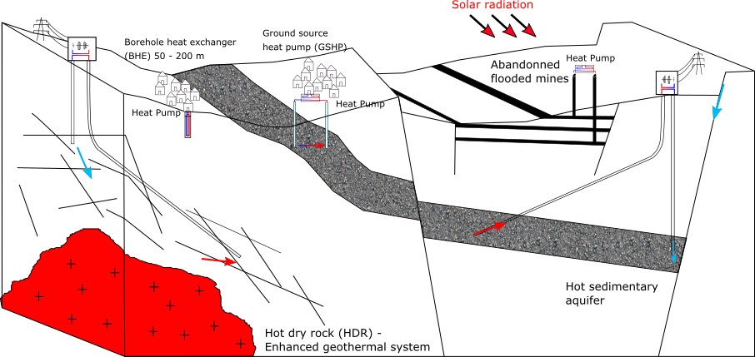

Figure 1.1: Type of geothermal energy available in the UK. The aim of this paper is to assess the long-term heat potential of the shallow subsurface, based on heat extraction from vertical borehole heat exchanger (BHE). The conceptual model here assumes conductive heat transfers in a dry porous rock without groundwater flow

The objective of this paper is therefore to investigate the footprint area of heat extraction from an individual vertical BHE in the UK, based on different production scenarios, looking at the impact of heat extraction from a geological resource perspective rather than a BHE performance perspective. Mathematical solutions are first use to calculate the volume of rock required to provide the equivalent of a yearly average heat consumption to a single house in the UK, and quantify the amount of heat recharge available in the ground. Heat balance calculations are then verified numerically by performing a series of 1D and 3D heat extraction simulations in a homogeneous porous medium. Results are used to quantify the relative contributions from vertical and lateral conductive heat fluxes providing heat to the borehole over a 30-year extraction period, through heat mining of surrounding rock. A sensitivity analysis performed to assess the key parameters controlling the extent of the heat depletion caused by constant/cyclical production as well as the maximal temperature drop at the borehole. Similarly, we finally investigate how cyclical production and heat recharge contribute to reduce the impact on the ground. Results indicate that cyclical production with period of artificial heat recharge to the ground is mandatory to both constrain the areal impact of heat extraction on the ground and reduce the temperature decline at the borehole, both inversely correlated depending on the thermal conductivity of the ground.

# Mathematical model

## Borehole Heat Exchanger

Geothermal energy characterizes the heat energy contained in rocks of the Earth’s crust and that can be either used as an energy source for space or water heating, or converted into electricity. Different technologies have been developed to access this energy resource, depending on its depth, on the presence of groundwater or not, and on the purpose of utilization. Rocks are generally getting hotter with depth according to the geothermal gradient, and despite accessible high-temperature geothermal resources are limited to only a few geographical area, harnessing the shallow low temperature geothermal resources available worldwide have been of growing interest since the 80’.

In areas with no available groundwater, the energy contained in the shallow-subsurface can be accessed using vertical Borehole Heat Exchangers. Despite the total heat content of a rock is intrinsically linked to its temperature, the amount of energy that can be extracted from its cooling is generally expressed as a function of a temperature gradient ∆*T*. In a doublet system (i.e. extraction and re-injection of groundwater within sedimentary aquifers), it generally represents the temperature difference between the abstracted and injected water, while it usually corresponds to the difference between the inflow and outflow temperature through the Heat Pump in a BHE system (generally in the order of 5◦*C*). This relationship is expressed as:

*Q* = ∆*TV*(1−*φ*)*ρc* (2.1)

where *ρc* is the volumetric heat capacity of the rock of volume *V* and porosity *φ, c* is the heat capacity, *λ* the heat conductivity, and *ρ the density* of the material. Raymond and Therrien (2008) suggested to use this relationship to calculate the heat content of rock sections along a vertical profile, where ∆*T* = *dTdz* ×*z*, with *z* the average depth of the considered rock section and *dTdz* the mean geothermal gradient. Previous studies aiming at assessing the performances of BHE and Ground-Source Heat Pump systems showed that the efficiency of heat extraction mostly depends on the heat transfer process between the BHEs and the ground. In a purely diffusive medium, it mainly depends on the thermal conductivity of the ground (i.e. Stylianou et al., 2017; Chen et al., 2019; Choi and Ooka, 2015). The presence of groundwater was suggested to improve the long-term performance of BHE both by increasing the heat exchange rate during production (Zanchini et al., 2010; Stylianou et al., 2017; Wang et al., 2013) and by favouring heat recovery (Hein et al., 2016; Erol et al., 2015). In medium with groundwater circulation, analysis showed that soil heat capacity and thermal conductivity only have minor impact on the sustainability of a GSHP system and that dispersion tends to increase the area of impact of heat extraction. Here, we focus our analysis on vertical BHE systems, extracting heat from a purely diffusive porous medium. We consider an homogeneous ground, whose characteristics are defined accordingly to a typical geological profile in the Midlothian Coalfield, our study area.

## Heat load

We first suggest to calculate the volume of rock that would be required to provide the energy requirements for a single house in the UK, which is in the order of 12 400 kWh in average per year, with a maximum of 18 000 kWh in winter and 8 000 kWh in summer. To satisfy this yearly demand, a heat pump would need to deliver an average heat load *H* = 1415 W by extracting heat from the subsurface. In reality, part of the heat load is supplied by the heat pump in the form of electrical heat *E*, reducing the energy that needs to be extracted from the ground *G* (Banks, 2008) by an amount that depends on the Coefficient of Performances (COP) of the heat pump. The COP, which characterizes the efficiency of the system, is defined as the ratio of the total heat load *H* over the electrical power *E* required by the heat pump and can be used to derive the electrical power required for air compression as followed:

1

*G* = *H* (1− ) (2.2)

*COP*

Using an average COP of 3.4, the average heat that would need to be extracted from the ground to satisfy a heat demand H = 1415 W is therefore reduced to G = 1000. This corresponds to a total energy of 3*.*15×1010*J* over a year. Considering a 40 m long borehole heat exchanger (BHE), the specific heat absorption from the rock, as defined by Banks, 2008 is therefore  = 25 W/m.

Using Eq. 2.1, we then estimate the volume of rock required to provide a total heat load *Q* = 3*.*15×1010*J* (i.e. energy required in one year). Considering a dry solid rock mass of volume *V* = *V*(1−*φ*), with a porosity *φ* = 0*.*1, a density of *ρ* = 2500 *kg/m*3 and a specific heat capacity of c = 950 *J/kg.*◦*C*, the volume of rock required to provide this energy by cooling the rocks by ∆*T* = 5◦*C* is about 2800 *m*3. Assuming that the heat is extracted radially from a borehole with a length h = 40 m situated in the center of a cylinder, the estimated radius of this cylinder would be 4.8 m, corresponding to a surface area of about 70 *m*2. Over a 30-year operation period (*Q* = 9*.*47×1011*J*) and if no recharge is considered, an area of 2200 *m*2 would be required (r= 26.5 m), corresponding to a rock volume *V* = 8*.*9×104 *m*3.

## Heat recharge

Sustainable heat production from BHE can be achieved if the heat load extracted is balanced by heat recharge in the subsurface. We therefore here attempt to quantify the rate of heat production in the subsurface as well as the potential recovery rate from solar and geothermal heat flux, based on a typical temperature and geological profile in Scotland.

### Radiogenic heat production

The Earth’s natural heat flow is primarily attributed to a contribution from the primordial heat inherited from the formation of Earth and from the natural decay of radioactive elements, mainly of the isotopes of uranium (238U, 235U), Thorium (232Th) and potassium (40K) (Pollack and Chapman, 1977). Due to geochemical differentiation, partial melting and magma crystallization processes, the upper crust is generally enriched in heat producing elements (HPEs) compared to lower levels (Beamish and Busby, 2016). The distribution of radiogenic HPEs therefore provides an important control on the temperature distribution within the earth lithosphere (Sandiford, McLaren, et al., 2006) and a combined determination of the conductive heat flow and radiogenic heat production (RHP) can provide a good constrain on the thermal field within the crust (Jaupart and Mareschal, 2005).

We here focus our analysis on the Midlothian Coaldfield area, situated in the south east of a 80 km wide, 150 km long WSW-ENE trending Carboniferous graben extending across Scotland, the Midland Valley of Scotland (MVS) (Browne et al., 1999; Underhill et al., 2008). This area is located on a geologically stable part of Earth’s crust, where only granite intrusions would contain sufficient concentration of K,T and U element to generate significant radiogenic heat (Gillespie et al., 2013). However, intrusions dated from the Carboniferous to Permian can be found in Scotland in high concentration in the block of crystalline rocks bounded by the Highland Boundary Fault and the Great Glen Fault. Some are located south of Inverness and near Aberdeen but only have small heat producing (HP) values (0.6–2.2 uW/m3), in the Grampian Highlands and in the Northern Highlands (HP of 2.2 to 7.3 uW/m3). Two large intrusions (Fleet and Criffel), with HP values of 3 and 2.2 uW/m3, respectively, were emplaced in Southern Scotland at the end of the Caledonian Orogeny (410–390 Ma). Only one intrusion of significant size, the Distinkhorn intrusion, can be found in the MVS and consists of diorite and granodiorite with relatively low HP capacity (2.0 uW/m3).

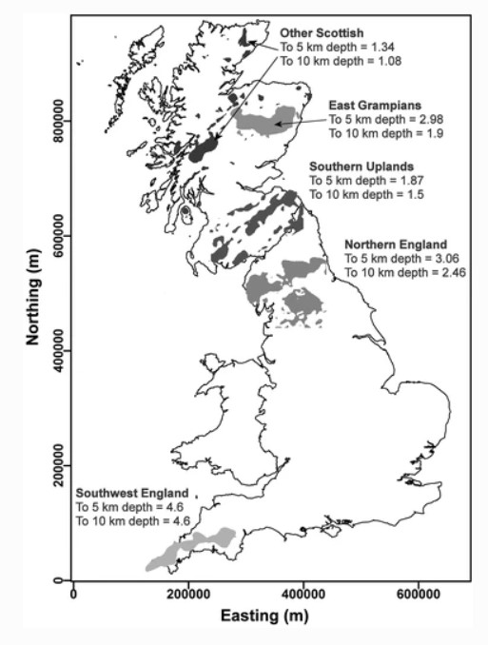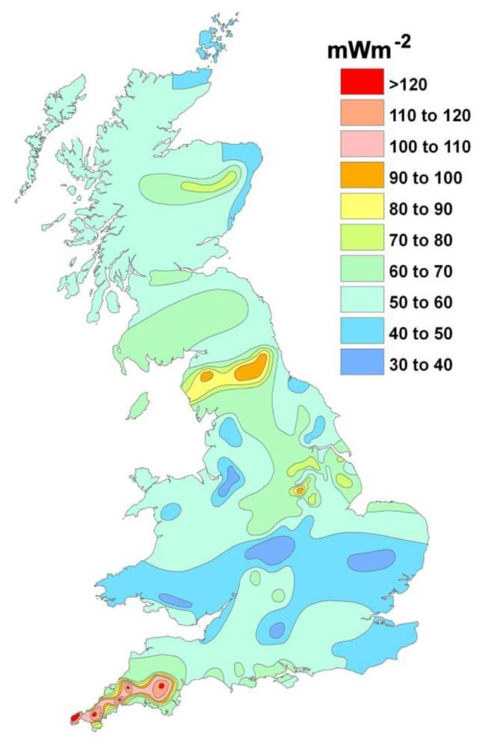

Figure 2.2: a) Locations in Great Britain with significant quantities of heat producing granites within the upper crust. Quantitative figures of average heat production in, uW/m3 (Busby, 2017) b) Heat flow map for the UK (Busby, 2011).

According to XXX, isotopes of U, Th and K can be found in minerals in most crustal lithologies. We therefore attempt to calculate the average radiogenic heat produced in a typical Carboniferous sedimentary succession of the Midlothian Coalfield to evaluate if this could represent an additional source of in-situ heat (Fig. 2.3). Our estimates are based on the thickness of each Carboniferous formation identified the Carrington-1 well (Monaghan, 2014), on the average proportion of lithologies in each group (Entwisle, 2019; Vincent et al., 2010) and on typical RHP values for those lithologies obtained from the literature (Vila et al., 2010; Osimobi et al., 2018). In the Midlothian Coalfield, the sedimentary succession consists of 10-m thick cycles of non-metamorphized sandstones, siltstones and mudstones with beds of limestone, coal, fireclay, ironstone and oil-shale, intersected by andesitic/basaltic lava flows and pyroclastic rocks (Cameron and Stephenson, 1985). This succession, typical of the one found in Scotland, can be subdivided into the Inverclyde group, the Strathclyde group, the Clackmannan (i.e. Upper Limestone Formation (ULGS), Limestone Coal Formation (LSC) and Lower Limestone Formation (LLGS)) and of the Scottish Coal Measures group (i.e. Lower (LCMS), Middle (MCMS) and Upper Coal Measures formations (UCMS)) (Browne et al., 1999). The Upper Limestone Coal Formation is separated from the overlying Coal Measures Group by the Passage Formation (PGP), dominated by relatively coarse-grained sandstone (Browne et al., 1999) (Fig. ??). Using an area of about 82 *km*2 corresponding to the zone covered by the outcrops of the Coal Measures Formation, we find that the total radiogenic heat produced in the Midlothian Coalfield would be in the order of about 86 kW.

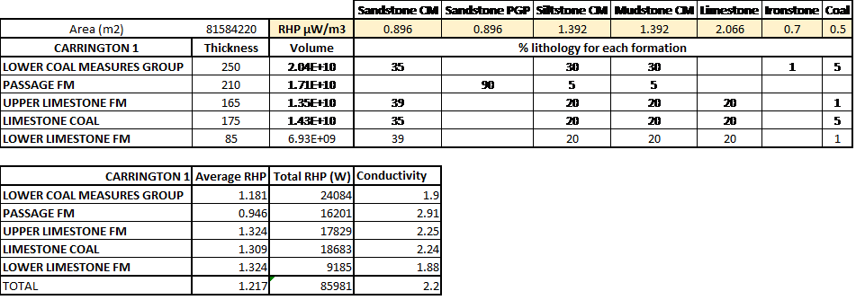

Figure 2.3: Estimates of total radiogenic heat produced in the Midlothian Coalfield based on the thickness of each Carboniferous formation in the Carrington 1 well and on the percentage of lithologies for each formation of the MVS. Data for the Lower (LCMS) and Middle (MCMS) Coal Measures are from the BGS Open Report OR19019 (Entwisle, 2019). Data for the Upper Coal Measures (UCMS), Limestone Coal (LSC) to Passage (PGP) Formations were determined from 9 boreholes logs in Vincent et al., 2010. The average thermal conductivity were estimated from the Maryhill, Hurlet House, Clachie Bridge, Barnhill, Kipperoch (Oxburgh, 1982), Boreland (Anderson, 1940) and Glenrothes (Gebski et al., 1987) borehole logs by Busby, 2019).

Based on the BHE geometry discussed in the previous section, we then calculate the amount of radiogenic heat that would be produced in an homogeneous rock volume with an average RHP of 1.217 uW/m3. Considering a rock volume V = 2800 *m*3, the total heat generated would equal 3*.*41×10−3 W, representing about 0.0003 % of the yearly average heat requirements of 1000 W, which is insufficient to regenerate the heat extracted. With such low RHP, a volume of 0.8 *km*3 would be required to regenerate the heat extracted from decay of radioactive elements.

### Geothermal gradient

Geothermal gradients represent the rate of increase in the subsurface temperature with depth and can be derived from the geothermal heat flux and the thermal conductivity of the rocks *λ* (W/m.K) (Busby et al., 2011). In 2013, Gillespie et al., 2013 used a compilation of 35 heat flow data reported from the BGS Catalogue of Geothermal Data for the UK (Burley et al., 1984; Rollin, 1987) and Brereton et al., 1988 to map the heat flow in Scotland (Fig. 2.1). Most of the values were measured at depth < 400 m in onshore boreholes. Results indicated an average heat flow of 56 mW/m2, with values ranging from 29 to 82 mW/m2. Apparent ‘hot spots’ corresponding to granite intrusions were identified in the central part of the Midland Valley and in the East Grampians region, with heat flows of 60 mW/m2 and 70 mW/m2, respectively (Gillespie et al., 2013).

In borehole where no heat flow has been measured, geothermal gradients were calculated from the bottom-hole temperatures measured in 61 boreholes, down to 1300 m depth (Burley et al., 1984). The average temperature gradient for all boreholes ranges from 3.7 to 45 ◦C/km, with a mean of 22.5 ◦C/km while plotted all together, the data indicate an average of 30.5 ◦C/km. Using 133 BHT acquired from depth >1.5 km in 72 offshore wells in the North West Margin area (Gatliff et al., 1996 in Gillespie et al., 2013) however noted the increase in the deep geothermal gradient from about 35.8 ◦C/km at 1 - 3.5 km to 46.7 ◦C/km at 3.5 - 5 km, relatively consistent across Scotland, and independent of the location (i.e. onshore or offshore) and the type of rock (i.e. sedimentary, crystalline basement) in which measurement were taken. Plotted together, onshore and offshore temperature measurements indicated an average geothermal gradient of 31.9 ◦C/km.

We calculate the weight average thermal conductivities for a typical vertical rock profile in the Midlothian Coaldfield (see Table 2.2), that we then used to calculate the steady state heat flux, based on a linear geothermal gradient of 31 ◦C/km, using Eq. 2.3.

With = 2.2 *W/*◦*C.m.* Using an area of 70 *m*2, assumed to represent the required area for a BHE to extract the required heat for a single house in the UK for one year, we calculate the total recharge available from the calculated geothermal heat flux of 0.068*W/m*2. Results indicate a heat load of 4.9 W, representing 0.5 % of the heat load extracted for a single house in the UK. Alternatively, if we assume a yearly average geothermal heat flux of about 0.068 W/m2, the area required to provide the necessary recharge to the BHE (for G = 1000 W) is in the order of 14300*m*2, or 200 times the surface area required for heat extraction in one year. Given that the average area of a house in the UK is 70-100 *m*2 (source: LABC Warranty, 2018), such required area is not realistic and vertical heat flux only can not contribute to a recharge the subsurface in heat in a sustainable way.

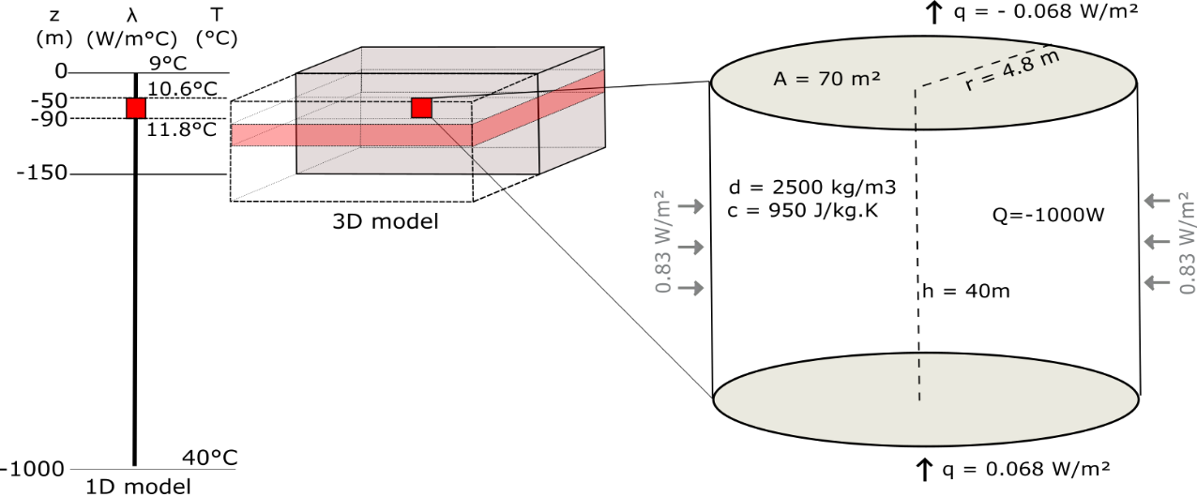

Figure 2.4: Conceptual, mathematical and numerical models for the heat extraction model from vertical BHE. The left part represents the 1D and 3D numerical models developed in this study. The thermal state of the models is defined by an initial temperature gradient of 0.031 ◦C/m and an average effective thermal conductivity of 2.2 *W/m*2. Detailed of the heat balance around the vertical BHE (red rectangle) determined from mathematical estimates is shown on the conceptual figure on the right.

### Heat recharge from solar flux

Low temperature geothermic are based on the use of heat contained in the soil via BHE and heat pumps, and are generally located below the depth of influence of solar variations, down to a hundred meters. As the temperature of the soil in the upper meters is not very different from the ground surface, heat pumps are used to increase the temperature of the circulating fluid in the heat exchanger to values on the order of 35 8C, which can be used to heat buildings directly in a low-temperature heating system.

Where ground temperature has not been disturbed by heat production, heat conduction from or toward the surface depends on the effective surface or air temperature relative to the temperature in the subsurface. The effective surface temperature depends on a complex combination of several factors, such as the amount of solar shortwave radiations, longwave radiations or the wind speed (i.e. convective heat flux from the air to the ground surface). All those parameters will impact both daily and yearly temperature fluctuations and thus the heat recharge from the surface.

In Edinburgh, the average annual rate of insulation is in the order of 94 W/m2, with a minimum of 13 W/m2 in December and 181 W/m2 in July (Whitlock et al., 200). Due to the low diffusivity of soil, the refraction of solar radiation and the emission of long-wave radiation by the ground, the net incoming shortwave radiation into the ground only equals 10s of *W/m*2 and solar radiations only heat up the upper meters of the ground. Annual variations of the air temperature generally propagate down to about 20 m depth only. Due to a complex interactions between the heat coming from the surface and that coming from the depths of the earth, the subsurface temperature is relatively constant throughout the year below that depth and down to about 50 years, and equals the annual average surface/air temperature. Below that depth, the ground temperature is no longer influenced by the yearly changes in surface temperature and starts following the trend of the local geothermal gradient. As a result, the temperature of the ground will generally be higher than air temperature in winter, inducing heat transfers from the ground toward the surface. In summer, this process is reversed as the ground will tend to be colder than the air temperature, allowing heat transfers from the surface that will recharge the ground with heat.

Solar radiations in Scotland are about 1000 kwh/year, that is about 2.5 kwh/day. Solar collectors for a single family house of 4 persons are typically 3-4 m2, allowing to generate 3 to 4 kWh/day (i.e. 150 W, assuming 24h consumption) of heat that can be used for hot water heating. XXX suggested that a way to counteract the imbalance caused by ground heat extraction would be to use hybrid system, and re-inject the excess heat collected by solar panels. On a yearly average, recharging the ground with solar heat (i.e. if all produced heat is re-inject, i.e. would include heat for hot water heating purpose and excess heat) would therefore allow reducing the heat extraction from the ground by 15%.

### Lateral heat flux: Heat mining

We then assume that heat extraction from BHE induces lateral heat flow from surrounding rock (i.e. Heat mining). Based on the estimated 70 m2 footprint area required for heat consumption for one year from cooling the rocks by 5 ◦C, the geothermal heat flux would contribute up to 0*.*068×70 ≈ 5*W* to the total heat recharge. That means that about 995 W will be mined from surrounding rocks. Using h = 40 m and a perimeter of 30 m (2*π*r with r =

4.8 m), the lateral heat flux would be in the order of 995*/*(40×30) = 0*.*83*W/m*2 (Fig. 2.4).

## Analytical solutions

Analytical solutions are necessary to benchmark (quasi-) linear problems and are required to verify numerical methods that will be used to solve for problems with greater geometrical complexity. Solutions of the partial differential equation for heat transport in porous media have been developed for scenarios with different boundary conditions. A general solution for the calculation of the residual heat dissipated by conduction after an instantaneous heat pulse of energy q in an infinite homogeneous and isotropic medium, derived by Carslaw and Jaeger, 1959, is given in Bauer et al., 2015:

(2.4) *ρ* (4*παt*) 2

∆

*T*

(

*r*

*,*

*t*

)=

*q*

*c*

*n*

+

1

*exp*

(

−

*r*

2

4

*α*

*t*

)

where ∆*T* is the temperature difference between the measured temperature and the background temperature at the time t elapsed since the heat pulse and at a radial distance r from the source (i.e. *r*2 = *x*2 +*y*2), and *n* is a factor accounting for the geometry of the heat source (*n*1*D*=0 for a plan, *n*2*D*=1 for a cylinder and *n*3*D*=2 for a point source). *α* = *λ/ρc* is the thermal diffusivity of the subsurface (*m*2*/s*), with *λ* the bulk ground thermal conductivity (W/m.◦C) and *ρc* =*φρwcw* +(1−*φ*)*ρscs* the volumetric heat capacity of the saturated porous media ), calculated from the weighted arithmetic mean of the solid matrix *ρscs* and water *ρwcw*.

The problem of heat diffusion in a porous media due to heat extraction/injection from BHE has first been described using the Infinite Line Source (ILS) model (Carslaw and Jaeger, 1959). For a constant heat injection *q* (W/m) along the vertical axis of a line source, the temperature distribution around a BHE can be solved using the following solution (Monzo, 2011; He et al., 2018):

*q r*2

∆*TILS*(*r,t*) = *E*1 (2.5)

4*πλ* 4*αt*

where *E*1 is the exponential integral function. This function can be approximated by *r* for large values of *αr*2*t* , with *γ* the Euler’s constant = 0.5772. In BHE models, a thermal resistance factor *Rb* is generally added in order to faithfully characterise the heat transfers between the borehole walls the circulating fluid (i.e. Monzo, 2011). Extensions of infinite line source model have been made to better study the fluxes induced by heat extraction/injection whilst accounting for axial effects (Zeng et al., 2002; Molina-Giraldo, 2011) and for seasonal/cyclical effects (i.e. Rivera et al., 2015; Erol et al., 2015 in situations with or without groundwater flows. The solution derived by zeng_finite_2002 to evaluate the axial effects is based on a constant line-source with finite length H in a porous media, derived by applying the method of images (Eq. 2.6).

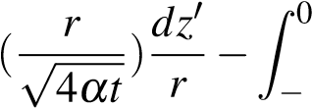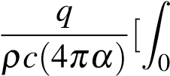 *Hr dz*0

∆*TFLS*(*x,y,z,t*) = *erfc erfc*(~~√~~ ) ] (2.6)

*H* 4*αt r*

# Numerical model

We use the OpenGeosys finite element modelling software (i.e. Kolditz et al., 2012; Chen et al., 2019 to simulate temperature change due to heat extraction and calculate the heat fluxes induced in the subsurface. Results are used to validate the analytical solution against the volume of accessible rock and the average conductivity of the profile, and evaluate the relative contribution from the geothermal/solar flux on the recharge in heat over a year. We finally use our analysis to assess the energy input required to maintain sustainable heat extraction over time, and quantify the footprint area affected by heat extraction.

The Borehole Heat Exchanger (BHE) is first modelled as a vertical line source embedded within a 1D model composed of 10 000 elements, 0.1 m in length. The profile is treated as a homogeneous porous medium with a specific heat capacity of 950 J/Kg.K, a density of 2500 *kg/m*3 and a thermal expansion coefficient of 1 × 10−5 ◦*C*−1. The initial steady-state temperature distribution along the model is calculated based on a surface temperature of *T*0 = 9 ◦C, corresponding to the average yearly air temperature in the Glasgow area in Scotland, and a bottom temperature *Tz* = 40 ◦C at z = 1000 m.

To keep the problem simple, we assume that the ground is a homogeneous medium with a uniform, where the temperature distribution follows a geothermal gradient of 0.031 ◦/ m and whose thermophysical properties do not change with temperature. The heat transfer in the ground is assumed to be carried out solely by heat conduction with the neglect of groundwater advection. The effective thermal conductivity correspond to the one of a dry soil.

## Solar flux

We want to assess the potential effect of the yearly variations in solar heat flux on the subsurface recharge in heat. This flux represents the seasonal variations in the energy balance between the air and the ground surface temperature. In summer, as the ground tends to be colder than the air, downward heat fluxes are induced, allowing to recharge the subsurface in heat. In winter, this process is reversed as the ground tends to be warmer than the air, inducing heat fluxes from the ground to the surface. To quantify the amplitude of the fluctuations, we perform a series of transient simulations aiming at reproducing the measured average temperature variations in the ground surface in east Scotland. Those were calculated based on the soil temperature data acquired in 2000 in the Glasgow area, and available on the UK Meteorological Office website. In steady state conditions, it is expected that the flux coming in from below (i.e. geothermal heat flux) is equal to the flux coming out of the system at the surface by purely conductive heat transfers through the rock. Here, the the yearly average of the fluctuating heat flux is define so as to equal the geothermal heat flux *q*, with opposite sign, according to Eq.3.1.

∆*t*

*Q* = −*Asin*(2*π*∗ )−*q* (3.1)

*t*

where Q is the average daily heat flux, ∆*t* the time increment (days), t the period of fluctuation (366 days), ∆*t*

the time increment (86400 sec, i.e. one day) q = 0.068 W/m2 the geothermal flux from below and A the amplitude of the variations. Based on this equation, we calculated a series of fluctuating heat flux curves that are used as input to define the upper boundary of the 1D line model as a source term (i.e. Neummann surface boundary condition). For each scenario, we simulate the change in temperature in the model for a period of 50 years. We find that the yearly temperature change that best fits the measured soil temperature (see data and mathematical approximation in Fig. 3.1) can be simulated for an heat flux input of amplitude A = 8.4 *W/m*2. The shift between the input flux and resulting surface temperature change is shown in Fig. 3.1.a.

Results of a 50-year simulation period with no heat extraction indicate that a fluctuating stead-steady temperature is reached at the surface after about 20 years. A decrease in the yearly average surface temperature of about 1.5 ◦C is indeed observed in the initial years of the simulation. This is accompanied by a slight increase in the geothermal gradient, which is shifted toward higher temperatures below the depth of influence of the seasonal variations in heat flux, situated at about 25 m depth. This is shallower than the damping depth of 96 m calculated as described in Ozgener et al., 2013 as 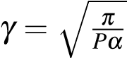, where *α* is the rock diffusivity *α* = *ρλc* and P the period of oscillations. At 25 m, the yearly average temperature stabilizes at about 10 ◦C (Fig. 4.3). This is about 1 ◦C higher than then average air temperature (i.e. 9.4 ◦C), in accordance with the literature (XXX). The shift in the gradient caused by the fluctuating surface heat flux can be observed down to a depth of about 150 m over the 50-year period of simulation with no heat extraction. Below that depth, the ground temperature follows the local geothermal gradient.

## Heat extraction from steady state profile

The relative contribution of solar and geothermal recharge will be described using 1D model while lateral heat flux will be quantified from 3D diffusion models.

### Axial flux

A large number of studies of heat transfers around Borehole Heat Exchangers used isothermal boundary conditions (i.e. Zhao et al., 2020). To realistically assess the heat recharge through the ground surface, Singh and Sharma, 2017 suggested to expressed heat conduction through the surface boundary as a general convective heat transfer boundary condition. An effective temperature accounting for both convective and conductive heat transfers between the ground surface and the air was calculated from the ambient air temperature, the solar radiation and the wind speed, and used to derive the time-variant first type boundary condition on a hourly basis. Several authors however underlined the importance of considering heat flux boundary conditions rather than an imposed temperature at the surface (Saadi and Gomri, 2017). During production, the temperature distribution around BHE is not equal to the undisturbed ground temperature from the surface to the bottom, and axial effects (i.e. vertical heat transfers) become important at both ends of the borehole (Erol et al., 2015). Setting a Neummann boundary condition would allow modelling the potential temperature decline at the surface due to heat extraction from the ground, and therefore avoid overestimating available recharge.

We simulate heat extraction along the BHE situated between 40 and 90 m depth in the 1000m long 1D model, representing a semi-infinite vertical homogeneous line source. Similarly, we simulate heat extraction within a 40m long line source model corresponding to a finite section of the BHE in the 1000m long profile. This is done to validate the analytical solutions described in the previous section, using purely diffusive heat transfer. Different scenarios aiming at quantifying the relative contribution of solar and geothermal heat flux on the recharge are simulated. Those scenarios include: 1) constant boundary conditions, 2) constant surface and bottom heat flux boundaries of −0*.*068*W/m*2 and 0*.*068*W/m*2, that corresponds to the vertical heat flux generated by a gradient Conceptualization of mine-water temperatures Mylene Receveur

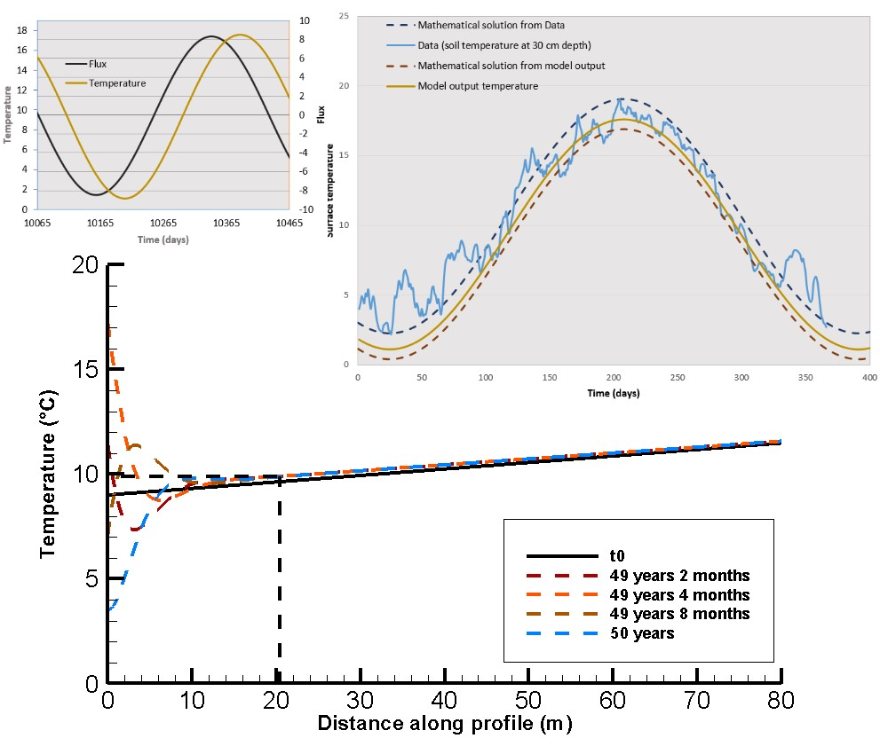

Figure 3.1: a) Input surface heat flux for the time-varying surface boundary conditions (black line) and output surface temperature time series (z = 0 m) for A = 8*W/m*2. b) Comparison of the data, mathematical and numerical output for the surface temperature. Data are the daily soil temperature measured at 30 cm depth at the Paisley station, Glasgow area, in 2000.

of 0*.*31◦*/m* through a rock column of average thermal conductivity *λ* = 2.2 *W/*◦*C.m*2, and 3) fluctuating surface heat flux boundary.

After verifying that the steady state gradient used as initial condition remains stable using Neumann boundary conditions (or a fluctuating steady-state in the case of a simulation fluctuating heat flux on the surface), temperature change due to heat extraction is simulated for periods of 1 and 30 years, using line source areas of 70 *m*2 and 2200 *m*2, respectively. For each scenario, a constant source term of -1000 W, equally distributed along the 40 m long BHE section of the 1D profile is added.

### Lateral heat flux

Line models can be used to study one-dimensional heat transfers and allow to efficiently estimate the energy content of a volume of rock, as well as steady state conditions. In those models, recharge is assumed to occur from above (i.e. surface recharge) or below (i.e. geothermal heat flux) only, as no lateral heat flux is possible. As recharge can’t be provided from neighboring areas, 1D models tend to overestimate the temperature decline, representing a most pessimist case.

Results from 1D models are expected to represent the far field conditions in a 3D scenario. For a 1D line source model of sectional area equal to 70 *m*2, results would corresponds to the conditions at 4.7 m from a line source embedded in a 3D model. Similarly, for a 2200 *m*2 vertical source, results would corresponds to conditions at a distance of 26.5m. Any difference between the results from the 1D and 3D model at such distance would therefore allow evaluating lateral effects.

To study lateral heat fluxes induced by the heat extraction from the 40 m long BHE, we therefore set up a three-dimensional model whose properties and thermal state are equivalent to the 1D model previously described. This 300 m large, 300 m long and 150 m deep model is composed of 5000 prismatic elements. The borehole is situated in the center of a cylindrical volume between 50 and 90 m depth. This cylinder has a radius of 26.5 m and defines a zone with a high resolution mesh. The size of the elements increases from 2 m inside the cylinder and up to 20m at the lateral boundaries of the 3D block. Th vertical resolution of the model is of 1m within the borehole depth interval and of 4m elsewhere.

# Results

## Axial recharge

Results from the 40-m long BHE model confirm that the extraction of a 1000 W heat load (25 W/m) induces a uniform temperature decline of 5 ◦C along the borehole over a year of production when the volume of accessible rock has an area of 70 *m*2, and over 30 years when an area of 2200 *m*2 is available, in accordance with the mathematical model described in section 3.

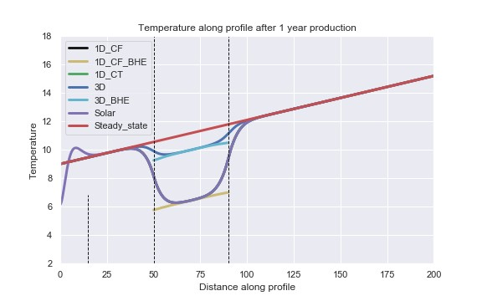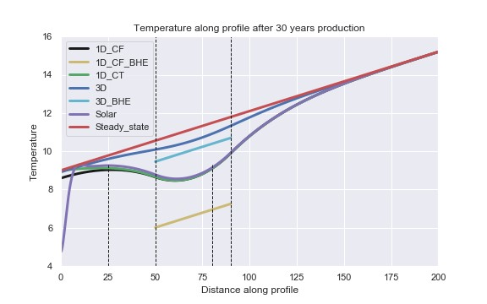

Figure 4.1: Temperature profile after 1 year (left) and 30 years (right) for different scenarios

The effects of axial heat recharge are evaluated by comparing the results from the semi-infinite 1000-m long model and the 40-m long finite model. Over a year of extraction at a rate of -1000W, the integration of the temperature change relative to the initial steady-state temperature profile for each scenario indicates that about 10% of the heat is sourced from the area available above and below the borehole. Over 30 years of heat extraction at the same rate but with a larger volume available (area of 2200 *m*2), the decrease in temperature within the borehole depth interval is considerably reduced, with the rocks situated above and below providing up to 50% of the heat required by the borehole. Similar results are obtained when the volume of rock is reduced to an available area of 500 *m*2 (see section 5. As the production time increases (see Fig. 5.4), the layer of rock affected by heat mining expands vertically. After 100 years of heat extraction, results indicate that axial effects become dominant, with the area above/below the borehole contributing up to 65% of the heat extracted by the borehole.

As mentioned earlier, heat recharge in a 1D vertical profile with steady state temperature condition can only be attributed to the geothermal heat flux. This heat flux only cannot compensate by itself heat extraction from the BHE, and this will result in a loss of heat balance in the system. As the production time increases and axial effects become dominant to provide the BHE with the required heat, the absence of heat recharge up to and at the surface will lead to a progressive decline in the ground surface temperature. In the scenario with constant heat flux boundaries, temperature time series indicates that the ground surface starts declining in temperature after about 6 years of heat extraction, reaching 8.6 ◦C after 30 years (Fig. 4.3.b). By comparing the profiles obtained after 30 years of heat extraction from the 2200 *m*2 semi-infinite models for a constant heat flux and constant surface temperature, we suggest to quantify the recharge that would be provided by a constant heat source on the surface (i.e. solar recharge of constant temperature). Results show that a constant temperature on the surface influences the temperature profile down to about 80 m depth, where the temperature difference relative to the profile obtained from a constant flux boundary is below a selected threshold of 1−3 ◦C. However, the integrated temperature difference between the two profiles is only 70 ◦C or 0.02% of the overall temperature change in the system due to heat extraction for 30 years.

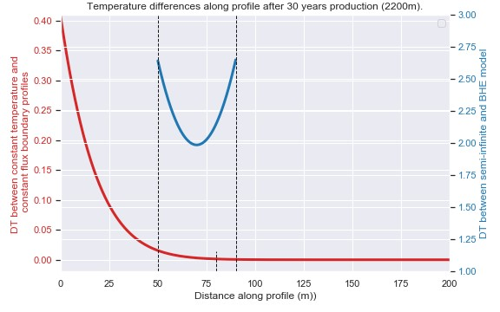

Figure 4.2: Difference in temperature profiles after 30 years of heat extraction obtained from different scenarios. The red curve show the impact of the upper boundary condition reached about 80 m depth after 30 years.

We then compare the profiles and temperature time series obtained after a 30-year heat extraction period, when considering a fluctuating heat flux at the surface. We use the curve calculated in the previous section (i.e. with an amplitude of variation A = 8 *W/m*2) as a source term to the heat extraction model. After correcting the profiles and time series at z = 0 and z = 70 m depth for the effects of the initial temperature gradient and for the shift induced by unstable fluctuating heat flux conditions (see Fig. 4.3a, similar heat extraction profiles are obtained for both scenario at t=30 years. Figure 4.3.b moreover shows that after correction, the yearly average ground surface temperatures (and at z = 70 m, not displayed here) are similar for both scenario, with the effect of fluctuating heat flux being dissipated with depth. Over 30 years, both scenario result in the same yearly average ∆ T of 0.4 ◦C on the surface.

Solar effects tends to superimpose onto the undisturbed steady-state profile and impact the direction of the heat fluxes (i.e. downward or upward) down to a damping depth of about 25 m, according to the presented model. It has been shown from previous studies that solar effects are particularly important when studying the efficiency of borehole heat exchanger, especially when the heat extraction is performed at shallow depth (i.e. in the zone of influence of the yearly fluctuation). In our case, despite the fluctuating source term appears to shift the upper part of the geothermal gradient toward higher temperatures (up to 1 ◦C at 25 m depth), the surface heat flux variations does not impact the overall change in energy content of the system over the long term and on a yearly average.

The amplitude of the vertical downward and upward heat fluxes induced by the long-term heat extraction are calculated as a function of depth after 1-year of heat extraction for the 70 *m*2 line source and after 1, 10, 20

Figure 4.3: Change in the surface temperature for a case with fluctuating and constant surface heat flux

and 30 years for the 2200 *m*2 lime source (see Fig. 4.4). Results show that after one year, the maximal fluxes are induced at the top/bottom of the BH. As production continues, the axial effects become more important and temperature starts decreasing further below and above the borehole. After about 6 years, the temperature and flux profiles indicate that the downward fluxes induced by heat extraction reach the surface, inducing the decline in temperature observed at z = 0 (Fig. 4.4). In the short-term model, the maximum fluxes induced at the extremities of the borehole peaks at 1 *W/m*2. As the initial heat content is increased in the long-term simulation model due to the larger area available, the amplitude of those fluxes is reduced down to 0.2 *W/m*2.

A comparison of those results with profile from the constant temperature boundary scenario is done to evaluate the increase in the downward surface fluxes as the effects of heat extraction reach the surface.

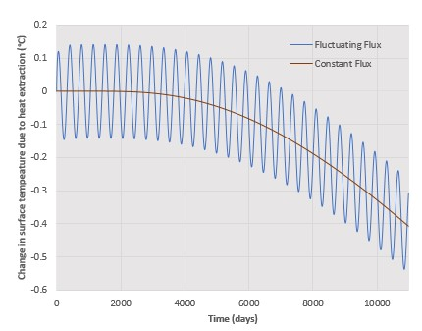Despite the influence of the upper boundary condition on the temperature profile increases with the production time, as the effects of heat extraction reach the surface, out analysis show that it only slightly affects the overall temperature change after 30 years when considering a 2200 *m*2 area. Further analysis, discussed in section XXX, will aim at showing the effects of the surface boundary condition for heat extraction performed at shallower depth (i.e. in the depth of influence of yearly solar variation), for longer operation time or with smaller available rock volume. We will discuss the potential use of dimensionless parameters to better understand the relative contribution from the geothermal and solar flux on the resulting temperature profile, independently of the geometry and properties of the model.

## Lateral recharge

In the 3D model, temperature time series at the mid-borehole (where *Tiz*=−70*m* = 11*.*17◦*C*) reaches a quasi steadystate temperature of about 4◦C after about 8 years. At 26.5 m from this point, results from the 3D model indicate that a decline in temperature can be detected after about one year of heat extraction. This decline keeps going without reaching any steady-state conditions after 30 years of heat extraction, where the temperature reached 10.55 ◦C, which is higher than the temperature at that depth in the 1D semi-infinite model (T=8.6 ◦C). This indicate that despite a steady-state temperature can be obtained at the borehole, often interpreted by previous

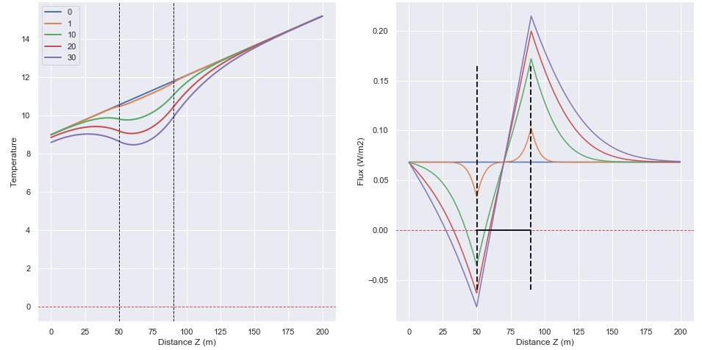

Figure 4.4: Temperature profile and vertical flux profile in the shallow part (< 200-m) of the 1000-m long 1D model (2200 *m*2) after a 30-year production period with constant heat extraction and constant heat flux boundary conditions.

studies as an indication of efficient system, this steady state situation can hardly be reached away from it.

To better understand the rate at which the heat is mined laterally and the expansion rate of the temperature decline (footprint area), we compare after 30 years, the profiles obtained from the 1D model and the one obtained at x =26.5m from the line source in the 3D model.

The profiles referring to results from the 3D models shown in Fig. 4.4 corresponds to the vertical profiles taken 4.5 and 26.5 m away from the borehole. We compare them to the profile obtained from 1D models after 1 year of heat extraction (70 *m*2) and 30 years (2200 *m*2), respectively.

Using the following relationships, we calculate the contribution from lateral *qH* and axial heat recharge *qV* on the temperature profile:

*TBHE**TBHE qH* = 90 3*D*

R50 ∆*TBHE*1*D*

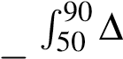*TBHE**TProfile*1*D*

*qV*1*D* = 1

*TBHE*1*D*

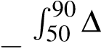*TBHE**TProfile qV*3*D* = 1 3*D*

*TBHE*3*D*

Our results show that *qV*1*D* = *qV*3*D* = 50% of the total heat extracted from the system, while lateral recharge will account for 75% of the remaining heat required, that is 38% of the total heat extracted. 12% of the heat is therefore directly mined from area surrounded by the borehole.

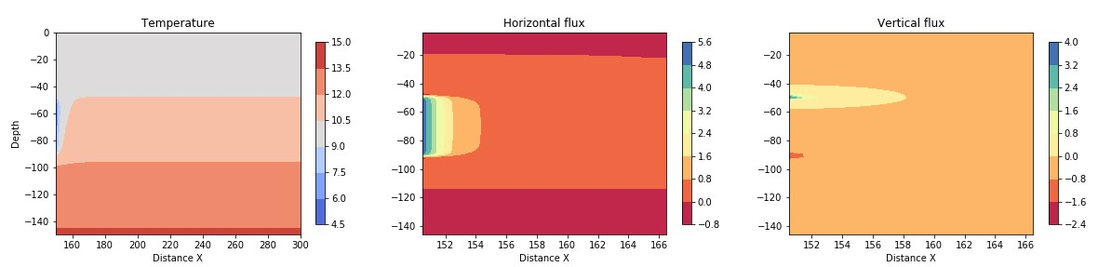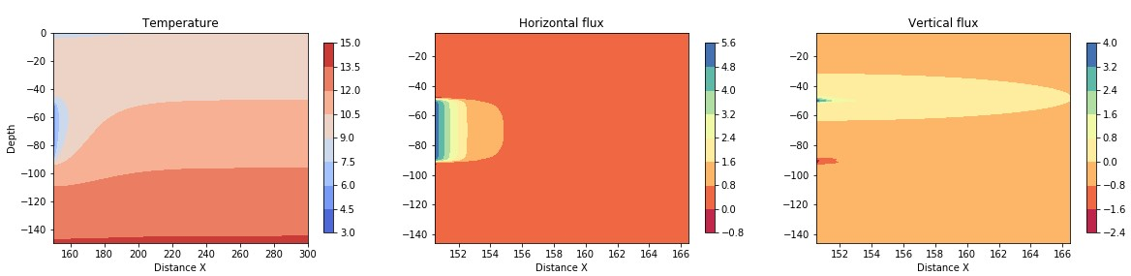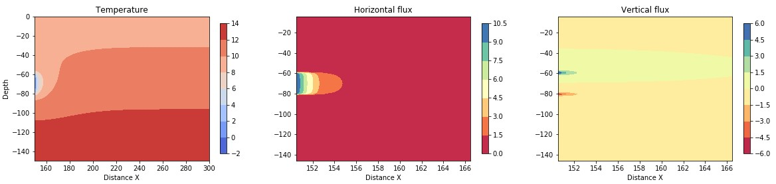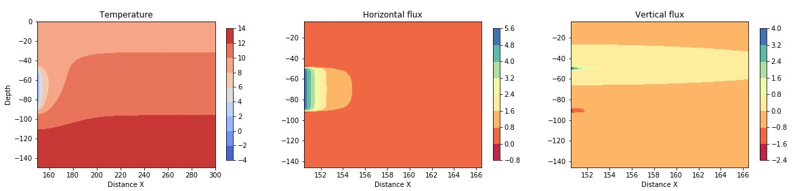

Figure 4.5: 2D section in the central part of the 3D model showing the vertical and horizontal fluxes after one year (a) and 30 years (b), for a case with a 20m long BHE (c) and for a production period of 100 year (d);

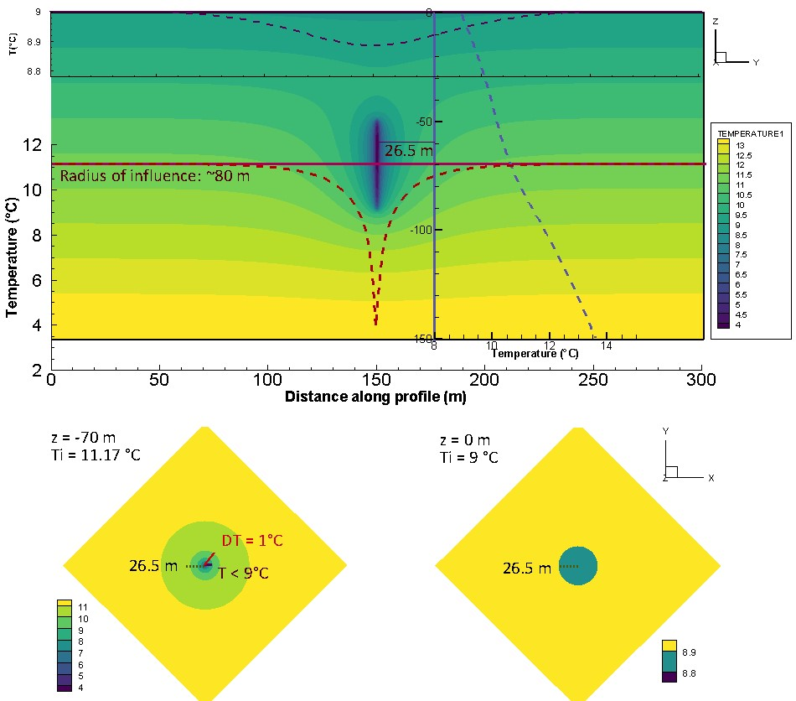

Figure 4.6: 3D model with constant vertical flux

# Discussion

According to Banks, 2008, heat extraction from the ground in the early stage of production is expected to create a zone of depressed temperature around the borehole, leading to radial conduction of the heat stored in surrounding rocks toward the BHE. The cooling of the area might then induce an increasing heat flow of solar energy from the surface that will eventually balance the heat abstracted. In Chen et al., 2019, the authors showed that using a specific heat extraction rate of 100 W/m, quasi steady-state outflow temperature could be reached after 20 years of production from a BHE in China, considering a geothermal gradient of 0.03 ◦C/m.

After performing a sensitivity analysis on different parameters, we will attempt to estimate the footprint area of heat extraction for a single house in the UK, and compare it to the available recharge to assess the sustainability of BHE systems from the heat resource perspective.

Axial recharge means that relative to simple mathematical models, the require surface area can be reduced. In out case, by reducing the area by 4 (down to 500 m2), the minimal temperature decrease observed at 70 m depth (midle BHE) reached 0 degree after the 30-year production period.

## Sensitivity analysis

### Available area

We evaluate the impact of the available stored energy on the temperature decrease in the system, using line source areas of 200, 350 and 600 m2 and yearly fluctuating surface heat flux. For each case, the solar and geothermal heat flux are scaled up appropriately and simulations are performed for constant extraction (Fig. 5.1).

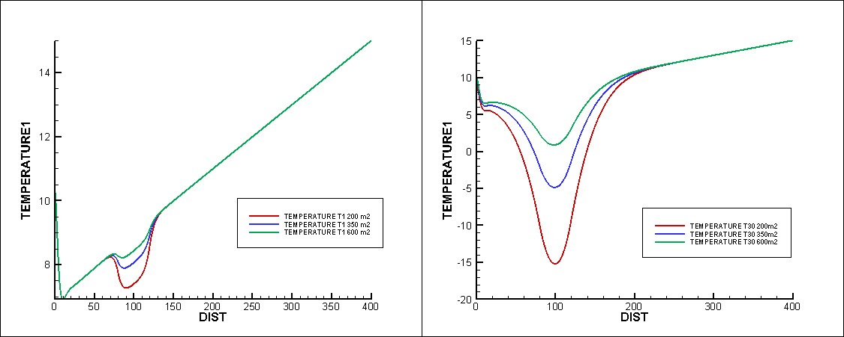

Figure 5.1: Temperature profiles after a) 1 year and b) 30 years, for a constant extraction rate of -1000 W

With a higher constrain of the available area (i.e. 500 *m*2), the temperature decline after 30 years reached 0 degree at the borehole location, as recharge flux are similar to those previously described. The overall temperature change in the system is increased and the temperature change at the surface is in the order of 1.9 ◦C.

Using a fixed ∆*T* rather than a dependence to implies that equivalence between the rock volume and its energy content does not depends on the initial rock temperature (i.e. the absolute heat content), but only on the amount of cooling imposed by the Heat Pump. More importantly, using ∆*T* = 5◦*C* might also underestimate the volume of rock required to provide the required energy. Assuming that the borehole is situated between 50 and 90 m depth (average depth of *z* = 70 m), with a gradient *α* = 31 ◦*C/km*, the ∆*T* assumed to be required to ensure long-term energy balance would here only equal 2 ◦*C*, increasing the required area for one year to 180 *m*2. In models with constant surface temperature, such model would ensure recharge by constant purely conductive flux from the surface.

### Borehole length

We assess the impact of the length of the BHE on the final temperature and the temperature distribution within the line source. By dividing the borehole size by two (i.e. 60 to 80 m depth), the specific specific heat absorption of the BHE is doubled (i.e. from 25 to 50 W/m). Simulations for a constant and seasonal extraction rates done for a constant surface heat flux are displayed in Fig. 5.2. Results show that reducing the BHE length tends to increase the temperature decrease of the rock mass while maintaining the same thickness of rock affected after 30 years.

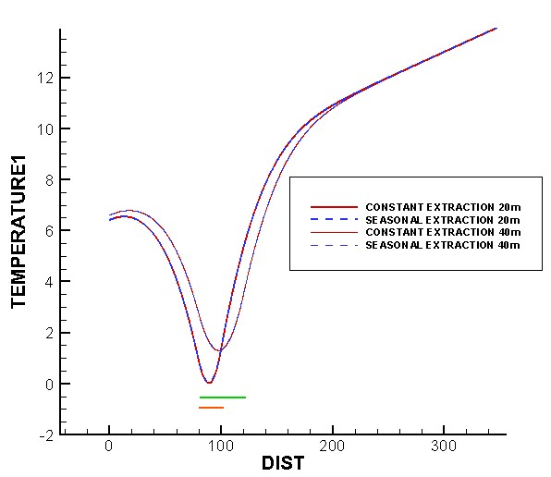

Figure 5.2: Temperature profile for a constant and seasonal extraction rate from a 630 m2 and 20m (orange) and 40m (green)long BHE after 30 years of production.

Results show that lateral effects remain the same, contributing up to 76% of the recharge. however, axial effects increase to account for the smaller borehole length, reaching up to 69% of the total heat extracted. the absolute temperature change however remains the same compared to a 40m long borehole (R∆*T* = 1820◦*C*), so is the temperature decline at the surface (-0.4 ◦C)

### Borehole depth

Choosing a Neumann boundary condition is especially important when heat is extracted from shallow depth and for long operation periods. Over 30 years, the ground surface experiences a decrease in temperature that depends on the borehole depth. For a BHE situated between 50 and 90 m depth, the induced downward fluxes reach the surface after about 10 years. For a shallow borehole (depth of 10-50 m), the heat extracted directly originates from the surface and thus temperature starts decreasing on the surface after a year only.

Axial recharge is reduce to 40% due to a decrease recharge from the area situated above the borehole. The impact of the surface boundary condition over 30 years of production is in this case important, as it leads to, in the case of a constant flux or constant temperature, a difference up to 2.6 ◦C on the surface. Thus the overall temperature change is in the order of 573 ◦C, above 100 ◦higher than the reference case, that means that a constant temperature boundary would underestimated the heat depletion by 30%. The figure below shows that the rate of temperature decline for shallow BHE is higher than deeper borehole. In addition, for shallower depth, the BHE is located in the depth range of influence of yearly solar variations. After corrected for the shift induced by solar variations, the apparent temperature profile does not differ from the scenario with constant heat flux on the surface.

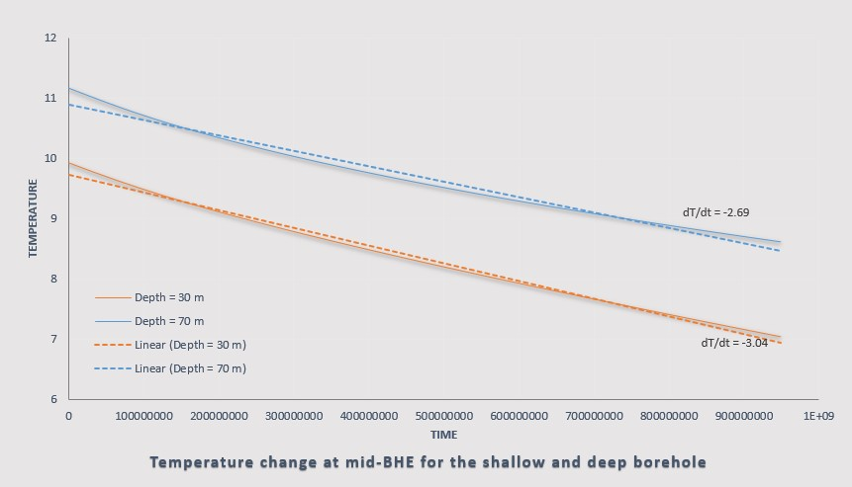

Figure 5.3: Rate of temperature decrease at the borehole mid-depth for the shallow and deep boreholes

### Production time

As the production time increases, the contribution from axial recharge increases from 50% to 65% while lateral flux remains relatively stable (mine lateral area from heat at a constant rate). This is due to the increase in the thickness of the layer of rock affected by cooling above and below the borehole.

### Rock heat conductivity

Mathematical assessments suggest that reducing the conductivity reduces the fluxes down to 0.037 (instead of 0.068) and thus the availbable geothermal recharge. The rate of vertical extension of the thickness of the layer of rock that is depleted in heat over time mainly depends on XXX. Lower conductivity (i.e. 1.2 instead of 2.2 W/◦.m) results in a reduced lateral recharge by 4% (73 instead of 76%) and of vertical recharge by 20% (40 instead of 50%) after 30 years. This results in a smaller temperature decline at the surace (only 0.2 ◦C).

## Transient temperature profile

Despite temperature measured below 1.5 km depth are assumed to be only little affected by surface perturbations, (Westaway and Younger, 2013) suggested that near-surface temperatures in Scotland might have been disturbed by climate warming since the last prolonged glaciation (i.e Ice Age), accounting for the lower geothermal gradient

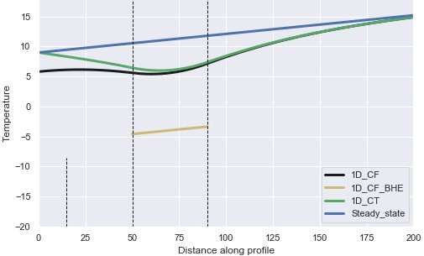

Figure 5.4: Temperature profile for a constant heat extraction rate from a 2200 m2 area after 100 years of production.

near the surface. When extrapolated to the surface, the best-fit shallow geothermal gradient estimated from boreholes < 400 m depth indeed indicates a surface temperature of 4.0 ◦C, which is lower than the current yearly average surface temperature in Scotland of about 9◦C (Gillespie et al., 2013). Several studies already mentioned the importance of considering the effects of past climatic variations on the shallow geothermal gradient, especially at high latitudes (i.e. Carslaw and Jaeger, 1959; Majorowicz et al., 2012; Raymond, 2018; Beltrami et al., 2017; Gosnold et al., 2011). Paleo-climate signals have been described as a series of mean surface temperature change before present day, that propagates downward by conduction and tends to superimpose to the quasi-steady state thermal field associated to the Earth’s internal heat (Beltrami et al., 2017). While the extent of the perturbations mainly depends on the magnitude and time scale of the past variations, the amplitude of the temperature change due to surface disturbances will tend to decrease exponentially with depth depending on the thermal conductivity of the ground, and with a time lag since the onset of the perturbation at the surface (Westaway and Younger, 2013; Beamish and Busby, 2016; Busby et al., 2015). In the UK, Wheildon and Rollin, 1986 suggested that boreholes < 100 m depth are sensitive to surface temperature variations over the past 500 years, while Beltrami et al., 2017 showed that past climatic signals > 1000 years B.P are still contributing to the thermal state of the subsurface down to 500 m depth. Using individual temperature measurements from shallow depth (< 400m) would therefore tend to underestimated the true "steady-state" background geothermal gradient and thus the extent of the geothermal resource at depth. New interests in re-evaluating the heat flow including paleo-climate corrections have recently grown in the UK. Westaway and Younger, 2013 suggested that heat fluxes measured in shallow boreholes in Scotland would need to be increased by 18 mW/m2 to account for the effects of palaeoclimate. The correction would be reduce to 8.8-13.5 mW/m2 for 1 km deep boreholes and 0.2-9.1 mW/m2 for

1.5 km deep boreholes.

Assuming steady state conditions, the energy that comes in from below is equal to the flux that comes out of the model above (flux through the vertical column is initially constant) and therefore, the recharge only comes from the geothermal heat flux. We suggest to evaluate the impact of the initial temperature profile on the recharge heat flux on the system. We simulate the effects of long term surface warming (i.e. 1000 years) on the shallow temperature gradient by using a transient simulation, where the initial gradient of 40 ◦C/km is disturbed by a constant surface temperature of 9 ◦C. The significant difference in the profiles obtained from steady state and transient simulation show that for ∆*T* = 9◦*C* on surface, 1000 years is not sufficient for the gradient to reach its undisturbed steady state, with perturbations visible down to 180 m depth.

Unsteady temperature gradients results in different heat fluxes compared to a steady-state scenarios. In our model, a flux of -0.012 is set on the surface against 0.092 on the bottom of the model, allowing a recharge from the surface of about 0.08 W/m2. If no production is performed, this leads to a increase in temperature at the surface of about 3e-5 ◦C in one year. This flux, which allows greater recharge both from below (geothermal flux) and above (solar flux) participates to the return to steady state condition of the geothermal gradient.

## Radioactive heat production

RHP source terms are then added to evaluate their contribution on the steady state temperature profile. Results for 100 year long simulations using either constant flux or fixed temperature at the upper and bottom boundaries are shown in Fig. ?? (green line and dashed black lines, respectively) and show a consistent increase in temperature along the trend of the geothermal gradient that might indicate that RHP has been overestimated.

## Recommendations

The average area of a housing property in the UK is 70-100 *m*2. To constrain the footprint area of heat extraction to this extend, we ...

### Cyclic production

Some studies showed that other ways to achieve sustainable heat extraction were to perform cyclic production or artificial heat recharge (i.e. Cruickshank] and Baldwin, 2016). Another heat extraction scenario was therefore simulated considering seasonal heat extraction, with a minimum of -1294 W in winter and a maximum of -706 W in summer, distributed along the 40-m long BHE. The fluctuating heat load is calculated using Eq. 3.1, with *A* = 294 W, the amplitude of the variations and *q* = 1000 W the average year heat load. After 30 years of production, similar temperature profiles are obtained (Fig. 5.2), indicating that average yearly extraction rate is representative of a fluctuating extraction rate around this average.

Cyclical production with periods of no production most efficient0

### Recharge

Recharge allows decreasing the temperature sink at the borehole by a few degrees, which is not effective enough relative to cyclical production (allow better recharging the system over the long term). Recharge create a temperature source that maintain the overall energy contend of the system, by high conductivity would be required so it can be effectively transmitted to the BHE.

### Waste heat

Recent reports published by the Scottish Government revealed that over 50% of the total energy consumption in Scotland is for heating purposes. In addition to finding new low-carbon energy sources, increasing the efficiency in the energy production and distribution systems, the recovery of energy from waste heat is a key to meet the challenging ambitions to reach net zero carbon emissions by 2045. Harnessing this heat and divert it into homes could provide an environmentally-friendly alternative to gas heating.Heat is often a wasted by-product of industrial processes that is either vented into the atmosphere, or requires even more energy to cool components. Heat recovery technologies aim at recovering waste heat from industrial processes (i.e. from effluent streams or from cooling processes), through the use of heat exchanger or water source heat pump systems. This also includes heat recovery from waste water that runs through the sewers or in water treatment facilities. The first heat from waste water scheme in the UK has been implemented at Borders College, Galashiels, and more recently, such technologies have been implemented in combination with a combined heat and power engine in Stirling to provide low carbon heat to a city community through a district heating network (source: Scottish Water).

The Scottish district heat network investment opportunity has proposed the integration of renewable energy from diverse sources, including industrial waste heat, biomass boilers, heat extracted from bodies of water or the ground via a heat pump and geothermal. To achieve its net zero targets, Scotland is looking to transform residual waste (i.e. waste that cannot be recycled and generally placed in landfills) into energy. New technologies are being developed to allow the incineration of residual waste to produce electricity and heat by energy from waste (EFW) operations. According to SEPA, Energy from Waste could ultimately contribute up to 31% of Scotland’s renewable heat target and 4.3% of our renewable electricity target under the Climate Change (Scotland) Act 2009. Energy from waste plants consist at creating energy, either electricity or heat, from the incineration of waste or from landfill gas. Several energy to waste sites already exist in Scotland, one of them is the waste treatment plant at Polmadie, where the biogas produced from sludge (residual waste) is captured and transferred to a Combined Heat and Power (CHP) plant where it is combusted to produce electricity and heat. Additional industrial waste heat recovery feasibility studies are being conducted in Scotland (i.e. heat recovery from glassworks area in Alloa) by Zero Waste Scotland. In Edinburgh, the Millerhill recycling and energy recovery centre RERC opened in 2019, is a thermal tratment plant aiming at diverting 155 kt of residual waste from landfill to generate electricity, that would power 32 000 households and business in the Midlothian.

In 2018, biomass combustion and biomass CHP output account for the largest proportion of renewable heat generated. Heat pump output accounts for 6% (340 GWh) of the total renewable heat output while solar thermal installations contribute less than 1% (18 GWh) to the total output with the remaining 20% (1,027 GWh) generated from energy from waste sources. 47% of renewable heat generated in Scotland in 2018 came from large size installations (i.e. generally biomass and energy from waste technologies), which provide heat all year in opposition to smaller installations which generally have more seasonal demands such as providing space and water heating. Most of the operation heat output provided by heat pump and solar thermal technologies is generated from micro installations (lower than 45 kW), while energy from waste and biomass comes from large installations ( more than 1 MW). Small to medium installation have capacities of 45 4W - 1MW.

Data centers require a vast amount of cooling energy, typically produced with air conditioning units, in addition to the direct electricity consumed by the IT technology. Considering that every Watt of power required by the IT equipment produces heat that is dissipated into the air, appropriate cooling is required to avoid extreme rise in temperature in the facilities. Cooling systems are generally designed to bring appropriate cooling requirements, that are the sum of heat gained from the IT equipments, power distribution, air conditioning units, lighting, people, from the building envelope (roof, waal, windows)... Today, the heat dissipated in DC is generally not used even though technology exists. In nordic countries, industrial waste heat is already utilized in different processes and district heating on a large scale. At least 5 data centers are located within edinburgh, that is not far from the population. Pulsant Edinburgh data centers South Gyle and Medway (31000 and 182986 *ft*2, respectively) have capacities of 12.85 and 4.20 MW, respectively (290 and 16 *W/ft*2, assuming 70% of the IT power need). The total heat load (cooling density) of a typical data center in the order of 50-150 *W/ft*2.

Alternatively to study the energy efficiency of DCs through efficient cooling systems, a few authors assessed the possibility of reusing waste heat from DCs, on an economical and technological aspects and a review of the different solution for waste heat utilization has been made by Wahlroos et al., 2018. Depending on the cooling system, waste heat can be captured at a temperature ranging from 25-35 ◦C (air-cooled DCs) and 50-60 ◦C (liquid cooling). The estimated amount of waste heat recovered from datacenters ranges from 20 GWh/a (Mantsala DC, Finland - 10 MW) to 200 GWh/a (Helsinki DC -24MW) (Wahlroos et al., 2018). Waste heat can be utilized for different purpose, ranging from small-scale and location-specific heat source (i.e. swimming pool) up to large-scale facilities (district heating), for space or domestic water heating, drying processes. However, barriers and limitations of DC waste heat utilization, studied by Ebrahimi et al. (2015) and Linna (2016) are linked to the heat demand, low quality of heat (e.g. low temperature or unstable source of heat) and profitability (i.e high investment costs) with interest that diverge between the DC and DH operators. As heat cannot be distributed over long distance, consumers need to be located close to the data center, which also allow to limit the connection fees. DC can be seen as one possible HP heat source for, among some others. The alternatives are at least ambient air, sea/lake/river water, ground source heat, sewage water, exhaust air from buildings, and heat from space-cooling or industrial processes. Compared to natural sources, the advantage of excess heat from human activities (including DC) is the higher temperature (Wahlroos et al., 2018).

To deal with some of the barriers implied by waste heat, especially the unstable heat source, we suggest to use waste heat as an artificial heat recharge to the ground, that would allow compensate for the lack of natural recharge. The possibility of using the ground as a Thermal Energy Storage (TES) system for industrial waste heat recovery has been reviewed by Miró et al., 2016; Köfinger et al., 2018. Seasonal TES (see study of the effect of TES on the change in soil temeprature by Han et al., 2017 and review of available technologies for seasonal TES by Xu et al., 2014) is a technology that solve for possible mismatch between offer (i.e. unreliability of solar radiation (Gao et al., 2015), irregular waste heat generation) and demand by recovering the IWH or solar energy and storing it for a later use (Köfinger et al., 2018; Moser et al., 2018). Many theoretical studies of large-scale or seasonal storage systems (i.e. hot-water thermal energy store (water tanks, solar ponds), aquifers (ATES), borehole TES and gravel-water TES (rock beds, grounds)) have been made, but only a few real-case study exists. Most of them concerns solar thermal energy integration and have been implemented in small networks in Germany, Denmark and Sweden (Fisch et al., 1998; Hirvonen et al., 2018; Pinel et al., 2011; Bauer et al., 2016; Schmidt et al., 2004; Gao et al., 2015), focusing on technico-economic aspects. In the review of the different storage system, mediums, methods and projects by Pinel et al., 2011, the authors mentioned that despite seasonal storage is more economically competitive at the community scale, single detached housing represents a large fraction of the building stock. Small scale seasonal thermal energy storage systems have been explored in US and Canada (i.e. Providence House, Hooper, XXX), mostly based on solar tanks, rock beds. A few studies focused on industrial waste heat integration with seasonal storage (i.e. Miró et al., 2016; Cui et al., 2015), but such system is still on a demonstration stage(i.e. central solar-IWH heating system with 500000 m3 borehole (468 * 80m depth boreholes acting as ground heat exchangers) thermal energy storage in China: Guo et al., 2017 showed that stable energy output and supply could be ac hived by adopting the described strategy combining a 20 MW IWH recovery system and solar collectors). For now, one on the main limitation is the economics of the project, where investments costs are high and scenarios where the payback is less than 20 years give high constraints to such project (Köfinger et al., 2018). Borehole heat storage stores heat in soil/rock through borehole heat exchanger embedded in the drilled holes with a depth of 30-200m, and the stored heat is extracted whenever needed (). The idea of combining solar collectors and BHE was first suggested in 1956 by Penrod, and store heat underground (Gao et al., 2015). Many studies in China (Li and Lai, 2015; Wang et al., 2012) now focus on solving for the imbalance of the temperature in the ground caused by ground source heat pump, due to extensive heat load extractions relative to cooling needs in some areas (Gao et al., 2015). Most of the experiments and demonstration project showed that systems can meet the heating cooling demand by using hybrid systems combining solar collectors and GSHP with seasonal thermal storage. Bakirci et al., 2011 also showed from an experimental set up that solar-GSHP systems in a cold province in Turkey could be used for residential heating, by improving the system COP. Those allow decreasing the thermal load of the boreholes so would do increasing their length. In a study based on meteorological data from 3 US cities, Chiasson (XXX) showed that combining solar collectors with GCHP can help reduce the borehole length, in the order of 4.5 to 7.7 m /m2 of solar collector area. Recharging the ground with solar heat is particularly interesting when bhe are too shallow or undersized to collect the necessary heat load. Han et al., 2017 showed that for a multi-source hybrid heat pump system (MSHHPS) with seasonal thermal storage utilizing solar energy, geothermal energy and air energy, for an utilization in a building in Harbin, the average coefficient of performance (COP) is 3.06 after 10 years, the soil thermal balance rate was 100.33% and the energy-saving rate was 29.84% comparing to the ground source heat pump system (GSHPS). The barriers associated to borehole seasonal solar thermal recharge include special geological conditions (unclear heat transfer mechanism underground, small heat capacity leading to large storage volume...), lack of land...

Geothermal heat pump systems that use the shallow geothermal energy as a heat source or sink for space heating or cooling is of growing interest worldwide. Vertical boreholes (ground couples heat pump) is of main interest as they require less land area. However, yearly imbalance in heat extraction and injection into the ground, especially in cold areas and for large-scale systems with long operational periods, can cause irreversible drop in temperature into the ground, resulting in a decrease in the HP efficiency/performances. A way to eliminate the cooling load accumulated into the ground is to provide additional heat recharge during the non heating season, such as solar thermal energy and industrial waste heat recharge (Cui et al., 2015). Experimental studies conducted by Trillat-Berdal et al., 2006 showed that the ground thermal loads could be balanced by a system combining geothermal coupled heat pump and thermal solar collector, when the excess heat not used for hot water heating is injected into the ground, and the heat pump either used in cooling or heating mode. Cui et al., 2015 performed similar analysis on the performances of seasonal storage of industrial waste heat, by developing a heat transfer model for vertical GHE boreholes with multi-stage series connections.

Vertical BHE is ofter prefered relative to horizontal heat exchanger. First, it is situated deeper (> 6m depth), which ensures good performances through the year as the temeprature is not affected by surface local climatic/weather conditions. then, despite of the high cost of the installation of BHE which required drilling technologies, the soil surface area occupied by a BHE is very small compared to that occupied by a horizontal ground heat exchanger, an advantage in areas of high land prices (Trillat-Berdal et al., 2006).

Most of these studies focus on the performance of the system, that is expressed by calculating the COP, and mainly depends on the temperature contrast between the ground and the circulating fluid in the BHE.

# Conclusion

The integration of renewable heat sources combined with i.e.industrial waste heat or solar recharge in urban district heating (DH) networks is essential for a sustainable and low-carbon heat supply (Köfinger et al., 2018).

Using simple elergy balance calculations validated through numerical models, we showed that in geographical areas with low geothermal heat flux and low in-situ heat production (i.e. sedimentary basins), artificial heat recharge might be required to ensure sustainable heat extraction and constrain the footprint area impacted by heat mining (and not only the area of land required to drill a borehole heat exchanger system). Talking in terms of flux percentage allow getting independent of the absolute temperature change within a system results showed that the initial recharge in the system depends on the long-term energy balance between surface a deep geothermal fluxes. This is due tot he fact that the temperature gradient might not have reached equilibrium since the last ice Age. We estimated the amount of recharge required to balance the heat extracted in the system Compared to the amount of waste heat available... Next step will be to assess the relative contribution from heat convection and conduction through the porous medium, using 2D advection-diffusion models (i.e. with groundwater flow). Iterative loop would be necessary to adjust the heat flux on the surface due to change in the sub-surface temperature conditions. Previous studies mentioned that temperature steady state can be reached after a few years of production. Despite steady state flux in the sub-surface are indeed reached, the recharge from solar of geothermal gradient does not compensate for the heat extracted and thus, the heat extracted is mined from further and further away from the borehole (extension of the temperature gradient laterally). However, in a context where geothermal energy becomes of real interest, putting a constraint of the footprint area of heat extraction is required to avoid superimposition effects of heat extraction and interference.

Mathematical results showed that energy balance in the shallow sub-surface (i.e. < 100 m) cannot be naturally reached over the long term. We evaluated the extent of heat depletion caused by a constant/cyclical heat load extraction from a simple homogeneous system without groundwater flow for 30 years. We confirm that despite steady state fluxes and temperature equilibrium are reached at the BHE after a few years of heat extraction, the extent of the temperature decline (i.e. the energy mined from the system to provide the necessary energy to consumers) keeps increasing with time. Results from the sensitivity analysis showed that the footprint area of heat extraction mainly depends on the conductivity of the ground, to the yearly average heat extraction rate and to the borehole length (and consequently the impact of heat extraction on the surface temperature reduced with the borehole depth), and is inversely proportional to the temperature decline at the borehole. Different heat extraction scenarios are finally simulated in order to investigate how to optimize heat recharge. Discontinue heat extraction (i.e. with periods of total recovery allowed) allows reducing up to XXX the footprint area, while providing artificial recharge contribute to both reducing the temperature decline in the system, and to a lesser extent to the footprint area of heat extraction.

Our main conclusion is that sustainable heat extraction and steady state situations cannot be reached without providing additional artificial heat recharge to the system through cyclical heat extraction/injection of same amplitude, while expecting to constrain the areal impact of heat extraction from the shallow sub-surface. Such scenario could be achieved by injecting excess heat from unreliable renewable energy sources (i.e. solar, wind farms) or "waste heat" produced in cities (i.e. here we use the example of data centres from Edinburgh). Those could be used to recharge the system and guarantee sustainable heat extraction over the long term.

Need to diversify energy sources - combination of solar/IWH and geothermal to ensure balance.

We will extend this study by using mine-water heat source as a way to disperse heat injected from artificial sources.

# A Appendix

## A.1 Equations

The transient heat diffusion equation can be written as follow.

*dT dT*

*ρc*  = −*ρwcwvw*  +∇(*λ*∇*T*) *dt dx*

The first term on the right side represents the advective term, with the mass flow being characterized by the product of the water density *ρw* (*kg/m*3) and velocity *v*, and the second term is the conductive heat transfer. The medium heat conductivity *λm* (W/m.◦C) and heat capacity of the wet rock *ρc* can be defined as the product of the porous rock and water properties, as followed:

*λm* = *φλw* +(1−*φ*)*λr ρc* = *φρwcw* +(1−*φ*)*ρrcr*

with *φ* the rock porosity, *c* the specific heat capacity (J/kg.◦C) and *ρ* the density (*kg/m*3). Subscripts r and w account for the dry solid rock and the water, respectively. In a porous rock, the total energy extractable from cooling can be calculated as follow:

*E* = *mr*∆*Tcr*

with E the total energy (J) extracted from cooling rocks of volume V, *mr* = *V*(1−*φ*)*ρr* the mass of rock and ∆*T* the change in rock temperature. ∆*T* can in some cases relates to the maximum temperature change allowed across the heat exchanger.Raymond and Therrien, 2008 estimated that the total geothermal energy content in mines from the sum of the energy associated with each flooded underground section, as:

*Er* =*Vzαρc*

where *Er* is the energy of a given section, V the volume of water in the mine section, z its average depth and *α* the measured geothermal gradient. The rate *Ehp* at which geothermal energy can be extracted from water using heat pumps was calculated as followed:

*Ehp* = *Qw*(*Tp* −*Tr*)*ρwcw*

with *Qw* the average flow rate, *Tp* the pumped water temperature and *Tr* the exchanger return temperature. Assuming that the energy is extracted from water flowing at a rate *Qw*(*m*3*/s*), recharging the system at a temperature *Ti* and extracted at a temperature *Tout*, the rate of cooling of the reservoir ∆*Tr*(◦*C/s*) can be expressed as follow:

Conceptualization of mine-water temperatures Mylene Receveur

*Qwρwcw*

∆*Tr* = ∆*Tw*

*Vφρc*

with ∆*Tw* = *Tout* −*Ti*. The heat fluxes induced by water advection *q*(*W/m*2) can be expressed through the coefficient of heat transfer *h*(*W/m*2*.K*) as *q* = *h*×(*Tr* −*Tw*). The power exchange of water in a system with colder fluid reinjection can thus be written as followed:

*Cφρc*

*P* = (*Tin* −*Tsystem*)

*t*

### A.1.1 Periodic heating

The analytical solution for temperature change in a semi-infinite half space under periodic heating/seasonal change in temperature *Ts* = *T*0+∆*Tcos*(*ωt*) given by Turcotte and Schubert, 2002 is:

*T* 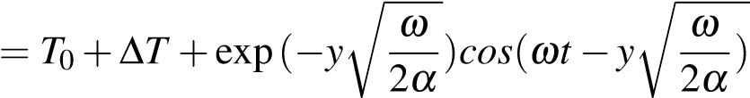

where *ω* = , with *τ* the period of the oscillations. A sinusoidal temperature model representing the variations in heat transferred to the soil at the surface was derived by Hillel (1982) using a sinusoidal forcing function (Ozgener et al., 2013), describing the soil temperature at time t and depth z as:

*T*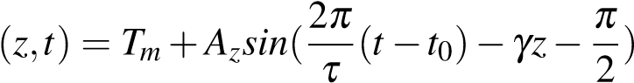

Here, 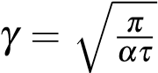 is the inverse damping depth, with *α* the thermal diffusivity (m2/s), defined as *α* = *λρmc*. *Tm* is the mean surface temperature, *t*0 the time lag needed for the surface soil temperature to reach *Tm*, and *Az* = *A*0exp(−*γt*) the amplitude of temperature wave at depth z, time t, which decay exponentially with depth. The undisturbed temperature at depth z and time t taking into account daily and annual temperature variations was expressed in Radioti et al., 2017 as followed:

*T*(*z,t*) = *Tm* 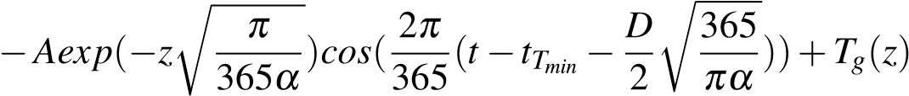

where A is the amplitude of air temperature oscillations, *tTmin* the day number corresponding to the minimum temperature, *α* the equivalent ground daily thermal diffusivity and *Tg* the product of the geothermal gradient by the testing depth.

### A.1.2 Seasonal production

Angelotti et al., 2018 modelled in 3D the temperature distribution (i.e. thermal plume) in porous aquifer under seasonal production from BHE, considering different groundwater velocity. The temperature response of the medium is here expressed as follow:

*q ux* Z *r*2*/*(4*αt*) 1 1 *u*2*r*2*ψ*

*T*(*x,y,t*) = *Tg*0+ *exp*( ) exp(− − 2 )*dψ*

## 4*πλ* 2*α* 0 *ψ ψ* 16*α*

with *u* = *vx ρρwccw* the effective water velocity. A steady state temperature might be reached for high simulation time and can be defined as follow:

*q ux u*p*x*2+*y*2

*T*(*x,y,t*) = *Tg*0+ *exp*( )*K*0( )

2*πλ* 2*α* 2*αt*

### A.2 Analytical solutions

#### A.2.1 Diffusion only

For a instantaneous cooling/heating of a semi-infinite half-space, where a constant temperature *T*0 is applied on the top boundary condition of a domain of initial temperature *T*1, the temperature profile can be calculated at a time *t* or distance *z* from the boundary using the following equation (Heat conduction - Dirichlet BC, with q = 0 on the other boundary):

*x*

*T* = *T*1+(*T*0−*T*1)*erfc*(~~√~~ ) (A.1)

4*αt*

with *α* = *ρλrcrr* or *α* = *λρmc*, for diffusion in a dry solid matrix or in a saturated porous medium, respectively. While this solution fits well the numerical time-dependent results, it has been slightly modified to fit the temperature profile at t = 10 000 s, as followed:

*x*

*T* = *T*0*erfc*(√ ) (A.2)

16*παt*

The analytical solution for an instantaneous heat pulse (pulse length = 1 sec) given below () has been tested, but do not fit properly the numerical results (see Fig. ??):

 *T* 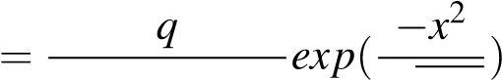 (A.3)

*t*

# References

Angelotti, A., Ly, F., and Zille, A. (2018). On the applicability of the moving line source theory to thermal response test under groundwater flow: considerations from real case studies. *Geothermal Energy* [online].

6.1, p. 12. ISSN: 2195-9706. DOI: [10.1186/s40517-018-0098-z.](https://doi.org/10.1186/s40517-018-0098-z) [Accessed May 15, 2020].

Banks, D. (2008). *An Introduction to Thermogeology: Ground Source Heating and Cooling*. Oxford, UK: Blackwell Publishing, Ltd. DOI: [10.1002/9781444302677.](https://doi.org/10.1002/9781444302677) [Accessed Oct. 4, 2019].

Bauer, F., Michalowski, A., Kiedrowski, T., and Nolte, S. (2015). Heat accumulation in ultra-short pulsed scanning laser ablation of metals. *Optics Express* [online]. 23.2, p. 1035. ISSN: 1094-4087. DOI: [10.1364/OE. 23.001035.](https://doi.org/10.1364/OE.23.001035) [Accessed May 15, 2020].

Beamish, D. and Busby, J. (2016). The Cornubian geothermal province: heat production and flow in SW England: estimates from boreholes and airborne gamma-ray measurements. *Geothermal Energy* [online]. 4.1, p. 4.

ISSN: 2195-9706. DOI: [10.1186/s40517-016-0046-8.](https://doi.org/10.1186/s40517-016-0046-8) [Accessed Apr. 14, 2020].

Beltrami, H., Matharoo, G. S., Smerdon, J. E., Illanes, L., and Tarasov, L. (2017). Impacts of the Last Glacial Cycle on ground surface temperature reconstructions over the last millennium. *Geophysical Research Letters*. 44.1, pp. 355–364.

Brereton, R., Browne, M., Cripps, A., Gebski, J., Bird, M., Halley, D., and McMillan, A. (1988). Glenrothes Borehole: Geological Well Completion Report. Investigation of the Geothermal Potential of the UK. *British Geological Survey, Keyworth*.

Browne, M., Dean, M., Hall, H., McAdam, A., Monro, S., and Chisholm, J. (1999). *A lithostratigraphical framework for the Carboniferous rocks of the Midland Valley of Scotland*. Research report RR/99/07. British Geological Survey, p. 30.

Burley, A., Edmunds M., W., and Gale, I. (1984). *Catalogue of geothermal data for the land area of the United Kingdom*. Second revision. British Geological Survey.

Busby, J., Kingdon, A., and Williams, J. (2011). The measured shallow temperature field in Britain. *Quarterly Journal of Engineering Geology and Hydrogeology* [online]. 44.3, pp. 373–387. ISSN: 1470-9236, 20414803. DOI: [10.1144/1470-9236/10-049.](https://doi.org/10.1144/1470-9236/10-049) [Accessed May 15, 2020].

Busby, J., Gillespie, M., and Kender, S. (2015). How hot are the Cairngorms? *Scottish Journal of Geology*. 51.2, pp. 105–115.

Busby, J. (2019). Thermal conductivity and subsurface temperature data pertaining to the Glasgow Geothermal Energy Research Field Site (GGERFS).

Cameron, I. and Stephenson, D. (1985). *British regional geology: The Midland Valley of Scotland.* Keyworth, Nottingham: British Geological Survey.

Carslaw, H. S. and Jaeger, J. C. (1959). *Conduction of heat in solids*. Clarendon P.

Chen, C., Shao, H., Naumov, D., Kong, Y., Tu, K., and Kolditz, O. (2019). Numerical investigation on the performance, sustainability, and efficiency of the deep borehole heat exchanger system for building heating.

*Geothermal Energy* [online]. 7.1, p. 18. ISSN: 2195-9706. DOI: [10.1186/s40517-019-0133-8.](https://doi.org/10.1186/s40517-019-0133-8) [Accessed Apr. 14, 2020].

Entwisle, D. C. (2019). Engineering geology and geotechnical summary of central Glasgow in the vicinity of the UK Geoenergy Observatories field sites.

Erol, S., Hashemi, M. A., and François, B. (2015). Analytical solution of discontinuous heat extraction for sustainability and recovery aspects of borehole heat exchangers. *International Journal of Thermal Sciences* [online]. 88, pp. 47–58. ISSN: 12900729. DOI: [10.1016/j.ijthermalsci.2014.09.007.](https://doi.org/10.1016/j.ijthermalsci.2014.09.007) [Accessed May 15, 2020].

Fisch, M., Guigas, M., and Dalenbäck, J. (1998). A REVIEW OF LARGE-SCALE SOLAR HEATING SYSTEMS IN EUROPE. *Solar Energy* [online]. 63.6, pp. 355–366. ISSN: 0038-092X. DOI: [https://doi.org/ 10.1016/S0038-092X(98)00103-0.](https://doi.org/https://doi.org/10.1016/S0038-092X(98)00103-0) Available from: [http://www.sciencedirect.com/science/ article/pii/S0038092X98001030.](http://www.sciencedirect.com/science/article/pii/S0038092X98001030)

Gillespie, M., Crane, E., and Barron, H. (2013). *Study into the Potential for Deep Geothermal Energy in Scotland - Volume 2*. AEC/001/11. Scottish Government, p. 129.

Gosnold, W., Majorowicz, J., Klenner, R., and Hauk, S. (2011). Implications of post-glacial warming for northern hemisphere heat flow. *Grc Transactions*. 35.GRC1029332.

He, H., Dyck, M. F., Horton, R., Ren, T., Bristow, K. L., Lv, J., and Si, B. (2018). Development and Application of the Heat Pulse Method for Soil Physical Measurements. *Reviews of Geophysics* [online]. 56.4, pp. 567–

620. ISSN: 87551209. DOI: [10.1029/2017RG000584.](https://doi.org/10.1029/2017RG000584) [Accessed May 15, 2020].

Hein, P., Kolditz, O., Görke, U.-J., Bucher, A., and Shao, H. (2016). A numerical study on the sustainability and efficiency of borehole heat exchanger coupled ground source heat pump systems. *Applied Thermal Engineering* [online]. 100, pp. 421–433. ISSN: 13594311. DOI: [10.1016/j.applthermaleng.2016.02.039.](https://doi.org/10.1016/j.applthermaleng.2016.02.039)

[Accessed May 15, 2020].

Jaupart, C. and Mareschal, J. (2005). Production from Heat Flow Data. *The Crust*. 3, pp. 65–84.

Kolditz, O., Bauer, S., Bilke, L., Böttcher, N., Delfs, J. O., Fischer, T., Görke, U. J., Kalbacher, T., Kosakowski, G., McDermott, C. I., Park, C. H., Radu, F., Rink, K., Shao, H., Shao, H. B., Sun, F., Sun, Y. Y., Singh, A. K., Taron, J., Walther, M., Wang, W., Watanabe, N., Wu, Y., Xie, M., Xu, W., and Zehner, B. (2012). OpenGeoSys: an open-source initiative for numerical simulation of thermo-hydro-mechanical/chemical (THM/C) processes in porous media. *Environmental Earth Sciences* [online]. 67.2, pp. 589–599. ISSN: 1866-6280, 1866-6299. DOI: [10.1007/s12665-012-1546-x.](https://doi.org/10.1007/s12665-012-1546-x) [Accessed Oct. 31, 2019].

Lazzari, S., Priarone, A., and Zanchini, E. (2010). Long-term performance of BHE (borehole heat exchanger) fields with negligible groundwater movement. *Energy*. 35.12, pp. 4966–4974.

Lyu, Z., Song, X., Li, G., Hu, X., Shi, Y., and Xu, Z. (2017). Numerical analysis of characteristics of a single U-tube downhole heat exchanger in the borehole for geothermal wells. *Energy* [online]. 125, pp. 186–196.

ISSN: 03605442. DOI: [10.1016/j.energy.2017.02.125.](https://doi.org/10.1016/j.energy.2017.02.125) [Accessed Apr. 14, 2020].

Majorowicz, J., Gosnold, W., Gray, D., Safanda, J., Klenner, R., and Unsworth, M. (2012). “Implications of PostGlacial Warming for Northern Alberta Heat Flow— Correcting for the Underestimate of the Geothermal Potential”. In: Transactions - Geothermal Resources Council. Vol. 36.

Molina-Giraldo, N. (2011). “Heat transport modeling in shallow aquifers: The role of thermal dispersion in aquifers and heat conduction into confining layers”. PhD thesis. Universität Tübingen.

Monaghan, A. (2014). *The Carboniferous shales of the Midland Valley of Scotland: geology and resource estimation*. British Geological Survey for Department of Energy and Climate Change, London, UK. [Accessed Oct. 4, 2019].

Monzo, P. (2011). “Comparison of different Line Source Model approaches for analysis of Thermal Response Test in a U-pipe Borehole Heat Exchanger”. PhD thesis. Stockholm. 113 pp.

Ozgener, O., Ozgener, L., and Tester, J. W. (2013). A practical approach to predict soil temperature variations for geothermal (ground) heat exchangers applications. *International Journal of Heat and Mass Transfer* [online].

62, pp. 473–480. ISSN: 00179310. DOI: [10.1016/j.ijheatmasstransfer.2013.03.031.](https://doi.org/10.1016/j.ijheatmasstransfer.2013.03.031) [Accessed May 15, 2020].

Radioti, G., Sartor, K., Charlier, R., Dewallef, P., and Nguyen, F. (2017). Effect of undisturbed ground temperature on the design of closed-loop geothermal systems: A case study in a semi-urban environment. *Applied*

*Energy* [online]. 200, pp. 89–105. ISSN: 03062619. DOI: [10.1016/j.apenergy.2017.05.070.](https://doi.org/10.1016/j.apenergy.2017.05.070) [Accessed May 15, 2020].

Raymond, J. (2018). Colloquium 2016: Assessment of subsurface thermal conductivity for geothermal applications. *Canadian Geotechnical Journal* [online]. 55.9, pp. 1209–1229. ISSN: 0008-3674, 1208-6010. DOI:

[10.1139/cgj-2017-0447.](https://doi.org/10.1139/cgj-2017-0447) [Accessed Feb. 26, 2020].

Raymond, J. and Therrien, R. (2008). Low-temperature geothermal potential of the flooded Gaspé Mines, Québec, Canada. *Geothermics* [online]. 37.2, pp. 189–210. ISSN: 03756505. DOI: [10.1016/j.geothermics.2007. 10.001.](https://doi.org/10.1016/j.geothermics.2007.10.001) [Accessed Oct. 4, 2019].

Rivera, J. A., Blum, P., and Bayer, P. (2015). Analytical simulation of groundwater flow and land surface effects on thermal plumes of borehole heat exchangers. *Applied Energy* [online]. 146, pp. 421–433. ISSN: 03062619.

DOI: [10.1016/j.apenergy.2015.02.035.](https://doi.org/10.1016/j.apenergy.2015.02.035) [Accessed May 15, 2020].

Rollin, K. (1987). Catalogue of geothermal data for the land area of the United Kingdom. Third revision: April 1987. Investigation of the Geothermal Potential of the UK.

Rybach, L. and Eugster, W. J. (2010). Sustainability aspects of geothermal heat pump operation, with experience from Switzerland. *Geothermics* [online]. 39.4, pp. 365–369. ISSN: 03756505. DOI: [10.1016/j. geothermics.2010.08.002.](https://doi.org/10.1016/j.geothermics.2010.08.002) [Accessed May 15, 2020].

Saadi, M. S. and Gomri, R. (2017). Investigation of dynamic heat transfer process through coaxial heat exchangers in the ground. *International Journal of Hydrogen Energy* [online]. 42.28, pp. 18014–18027. ISSN: 03603199. DOI: [10.1016/j.ijhydene.2017.03.106.](https://doi.org/10.1016/j.ijhydene.2017.03.106) [Accessed Apr. 14, 2020].

Sandiford, M., McLaren, S., et al. (2006). *Thermo-mechanical controls on heat production distributions and the long-term evolution of the continents*. Citeseer.

Schmidt, T., Mangold, D., and Muller-Steinhagen, H. (2004). Central solar heating plants with seasonal storage in Germany. *Solar Energy* [online]. 76.1. Solar World Congress 2001, pp. 165–174. ISSN: 0038-092X. DOI: [https://doi.org/10.1016/j.solener.2003.07.025.](https://doi.org/https://doi.org/10.1016/j.solener.2003.07.025) Available from: [http://www.sciencedirect. com/science/article/pii/S0038092X03002937.](http://www.sciencedirect.com/science/article/pii/S0038092X03002937)

Signorelli, S., Kohl, T., and Rybach, L. (2005). “Sustainability of Production from Borehole Heat Exchanger Fields”. In: *Proceedings World Geothermal Congress*. World Geothermal Congress 2005. Antalya, Turkey.

Singh, R. K. and Sharma, R. V. (2017). Numerical analysis for ground temperature variation. *Geothermal Energy*

[online]. 5.1, p. 22. ISSN: 2195-9706. DOI: [10.1186/s40517-017-0082-z.](https://doi.org/10.1186/s40517-017-0082-z) [Accessed May 15, 2020].

Stylianou, I. I., Florides, G., Tassou, S., Tsiolakis, E., and Christodoulides, P. (2017). Methodology for estimating the ground heat absorption rate of Ground Heat Exchangers. *Energy* [online]. 127, pp. 258–270. ISSN:

03605442. DOI: [10.1016/j.energy.2017.03.070.](https://doi.org/10.1016/j.energy.2017.03.070) [Accessed Apr. 14, 2020].

Turcotte, D. L. and Schubert, G. (2002). *Geodynamics*. Cambridge university press.

Underhill, J. R., Monaghan, A. A., and Browne, M. A. (2008). Controls on structural styles, basin development and petroleum prospectivity in the Midland Valley of Scotland. *Marine and Petroleum Geology* [online].

25.10, pp. 1000–1022. ISSN: 02648172. DOI: [10.1016/j.marpetgeo.2007.12.002.](https://doi.org/10.1016/j.marpetgeo.2007.12.002) [Accessed Oct. 4, 2019].

Vincent, C. J., Rowley, W. J., and Monaghan, A. A. (2010). Thermal and burial history modelling in the Midlothian-

Leven syncline in the Midland Valley of Scotland using BasinMod and HotPot. *Scottish Journal of Geology* [online]. 46.2, pp. 125–142. ISSN: 0036-9276, 2041-4951. DOI: [10.1144/0036-9276/01-376.](https://doi.org/10.1144/0036-9276/01-376) [Accessed Apr. 14, 2020].

Wang, H., Yang, B., Xie, J., and Qi, C. (2013). Thermal performance of borehole heat exchangers in different aquifers: a case study from Shouguang. *International Journal of Low-Carbon Technologies* [online]. 8.4, pp. 253–259. ISSN: 1748-1317. DOI: [10.1093/ijlct/cts043.](https://doi.org/10.1093/ijlct/cts043) [Accessed May 15, 2020].

Westaway, R. and Younger, P. L. (2013). Accounting for palaeoclimate and topography: A rigorous approach to correction of the British geothermal dataset. *Geothermics* [online]. 48, pp. 31–51. ISSN: 03756505. DOI: [10.1016/j.geothermics.2013.03.009.](https://doi.org/10.1016/j.geothermics.2013.03.009) [Accessed Apr. 14, 2020].

Wheildon, J. and Rollin, K. (1986). *Heat Flow. 8-20 in Geothermal Energy: the Potential in the United Kingdom*. London: British Geological Survey.

Zanchini, E., Lazzari, S., and Priarone, A. (2010). Improving the thermal performance of coaxial borehole heat exchangers. *Energy* [online]. 35, pp. 657–666. DOI: [10.1016/j.energy.2009.10.038.](https://doi.org/10.1016/j.energy.2009.10.038)

Zeng, H. Y., Diao, N. R., and Fang, Z. H. (2002). A finite line-source model for boreholes in geothermal heat exchangers. *Heat Transfer Asian Research* [online]. 31.7. 2D unsteady state analytical solution and a semi analytical solution: Establishes the transient response at any point in the ground for the radial and the axial coordinates subject to a constant line heat source (FLS) in the rod., pp. 558–567. ISSN: 1099-2871, 15231496. DOI: [10.1002/htj.10057.](https://doi.org/10.1002/htj.10057) [Accessed Apr. 27, 2020].

Zhang, C., Tu, S., Zhang, L., Bai, Q., Yuan, Y., and Wang, F. (2016). A methodology for determining the evolution law of gob permeability and its distributions in longwall coal mines. *Journal of Geophysics and Engineering* [online]. 13.2, pp. 181–193. ISSN: 1742-2132, 1742-2140. DOI: [10.1088/1742-2132/13/2/181.](https://doi.org/10.1088/1742-2132/13/2/181) [Accessed May 15, 2020].

Zhao, Y., Ma, Z., and Pang, Z. (2020). A Fast Simulation Approach to the Thermal Recovery Characteristics of Deep Borehole Heat Exchanger after Heat Extraction. *Sustainability*. 12.5, p. 2021.