Code:

#ItemToPurchase Class

class ItemToPurchase():

    def __init__(self, name ='none', price=float(0), quantity = int(0)):

        self.item_name = name

        self.item_price = price

        self.item_quantity = quantity

    def print_item_cost(self):

        cost = float(self.item_price) * int(self.item_quantity)

        print(f'{self.item_name} {self.item_quantity} @ ${self.item_price} = {cost}')

        return cost

#prompt user for items and instantiate ItemToPurchase Objects

print('Item 1')

i1name = input('Enter the Item Name: ')

i1price = input('Enter the Item Price: ')

i1quantity = input('Enter the item Quantity: ')

item1 = ItemToPurchase(i1name,i1price,i1quantity)

print('\nItem 2')

i2name = input('Enter the Item Name: ')

i2price = input('Enter the Item Price: ')

i2quantity = input('Enter the item Quantity: ')

item2 = ItemToPurchase(i2name,i2price,i2quantity)

#print total cost

print(f'\nTotal: ${item1.print_item_cost() + item2.print_item_cost():.2f}')

Screenshot of running application:

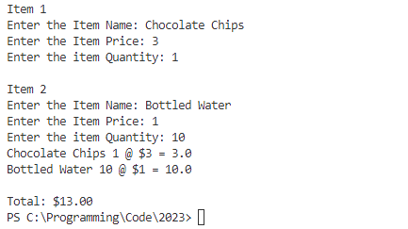

GIT LINK:  
<https://github.com/mylesndavid/csu/blob/main/CSC500/module_4_milestone.py>