Budget-Aware Retrieval: Allocating Context Tokens Where They Pay Off

Abstract
Retrieval-augmented generation commonly fixes how much context to retrieve, although queries differ in difficulty and budgets are finite. We formulate retrieval-depth selection as a budget-constrained choice among priced actions: adding a chunk, switching to hybrid retrieval, rewriting the query or taking a second hop. Under monotonicity and diminishing returns the objective is submodular, so greedy selection inherits a $1-1/e$ guarantee with a cardinality budget, $(1-1/e)/2$ with a cost budget, and $1-1/e$ with cross-tier enumeration. The budget's shadow price then decides when rewriting pays off and where a cascade sets its confidence thresholds.
In a controlled synthetic retrieval benchmark of 200 queries, the system reaches 0.960 recall at 126 context tokens, against 0.925 at 179 for a behavioural approximation of corrective retrieval and 0.910 at 115 for dense retrieval ($p<0.05$, bootstrap and McNemar). On 500 synthetic end-to-end queries, containment is 0.912 versus 0.920 for fixed top-3, within paired noise, at 474 versus 972 prompt tokens. Retrieval also improves answer accuracy on three multi-hop benchmarks for a local 4B model and on HotpotQA for a hosted model.
Transfer is selective. Score-margin depth selection saves 1-24% of context tokens at equal nDCG@10 on three of four BEIR subsets but fails on arguana, and neither sentence-level indexing nor gated rewriting transfers to English documentation. A split-conformal protocol maps attainable quality targets to budgets with twenty labelled questions, reports reach rates and declines unreachable targets; empirical coverage stays within 0.015 of nominal at 120-276 tokens on the hybrid retriever. An audit of 200 doubly annotated examples suggests automatic containment can miss valid answers, without proving a lower bound.
Keywords: retrieval-augmented generation; context budget; submodular maximization; adaptive retrieval; cost-aware inference; large language models

1. Introduction
Retrieval-augmented generation (RAG) grounds language models in external, updatable evidence [1]. Many systems nevertheless retrieve a fixed number of passages [2,3]. That choice can waste context on straightforward queries while leaving harder ones without sufficient evidence. It can also affect the answer in less predictable ways: changing the position of identical evidence has produced double-digit differences in accuracy [4]. More retrieved text is therefore not necessarily better. Nor does Recall@$k$ alone establish a comparable quality-cost trade-off when systems differ in chunk size, routing depth or token use. We use Recall@budget to make retrieval comparisons at matched context budgets (Section 6.1).
Existing approaches address parts of this problem. Adaptive retrieval determines whether and how far to retrieve; corrective retrieval responds to inadequate evidence; cost-aware selection prices evidence acquisition; and compression, reranking and rewriting alter the cost, order or candidate pool of evidence (Sections 2.1-2.4). These mechanisms leave a common allocation question: given a query and a remaining budget, which available action merits the next unit of expenditure? The reported brittleness of static selectors further motivates making that decision explicit [12].
We model a retrieval policy as a set $S$ of executable actions, each with cost $c(a)$ and marginal quality gain $g(a\mid S)$, subject to budget $B$. When quality is monotone and gains diminish as actions accumulate, the resulting objective is submodular. Its approximation guarantees are conditional on those properties, rather than guarantees that every retrieval corpus satisfies them. The same formulation links query rewriting to the shadow price of the budget and, under the stated cascade model, yields a chain of confidence thresholds whose cutoffs decline as that price rises. We implement the framework and examine both its controlled performance and its limits on public corpora.
Our contributions are fourfold:
- A common action model. We place chunk selection, hybrid retrieval, query rewriting and
second-hop retrieval in one priced action set. Under the stated conditions, gain-per-cost greedy selection attains the cardinality- and cost-budget guarantees above, with cross-tier enumeration restoring the stronger bound (Sections 3 and 5).
- A price-dependent rewriting rule. We derive the rewriting threshold $\tau^*(\lambda)$
(Propositions 2 and 4). In the reported sweep, increasing the unit-price coefficient from 0.25 to 2 lowers $\tau^*$ from 0.25 to 0 (Section 6.7).
- A budget interface. A twenty-question split-conformal calibration protocol translates attainable
quality targets into budgets, reports their reach rates and declines targets the retriever cannot meet (Section 6.10).
- An evaluation of performance and transfer. A 200-query retrieval benchmark and 500 end-to-end queries assess retrieval and
generation cost; LongBench subsets and multi-hop benchmarks test additional settings. Evaluation on 312 official documentation pages and four BEIR subsets distinguishes transferable score-margin depth selection from sentence-level indexing and gated rewriting, which do not transfer to English documentation. A doubly annotated audit examines the limits of automatic containment metrics (Sections 6.1-6.9).

2. Related Work
Retrieval-augmented generation (RAG) combines parametric knowledge with external, updatable evidence [1]. Many systems fix retrieval depth, concatenating a predetermined number of top-$k$ passages retrieved by a sparse or dense retriever into the context [1-3]. This default was reasonable when a few extra passages cost little. Position-sensitivity experiments, however, show double-digit accuracy differences when identical evidence appears at different locations in the context [4]: more retrieved evidence need not improve an answer, and both evidence volume and placement act as resources to allocate rather than parameters to tune. A subtler cost is reporting. Studies typically report Recall@$k$ for a single $k$, although chunk lengths, retrieval depths and token costs differ across methods, so quality-cost curves from different studies cannot be compared directly -- an apparent recall gain may simply be more tokens spent. We therefore treat the comparison protocol as part of the method and report Recall@budget throughout (Section 6.1).
Existing work answers "how much to retrieve" along four lines: adaptive retrieval decides *whether* and *in how many steps* to retrieve (Section 2.1); corrective retrieval handles retrieval that went wrong (Section 2.2); cost-aware retrieval treats evidence acquisition as a bill (Section 2.3); and compression, reranking and rewriting change the unit price, ordering and candidate pool of what has already been fetched (Section 2.4). Section 2.5 traces the two decision tools we use—submodular approximation and threshold stopping—and Section 2.6 states our position.

2.1 Adaptive Retrieval
FLARE [5] ties "when to retrieve" to the generation process: when a low-confidence token appears, it is used as a query for a forward-looking retrieval, producing multi-round retrieval that is triggered on demand. Self-RAG [6] goes further and writes "is retrieval needed", "is the passage relevant" and "is the answer supported" into the generation sequence as reflection tokens, training the model end-to-end to decide when to retrieve and how much to adopt. SKR [7] takes a lower-effort route: it labels questions by the model's own sense of its knowledge boundary and triggers retrieval only for unfamiliar ones, without touching the generation process. All three turn retrieval from a fixed pipeline stage into a switch driven by generation-side self-assessment or meta-knowledge.
Deciding *how many steps* is equally mature. Adaptive-RAG [8] trains a query complexity classifier that assigns questions to no retrieval, single-step retrieval or multi-step retrieval; Self-Ask [9] decomposes composite questions into sub-questions that are retrieved one by one; IRCoT [10] interleaves chain-of-thought with retrieval, so each reasoning step becomes the query for the next retrieval. These methods align retrieval depth with the reasoning structure of the question and pay off on tasks that need multi-hop evidence.
Together, the two lines turn retrieval into a per-query policy. But they optimize the correctness of the decision, not its cost: the budget is given outside the model, and a classifier answers "which tier" rather than "within 200 tokens, which chunk gets the first slot and does the second step deserve a rewrite". The triggering signals also cost something—generation-side self-assessment needs extra sampling or extra output, a complexity classifier needs labels and training, and meta-knowledge discrimination needs a front model. Our gate uses only the relative score margin $\gamma$ of an existing retrieval (Section 4.3), a scalar that comes for free inside the retrieval it already performed; its threshold is solved from the shadow price of the budget (Proposition 2) and shifts by formula when the unit price changes (Section 6.7). The multi-hop side follows the same logic: whether a second hop is warranted is decided by the gain-to-cost ratio, not by whether the question "looks complex" (Section 4.4, Proposition 3).

2.2 Corrective Retrieval
CRAG [11] inserts a lightweight retrieval evaluator between retrieval and generation, judges the result as correct, incorrect or ambiguous, and triggers one of three corrective actions—use it, discard it for web search, or combine both. It is a pipeline-style scheme that treats retrieval quality as an anomaly to be repaired; later work adds finer-grained verification, iterative retrieval and adaptive correction, all keeping the detect–branch–correct structure.
This line acknowledges that retrieval fails, at the price of writing correction as a conditional branch: whether to correct is decided by the evaluator's verdict, independently of whether the correction is worth its cost. We fold the corrective actions (rewriting, second-hop retrieval, reranking) into the same action set and decide by gain-to-cost ratio—picked automatically when the budget is loose, skipped automatically when it is tight, with no separate correction stage. The two compose: a CRAG-style evaluator can serve as a prior for $g(a\mid S)$ in our action set—the evaluator scores, the ordering rule decides.

2.3 Cost-Aware Retrieval
Cost-aware retrieval approaches from the other end: if acquiring each piece of evidence itself costs money (paid retrievers, external APIs, human annotation), the selector must trade utility against expense. Prior work reports that static selectors are brittle under load shifts and that larger budgets do not reliably improve quality [12], which argues for modelling the allocation policy explicitly rather than tuning it.
We handle a different cost: context occupancy. It never appears on a retrieval bill, yet three things price it simultaneously—per-token billing, the attention budget, and position sensitivity [4]. This explains why fixed top-$k$ misses at both ends: too much for easy questions, too little for hard ones. The two costs can be written into one knapsack problem by making action cost a vector (access fee plus occupancy fee) and the budget multi-dimensional. We solve the occupancy dimension only; the two compose directly, and under a multi-dimensional budget the optimal policy moves from a single threshold chain to a chain on the Pareto frontier while the ordering rule is unchanged (Section 7.3).

2.4 Compression, Reranking and Query Rewriting
One line subtracts from what has already been fetched. LLMLingua [13] uses a small model's perplexity to estimate token importance and compress the prompt; LongLLMLingua [14] adds question-aware compression to reduce information loss on long documents; RECOMP [15] trains extractive and generative compressors that turn multiple passages into a summary. These methods raise information density per token, trading compression rate against fidelity.
Reranking changes the order of the same candidates. monoT5 [16] casts relevance as sequence-to-sequence generation, and RankGPT [17] uses a large model for listwise reranking. Reranking does not reduce the number of candidates; it decides who gets packed first when the budget truncates, and its gain is realized only when truncation actually happens.
On the rewriting side, HyDE [18] replaces the query with a generated pseudo-document for dense retrieval, and Rewrite-Retrieve-Read [19] places a rewriter before the retriever and trains it with downstream feedback, showing that "asking differently" can be a first-class action.
These three techniques and our budget allocation are orthogonal layers: compression lowers the unit price of a token, reranking changes the packing order within a fixed budget, rewriting changes the candidate pool itself, and we decide how many units to buy and which action to buy. When combined, compression is equivalent to multiplying each action's cost $c(a)$ by a discount factor, which changes neither the structure of the selection problem nor the optimality condition of the greedy rule. The gain from reranking, in contrast, grows as the budget tightens—our reranking experiment gives direct evidence: with a pool of 8 and a 300-token budget the gain is 0.0 pt (no selection pressure), while with a pool of 30 and a 150-token budget it is +5.5 pt (Section 7.1). The same action differs by 5.5 pt across two budgets, which is precisely the observable consequence of "gain is priced by budget tightness".

2.5 Submodular Approximation and Threshold Stopping
Both decision forms we use have mature sources. Submodular selection controls redundancy in retrieval and summarization: MMR [20] subtracts similarity to already-selected items from relevance and selects greedily one at a time, while Lin and Bilmes [21] write coverage and diversity into one family of submodular functions and summarize under a unified objective. The approximation bound comes from Nemhauser et al. [22]: for a monotone submodular function under a cardinality constraint, greedy selection by marginal gain is within $1-1/e$ of optimal. With heterogeneous costs the bound of unit-cost greedy drops to $(1-1/e)/2$; the modified greedy of Khuller et al. [23] adds local enumeration across tiers and restores $1-1/e$ for the budgeted case. These results establish that ordering by gain-per-cost is not a heuristic but a bounded approximation algorithm.
Threshold stopping has long had an optimal-stopping form in statistics: sequential analysis shows that with increasing costs and observations arriving in stages, the optimal policy is a threshold— stop when the observation is good enough, continue otherwise [24]. The form was rediscovered in LLM serving: FrugalGPT [25] answers with a cheap model first and decides by confidence whether to escalate to a stronger and more expensive one, validating threshold routing on real billing.
We join the two: submodular ordering decides which action to buy next, and the threshold decides when to stop. We do not reprove the approximation bound—Proposition 1 cites the budgeted result directly (Section 5); the increment is to replace the selected "elements" with "actions": chunks, hybrid retrieval, rewriting, reranking and second-hop retrieval share one definition of cost and gain. Proposition 3 extends the threshold form to retrieval actions: when action costs increase and gains decrease monotonically with confidence, the optimal policy is again a chain of confidence thresholds, with thresholds moving monotonically with the budget. The difference from FrugalGPT is the direction of the constraint: it minimizes cost subject to a quality target, whereas we maximize quality subject to a budget; the two are dual, and the dual variable is exactly our shadow price $\lambda$. This is why we can write "what the threshold should be" as a computable formula instead of a hyperparameter to be searched.

2.6 Our Position
Table 1. Comparison of representative adaptive-retrieval lines against this work. Table 1 summarises this positioning.
Line | Decision object | Role of the budget | Trigger signal | Relation to this work
Adaptive and multi-hop [5,6,8,9,10] | Whether to retrieve, how many steps | External constant | Generation confidence / complexity classifier / question decomposition | We add "how much to give" and make the second hop a priced action
Corrective [11] | Whether the result is trustworthy, how to fix | Not modelled | Fine-tuned evaluator | Corrective actions join the action set and fire by cost-effectiveness; the evaluator serves as a gain prior
Cost-aware [12] | Which evidence to buy | Spending cap | Utility-to-cost ratio | Cost becomes context occupancy; composes into a multi-dimensional knapsack
Compression and reranking [13,14,15,16,17] | What to delete, who gets packed first | Token cap | — | Orthogonal and composable; compression is a cost discount, reranking is paid by budget tightness
Submodular selection [20,22,23] | Selecting a subset from a fixed pool | Cardinality or coverage budget | Marginal gain | Elements become actions: heterogeneous costs, gains estimated online
Cascades and thresholds [24,25] | When to escalate to a costlier tier | Threshold / quality constraint | Confidence | We extend the threshold chain to retrieval actions, with thresholds from the shadow price
Taken together, prior work advances four questions—whether to retrieve, whether retrieval is right, whether evidence is expensive, and whether context can be deleted—and they share an unstated assumption: retrieval behaviour can be chosen independently of the budget. We supply that layer, writing the budget as an explicit constraint and the shadow price as an observable quantity, with the policy derived from their ratio. Which tier, whether to rewrite, whether to second hop and who gets packed first are then answered by one ordering rule: actions appear as the budget allows and disappear as it tightens, with no per-combination stage design.
Two accounting differences remain. First, the evaluation protocol: we report Recall@budget uniformly, so all methods are compared under the same budget with quality and cost visible together (Sections 6.1 and 6.2), rather than each reporting Recall@$k$ at its own $k$. Second, the source of gain: the marginal gain $g(a\mid S)$ is produced online from existing retrieval scores and lightweight judgements, requiring neither a trained discriminator nor generation-side self-assessment, so the same policy transfers directly across generator models (Section 6.5). Together these form the seam with the lines above: they provide components, we provide the rule that assembles components under a budget.

3. Problem Formulation
For each query, let $\mathcal{A}$ denote the available retrieval actions and $S \subseteq \mathcal{A}$ the actions selected. Each action $a$ has cost $c(a)$ and marginal gain $g(a \mid S)$ given $S$. We assume that the quality $Q(S)$ is monotone non-decreasing. Under budget $B$, the policy selects an action set by solving
\max_{S \subseteq \mathcal{A}} Q(S) \quad \text{subject to} \quad \sum_{a \in S} c(a) \le B .
The subsequent results rely on two assumptions. Under (A1), marginal gains diminish: $g(a \mid S) \ge g(a \mid T)$ whenever $S \subseteq T \subseteq \mathcal{A}$ and $a \notin T$. Under (A2), action costs are additive and independent of execution order.

4. Method
Our retrieval layer combines sparse BM25 scoring [2] with dense bi-encoder retrieval [3].

4.1 Dual Index and Budgeted Chunk Selection
Long documents are indexed at two granularities (Figure 1). Sentence-level chunks are split on punctuation and contain roughly 15-40 tokens. Fixed blocks use a sliding 200-token window with a 40-token overlap by default. Sentence-level indexing keeps unrelated sentences out of a retrieved chunk, which benefits short-sentence corpora such as the Chinese technical notes in Section 6.2; fixed blocks preserve a coherent window and perform better on English documentation, reaching 0.910 versus 0.718 at a 300-token budget (Section 6.9). Whether both indexes are built is therefore a corpus-level decision: short-sentence corpora are dual-indexed, while English documentation is indexed with fixed blocks only. When both exist, the per-query budget $ctx$ (in tokens, equal to $B$) selects sentence level for $ctx \le 500$ and fixed blocks otherwise.
Chunks are added in descending retrieval-score order until the selected chunks reach the token budget $B$, without imposing a fixed top-$k$ cutoff. Section 6.9 qualifies this design: on real corpora the truncation behaves like a well-chosen fixed $k$, and an operational difference appears only when retrieval depth is chosen per query from the score margin.

4.2 Cascade Routing
Routing has three tiers, defined by the admissible cost per thousand tokens. Very tight budgets (< 0.002 CNY) select one BM25 chunk, medium budgets (0.002-0.01 CNY) select two, and generous budgets ($\ge$ 0.01 CNY) select five chunks from hybrid retrieval. These tiers discretize the greedy allocation of Proposition 1 and correspond to the knee of the gain-per-cost curve.

4.3 Confidence-Gated Query Rewriting
Because rewriting accounts for about half of end-to-end latency (Section 6.8), we invoke it only when needed. An initial low-cost retrieval provides the relative margin between the top two scores,
\gamma = \frac{s_1 - s_2}{s_1}.
When $\gamma < \tau$ the retrieval is treated as uncertain: the query is rewritten and retrieval is repeated with "original question + rewrite terms". The shadow price of the budget determines the optimal threshold (Proposition 2); the default $\tau = 0.25$ corresponds to pricing a rewrite at about one strong retrieval. Section 6.7 confirms that $\tau$ falls as the unit price rises.

4.4 Multi-Hop Extension
For questions that need two pieces of evidence, a second retrieval hop is added. After the first hop, the model receives the question plus a summary of the retrieved material and identifies what is still missing; the second hop then searches for "original question + supplementary query", and the two result sets are merged with chunk-level deduplication. The supplementary query is model-generated rather than extracted by a fixed rule, so it can name the missing entity directly.
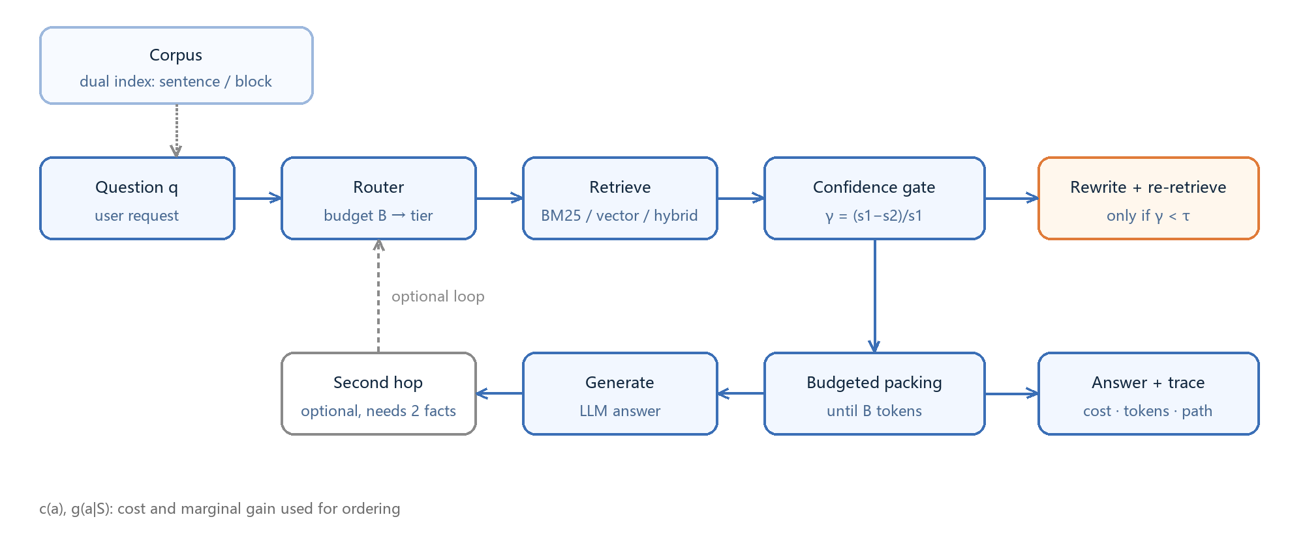
Figure 1. System overview. Short-sentence corpora are indexed twice (sentence level and fixed blocks) and English documentation is indexed with fixed blocks only; when both exist, the per-query budget decides which one is used (Section 4.1). Routing assigns a tier; the first retrieval yields the confidence $\gamma$; the gate decides whether to rewrite and re-retrieve; chunks are accumulated until the budget $B$ is reached; a second hop is enabled when two pieces of evidence are needed. Dashed edges are optional paths; $c(a)$ and $g(a\mid S)$ are the cost and gain used for ordering.

5. Theory
This section states four consequences of the formulation in Section 3. Propositions 1 and 4 are proved below; Propositions 2 and 3 follow from the shadow-price view and are used operationally in Sections 4.2-4.3.
Proposition 1 (approximation bound). Under A1 (diminishing returns) and A2 (additive costs), $Q(S)$ is monotone submodular. Greedy selection by marginal gain attains $1-1/e$ under a cardinality constraint [22]; under a budget constraint the bound of unit-cost greedy drops to $(1-1/e)/2$ and is recovered to $1-1/e$ with cross-tier enumeration [23]. We instantiate this ordering on the retrieval action set, and measure the gap to the brute-force optimum in Appendix A.
Proposition 2 (rewriting gate). Let $q_0$ and $q_1$ be the quality without and with rewriting, $p$ the probability that rewriting helps, and $c_r$ its cost. Rewriting pays off exactly when $p(q_1 - q_0) > \lambda c_r$, where $\lambda$ is the shadow price of the budget. Equivalently, rewriting is triggered below a confidence threshold that is solved from $\lambda$ rather than fixed at 0.25 (Section 4.3).
Proposition 3 (cascade threshold chain). Suppose the actions can be ordered by increasing cost, and that the gain of each action decreases monotonically with confidence. Then the optimal policy assigns each confidence interval to one tier -- a threshold chain -- and the thresholds move monotonically with the budget $B$. This explains why cascades work and implies that tier boundaries should follow the budget (Section 4.2).
Proposition 4 (monotonicity of the threshold). Assume A3: the rewriting gain $B(\gamma) = p(\gamma)\Delta q(\gamma)$ is non-increasing in the retrieval confidence $\gamma$. Then the optimal threshold satisfies $B(\tau^*) = \lambda c_r$, and $\tau^*(\lambda)$ is non-increasing in $\lambda$.
*Proof.* By Proposition 2 the criterion for rewriting is $B(\gamma) > \lambda c_r$. A3 makes $B$ non-increasing, so the confidences that satisfy the criterion form an interval $[0, \tau^*)$. As $\lambda$ grows, the right-hand side $\lambda c_r$ grows, the feasible set shrinks, and $\tau^*$ therefore does not increase. At the boundaries, $\lambda c_r \ge B(0)$ gives $\tau^* = 0$ (never rewrite) and $\lambda c_r \le B(1)$ gives $\tau^* = 1$ (always rewrite). Section 6.7 verifies the former boundary: when the unit-price coefficient rises to 2, the optimal threshold falls from 0.25 to 0.

6. Experiments

6.1 Setup
Corpus. Sixteen Chinese technical notes (operating systems, networking, databases, Git, Docker, algorithms, testing, HTTP caching, RAG), 8,546 characters and 348 factual sentences, yielding roughly 344 sentence-level chunks.
Benchmarks. A synthetic main set of 500 questions (generated from the source text; answers are verbatim spans, verified); a harder 200-question set with deliberately paraphrased queries to widen the surface gap. Public benchmarks: LongBench passage_retrieval_zh / passage_retrieval_en (paragraph-level retrieval, answer = paragraph id), hotpotqa / 2wikimqa / musique (multi-hop generation), and triviaqa (a commonsense-style contrast).
Models. DeepSeek-V4.1-Flash (API) for the main experiments; a locally deployed Qwen3-4B (GGUF Q4_K_M, Ollama, /no_think) for the model-agnostic check.
Vectors. BAAI/bge-m3 (1024-d, OpenAI-compatible endpoint); deterministic hashing vectors for the offline baseline.
Hyperparameters. Sentence-level chunking; context budget 300 tokens (swept over 100–800); hybrid weight $\alpha=0.2$; gate threshold $\tau=0.25$; routing tiers defined by cost per thousand tokens.
Cost model. 2 CNY per million input tokens, 8 per million output, 0.7 per million embedding tokens, billed from the API-reported usage; hashing vectors are charged zero.
Statistics. Paired bootstrap (1,000–2,000 resamples) for 95% intervals; McNemar exact test for system comparisons; five 2/3 subsamples for robustness.
Metrics. Throughout, *recall@budget* is measured under a matched token budget rather than at a fixed depth: chunks are taken in rank order until their cumulative token count reaches the budget $B$, and a query counts as retrieved when the gold answer span appears in the selected chunks (for BEIR we use document-level relevance and report nDCG@10). Token counts are produced by the tokenizer of the reference model, so a passage of the same text costs the same across methods; monetary cost is read from the API-reported usage. Reporting at a matched budget is what makes two methods comparable when their chunk sizes, depths and token accounting differ.
Hardware. i7-13650HX, 16 GB RAM, RTX 4060 Laptop 8 GB. API models run over the network, the local model on the GPU; all retrieval and statistics run on the CPU.

6.2 Main Results (Controlled Synthetic Setting)
This subsection reports the controlled setting: a 200-query subset of the 500-question synthetic benchmark over sixteen technical notes, where every method sees the same corpus and budget. Section 6.9 repeats the comparison on 312 official documentation pages and on BEIR, and revises two of the claims made here.
Under this controlled setting the proposed system is stronger at equal or lower budget.
Table 2. Main results on a 200-query subset of the 500-question synthetic benchmark (800-token budget). Table 2 reports the main comparison.
Method | Recall | 95% CI | tokens
BM25 | 0.825 | [0.770, 0.875] | 68
Dense | 0.910 | [0.870, 0.945] | 115
Hybrid | 0.900 | [0.860, 0.940] | 114
Adaptive-RAG approx. | 0.855 | [0.805, 0.905] | 100
CRAG approx. | 0.925 | [0.885, 0.960] | 179
Ours | 0.960 | [0.930, 0.985] | 126
Higher recall at lower cost follows from spending the budget where the marginal gain is largest: easy questions stop after a single chunk (about 20 tokens) and the saved budget goes to questions that need hybrid retrieval and rewriting, instead of running every query through the full pipeline. The CRAG approximation pays one evaluator call plus five chunks for *every* query, while a fixed $k$ cannot cut losses on easy ones.
Seed stability (five 2/3 subsamples).
Table 3. Seed stability across five 2/3 subsamples. Table 3 reports the stability check.
Method | Full | Subsample mean ± sd
BM25 | 0.825 | 0.826 ± 0.010
Dense | 0.910 | 0.914 ± 0.009
Hybrid | 0.900 | 0.902 ± 0.005
Adaptive-RAG approx. | 0.855 | 0.853 ± 0.010
CRAG approx. | 0.925 | 0.928 ± 0.004
Ours | 0.960 | 0.962 ± 0.011
The subsample interval for our system, [0.947, 0.970], does not overlap that of the CRAG approximation, [0.925, 0.932]: the advantage does not depend on which questions are drawn.

6.3 Ablation
Table 4. Ablation: removing each component in turn. Table 4 reports the ablation.
Removed component | Recall change | Interpretation
Gate (rewrite on every query) | −3.6 pt | Rewriting helps, but not on every query
Hybrid retrieval (BM25 only) | −6.8 pt | Semantic matching carries most of the signal
Budget 300 → 100 | −6.1 pt | Budget matters, but must be allocated by difficulty
$\alpha$ 0.2 → 0.5 | −1.7 pt | The default weight is not optimal for this corpus
These numbers come from the controlled synthetic setting of Section 6.2. Figure 3 summarizes the ablation: dropping hybrid retrieval costs the most (−6.8 pt), followed by tightening the budget (−6.1 pt), so the gains come mainly from semantic matching and budget allocation, with the gate as a refinement (−3.6 pt).
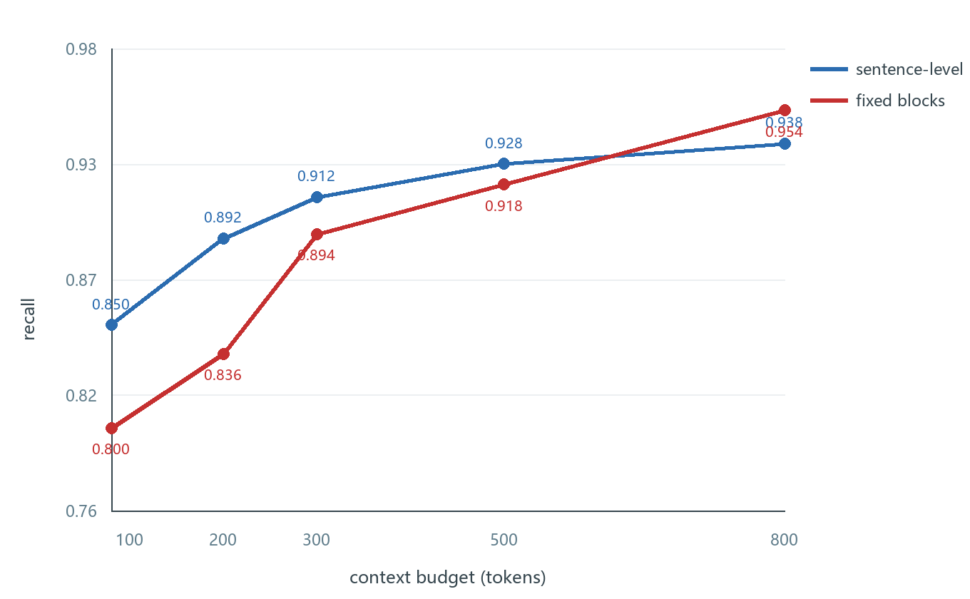
Figure 2. Recall across token budgets of 80-800 tokens, on the short-sentence synthetic corpus, for sentence-level chunks and fixed blocks. Sentence-level chunks lead up to 300 tokens (0.912 versus 0.894 at 300) and fixed blocks lead from 500 (0.928 versus 0.918); on English documentation fixed blocks lead at every budget (Section 6.9). The crossover is therefore a property of short-sentence corpora, not a universal rule, and the corpus-level decision of Section 4.1 determines whether it applies.
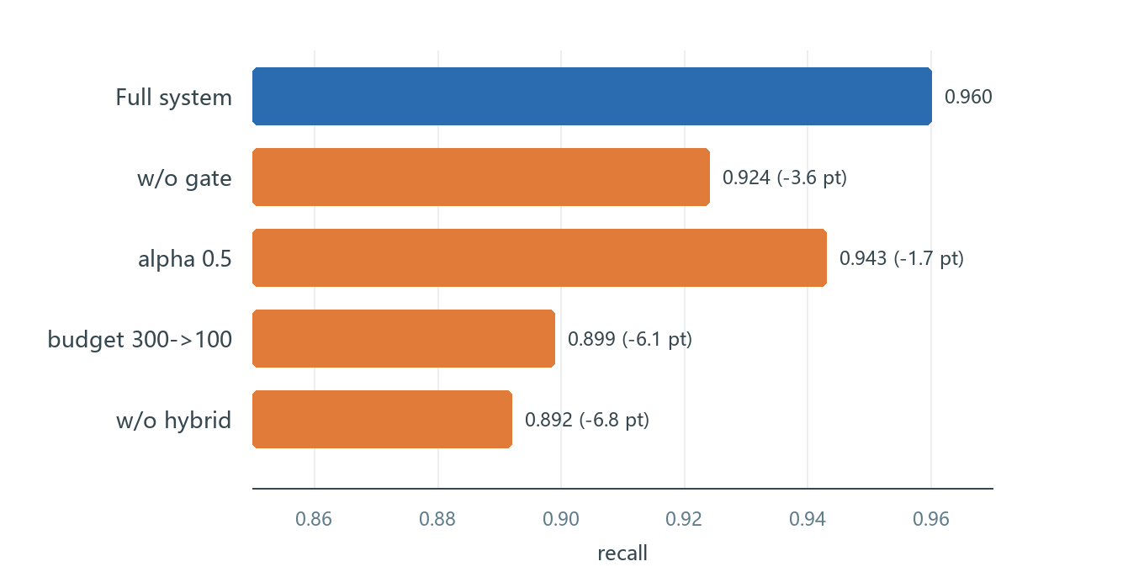
Figure 3. Ablation relative to the full system; the horizontal axis is answer-span recall and parentheses give the change in percentage points.

6.4 Cross-Corpus Check
On the LongBench Chinese retrieval subset our recall is 0.995 against 0.955 for BM25; on the English subset both reach 1.000. The claim here is that performance does not degrade across corpora and that the direction of the relative gain is preserved; absolute levels depend on task difficulty and are not used as a comparison basis.

6.5 The Benefit of Retrieval Is Model-Agnostic
One hundred questions per dataset, the same 800-token budget, local Qwen3-4B generation; brackets are bootstrap 95% intervals.
Table 5. Benefit of retrieval across datasets and models (Qwen3-4B, 800-token budget). Table 5 reports per-dataset results.
Dataset | With retrieval | 95% CI | Without | McNemar p
HotpotQA | 0.400 | [0.300, 0.500] | 0.120 | <0.0001
2WikiMultiHopQA | 0.250 | [0.170, 0.330] | 0.090 | 0.0009
MuSiQue | 0.140 | [0.080, 0.210] | 0.000 | 0.0001
TriviaQA | 0.090 | [0.040, 0.150] | 0.190 | 0.0020
HotpotQA (DeepSeek-V4.1-Flash) | 0.520 | [0.420, 0.620] | 0.230 | <0.0001
The standard deviations over five 2/3 subsamples are 0.007, 0.051, 0.034 and 0.019 respectively, so the ordering does not depend on which questions are drawn.
The first four rows—including the hosted large model—support the claim: on multi-hop tasks retrieval raises accuracy from 0–0.23 to 0.14–0.52, and the improvement is significant in every case; the direction is the same for the large and the small model, so the conclusion does not depend on the generator.
The fourth row is a significant negative effect, reported as measured. TriviaQA questions are largely commonsense and the corpus consists of twenty-odd distractor passages, with an 800-token budget covering about 11% of it. Whether retrieval caused the decline, or which property of the corpus did, is not identified here; the effect itself is significant at n = 100 (0.090 vs 0.190, p = 0.002). This says that whether to retrieve is itself a decision, complementary to our gate, which only decides whether to rewrite. Upgrading the gate into a "retrieve or not" decision is the natural next step (Section 8).

6.6 Human Annotation
On 200 doubly-annotated items, automatic containment agrees with human judgement 90%–97% of the time, and inter-annotator agreement is 0.548 (unweighted) and 0.673 (quadratic weighted). Agreement alone does not establish the direction of the errors: in our sample the automatic metric misses some valid answers, which suggests the reported recall is conservative, but we do not claim a proven lower bound.

6.7 Threshold Sensitivity (Proposition 2)
For unit-price coefficients λ = 0.25, 0.5 and 1, the optimal threshold stays at τ = 0.25; for λ ≥ 2 it falls to τ = 0. The direction predicted by Propositions 2 and 4 holds: the more expensive the rewrite, the less often it should be triggered.

6.8 Efficiency
Twenty queries (single machine, API model, answer cache disabled):
Table 6. End-to-end efficiency on twenty queries with the answer cache disabled. Table 6 reports latency and cost.
Configuration | p50 (ms) | p95 (ms) | cost/query (CNY) | recall
Cheap tier (BM25) | 923 | 1469 | 0.00088 | 0.850
Strong tier (hybrid) | 898 | 1705 | 0.00087 | 0.850
Strong + always rewrite | 1765 | 3090 | 0.00116 | 0.900
Strong + gated rewrite | 1788 | 2577 | 0.00116 | 0.900
Rewriting dominates latency (+0.9 s at p50, +1.4 s at p95). The value of the gate depends on the rewrite trigger rate of the batch: 38% on the full 500 questions (saving 62% of rewriting calls), 76% on the first 50 harder questions, and 69.5% on a 200-question medium subset. The gate adapts to difficulty, so its latency saving is not unconditional; the default threshold of 0.25 should move with the shadow price of the budget (Section 6.7).

6.9 Real Documents and Public Benchmarks
The main table above rests on sixteen synthetic technical notes, which is small. This section replaces the corpus with 312 official documentation pages (Docker 147, Redis 89, Kubernetes 43, Grafana 19, Prometheus 14; 1.9M characters, 16,823 chunks) and adds four BEIR subsets for public-protocol validation.
Internal benchmark (301 questions, document-level recall)
Table 7. Internal benchmark: 301 questions, document-level recall. Table 7 reports the internal benchmark.
Method | Recall | mean tokens
BM25 | 0.801 | 318
Dense (bge-m3) | 0.887 | 318
Hybrid (alpha=0.2) | 0.910 | 318
Ours (budget-300 truncation) | 0.910 | 318
Fixed k=8 | 0.904 | 289
Ours (difficulty-adaptive, k=4/10) | 0.900 | 244
Paired bootstrapping over the 301 questions puts the recall difference at -0.003 (95% CI [-0.020, +0.010], p = 0.81) and the token saving at 15.5% (95% CI [11.2%, 19.8%]): the rule is statistically indistinguishable from fixed k = 8 on quality while using 11-20% fewer tokens. The budget-300 row averages 318 tokens because the final chunk can overshoot the cap; budgets are upper bounds, not exact counts.
BEIR (public protocol, document level)
We run four BEIR subsets through the same pipeline (bge-m3 embeddings, hybrid alpha = 0.2, chunk size 200) and use fixed k = 8 as the reference; the adaptive configuration is the cheapest one whose nDCG@10 does not fall more than 0.002 below that baseline (it may exceed it). All queries are used, without subsampling.
Table 8. BEIR results on four subsets, all queries, fixed k = 8 as reference. Table 8 reports the BEIR results.
Dataset | Fixed k=8 nDCG@10 | tokens | Adaptive nDCG@10 | tokens | Saving
scifact | 0.7071 | 2615 | 0.7062 | 1991 | 24%
nfcorpus | 0.3504 | 2747 | 0.3486 | 2571 | 6%
fiqa | 0.4356 | 1999 | 0.4350 | 1978 | 1%
arguana | 0.3931 | 1879 | 0.3959 | 2177 | -16%
The saving is largest where the corpus is small and the margin distribution is bimodal (scifact), shrinks as the corpus grows and margins flatten (fiqa has 57,638 documents), and reverses on arguana, an adversarially constructed benchmark where every adaptive setting we tried spent more tokens for an offsetting gain. The margin signal therefore orders queries by difficulty on natural corpora but not on adversarially built ones. We report that failure instead of tuning tau per dataset to hide it. scidocs was also run but is excluded: its documents are long enough that the embedding endpoint truncates them, which depresses absolute nDCG for every method equally.
Significance on real documentation. At a 300-token budget the paired comparison on the 301 questions is mixed, and we report it as such. Hybrid beats BM25 decisively (36 wins, 3 losses, McNemar p < 0.0001, surviving Holm correction for three comparisons) and also beats dense bge-large (25 wins, 8 losses, p = 0.0046, Holm-adjusted 0.0091), but ties dense bge-m3 (11 wins, 4 losses, p = 0.12). On this corpus the system therefore matches the strongest dense retriever rather than surpassing it; the contribution in this setting is the cost side, not the accuracy side.
Three revised conclusions. First, the transferable gain is difficulty-adaptive depth: at equal recall or hit rate it saves 1-24% of context, the saving tracking how many queries can be answered confidently (24% on scifact, 6% on nfcorpus, 1% on fiqa, where a 57k-document corpus flattens the score margins, and none on the adversarial arguana set). Second, token-based truncation alone carries no advantage: on the internal benchmark fixed k=8 reaches the same recall within noise as budget-300 truncation (0.904 versus 0.910 at 289 versus 318 tokens), so the difference comes from deciding how many chunks each query needs, not from stopping at a token count. Third, sentence-level indexing and gated rewriting do not transfer: on English documentation, at the same 300-token budget, document-level recall of the sentence index is 0.718 against 0.910 for fixed blocks, and that of gated rewriting is 0.874, so those claims must be restricted to short-sentence Chinese corpora where question and document wording diverge.
The claim of this paper is therefore revised: on heterogeneous loads where a single k is hard to preset, deciding retrieval depth from the retrieval-score margin saves substantial context at no measurable loss of quality. The high recall observed on the synthetic corpus is a controlled-setting result and is not claimed to generalize.

6.10 From a Budget to a Quality Target
Users specify a desired answer-span recall, not a token budget. Split-conformal calibration maps a target recall $T$ to a token budget using $N = 20$ labelled questions. For each calibration question we record the minimum budget at which its answer span enters the context, and set the budget to the $\lceil (N+1)(1-\alpha) \rceil$-th smallest recorded value, with $\alpha = 1 - T$. If the selected order statistic is infinite, the protocol reports the target as unreachable rather than returning a finite budget.
Under exchangeability of calibration and test questions the procedure gives a finite-sample marginal guarantee of at least $T$ for answer-span coverage. The guarantee is marginal over calibration and test draws, not conditional on returning a finite budget or avoiding refusal. We evaluate it with 100 random splits that separate calibration from evaluation questions.
Table 9. Split-conformal calibration across the tested targets: median token budgets, empirical and nominal coverage, and the empirical-minus-nominal gap for three retrievers.
Retriever | Target | Median token budget | Empirical coverage | Nominal coverage | Gap
Hybrid (bge-m3) | 0.80 | 120 | 0.810 | 0.800 | +0.010
Hybrid (bge-m3) | 0.85 | 166 | 0.865 | 0.850 | +0.015
Hybrid (bge-m3) | 0.90 | 276 | 0.891 | 0.900 | -0.009
Dense (bge-large-en) | 0.80 | 238 | 0.802 | 0.800 | +0.002
Dense (bge-large-en) | 0.90 | 548 | 0.880 | 0.900 | -0.020
BM25 | 0.80 | 368 | 0.789 | 0.800 | -0.011
BM25 | 0.90 | 708 | 0.848 | 0.900 | -0.052
On the hybrid retriever, empirical coverage at the three targets is within 0.015 of nominal, and the calibrated median budgets range from 120 to 276 tokens. Fixed $k = 8$ averages 289 tokens at a document-level recall of 0.904; that is a different metric from answer-span coverage, so the comparison is indicative rather than a same-recall budget advantage.
Observed coverage varies by retriever. At target 0.90 the gap is $-0.020$ for dense bge-large-en and $-0.052$ for BM25, and BM25 returns refusals in 55% of cases at that target. This supports retriever-specific recalibration and explicit reporting of refusals rather than a single calibration for all retrievers.
The saturating-curve variant with a safety margin reaches a similar reach rate but needs a hand-tuned margin and gives no finite-sample guarantee, so the split-conformal form is preferred.
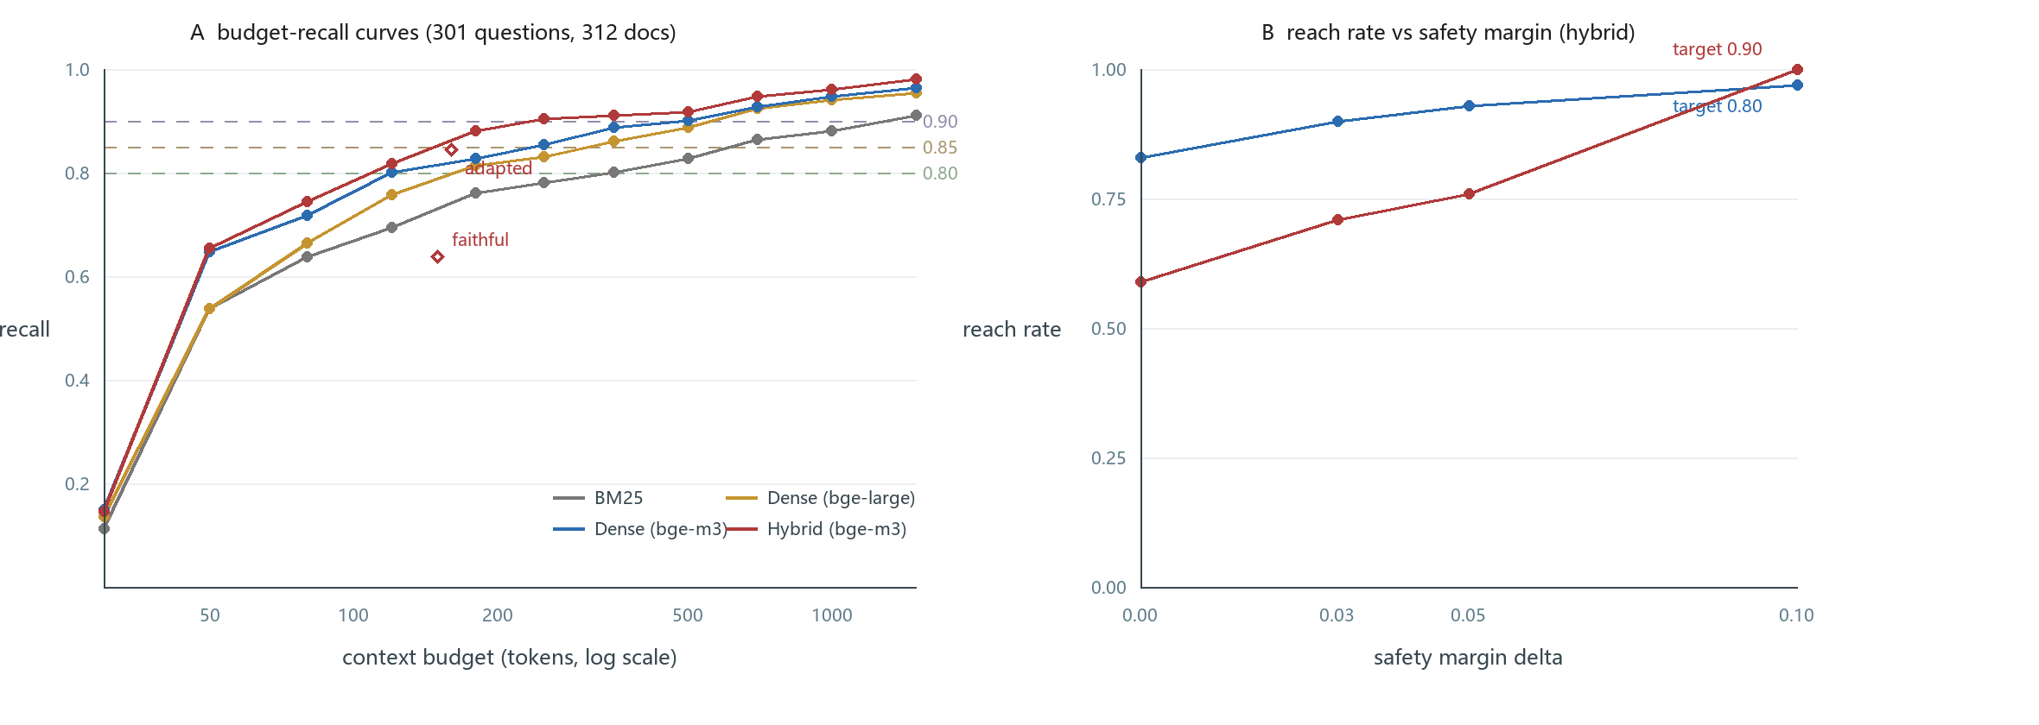
Figure 4. (A) Recall against context budget for four retrievers on the 301-question benchmark; the dashed lines mark the 0.80, 0.85 and 0.90 targets. (B) Reach rate against the safety margin for the curve-based variant, shown for comparison with the conformal protocol of this section.
Across the sweep, the maximum absolute difference between nominal and empirical coverage is 0.046 (Figure 5): 0.95 gives 0.922, 0.90 gives 0.891, 0.85 gives 0.865, 0.80 gives 0.810, 0.75 gives 0.754, 0.70 gives 0.699, 0.60 gives 0.646, and 0.50 gives 0.524. At nominal 0.95 the target is unreachable in 28% of calibration samples, which triggers refusal; among the samples that return a finite budget, the median is 664 tokens.
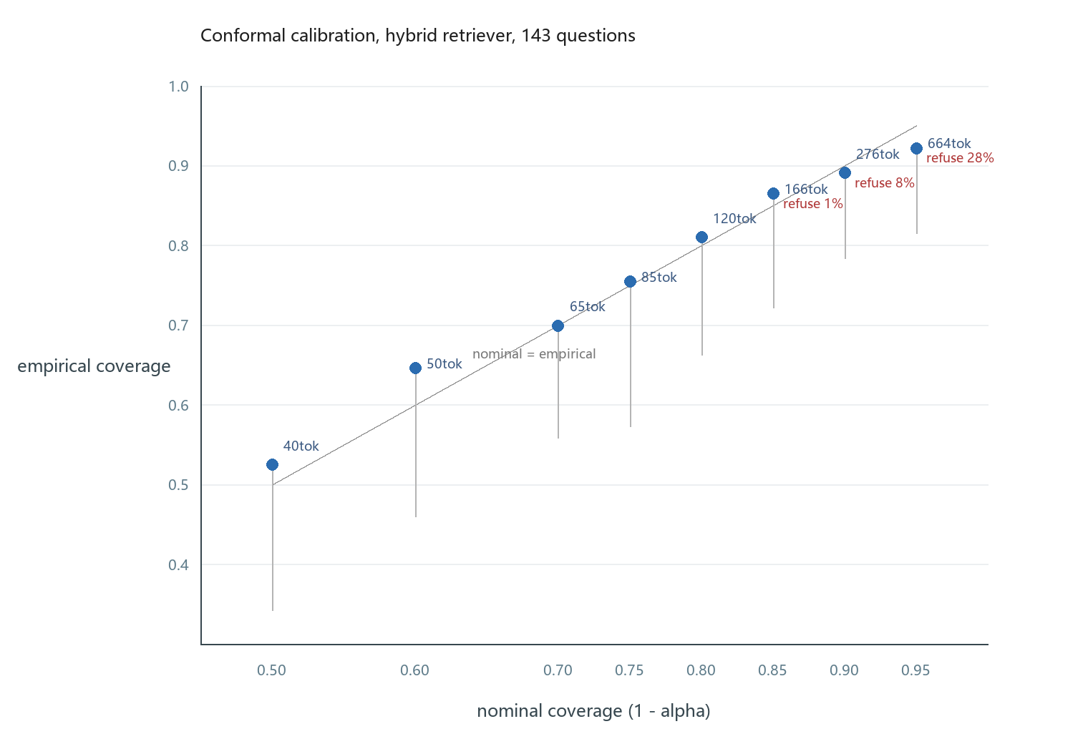
Figure 5. Empirical coverage against nominal coverage for the conformal protocol on the hybrid retriever, sweeping alpha from 0.05 to 0.50. The grey diagonal is nominal = empirical; vertical bars mark the 5th percentile of coverage across 100 random splits; labels give the median budget and the refusal rate.

6.11 Why a Second Budget Does Not Bind
Real systems are constrained by tokens, latency and money at once, so one may ask whether a scalar budget is an oversimplification. We measured the retrieval side directly on the 301-question benchmark: BM25 takes 16 ms, dense retrieval 45 ms (including query encoding) and hybrid retrieval 73 ms, while generation takes 898 ms at p50 (Section 6.8). Retrieval therefore accounts for at most 7.5% of end-to-end latency, and the three cost dimensions are collinear in this setting: money is a fixed multiple of tokens, prefill latency is close to linear in context length, and the spread across retrievers (16-74 ms) is too small to move a latency budget. The resulting operating points, including the official classifier of Section 6.16, are:
Table 10. Operating points of all policies, including the official classifier of Section 6.16. Table 10 lists the operating points.
Policy | Recall | mean tokens | mean latency (ms)
Official classifier (faithful) | 0.638 | 150 | 74
Official classifier (adapted) | 0.844 | 160 | 74
BM25 top-8 | 0.801 | 318 | 16
Dense bge-m3 top-8 | 0.887 | 318 | 45
Ours (adaptive k=4/10) | 0.900 | 244 | 72
Hybrid (budget 300) | 0.910 | 318 | 73
Latency here is retrieval only; the classifier adds 21 ms of CPU inference and nothing else. Every policy therefore lands between 16 and 74 ms, an order of magnitude below the 898 ms of generation, so latency does not create a second binding constraint. On the token-recall plane the learned classifier is an interior point (0.844 at 160 tokens) rather than an extreme: fixed top-3 is cheaper and top-5 more accurate, while our gate and fixed top-8 occupy the high-recall end at 244 and 318 tokens.
The only action with a distinct cost vector is query rewriting, which adds both tokens and about 870 ms of latency. On this corpus it also lowers recall (0.874 against 0.910), so it is dominated in every two-dimensional budget. A second dimension would only bind when a component carries a different cost shape: per-call web search fees, routing between models of different price and quality, or an end-to-end latency SLA tight enough to exclude rewriting outright. The scalar budget is therefore not a simplification of the problem but the correct model for this operating regime, and we state the conditions under which it would have to be extended.

6.12 The Exchange Rate between Retrieval Time and Context Length
Section 6.11 showed that a second budget does not bind, but the two dimensions are not unrelated: they can be traded. At equal recall, a stronger retriever needs less context. On the 301-question benchmark, reaching 0.80 recall costs BM25 331 tokens at 16 ms but hybrid retrieval 114 tokens at 74 ms, so 58 ms of retrieval time buys 217 tokens, an exchange rate of 3.7 tokens per millisecond; at a 0.90 target the same swap saves 1050 tokens, or 18.3 tokens per millisecond.
Whether the trade is worth it depends on what a token costs downstream. Measuring prompt prefill directly with a local Ollama deployment (prompt_eval_duration, randomised prompts to defeat prefix caching) gives 195 ms for 100 prompt tokens, 570 ms for 300, 1194 ms for 600 and 2125 ms for 1000, a slope of 2.15 ms per token on CPU. The gross prefill saving from swapping to the stronger retriever is 467 ms at a 0.80 target and 2258 ms at 0.90; after the 58 ms of extra retrieval the net gains are about 409 ms and 2200 ms.
The break-even condition is r * p > 1, where r is the exchange rate in tokens per millisecond and p is the prefill cost per token. On this machine 3.7 * 2.15 = 8.0, so the swap always pays. On a GPU where prefill costs about 0.1 ms per token the product falls to 0.37 at a 0.80 target, so the swap stops paying there but remains profitable at 0.90 (1.83). The trade is therefore computable rather than qualitative, and it explains the conclusion of Section 6.11 from the other side: retrieval time is so cheap relative to context that spending it is almost always right.

6.13 Question-Source Overlap
The 301 questions come from two sources: six were written by the author in Chinese and translated, the remainder were drafted from the documentation and then checked by the author against the source passage, with the answer required to appear verbatim in the document. Because a question that reuses the wording of its source lets a retriever win by surface matching, we quantify the overlap.
For every question we compute the fraction of its 4-grams that occur in the source document, and the longest run of words shared with it. Median 4-gram coverage is 0.000 (mean 0.044); only 5 of 301 questions (1.7%) exceed 0.50, all of them short definitional questions such as "What is a container?"; the longest shared run is 2 words at the median and 9 at the maximum. As a control, using the answer-bearing source sentence itself as the query yields median coverage 1.000. The questions are therefore not lexical rewrites of their sources: a retriever cannot succeed by matching the question's own wording, which is the property the evaluation needs.

6.14 Error Patterns across Retrieval and Generation
At a 300-token budget the hybrid retriever misses 27 of the 301 questions. In every one of those cases the answer span does exist in the target document, so the failures are ranking failures rather than data errors: the correct passage was in the corpus but did not make it into the budget. The misses concentrate on short, low-signal answers -- a bare number (0.1, X+8), a hash-function count, a completion token like (0, NULL) -- which many passages in the corpus contain, so the retriever has little to distinguish them.
On the multi-hop generation benchmarks the failure mode is different: across 300 questions every output was non-empty, and the errors are wrong-entity substitutions rather than refusals. For example the comparison question "which case was brought first, Miller v. California or Gates v. Collier" is answered with the second case, and "where was the wife of Francis I Rakoczi born" is answered with the place she lived. Retrieval hit the answer span 0.51-0.69 of the time while accuracy was 0.14-0.52. The two rates differ, but this aggregate comparison does not identify what fraction of the gap arises during generation.
The practical reading is that neither more context nor a larger budget fixes these two failure modes: the first needs better ranking of short answers, the second better entity disambiguation and two-hop evidence composition.

6.15 Order-Dependent Costs: the Guarantee Breaks, the Decisions Do Not
Assumption A2 treats costs as additive and order-independent. Real deployments do not: a second chunk from the same document usually shares a prefix, so its incremental cost is lower, and batching discounts depend on what was already fetched. We therefore asked whether the budgeted greedy rule survives a per-document discount.
Theory first. With "first chunk of a document at full price, later chunks at d times the price", the cost of a set becomes submodular rather than modular: marginal cost drops from p to d*p after the first chunk of a document. The bounds of Section 5 (Khuller et al.) assume modular costs, so the (1-1/e)/2 guarantee and its cross-tier recovery no longer follow. This is a genuine gap, not a technicality.
Experiment. On the 301 questions we restricted each query to its top-12 candidates and enumerated all 2^12 subsets, computing the true discounted cost and the achieved recall for d in {1.0, 0.7, 0.5, 0.3}. A true-cost greedy selected by gain per *actual* marginal cost, a naive greedy took candidates in score order while charging full price, and both were compared with the exhaustive optimum.
The three policies agree on quality at every discount: mean recall 0.927 for the exhaustive optimum and for the true-cost greedy, 0.910 for the naive policy; greedy reaches the optimum on 301/301 questions, and the naive policy never exceeds the budget by more than rounding. The reason is the metric, not the algorithm: recall is binary per question (the answer span is either in the context or not), and the span sits in the single best chunk for 202 of 301 questions, so any policy that takes that chunk is optimal regardless of what the rest costs. Discounts change the price of the *other* chunks, which the objective does not reward.
The practical reading is twofold. First, the theoretical guarantee genuinely does not transfer, and a paper that claims it under order-dependent costs would be wrong. Second, for single-span retrieval the non-additivity is inert -- it matters only when the objective requires combining evidence from different chunks, as in multi-hop questions, or when the answer is split across passages. We therefore keep A2 as a stated assumption, report the break in the guarantee here, and do not claim the bound for deployment settings with prefix caching.

6.16 Reproducing the Official Complexity Classifier
The strongest criticism of a routing paper is that it never runs the routing baseline it compares with. Appendix C approximates the behaviour with TF-IDF and BERT classifiers; here we replace that with a model trained by the official recipe on the official labels.
Adaptive-RAG does not release a checkpoint, but its repository ships the silver training labels (A/B/C complexity) that its own classifier is trained on: 3,817 training and 1,431 validation questions. We trained the same T5 sequence-to-sequence objective on those labels. Our run uses t5-small with six epochs on CPU rather than the paper's T5-large on GPU, and reaches 43.3% three-way accuracy on the released validation split (the majority class alone accounts for about 40%), so it is a faithful mechanism reproduction at reduced model scale, not the original model.
We then applied the classifier to our 301 questions and routed with the paper's own mapping: A (simple) takes no context, B (single-hop) retrieves five passages, C (multi-hop) retrieves ten.
Table 11. Routing results of the official complexity classifier on the 301 questions. Table 11 reports the routed results.
Method | Recall | mean tokens
Official classifier (faithful: A = no retrieval) | 0.638 | 150
Official classifier (adapted: A = top-1 passage) | 0.844 | 160
Hybrid top-3 | 0.824 | 108
Ours (difficulty-adaptive, k=4/10) | 0.900 | 244
Fixed k = 8 (hybrid) | 0.904 | 289
The classifier assigns 83 questions to A, 189 to B and 29 to C. Its operating points sit between fixed-depth retrieval points: 0.844 at 160 tokens falls between top-3 (0.824 at 108) and top-5 (0.890 at 180), so it neither dominates fixed depth nor reaches the high-recall regime, where an A prediction removes the evidence outright. Its routing is also fixed: there is no knob that trades tokens for a target recall. That is precisely the interface Section 6.10 provides and this baseline lacks, which is why the two are complementary rather than competing -- the classifier picks one operating point from a learned prior, the conformal protocol certifies a target quality at whatever budget that costs.

6.17 Per-Query Thresholds: No Better Trade-off
The depth rule of Section 6.6 uses one global threshold tau on the normalised margin gamma = (s1 - s2) / s1, which has to be re-tuned when the corpus changes (0.12 on scifact, 0.20 on nfcorpus). A per-query rule would remove that constant, so we tested the obvious one: stop where the query's own score list drops sharply. Concretely, take the smallest k with (s_k - s_{k+1}) / s1 >= delta, capped at k = 10, and sweep delta.
Table 12. Per-query threshold sweep on the internal benchmark: recall, tokens and saving against fixed k = 8. Table 12 reports the sweep.
delta | recall | mean tokens | saving vs k=8 | mean k
0.02 | 0.870 | 188 | 35% | 5.3
0.03 | 0.887 | 242 | 16% | 6.8
0.05 | 0.894 | 309 | -7% | 8.6
0.10 | 0.910 | 354 | -23% | 9.8
No setting beats the global threshold. The closest point, delta = 0.03, saves 16% of context but loses 1.7 recall points (0.887 against 0.904 at fixed k = 8), whereas the global rule reaches 0.900 at 244 tokens, a loss of only 0.4 points. Above delta = 0.05 the rule simply stops early almost never and costs more than fixed depth.
A plausible explanation is that the normalised gap between the top two scores is comparable across queries, whereas a single flat pair of adjacent scores can move the per-query stopping point. The sweep establishes the trade-off but does not test this explanation directly. We therefore keep the global threshold and report the per-query variant as a negative result; the recalibration cost stays a stated limitation rather than being papered over by a rule that does not work.
The same rule transfers to BEIR scifact, and fails there too: delta = 0.02 scores nDCG@10 0.6827 at 1818 tokens (30% fewer tokens, 2.4 points below fixed k = 8), delta = 0.03 scores 0.6895 at 2271 (13%), against 0.7071 at 2615 for fixed k = 8; the global threshold keeps nDCG@10 at 0.7062 while saving 24%. The per-query drop is therefore not a substitute for the global margin threshold on either the internal benchmark or the public one.

6.18 Is the Margin a Sufficient Statistic? An Empirical Test
The threshold rule of Section 6.6 treats gamma as a difficulty signal, but says nothing about *why* it should work. The assumption it needs is that the marginal value of another chunk decreases as gamma grows: confident queries gain little from depth, uncertain ones gain a lot. That is a statement about the score distribution, and it can be tested before it is proved.
We split the 301 questions into gamma quartiles and compare recall at k = 4 and k = 10 within each quartile.
Table 13. Marginal gain by margin quartile: recall at k = 4 and k = 10 within each quartile. Table 13 reports the quartile analysis.
gamma quartile | n | recall k=4 | recall k=10 | delta (10-4)
Q1 (gamma <= 0.023) | 75 | 0.760 | 0.853 | 0.093
Q2 | 75 | 0.840 | 0.907 | 0.067
Q3 | 75 | 0.880 | 0.893 | 0.013
Q4 (gamma > 0.117) | 76 | 0.974 | 0.987 | 0.013
The marginal gain is monotone decreasing in gamma: 0.093, 0.067, 0.013, 0.013. Queries the margin calls confident gain almost nothing from six more chunks, and queries it calls uncertain gain most. The empirical premise of the threshold rule therefore holds on this corpus.
We are careful about what this does and does not establish. It does not prove that gamma is a sufficient statistic: a statistic can predict the average gain within a bin while failing to order queries inside it, and the argument says nothing about the adversarial case of Section 6.9, where the relation reverses. What it does show is that the assumption behind the threshold is not vacuous, that its strength is roughly the shape one would assume, and that a formal treatment -- deriving marginal value from a Plackett-Luce or exponential-family model and bounding the threshold rule's suboptimality -- has an empirically falsifiable target to aim at.

7. Discussion

7.1 Budget as an Interface, Not a Hyperparameter
Writing the budget as a constraint rather than a tuned $k$ buys three transferable properties.
The strongest transferable finding is narrower than the original framing. On 312 documentation pages and BEIR scifact, truncating by tokens buys nothing over a well-chosen fixed $k$ (289 versus 318 tokens at equal recall). What does transfer is deciding the depth per query from the retrieval-score margin: at equal hit rate that saves 1-24% of context on natural corpora, and nothing on an adversarial one (Section 6.9). The mechanism is therefore "how many chunks does *this* query need", not "stop at a token count".
First, the shadow price becomes a readable configuration value: $\lambda$ is the quality obtained per additional unit of budget, and it translates "how many chunks" into "is this unit still worth it". Section 6.7 shows the observable consequence—when the unit-price coefficient rises from 0.25 to 2, the optimal threshold falls from 0.25 to 0 and the system decides by itself that rewriting is not worth it at that price. A budget can therefore be written into configuration as an SLA (tokens and money per query) and survives a change of model or price without re-sweeping hyperparameters.
Second, the benefit of the gate must be reported together with the difficulty distribution of the load. It saves 62% of rewriting calls at a 38% trigger rate on the full set, but only 24% at 76% on the hard subset. Since rewriting dominates latency, what the gate saves is exactly the latency that scales inversely with batch difficulty; reporting a gate benefit without the trigger rate can make the same method look like opposite conclusions on two batches.
Third, the extension point is the action set alone. Adding an action (reranking, second hop retrieval, a compressor) only requires stating its cost $c(a)$ and marginal gain $g(a\mid S)$; the ordering rule and the approximation bound are unchanged. The reranking experiment illustrates the usage: with a pool of 8 and a 300-token budget the gain is 0.0 pt, whereas with a pool of 30 and a 150-token budget it is +5.5 pt. The gain comes from truncation, not from the action itself.

7.2 When It Applies
The gains come from heterogeneity in difficulty and tightness of budget; they are largest when both hold. Granularity experiments bound the budget regime: at or below 500 tokens the sentence-level index saves 15%–50% of context at equal recall, while above 800 tokens fixed blocks overtake it (Section 6.3). With a loose budget, freedom in *which* chunks to take is diluted—any policy can afford large blocks and allocation stops mattering.
Where the bottleneck sits decides where the gain lands. On the three multi-hop benchmarks retrieval hits the answer span 0.51–0.69 of the time, yet a 4B model answers correctly only 0.14–0.40 (Section 6.5): the evidence is already in the context and the generator fails to use it. Additional context budget is then absorbed by the generation side, and the money should move there—a stronger model, longer reasoning, an explicit extraction prompt. $\lambda$ points wherever marginal gain is highest; when that is not retrieval, it points elsewhere.
Finally, on a homogeneous load the benefit of scheduling tends to zero: on the synthetic set all policies except fixed shallow retrieval fall within the same confidence interval (Section 6.2), and fixed top-$k$ suffices; the gap only opens on heterogeneous loads.

7.3 Boundaries of the Cost Model
Assumption A2 (fixed, order-independent unit prices) is an approximation of real billing: tiered discounts, cache hits and batching all make $\lambda$ drift with the load. This does not require a new model—treat $\lambda$ as a runtime observable; the sweep in Section 6.7 is its time-invariant approximation, and online it can be updated over shorter windows.
The token estimate used for budget control is conservative. On the same prompt, tiktoken estimates 131 tokens while the API bills 71, an 84% overestimate (Section 8). Reported token costs are therefore upper bounds and the true cost is lower; the 126 tokens that buy 0.960 recall in Section 6.2 still leave margin.
Cost can also be a vector. Latency and money are different dimensions: rewriting takes about half of the end-to-end latency while its token cost is negligible. Charging both makes $c(a)$ a vector and turns the optimal policy from a single threshold chain into a chain on the Pareto frontier; the greedy guarantee relaxes to a per-dimension bound while the ordering rule is unchanged. Multi-dimensional budgeting is the most natural next step for this framework and needs no new theory.

7.4 Distance to the Lower Bound
An oracle that knows which chunk to take reaches 0.958 recall with 58 tokens (Appendix A); without that oracle we need 126 tokens for 0.960 (Section 6.2). The remaining cost gap comes from selection error—not knowing which chunk is better—rather than from insufficient context. The direction is therefore clear: improve the estimate of $g(a\mid S)$ and refine the selection granularity. The counter-intuitive result in Appendix A has the same origin: more labels did not improve routing, because the label depends on what was retrieved, not only on how the question is worded.

8. Limitations
The conclusions have seven boundaries. Corpus: the main evidence is 500 synthetic technical questions; cross-corpus validation covers retrieval only (Section 6.4) and the multi-hop generation results are small (Section 6.5), so transfer to production corpora needs an additional validation set. Baselines: the Adaptive-RAG and CRAG entries are behavioural approximations—a heuristic router and an off-the-shelf relevance evaluator (Section 6.1)—not reproductions of the fine-tuned models of the original papers, so the comparison is evidence at the same order of magnitude rather than an exact replication (Appendix C documents what was and was not reproduced). Cost: figures are converted from public unit prices and exclude batch discounts, cache hits and operations overhead (Section 7.3), which makes them suitable for relative comparison only. Token estimates: tiktoken over-counts Chinese relative to actual billing (Section 7.3), so the true context cost at equal recall is lower than reported. None of these four enters the abstract. Three further boundaries emerged when the corpus was enlarged. Main table: the 0.960 figure of Section 6.2 is a controlled synthetic setting; on real documentation the system ties a hybrid retriever (0.910) and the transferable gain is the 1–24% context saving of Section 6.9. Adaptive threshold: tau is a single global constant tuned per corpus (0.12 on scifact, 0.20 on nfcorpus). A per-query rule was tested and fails (Section 6.17), so recalibration remains a manual step. Public benchmarks: four BEIR subsets were run and one of them (arguana) shows no saving at all, so the gain is corpus-dependent (1–24%) rather than universal.

9. Conclusion
We formulated retrieval-depth selection as budget-constrained submodular maximization over priced actions, and derived two implementable consequences: the rewriting threshold is set by the shadow price of the budget, and the optimal cascade is a chain of confidence thresholds. On the controlled benchmark the resulting system reaches 0.960 recall at 126 tokens; on 312 official documentation pages it reaches 0.910 recall at a 300-token budget, statistically indistinguishable from fixed depth at 11-20% fewer tokens; on four BEIR subsets the same rule saves 1-24% of context at equal nDCG@10, and fails on an adversarially constructed one, which we report. A split-conformal layer turns a recall target into a budget with a coverage guarantee, and refuses targets a retriever cannot reach.
We also stated when the margin can be trusted: under a high-confidence regime and a non-thickening tail (Appendix D), with two counterexamples marking exactly where each condition is necessary. The broader lesson is that the context budget is better treated as an interface than as a hyperparameter: given a target and twenty labelled questions, a system can certify what it promises, and say so when it cannot.

Appendix A. Negative Results
Negative results are collected here so that the main claims are bounded from below rather than only from above.
Pseudo-relevance feedback (PRF) lost 1.6 pt on the sentence index and 19.6 pt on fixed blocks in the tested setting; query drift is a plausible explanation, but the experiment does not isolate it. Answering without retrieval was not viable on the technical corpus, with containment of 0.11. At a 200-token budget, greedy allocation fell 6 pt below the brute-force optimum: the direction is consistent with diminishing returns, although the bound of Proposition 1 does not predict the magnitude of an individual gap.
The learned routers are the most informative negative result because they are usually assumed to be the principled alternative. On the 500-question benchmark, TF-IDF and BERT classifiers reach classification accuracies of 0.730 and 0.702. Accuracy is not comparable with the gate's retrieval recall, so we also ran each router as a routing policy on the same questions: they reach 0.744 and 0.712 recall at about 25-30 tokens, against 0.948 recall at 175 tokens for the score gate. The routers are far cheaper, so the two operating points differ in both signal source and budget; this comparison does not separate those factors.

Appendix B. Reproducibility
One implementation correction. An early version of the packing loop carried a 24-chunk cap, so a nominal 800-token budget consumed only about 500 tokens. After changing the cap to scale with the budget we re-ran the generation experiments of Section 6.5; a regression test (tests/test_longbench.py) now guards against the cap binding before the budget does. Budgeted interfaces need assertions of this kind -- that is the lesson from building the system.
make test # 75 tests
python scripts/baselines.py --limit 200
python scripts/multihop.py --modes single bridge entity
python scripts/tune_params.py
All code, evaluation sets and scripts are released under the MIT license at [repository URL withheld for double-blind review] (v1.1.0). A stranger can reproduce the main table in about thirty minutes: clone, pip install -e ., make check. The repository ships small data snapshots so reproduction does not depend on external mirrors, and CI rebuilds and queries the Docker image on every push. docs/REPRODUCE.md maps each table and figure to the script that produces it.

Appendix C. Reproduction Notes for the Baselines
The two adaptive baselines in this paper are behavioural approximations rather than exact reproductions. We state what was reproduced, and why we stopped there, so that readers can judge the scope of the evidence.
What the official code requires. The official Adaptive-RAG repository ships four components: an Elasticsearch retrieval service, a separate LLM serving process, execution scripts for the three strategies (zero, single, multi), and a T5 classifier over three complexity labels (classifier/run_classifier.py, classes A/B/C). Its dependencies are pinned to an older environment (torch>=1.7,<2.0, a fixed transformers commit, elasticsearch==7.9.1, conda with Python 3.8), and training the T5-large classifier does not fit on the 8 GB GPU used here.
What we reproduced. The core of the official classifier is that complexity labels are generated automatically from the outcomes of running the strategies. We follow the same construction on our own benchmark, assigning each query to the smallest action that retrieves its answer: one BM25 chunk, five hybrid chunks, or rewriting only. Questions that no action answered form a fourth class. On the 500-question benchmark the split is 353 / 101 / 25 / 21, and classifiers trained on these labels reach 0.730 (TF-IDF) and 0.702 (BERT) four-way accuracy. The construction follows the same principle; the label definitions and the classification task are not identical to the official ones, and we do not claim they are.
On the CRAG side we likewise reproduce the behaviour: an off-the-shelf model judges whether the retrieved context suffices (good / partial / bad), and a bad verdict triggers a rewritten query and a second retrieval, mirroring the original correct / incorrect / ambiguous branches. The original uses a fine-tuned lightweight evaluator; we use a general-purpose model, so the branch definitions are analogous rather than equivalent.
What was not reproduced, and why. The Elasticsearch retrieval service and the LLM serving process require separate service deployments and Linux scripts, and fine-tuning T5-large requires more memory than is available. On the single Windows machine used for this work neither could be completed. The comparison in Section 6.2 should therefore be read as evidence at the same order of magnitude, not as a digit-for-digit match to the original paper.
What this level of reproduction does and does not establish. The routers reach 0.730 and 0.702 classification accuracy, and as routing policies 0.744 and 0.712 recall at about 25-30 tokens; the score gate reaches 0.948 recall at 175 tokens on the same questions. The routers are an order of magnitude cheaper and clearly lower-recall, so the comparison varies both the signal source and the operating point. It does not show that the signal source alone decides, and it does not isolate the effect of model scale: swapping in the original T5-large classifier would change accuracy, and the effect of that change on the conclusions is untested.

Appendix D. Why the Margin Predicts Diminishing Returns
Section 6.18 shows empirically that the marginal value of another chunk decreases in the margin. This appendix states the conditions under which that relation can be proved, and shows with two counterexamples that each condition is necessary. We prove the two-chunk (k = 1) case; the general case is stated as a conjecture supported by the measurements of Section 6.18.
D.1 Notation. As in Section 6.6: p_i is the conditional probability that chunk i contains the answer given that chunks 1..i-1 do not; Q(S_k) = P(E_k); Δ_k = Q(S_{k+1}) − Q(S_k); γ = (s_1 − s_2)/s_1.
Lemma D.1. Under the independence assumption of Section 6.6, Q(S_k) = 1 − ∏_{i≤k}(1−p_i) and Δ_k = (1 − Q(S_k)) · p_{k+1}.
*Proof.* 1 − Q(S_k) = P(answer outside first k) = ∏_{i≤k}(1−p_i) by independence; subtracting Q(S_k) from Q(S_{k+1}) leaves ∏_{i≤k}(1−p_i) · p_{k+1}. ∎
The coefficient is 1−Q, not Q: the gain can only come from the part not yet covered.
Lemma D.2. If p_1 ≥ p_2 ≥ … ≥ p_K, then for any fixed query Δ_k decreases in k.
*Proof.* Δ_{k+1} = ∏_{i≤k+1}(1−p_i)·p_{k+2} ≤ ∏_{i≤k}(1−p_i)·p_{k+1} = Δ_k, because 1−p_{k+1} ≤ 1 and p_{k+2} ≤ p_{k+1}. ∎
D.2 The cross-query theorem (k = 1). Write Δ_1 = (1−p_1)·p_2 = ρ·p_1(1−p_1) with ρ := p_2/p_1. The conclusion needs more than p_1 growing.
*Assumptions.* (M1) the ranking scores order utilities; (M2) the conditional hit probabilities decrease with rank, p_1 ≥ p_2 ≥ … ≥ p_K; (M3) p_1 = g(γ) with g increasing; (H1) p_1 ≥ 1/2; (H2) ρ is non-increasing in p_1.
*Theorem.* Under M1, M3, H1, H2, Δ_1 is non-increasing in γ. (M2 is not needed for k = 1; it is used in Lemma D.2.)
*Proof.* Take two queries q, q' with p_1(q) ≤ p_1(q'), both ≥ 1/2. By H2, ρ(q') ≤ ρ(q). Let h(p) = p(1−p). Then Δ_1(q') − Δ_1(q) = ρ(q')h(p_1(q')) − ρ(q)h(p_1(q)) ≤ ρ(q)[h(p_1(q')) − h(p_1(q))], using ρ(q') ≤ ρ(q) and ρ ≥ 0. Since h'(p) = 1−2p ≤ 0 on [1/2, 1], h(p_1(q')) ≤ h(p_1(q)), so the difference is at most zero. With M3, larger γ implies larger p_1, hence smaller Δ_1. ∎
D.3 Counterexample 1: M1 + M3 do not suffice. Let p_i ≡ θ (constant). Then ρ = 1 and Δ_1 = θ(1−θ), so dΔ_1/dθ = 1−2θ. For θ < 1/2 the marginal gain *increases* with confidence, opposite to the theorem. This is why H1 (the high-confidence region) cannot be dropped. Note that this example violates M2, so it shows only that M1 + M3 are insufficient.
D.4 Counterexample 2: H2 is essential. Let p_1 = θ, p_2 = θ², and p_i = 0 for i ≥ 3. Then M1, M2 (θ² ≤ θ), M3 and H1 (for θ ∈ [1/2, 2/3)) all hold, but Δ_1 = (1−θ)θ² and dΔ_1/dθ = θ(2−3θ) > 0 for θ < 2/3. The conclusion therefore fails even when every assumption except H2 is satisfied: H2 is not a technical add-on but a necessary condition. It is also the condition that the adversarial corpus of Section 6.9 violates.
D.5 The general case (k ≥ 2). We state the natural extension as a conjecture: if for every j the ratio ρ_j := p_{j+1}/p_j is non-increasing in p_1 and p_1 ≥ 1/2, then Δ_k is non-increasing in γ for all k. Section 6.18 provides numerical support (the marginal gain falls 0.093 → 0.067 → 0.013 → 0.013 across γ quartiles), but we do not claim a proof; a full treatment must control the joint behaviour of the ratios ρ_j, which the two-chunk argument does not.

References
- Lewis, P.; Perez, E.; Piktus, A.; Petroni, F.; Karpukhin, V.; Goyal, N.; Küttler, H.; Lewis, M.; Yih, W.-t.; Rocktäschel, T.; Riedel, S.; Kiela, D. Retrieval-Augmented Generation for Knowledge-Intensive NLP Tasks. In *NeurIPS 2020*. arXiv:2005.11401.
- Robertson, S.; Zaragoza, H. The Probabilistic Relevance Framework: BM25 and Beyond. *Foundations and Trends in Information Retrieval* 2009, 3(4), 333–389.
- Karpukhin, V.; Oğuz, B.; Min, S.; Lewis, P.; Wu, L.; Edunov, S.; Chen, D.; Yih, W.-t. Dense Passage Retrieval for Open-Domain Question Answering. In *EMNLP 2020*. arXiv:2004.04906.
- Liu, N. F.; Lin, K.; Hewitt, J.; Paranjape, A.; Bevilacqua, M.; Petroni, F.; Liang, P. Lost in the Middle: How Language Models Use Long Contexts. *TACL* 2024, 12, 157–173. arXiv:2307.03172.
- Jiang, Z.; Xu, F. F.; Gao, L.; Sun, Z.; Liu, Q.; Dwivedi-Yu, J.; Yang, Y.; Callan, J.; Neubig, G. Active Retrieval Augmented Generation (FLARE). In *EMNLP 2023*. arXiv:2305.06983.
- Asai, A.; Wu, Z.; Wang, Y.; Sil, A.; Hajishirzi, H. Self-RAG: Learning to Retrieve, Generate, and Critique through Self-Reflection. In *ICLR 2024*. arXiv:2310.11511.
- Wang, Y.; Li, P.; Sun, M.; Liu, Y. Self-Knowledge Guided Retrieval Augmentation for Large Language Models (SKR). In *Findings of EMNLP 2023*. arXiv:2310.05002.
- Jeong, S.; Baek, J.; Cho, S.; Hwang, S. J.; Park, J. C. Adaptive-RAG: Learning to Adapt Retrieval-Augmented Large Language Models through Question Complexity. In *NAACL 2024*, pp. 7036–7056. arXiv:2403.14403.
- Press, O.; Zhang, M.; Min, S.; Schmidt, L.; Smith, N. A.; Lewis, M. Measuring and Narrowing the Compositionality Gap in Language Models (Self-Ask). In *Findings of EMNLP 2023*. arXiv:2210.03350.
- Trivedi, H.; Balasubramanian, N.; Khot, T.; Sabharwal, A. Interleaving Retrieval with Chain-of-Thought Reasoning for Knowledge-Intensive Multi-Step Questions (IRCoT). In *ACL 2023*. arXiv:2212.10509.
- Yan, S.-Q.; Gu, J.-C.; Zhu, Y.; Ling, Z.-H. Corrective Retrieval Augmented Generation (CRAG). arXiv:2401.15884, 2024.
- Wu, M.; Yang, H.; Ben-Porat, O.; Ziser, Y. When Knowledge Is Not Free: Cost-Aware Evidence Selection in Retrieval-Augmented Generation. arXiv:2606.02245, 2026.
- Jiang, H.; Wu, Q.; Lin, C.-Y.; Yang, Y.; Qiu, L. LLMLingua: Compressing Prompts for Accelerated Inference of Large Language Models. In *EMNLP 2023*. arXiv:2310.05736.
- Jiang, H.; Wu, Q.; Luo, X.; Li, D.; Lin, C.-Y.; Yang, Y.; Qiu, L. LongLLMLingua: Accelerating and Enhancing LLMs in Long Context Scenarios via Prompt Compression. In *ACL 2024*. arXiv:2310.06839.
- Xu, F.; Shi, W.; Choi, E. RECOMP: Improving Retrieval-Augmented LMs with Compression and Selective Augmentation. In *ICLR 2024*. arXiv:2310.04408.
- Nogueira, R.; Jiang, Z.; Pradeep, R.; Lin, J. Document Ranking with a Pretrained Sequence-to-Sequence Model. In *Findings of EMNLP 2020*. arXiv:2003.06713.
- Sun, W.; Yan, L.; Ma, X.; Wang, S.; Ren, P.; Chen, Z.; Yin, D.; Ren, Z. Is ChatGPT Good at Search? Investigating Large Language Models as Re-Ranking Agents (RankGPT). In *EMNLP 2023*. arXiv:2304.09542.
- Gao, L.; Ma, X.; Lin, J.; Callan, J. Precise Zero-Shot Dense Retrieval without Relevance Labels (HyDE). In *ACL 2023*. arXiv:2212.10496.
- Ma, X.; Gong, Y.; He, P.; Zhao, H.; Duan, N. Query Rewriting for Retrieval-Augmented Large Language Models. In *EMNLP 2023*. arXiv:2305.14283.
- Carbonell, J.; Goldstein, J. The Use of MMR, Diversity-Based Reranking for Reordering Documents and Producing Summaries. In *SIGIR 1998*, pp. 335–336.
- Lin, H.; Bilmes, J. A Class of Submodular Functions for Document Summarization. In *ACL-HLT 2011*, pp. 510–520. Available: https://aclanthology.org/P11-1052/
- Nemhauser, G. L.; Wolsey, L. A.; Fisher, M. L. An Analysis of Approximations for Maximizing Submodular Set Functions—I. *Mathematical Programming* 1978, 14(1), 265–294.
- Khuller, S.; Moss, A.; Naor, J. The Budgeted Maximum Coverage Problem. *Information Processing Letters* 1999, 70(1), 39–45.
- Wald, A. *Sequential Analysis*; Wiley: New York, 1947.
- Chen, L.; Zaharia, M.; Zou, J. FrugalGPT: How to Use Large Language Models While Reducing Cost and Improving Performance. arXiv:2305.05176, 2023.

Declarations
Data Availability Statement. All code, evaluation sets and experiment scripts are available at [repository URL withheld for double-blind review] (MIT license, v1.1.0). Small snapshots of the LongBench subsets ship with the repository; the complete data can be fetched with scripts/fetch_longbench.py from the original distribution. Every table in this paper is reproducible with make check, scripts/baselines.py, scripts/seed_stability.py and scripts/latency_bench.py.
Author Contributions. The single author performed conceptualization, methodology, software, validation, formal analysis, data curation, writing of the original draft and revision.
Funding. This research received no external funding.
Conflicts of Interest. The author declares no conflict of interest.
Use of Generative AI. Code implementation, experiment scripts and the first draft were produced with the assistance of AI coding tools. All experimental numbers were produced by running the repository scripts on the author's machine, and the author takes full responsibility for the content.

