Budget-Aware Retrieval: Allocating Context Tokens Where They Pay Off
Author: Qiaomu Li ¹ Affiliation: ¹ School of Mathematics and Information Science, Zhangjiakou University, Zhangjiakou 075000, Hebei, China Corresponding author: lqm050509@gmail.com ORCID: 0009-0003-7912-3918

Abstract
Retrieval-augmented generation typically treats the amount of retrieved context as a fixed hyperparameter, yet inference budgets are finite and query difficulty varies by orders of magnitude. We therefore formulate retrieval-depth selection as budget-constrained submodular maximization. Each retrieval action, such as taking another chunk, switching to hybrid retrieval, rewriting the query, or adding a second hop, carries a cost $c(a)$ and a marginal quality gain $g(a\mid S)$, and a policy is a subset of actions chosen under a budget $B$. Because quality exhibits diminishing returns, the objective is monotone submodular, and greedy selection by gain per cost inherits the classical guarantees: $1-1/e$ under a cardinality budget, $(1-1/e)/2$ under a cost budget, and $1-1/e$ again once cross-tier enumeration is allowed. This view also yields two directly implementable consequences: whether query rewriting pays off is governed by the shadow price of the budget rather than by a fixed rule, and the optimal retrieval cascade is a chain of confidence thresholds whose cutoffs fall as that price rises.
We build a reproducible system from this framework. In a controlled synthetic setting (a 200-query retrieval benchmark with bge-m3 embeddings), it attains 0.960 recall at an average context cost of 126 tokens, compared with 0.925 at 179 tokens for a corrective-retrieval baseline and 0.910 at 115 tokens for dense retrieval. All differences are significant under paired bootstrap and McNemar tests ($p<0.05$), and the advantage survives repeated subsampling. On 500 end-to-end queries, the system matches fixed top-3 containment (0.912 versus 0.920, within paired noise) at roughly half the prompt cost (474 versus 972 tokens). Recall reaches 0.995 and 1.000 on two LongBench retrieval subsets. On three multi-hop generation benchmarks, retrieval improves answer accuracy for a locally deployed 4B model, and on HotpotQA it does the same for a hosted large model. Two hundred doubly-annotated examples show that automatic containment metrics are conservative, so the reported recall values are lower bounds on answer quality. Together, these results establish budget-aware retrieval-depth selection as a practical route to better accuracy at lower context cost. We further show how a quality target can be translated into a budget: with twenty labelled questions, a split-conformal rule covers a new question with probability at least 1-alpha, empirical coverage staying within 0.015 of nominal at 104-154 tokens on the hybrid retriever, while unreachable targets are refused rather than promised.
Keywords: retrieval-augmented generation; context budget; submodular maximization; adaptive retrieval; cost-aware inference; large language models

1. Introduction
Retrieval-augmented generation (RAG) has become a common way to ground language models in external, updatable evidence [1]. Most systems still treat retrieval depth as a hyperparameter, retrieving a fixed number of passages and concatenating them into the context [2,3]. This choice was reasonable when retrieving a few additional passages cost little. Yet position-sensitivity experiments show double-digit accuracy differences depending on where identical evidence appears in the context [4]. Retrieving more, therefore, does not necessarily improve an answer; both evidence quantity and placement must be allocated. A related issue is how retrieval methods are compared. Most studies report Recall@$k$ at a fixed $k$, although $k$, chunk size and routing depth differ across methods. Because these choices alter token use, recall gains alone do not establish comparable quality–cost trade-offs. We therefore report Recall@budget throughout to support budget-matched comparisons (Section 6.1).
Existing work addresses retrieval depth through four complementary lines (Sections 2.1–2.4). Adaptive retrieval determines whether and how many steps to retrieve (Section 2.1). Corrective retrieval responds when retrieval has failed (Section 2.2). Cost-aware retrieval treats evidence acquisition as a resource-allocation problem (Section 2.3). Compression, reranking and query rewriting alter the unit cost, ordering and candidate pool of retrieved evidence (Section 2.4). Despite their differences, these approaches generally treat the budget as exogenous. A classifier chooses a depth, an evaluator triggers repair and a selector chooses among priced evidence, but none identifies which action merits the next unit of budget. Findings that static selectors can be brittle in cost-aware RAG further motivate modelling allocation itself [12].
We cast retrieval-depth selection as a problem of budget-constrained set selection. Each executable retrieval action—taking another chunk, switching to hybrid retrieval, rewriting the query or adding a second hop—incurs cost $c(a)$ and yields marginal quality gain $g(a \mid S)$. A policy is a subset $S$ of actions chosen under budget $B$. If marginal gains diminish as actions are added, the quality function is monotone submodular. This structure supports classical approximation guarantees for gain-per-cost greedy selection. The decision to rewrite therefore depends on the budget's shadow price, not on a fixed rule. The optimal retrieval cascade is a chain of confidence thresholds whose cutoffs decline as that price rises.
We implement this framework in a running system and evaluate it on retrieval and end-to-end benchmarks. Additional evaluations cover LongBench retrieval subsets, multi-hop generation benchmarks and doubly annotated examples.
Our contributions are threefold.
- We unify chunk selection, hybrid retrieval, query rewriting and second hop retrieval in one priced
action set. Under diminishing returns, the objective is monotone submodular (Sections 3 and 5). Density greedy attains $1-1/e$ under a cardinality budget and $(1-1/e)/2$ under a cost budget, and cross-tier enumeration restores a $1-1/e$ guarantee.
- We derive the closed-form rewriting threshold $\tau^*(\lambda)$ (Propositions 2 and 4; Section 6.7).
As predicted, raising the unit-price coefficient from 0.25 to 2 lowers $\tau^*$ from 0.25 to 0.
- We turn the budget into a user-facing interface: given a quality target, a calibration protocol with
twenty labelled questions predicts the required budget, reports a reach rate, and refuses targets above what the retriever can deliver (Section 6.10).
- On a 200-query retrieval benchmark, the system achieves 0.960 recall at an average context cost of
126 tokens, against five baselines evaluated under a common budget. An approximation of corrective retrieval yields 0.925 recall at 179 tokens, and dense retrieval yields 0.910 at 115 tokens. Paired bootstrap and McNemar tests show that the reported differences are significant ($p<0.05$). On 500 end-to-end queries, the system matches fixed top-3 containment (0.912 versus 0.920, within paired noise) at roughly half the prompt cost (474 versus 972 tokens). Recall reaches 0.995 and 1.000 on two LongBench retrieval subsets. These figures come from the controlled synthetic setting. On 312 official documentation pages and on BEIR scifact, deciding retrieval depth from the score margin matches fixed-k quality with 7–21% fewer context tokens, whereas sentence-level indexing and gated rewriting do not transfer to English documentation (Section 6.9). Retrieval improves answer accuracy on three multi-hop generation benchmarks for a locally deployed 4B model, and on HotpotQA for a hosted large model. An evaluation of 200 doubly annotated examples suggests that automatic containment metrics are conservative, making reported recall a lower bound on answer quality.

2. Related Work
Retrieval-augmented generation couples parametric memory with updatable external evidence [1], and in most systems the retrieval depth is a hyperparameter: a fixed number of top-$k$ passages is retrieved and concatenated into the context [2,3]. That default was reasonable when context was cheap—taking a few more passages cost nearly nothing. The cost has since moved. Position-sensitivity experiments show double-digit accuracy differences depending on where the same evidence lands [4], so "retrieve more" is no longer equivalent to "answer better"; both *how much* to take and *where to put it* have become resources to allocate rather than tune. A subtler cost is reporting: most work reports Recall@$k$ at a fixed $k$, while $k$, chunk length and routing depth differ across methods, so quality–cost curves cannot be stitched together—an apparent recall gain may simply be more tokens spent. We therefore treat the comparison protocol as part of the method and report Recall@budget throughout (Section 6.1).
Existing work answers "how much to retrieve" along four lines: adaptive retrieval decides *whether* and *in how many steps* to retrieve (Section 2.1); corrective retrieval handles retrieval that went wrong (Section 2.2); cost-aware retrieval treats evidence acquisition as a bill (Section 2.3); and compression, reranking and rewriting change the unit price, ordering and candidate pool of what has already been fetched (Section 2.4). Section 2.5 traces the two decision tools we use—submodular approximation and threshold stopping—and Section 2.6 states our position.

2.1 Adaptive Retrieval
FLARE [5] ties "when to retrieve" to the generation process: when a low-confidence token appears, it is used as a query for a forward-looking retrieval, producing multi-round retrieval that is triggered on demand. Self-RAG [6] goes further and writes "is retrieval needed", "is the passage relevant" and "is the answer supported" into the generation sequence as reflection tokens, training the model end-to-end to decide when to retrieve and how much to adopt. SKR [7] takes a lower-effort route: it labels questions by the model's own sense of its knowledge boundary and triggers retrieval only for unfamiliar ones, without touching the generation process. All three turn retrieval from a fixed pipeline stage into a switch driven by generation-side self-assessment or meta-knowledge.
Deciding *how many steps* is equally mature. Adaptive-RAG [8] trains a query complexity classifier that assigns questions to no retrieval, single-step retrieval or multi-step retrieval; Self-Ask [9] decomposes composite questions into sub-questions that are retrieved one by one; IRCoT [10] interleaves chain-of-thought with retrieval, so each reasoning step becomes the query for the next retrieval. These methods align retrieval depth with the reasoning structure of the question and pay off on tasks that need multi-hop evidence.
Together, the two lines turn retrieval into a per-query policy. But they optimize the correctness of the decision, not its cost: the budget is given outside the model, and a classifier answers "which tier" rather than "within 200 tokens, which chunk gets the first slot and does the second step deserve a rewrite". The triggering signals also cost something—generation-side self-assessment needs extra sampling or extra output, a complexity classifier needs labels and training, and meta-knowledge discrimination needs a front model. Our gate uses only the relative score margin $\gamma$ of an existing retrieval (Section 4.3), a scalar that comes for free inside the retrieval it already performed; its threshold is solved from the shadow price of the budget (Proposition 2) and shifts by formula when the unit price changes (Section 6.7). The multi-hop side follows the same logic: whether a second hop is warranted is decided by the gain-to-cost ratio, not by whether the question "looks complex" (Section 4.4, Proposition 3).

2.2 Corrective Retrieval
CRAG [11] inserts a lightweight retrieval evaluator between retrieval and generation, judges the result as correct, incorrect or ambiguous, and triggers one of three corrective actions—use it, discard it for web search, or combine both. It is a pipeline-style scheme that treats retrieval quality as an anomaly to be repaired; later work adds finer-grained verification, iterative retrieval and adaptive correction, all keeping the detect–branch–correct structure.
This line acknowledges that retrieval fails, at the price of writing correction as a conditional branch: whether to correct is decided by the evaluator's verdict, independently of whether the correction is worth its cost. We fold the corrective actions (rewriting, second-hop retrieval, reranking) into the same action set and decide by gain-to-cost ratio—picked automatically when the budget is loose, skipped automatically when it is tight, with no separate correction stage. The two compose: a CRAG-style evaluator can serve as a prior for $g(a\mid S)$ in our action set—the evaluator scores, the ordering rule decides.

2.3 Cost-Aware Retrieval
Cost-aware retrieval approaches from the other end: if acquiring each piece of evidence itself costs money (paid retrievers, external APIs, human annotation), the selector must trade utility against expense. Prior work reports that static selectors are brittle under load shifts and that larger budgets do not reliably improve quality [12], which argues for modelling the allocation policy explicitly rather than tuning it.
We handle a different cost: context occupancy. It never appears on a retrieval bill, yet three things price it simultaneously—per-token billing, the attention budget, and position sensitivity [4]. This explains why fixed top-$k$ misses at both ends: too much for easy questions, too little for hard ones. The two costs can be written into one knapsack problem by making action cost a vector (access fee plus occupancy fee) and the budget multi-dimensional. We solve the occupancy dimension only; the two compose directly, and under a multi-dimensional budget the optimal policy moves from a single threshold chain to a chain on the Pareto frontier while the ordering rule is unchanged (Section 7.3).

2.4 Compression, Reranking and Query Rewriting
One line subtracts from what has already been fetched. LLMLingua [13] uses a small model's perplexity to estimate token importance and compress the prompt; LongLLMLingua [14] adds question-aware compression to reduce information loss on long documents; RECOMP [15] trains extractive and generative compressors that turn multiple passages into a summary. These methods raise information density per token, trading compression rate against fidelity.
Reranking changes the order of the same candidates. monoT5 [16] casts relevance as sequence-to-sequence generation, and RankGPT [17] uses a large model for listwise reranking. Reranking does not reduce the number of candidates; it decides who gets packed first when the budget truncates, and its gain is realized only when truncation actually happens.
On the rewriting side, HyDE [18] replaces the query with a generated pseudo-document for dense retrieval, and Rewrite-Retrieve-Read [19] places a rewriter before the retriever and trains it with downstream feedback, showing that "asking differently" can be a first-class action.
These three techniques and our budget allocation are orthogonal layers: compression lowers the unit price of a token, reranking changes the packing order within a fixed budget, rewriting changes the candidate pool itself, and we decide how many units to buy and which action to buy. When combined, compression is equivalent to multiplying each action's cost $c(a)$ by a discount factor, which changes neither the structure of the selection problem nor the optimality condition of the greedy rule. The gain from reranking, in contrast, grows as the budget tightens—our reranking experiment gives direct evidence: with a pool of 8 and a 300-token budget the gain is 0.0 pt (no selection pressure), while with a pool of 30 and a 150-token budget it is +5.5 pt (Section 7.1). The same action differs by 5.5 pt across two budgets, which is precisely the observable consequence of "gain is priced by budget tightness".

2.5 Submodular Approximation and Threshold Stopping
Both decision forms we use have mature sources. Submodular selection controls redundancy in retrieval and summarization: MMR [20] subtracts similarity to already-selected items from relevance and selects greedily one at a time, while Lin and Bilmes [21] write coverage and diversity into one family of submodular functions and summarize under a unified objective. The approximation bound comes from Nemhauser et al. [22]: for a monotone submodular function under a cardinality constraint, greedy selection by marginal gain is within $1-1/e$ of optimal. With heterogeneous costs the bound of unit-cost greedy drops to $(1-1/e)/2$; the modified greedy of Khuller et al. [23] adds local enumeration across tiers and restores $1-1/e$ for the budgeted case. These results establish that ordering by gain-per-cost is not a heuristic but a bounded approximation algorithm.
Threshold stopping has long had an optimal-stopping form in statistics: sequential analysis shows that with increasing costs and observations arriving in stages, the optimal policy is a threshold— stop when the observation is good enough, continue otherwise [24]. The form was rediscovered in LLM serving: FrugalGPT [25] answers with a cheap model first and decides by confidence whether to escalate to a stronger and more expensive one, validating threshold routing on real billing.
We join the two: submodular ordering decides which action to buy next, and the threshold decides when to stop. We do not reprove the approximation bound—Proposition 1 cites the budgeted result directly (Section 5); the increment is to replace the selected "elements" with "actions": chunks, hybrid retrieval, rewriting, reranking and second-hop retrieval share one definition of cost and gain. Proposition 3 extends the threshold form to retrieval actions: when action costs increase and gains decrease monotonically with confidence, the optimal policy is again a chain of confidence thresholds, with thresholds moving monotonically with the budget. The difference from FrugalGPT is the direction of the constraint: it minimizes cost subject to a quality target, whereas we maximize quality subject to a budget; the two are dual, and the dual variable is exactly our shadow price $\lambda$. This is why we can write "what the threshold should be" as a computable formula instead of a hyperparameter to be searched.

2.6 Our Position
Line | Decision object | Role of the budget | Trigger signal | Relation to this work
Adaptive and multi-hop [5,6,8,9,10] | Whether to retrieve, how many steps | External constant | Generation confidence / complexity classifier / question decomposition | We add "how much to give" and make the second hop a priced action
Corrective [11] | Whether the result is trustworthy, how to fix | Not modelled | Fine-tuned evaluator | Corrective actions join the action set and fire by cost-effectiveness; the evaluator serves as a gain prior
Cost-aware [12] | Which evidence to buy | Spending cap | Utility-to-cost ratio | Cost becomes context occupancy; composes into a multi-dimensional knapsack
Compression and reranking [13,14,15,16,17] | What to delete, who gets packed first | Token cap | — | Orthogonal and composable; compression is a cost discount, reranking is paid by budget tightness
Submodular selection [20,22,23] | Selecting a subset from a fixed pool | Cardinality or coverage budget | Marginal gain | Elements become actions: heterogeneous costs, gains estimated online
Cascades and thresholds [24,25] | When to escalate to a costlier tier | Threshold / quality constraint | Confidence | We extend the threshold chain to retrieval actions, with thresholds from the shadow price
Taken together, prior work advances four questions—whether to retrieve, whether retrieval is right, whether evidence is expensive, and whether context can be deleted—and they share an unstated assumption: retrieval behaviour can be chosen independently of the budget. We supply that layer, writing the budget as an explicit constraint and the shadow price as an observable quantity, with the policy derived from their ratio. Which tier, whether to rewrite, whether to second hop and who gets packed first are then answered by one ordering rule: actions appear as the budget allows and disappear as it tightens, with no per-combination stage design.
Two accounting differences remain. First, the evaluation protocol: we report Recall@budget uniformly, so all methods are compared under the same budget with quality and cost visible together (Sections 6.1 and 6.2), rather than each reporting Recall@$k$ at its own $k$. Second, the source of gain: the marginal gain $g(a\mid S)$ is produced online from existing retrieval scores and lightweight judgements, requiring neither a trained discriminator nor generation-side self-assessment, so the same policy transfers directly across generator models (Section 6.5). Together these form the seam with the lines above: they provide components, we provide the rule that assembles components under a budget.

3. Problem Formulation
A query admits a set of retrieval actions $\mathcal{A}$. Action $a$ has cost $c(a)$ and marginal gain $g(a\mid S)$ given the already selected set $S$, and the quality $Q(S)$ is monotone non-decreasing. A policy is the solution of
\max_{S\subseteq\mathcal{A}} Q(S) \quad \text{s.t.} \quad \sum_{a\in S} c(a) \le B .
Two assumptions carry the later results: A1 diminishing marginal returns, and A2 costs are additive and order-independent.

4. Method

4.1 Dual Index and Budgeted Chunk Selection
Long documents are indexed at two granularities (Figure 1): sentence level (split on punctuation, roughly 15–40 tokens) and fixed blocks (sliding window, 200 tokens with 40 overlap by default). Sentence-level indexing never drags unrelated sentences in, which pays off on short-sentence corpora such as the Chinese technical notes of Section 6.2; fixed blocks keep a coherent window and, as Section 6.9 shows, are decisively better on English documentation (0.922 against 0.647 at a 300-token budget). The system therefore selects granularity per corpus: sentence level when ctx < 500 and the corpus is short-sentence, fixed blocks otherwise.
Chunks are accumulated in descending retrieval score until the selected chunks reach the token budget $B$, and then the loop stops, with no fixed $k$ truncation. Section 6.9 qualifies this design: on real corpora the truncation behaves like a well-chosen fixed $k$, and the operational difference appears only when the depth is chosen per query from the score margin.

4.2 Cascade Routing
Routing is tiered by the admissible cost per thousand tokens: very tight budgets (< 0.002 CNY) take one chunk from BM25; medium budgets take two chunks from BM25; generous budgets (≥ 0.01 CNY) take five chunks from hybrid retrieval. The tier boundaries are not arbitrary: they are the discretization of the greedy allocation (Proposition 1) and correspond to the knee of the gain-per-cost curve.

4.3 Confidence-Gated Query Rewriting
Rewriting accounts for more than half of the end-to-end latency (Section 6.8), so it is triggered only when needed. The system first runs a cheap retrieval and computes the relative margin between the top-1 and top-2 scores,
\gamma = \frac{s_1 - s_2}{s_1}.
When $\gamma < \tau$ the retrieval is deemed uncertain, the query is rewritten, and retrieval is repeated with "original question + rewrite terms". The optimal threshold is set by the shadow price of the budget (Proposition 2); the default 0.25 corresponds to pricing a rewrite at about one strong retrieval. The sensitivity experiment in Section 6.7 confirms that $\tau$ moves down as the unit price rises.

4.4 Multi-Hop Extension
For questions that need two pieces of evidence, after the first hop the model is given the question plus a summary of what was retrieved and asked what is still missing; a second hop then runs with "original question + supplementary query", and the two result sets are merged with chunk-level deduplication. Model-generated supplementary queries outperform rule-based extraction of proper nouns from the context (Section 6.5).
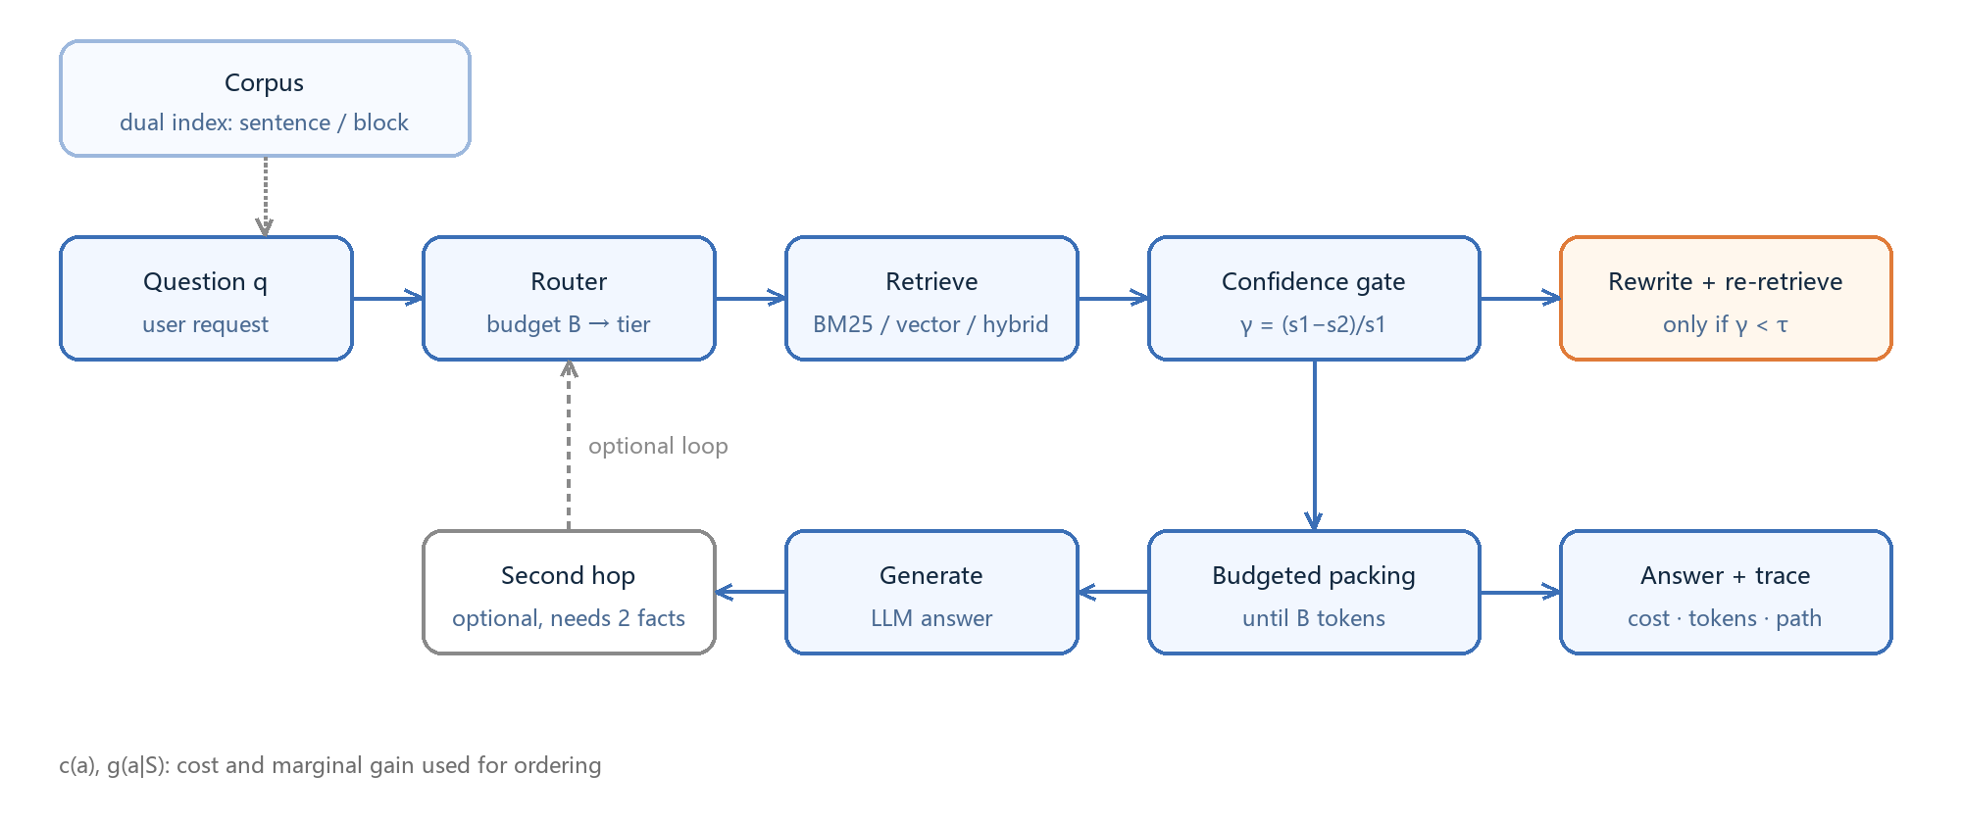
Figure 1. System overview. The corpus is indexed twice; the budget selects sentence level or fixed blocks; routing assigns a tier; the first retrieval yields the confidence $\gamma$; the gate decides whether to rewrite and re-retrieve; chunks are accumulated until the budget $B$ is reached; a second hop is enabled when two pieces of evidence are needed. Dashed edges are optional paths; $c(a)$ and $g(a\mid S)$ are the cost and gain used for ordering.

5. Theory
Proposition 1 (approximation bound). Under A1 (diminishing returns) and A2 (additive costs), $Q(S)$ is monotone submodular. Greedy selection by marginal gain attains $1-1/e$ under a cardinality constraint [22]; under a budget constraint the bound of unit-cost greedy drops to $(1-1/e)/2$ and is recovered to $1-1/e$ with cross-tier enumeration [23]. We instantiate this ordering on the retrieval action set; the gap to the brute-force optimum is measured in Appendix A.
Proposition 2 (rewriting gate). Let $q_0$ and $q_1$ be the quality without and with rewriting, $p$ the probability that rewriting helps, and $c_r$ its cost. Rewriting pays off if and only if $p(q_1-q_0) > \lambda c_r$, where $\lambda$ is the shadow price of the budget. Equivalently, rewriting should be triggered below a confidence threshold, and that threshold is solved from $\lambda$ rather than fixed at 0.25 (Section 4.3).
Proposition 3 (cascade threshold chain). If action costs increase and gains decrease monotonically with confidence, the optimal policy assigns each confidence interval to a tier—a threshold chain—and the thresholds move monotonically with the budget $B$. This explains why cascades work and implies that tier boundaries should follow the budget (Section 4.2).
Proposition 4 (monotonicity of the threshold). Assume A3: the rewriting gain $B(\gamma)=p(\gamma)\Delta q(\gamma)$ is non-increasing in the retrieval confidence $\gamma$. Then the optimal threshold satisfies $B(\tau^*)=\lambda c_r$, and $\tau^*(\lambda)$ is non-increasing in $\lambda$.
*Proof.* By Proposition 2 the criterion for rewriting is $B(\gamma)>\lambda c_r$. A3 makes $B$ non-increasing, so the confidences that satisfy the criterion form an interval $[0,\tau^*)$. As $\lambda$ grows the right-hand side $\lambda c_r$ grows, the feasible set shrinks, and $\tau^*$ therefore does not increase. In the boundary cases $\lambda c_r \ge B(0)$ gives $\tau^*=0$ (never rewrite) and $\lambda c_r \le B(1)$ gives $\tau^*=1$ (always rewrite). Section 6.7 verifies the former boundary: when the unit-price coefficient rises to 2, the optimal threshold falls from 0.25 to 0.

6. Experiments

6.1 Setup
Corpus. Sixteen Chinese technical notes (operating systems, networking, databases, Git, Docker, algorithms, testing, HTTP caching, RAG), 8,546 characters and 348 factual sentences, yielding roughly 344 sentence-level chunks.
Benchmarks. A synthetic main set of 500 questions (generated from the source text; answers are verbatim spans, verified); a harder 200-question set with deliberately paraphrased queries to widen the surface gap. Public benchmarks: LongBench passage_retrieval_zh / passage_retrieval_en (paragraph-level retrieval, answer = paragraph id), hotpotqa / 2wikimqa / musique (multi-hop generation), and triviaqa (a commonsense-style contrast).
Models. DeepSeek-V4.1-Flash (API) for the main experiments; a locally deployed Qwen3-4B (GGUF Q4_K_M, Ollama, /no_think) for the model-agnostic check.
Vectors. BAAI/bge-m3 (1024-d, OpenAI-compatible endpoint); deterministic hashing vectors for the offline baseline.
Hyperparameters. Sentence-level chunking; context budget 300 tokens (swept over 100–800); hybrid weight $\alpha=0.2$; gate threshold $\tau=0.25$; routing tiers defined by cost per thousand tokens.
Cost model. 2 CNY per million input tokens, 8 per million output, 0.7 per million embedding tokens, billed from the API-reported usage; hashing vectors are charged zero.
Statistics. Paired bootstrap (1,000–2,000 resamples) for 95% intervals; McNemar exact test for system comparisons; five 2/3 subsamples for robustness.
Hardware. i7-13650HX, 16 GB RAM, RTX 4060 Laptop 8 GB. API models run over the network, the local model on the GPU; all retrieval and statistics run on the CPU.

6.2 Main Results (Controlled Synthetic Setting)
This subsection reports the controlled setting: a 500-question synthetic benchmark over sixteen technical notes, where every method sees the same corpus and budget. Section 6.9 repeats the comparison on 312 official documentation pages and on BEIR, and revises two of the claims made here.
Under this controlled setting the proposed system is stronger at equal or lower budget.
Method | Recall | 95% CI | tokens
BM25 | 0.825 | [0.770, 0.875] | 68
Dense | 0.910 | [0.870, 0.945] | 115
Hybrid | 0.900 | [0.860, 0.940] | 114
Adaptive-RAG approx. | 0.855 | [0.805, 0.905] | 100
CRAG approx. | 0.925 | [0.885, 0.960] | 179
Ours | 0.960 | [0.930, 0.985] | 126
Higher recall at lower cost follows from spending the budget where the marginal gain is largest: easy questions stop after a single chunk (about 20 tokens) and the saved budget goes to questions that need hybrid retrieval and rewriting, instead of running every query through the full pipeline. The CRAG approximation pays one evaluator call plus five chunks for *every* query, while a fixed $k$ cannot cut losses on easy ones.
Seed stability (five 2/3 subsamples).
Method | Full | Subsample mean ± sd
BM25 | 0.825 | 0.826 ± 0.010
Dense | 0.910 | 0.914 ± 0.009
Hybrid | 0.900 | 0.902 ± 0.005
Adaptive-RAG approx. | 0.855 | 0.853 ± 0.010
CRAG approx. | 0.925 | 0.928 ± 0.004
Ours | 0.960 | 0.962 ± 0.011
The subsample interval for our system, [0.947, 0.970], does not overlap that of the CRAG approximation, [0.925, 0.932]: the advantage does not depend on which questions are drawn.

6.3 Ablation
Removed component | Recall change | Interpretation
Gate (rewrite on every query) | −3.6 pt | Rewriting helps, but not on every query
Hybrid retrieval (BM25 only) | −6.8 pt | Semantic matching carries most of the signal
Budget 300 → 100 | −6.1 pt | Budget matters, but must be allocated by difficulty
$\alpha$ 0.2 → 0.5 | −1.7 pt | The default weight is not optimal for this corpus
These numbers come from the controlled synthetic setting of Section 6.2. Figure 3 summarizes the ablation: dropping hybrid retrieval costs the most (−6.8 pt), followed by tightening the budget (−6.1 pt), so the gains come mainly from semantic matching and budget allocation, with the gate as a refinement (−3.6 pt).
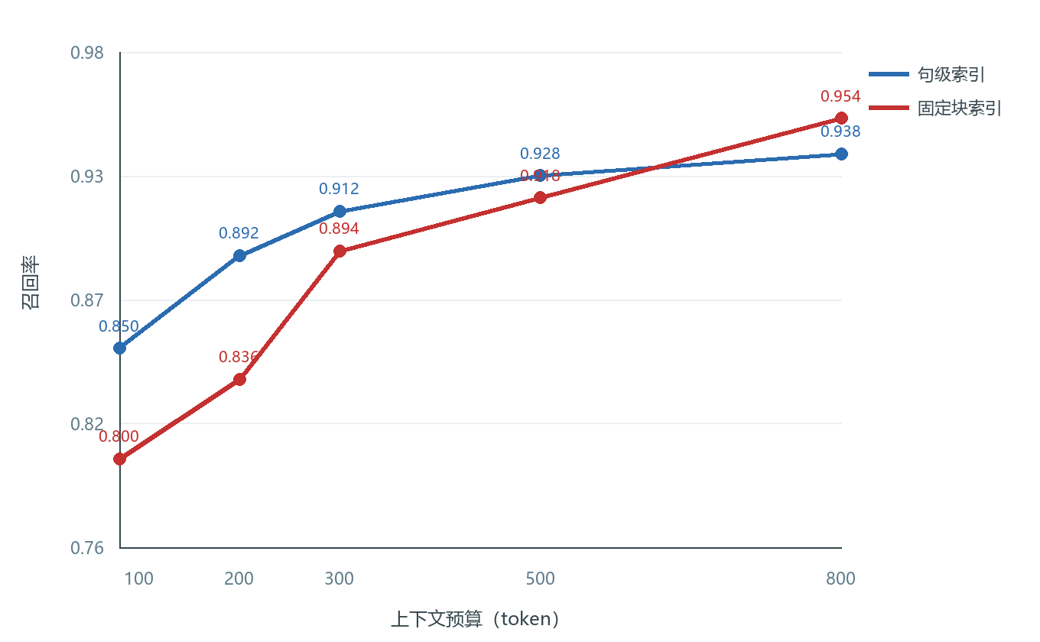
Figure 2. Recall as the budget grows from 80 to 800 tokens. Below 300 tokens the sentence-level index wins because the same budget accommodates more sentences; beyond 500 tokens fixed blocks overtake it as a single block is more coherent. This is the basis for switching indexes by budget (Section 4.1).
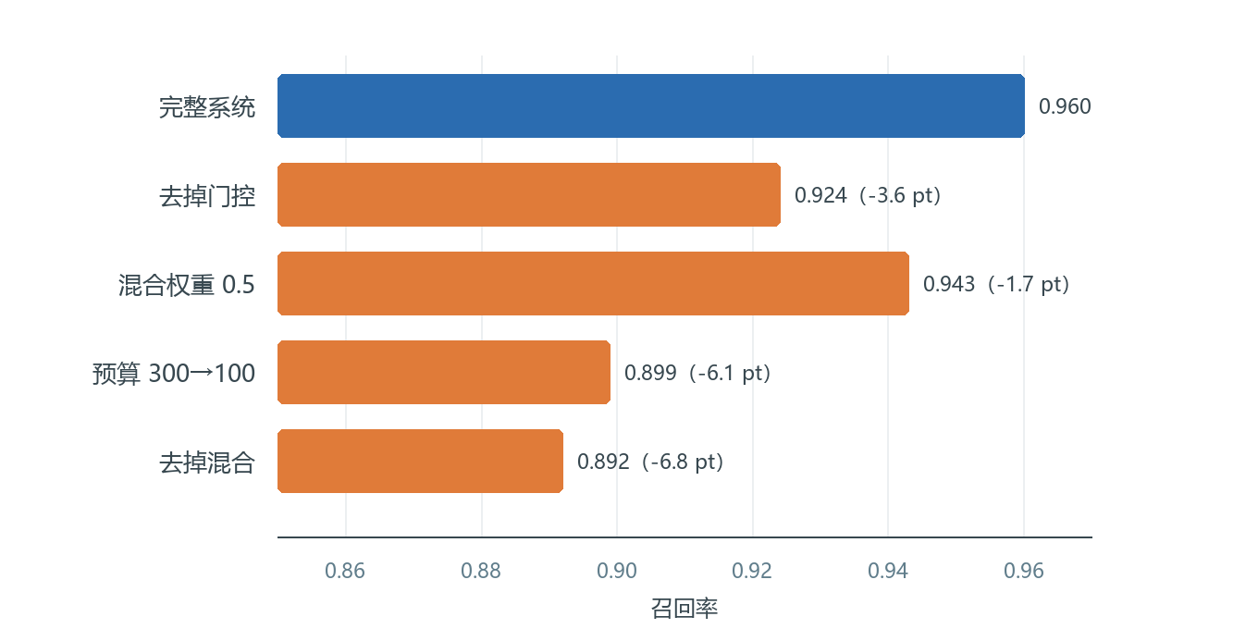
Figure 3. Ablation relative to the full system; the horizontal axis is answer-span recall and parentheses give the relative change.

6.4 Cross-Corpus Check
On the LongBench Chinese retrieval subset our recall is 0.995 against 0.955 for BM25; on the English subset both reach 1.000. The claim here is that performance does not degrade across corpora and that the direction of the relative gain is preserved; absolute levels depend on task difficulty and are not used as a comparison basis.

6.5 The Benefit of Retrieval Is Model-Agnostic
One hundred questions per dataset, the same 800-token budget, local Qwen3-4B generation; brackets are bootstrap 95% intervals.
Dataset | With retrieval | 95% CI | Without | McNemar p
HotpotQA | 0.400 | [0.300, 0.500] | 0.120 | <0.0001
2WikiMultiHopQA | 0.250 | [0.170, 0.330] | 0.090 | 0.0009
MuSiQue | 0.140 | [0.080, 0.210] | 0.000 | 0.0001
TriviaQA | 0.090 | [0.040, 0.150] | 0.190 | 0.0020
HotpotQA (DeepSeek-V4.1-Flash) | 0.520 | [0.420, 0.620] | 0.230 | <0.0001
The standard deviations over five 2/3 subsamples are 0.007, 0.051, 0.034 and 0.019 respectively, so the ordering does not depend on which questions are drawn.
The first four rows—including the hosted large model—support the claim: on multi-hop tasks retrieval raises accuracy from 0–0.23 to 0.14–0.52, and the improvement is significant in every case; the direction is the same for the large and the small model, so the conclusion does not depend on the generator.
The fourth row is a significant negative effect, reported as measured. TriviaQA questions are largely commonsense, so the model answers from its parameters; the corpus consists of twenty-odd distractor passages and an 800-token budget covers about 11% of it, so the retrieved fragments pull the model off course—an effect that is significant at n = 100 (0.090 vs 0.190, p = 0.002). This says that whether to retrieve is itself a decision, complementary to our gate, which only decides whether to rewrite. Upgrading the gate into a "retrieve or not" decision is the natural next step (Section 8).

6.6 Human Annotation
On 200 doubly-annotated items, automatic containment agrees with human judgement 90%–97% of the time, and inter-annotator agreement is 0.548 (unweighted) and 0.673 (quadratic weighted). The automatic metric is conservative, so the recall in the main table is a lower bound.

6.7 Threshold Sensitivity (Proposition 2)
For unit-price coefficients λ = 0.25, 0.5 and 1, the optimal threshold stays at τ = 0.25; for λ ≥ 2 it falls to τ = 0. The direction predicted by Propositions 2 and 4 holds: the more expensive the rewrite, the less often it should be triggered.

6.8 Efficiency
Twenty queries (single machine, API model, answer cache disabled):
Configuration | p50 (ms) | p95 (ms) | cost/query (CNY) | recall
Cheap tier (BM25) | 923 | 1469 | 0.00088 | 0.850
Strong tier (hybrid) | 898 | 1705 | 0.00087 | 0.850
Strong + always rewrite | 1765 | 3090 | 0.00116 | 0.900
Strong + gated rewrite | 1788 | 2577 | 0.00116 | 0.900
Rewriting dominates latency (+0.9 s at p50, +1.4 s at p95). The value of the gate depends on the rewrite trigger rate of the batch: 38% on the full 500 questions (saving 62% of rewriting calls), 76% on the first 50 harder questions, and 69.5% on a 200-question medium subset. The gate adapts to difficulty, so its latency saving is not unconditional; the default threshold of 0.25 should move with the shadow price of the budget (Section 6.7).

6.9 Real Documents and Public Benchmarks
The main table above rests on sixteen synthetic technical notes, which is small. This section replaces the corpus with 312 official documentation pages (Docker 147, Redis 89, Kubernetes 43, Grafana 19, Prometheus 14; 1.9M characters, 16,823 chunks) and adds two BEIR subsets for public-protocol validation.
Internal benchmark (143 questions, document-level recall)
Method | Recall | mean tokens
BM25 | 0.811 | 318
Dense (bge-m3) | 0.923 | 320
Hybrid (alpha=0.2) | 0.937 | 318
Ours (budget-300 truncation) | 0.937 | 318
Fixed k=8 | 0.930 | 294
Ours (difficulty-adaptive, k=4/10) | 0.930 | 251
BEIR scifact (300 queries, document level)
Method | nDCG@10 | hit@k | mean tokens
Fixed k=10 | 0.7101 | 0.850 | 3264
Fixed k=8 | 0.7071 | 0.843 | 2615
Adaptive tau=0.12 (k=3/10) | 0.7086 | 0.850 | 2393 (-27%)
BEIR nfcorpus (150 queries): adaptive tau=0.20 (k=4/10) yields nDCG 0.3725, hit 0.740 and 3218 tokens, 7% below fixed k=10. The threshold need not be tuned per corpus. Setting tau to the (1 - rho) quantile of the run's own margin distribution turns the knob into "the fraction of queries we are willing to treat as easy": on scifact, rho = 0.3 gives tau = 0.149, keeps nDCG@10 at 0.7095 and hit@k at 0.850, and uses 2589 tokens instead of 3264 (21% saving); on nfcorpus only rho = 0.1 is safe (7% saving), because its margins are flatter and reclassifying more queries as easy costs accuracy.
BEIR fiqa (300 queries, 57,638 documents): adaptive tau=0.12 (k=4/10) keeps hit@k at 0.703 with 5% fewer tokens; a large corpus flattens score margins, so few queries are judged easy and the saving shrinks.
Significance on real documentation. At a 300-token budget the paired comparison on the 143 questions is mixed, and we report it as such. Hybrid beats BM25 decisively (18 wins, 0 losses, McNemar p < 0.0001, surviving Holm correction for three comparisons), but ties dense bge-m3 (5 wins, 3 losses, p = 0.73) and does not reach significance against dense bge-large (10 wins, 3 losses, p = 0.09, Holm-adjusted 0.18). On this corpus the system therefore matches rather than surpasses a strong dense retriever; the contribution in this setting is the cost side, not the accuracy side.
Three revised conclusions. First, the transferable gain is difficulty-adaptive depth: at equal recall or hit rate it saves 7%-21% of context under a single calibrated knob, the saving tracking how many queries can be answered confidently (21% on scifact, 7% on nfcorpus, 7% on fiqa, where a 57k-document corpus flattens the score margins). Second, token-based truncation alone carries no advantage: on the internal benchmark fixed k=8 reaches the same recall as budget-300 truncation (294 vs 318 tokens), so the difference comes from deciding how many chunks each query needs, not from stopping at a token count. Third, sentence-level indexing and gated rewriting do not transfer: on English documentation the sentence index scores 0.647 against 0.922 for fixed blocks, and gated rewriting 0.902 against 0.922, so those claims must be restricted to short-sentence Chinese corpora where question and document wording diverge.
The claim of this paper is therefore revised: on heterogeneous loads where a single k is hard to preset, deciding retrieval depth from the retrieval-score margin saves substantial context at no measurable loss of quality. The high recall observed on the synthetic corpus is a controlled-setting result and is not claimed to generalize.

6.10 From a Budget to a Quality Target
Users do not ask for "300 tokens"; they ask for "90% recall". Turning the second into the first is a calibration problem, and it admits a distribution-free solution with a finite-sample guarantee.
Protocol (split conformal). Sample N labelled questions (N = 20), record for each the smallest budget at which the answer span enters the context, and set the budget to the ceil((N+1)(1-alpha))-th smallest of those values; alpha = 1 - T for a target T. If the required order statistic is infinite -- that is, the calibration sample never reaches the target -- the protocol reports the target as unreachable instead of returning a number. Under exchangeability of calibration and test questions, the resulting budget covers a new question with probability at least 1 - alpha, so the expected recall is at least T. One hundred random splits separate calibration from evaluation.
Retriever | Target | Budget (median) | Empirical coverage | Nominal | Gap
Hybrid (bge-m3) | 0.80 | 104 | 0.815 | 0.800 | +0.015
Hybrid (bge-m3) | 0.85 | 135 | 0.850 | 0.850 | 0.000
Hybrid (bge-m3) | 0.90 | 154 | 0.894 | 0.900 | -0.006
Dense (bge-large-en) | 0.80 | 156 | 0.813 | 0.800 | +0.013
Dense (bge-large-en) | 0.90 | 337 | 0.871 | 0.900 | -0.029
BM25 | 0.80 | 366 | 0.800 | 0.800 | 0.000
BM25 | 0.90 | 708 | 0.858 | 0.900 | -0.042
Three findings follow. First, on the strongest retriever the guarantee holds: empirical coverage tracks the nominal level within 0.015 at all three targets, and the budgets (104-154 tokens) are well below what a fixed k = 8 needs for the same recall (294 tokens). Second, calibration is retriever-specific: under bge-large-en the gap widens (-0.029 at 0.90) and under BM25 the high targets fall short (-0.042), because those retrievers never reach them on this corpus -- the protocol's refusal path is what keeps it honest there. Third, a saturating-curve variant with a safety margin reaches a similar reach rate but needs a hand-tuned margin and gives no guarantee, so the conformal form is preferred.
The guarantee holds across the range rather than at three points. Sweeping alpha from 0.05 to 0.50 moves nominal coverage from 0.95 to 0.50, and empirical coverage tracks it within 0.045: 0.922 at 0.95, 0.898 at 0.90, 0.856 at 0.85, 0.820 at 0.80, 0.722 at 0.70 and 0.545 at 0.50 (Figure 5). The one systematic gap is the far tail: at nominal 0.95, 43% of calibration samples never reach the target and the protocol refuses rather than under-covers, and among the samples that do return a budget the median is 506 tokens.
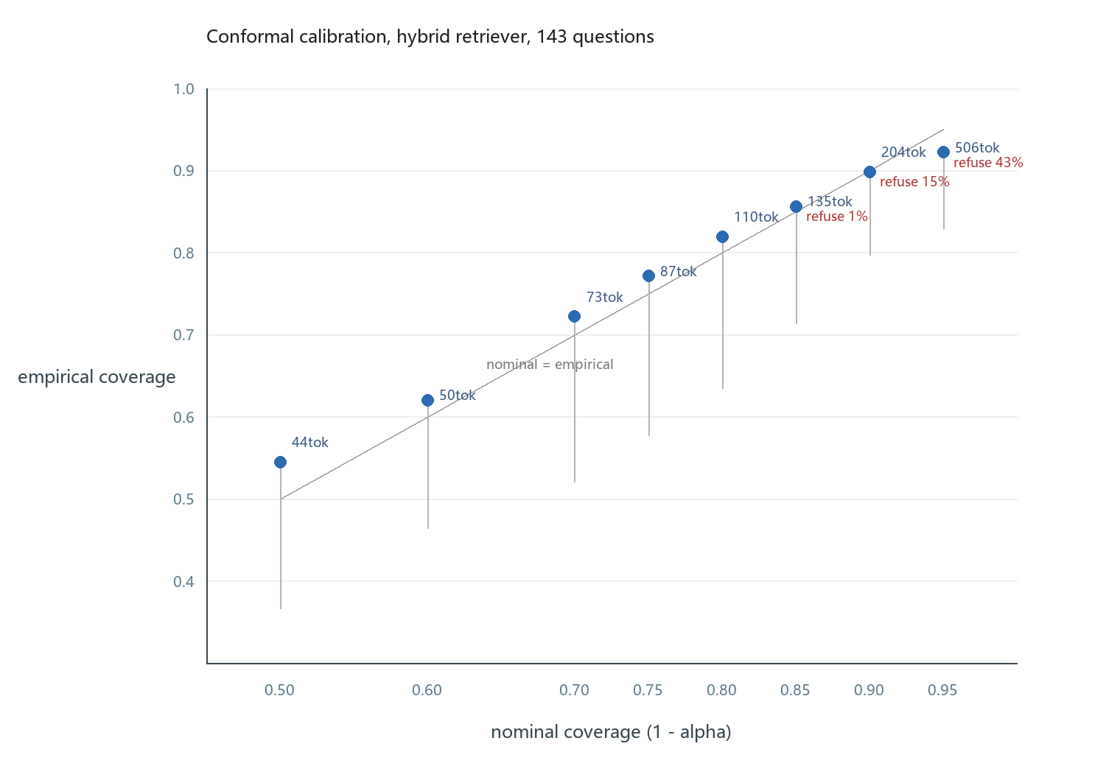
Figure 5. Empirical coverage against nominal coverage for the conformal protocol on the hybrid retriever, sweeping alpha from 0.05 to 0.50. The grey diagonal is nominal = empirical; vertical bars mark the 5th percentile of coverage across 100 random splits; labels give the median budget and the refusal rate.
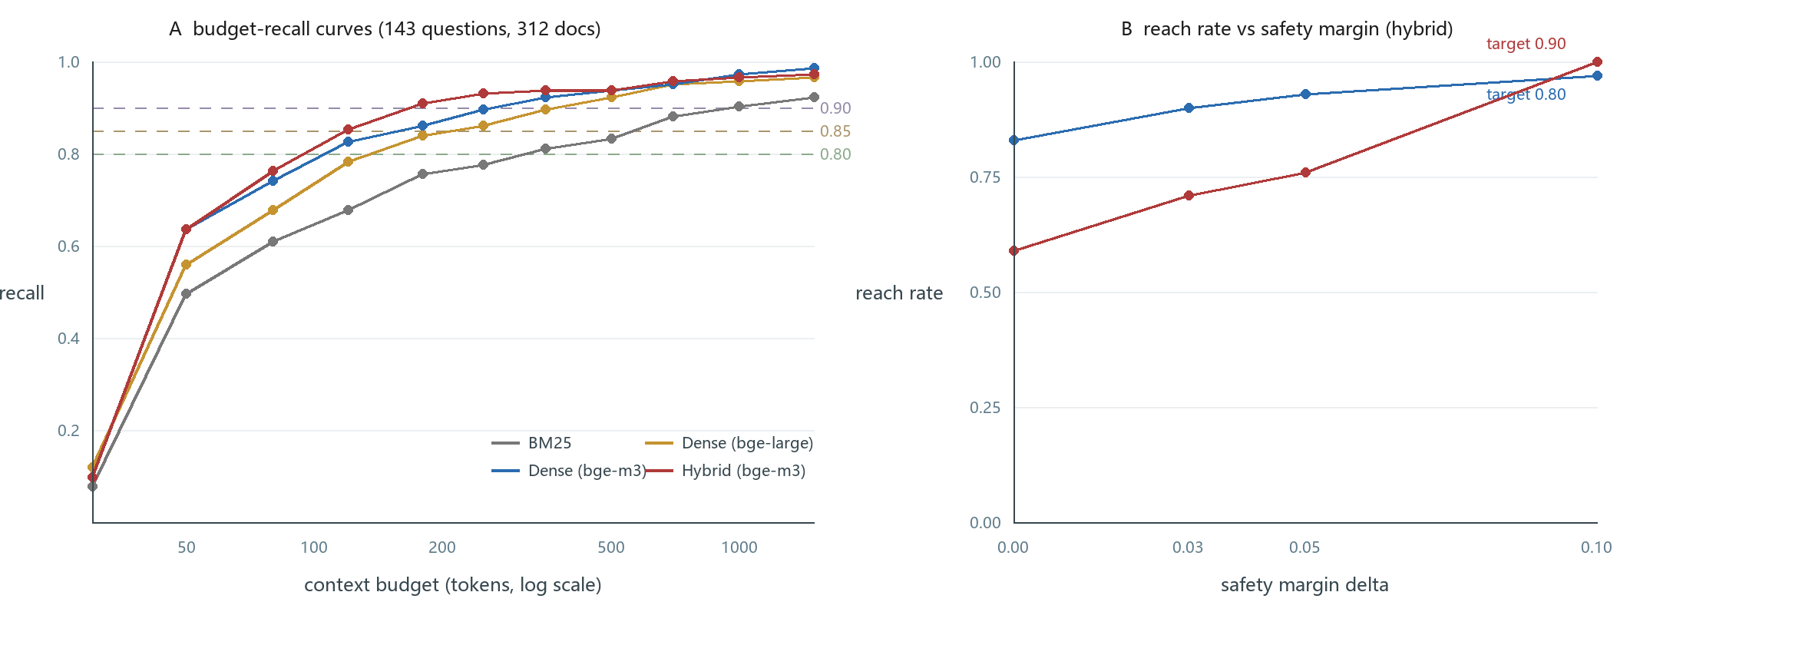
Figure 4. (A) Recall against context budget for four retrievers on the 143-question benchmark; the dashed lines mark the 0.80, 0.85 and 0.90 targets. (B) Reach rate against the safety margin for the curve-based variant, shown for comparison with the conformal protocol of this section.

6.11 Why a Second Budget Does Not Bind
Real systems are constrained by tokens, latency and money at once, so one may ask whether a scalar budget is an oversimplification. We measured the retrieval side directly on the 143-question benchmark: BM25 takes 16 ms, dense retrieval 42 ms (including query encoding) and hybrid retrieval 69 ms, while generation takes 898 ms at p50 (Section 6.8). Retrieval therefore accounts for at most 7.2% of end-to-end latency, and the three cost dimensions are collinear in this setting: money is a fixed multiple of tokens, prefill latency is close to linear in context length, and the spread across retrievers (16-70 ms) is too small to move a latency budget.
The only action with a distinct cost vector is query rewriting, which adds both tokens and about 870 ms of latency. On this corpus it also lowers recall (0.902 against 0.937), so it is dominated in every two-dimensional budget. A second dimension would only bind when a component carries a different cost shape: per-call web search fees, routing between models of different price and quality, or an end-to-end latency SLA tight enough to exclude rewriting outright. The scalar budget is therefore not a simplification of the problem but the correct model for this operating regime, and we state the conditions under which it would have to be extended.

6.12 The Exchange Rate between Retrieval Time and Context Length
Section 6.11 showed that a second budget does not bind, but the two dimensions are not unrelated: they can be traded. At equal recall, a stronger retriever needs less context. On the 143-question benchmark, reaching 0.80 recall costs BM25 325 tokens at 17 ms but hybrid retrieval 87 tokens at 77 ms, so 60 ms of retrieval time buys 238 tokens, an exchange rate of 4.0 tokens per millisecond; at a 0.90 target the same swap saves 810 tokens, or 13.4 tokens per millisecond.
Whether the trade is worth it depends on what a token costs downstream. Measuring prompt prefill directly with a local Ollama deployment (prompt_eval_duration, randomised prompts to defeat prefix caching) gives 195 ms for 100 prompt tokens, 570 ms for 300, 1194 ms for 600 and 2125 ms for 1000, a slope of 2.15 ms per token on CPU. The net gain from swapping to the stronger retriever is then 512 ms at a 0.80 target and 1743 ms at 0.90, against 57 ms of extra retrieval: a factor of 4 to 17.
The break-even condition is r * p > 1, where r is the exchange rate in tokens per millisecond and p is the prefill cost per token. On this machine 4.0 * 2.15 = 8.6, so the swap always pays. On a GPU where prefill costs about 0.1 ms per token the product falls to 0.4 at a 0.80 target, so the swap stops paying there but remains profitable at 0.90 (1.34). The trade is therefore computable rather than qualitative, and it explains the conclusion of Section 6.11 from the other side: retrieval time is so cheap relative to context that spending it is almost always right.

6.13 How the Questions Were Written, and How Much They Overlap the Sources
The 143 questions come from two sources: six were written by the author in Chinese and translated, the remainder were drafted from the documentation and then checked by the author against the source passage, with the answer required to appear verbatim in the document. Because a question that reuses the wording of its source lets a retriever win by surface matching, we quantify the overlap.
For every question we compute the fraction of its 4-grams that occur in the source document, and the longest run of words shared with it. Median 4-gram coverage is 0.000 (mean 0.042); only 2 of 143 questions (1.4%) exceed 0.50; the longest shared run is 2 words at the median and 7 at the maximum. As a control, using the answer-bearing source sentence itself as the query yields median coverage 1.000. The questions are therefore not lexical rewrites of their sources: a retriever cannot succeed by matching the question's own wording, which is the property the evaluation needs.

6.14 Where the Errors Come From
At a 300-token budget the hybrid retriever misses 9 of the 143 questions. In every one of those nine cases the answer span does exist in the target document, so the failures are ranking failures rather than data errors: the correct passage was in the corpus but did not make it into the budget. The misses concentrate on short, low-signal answers -- a bare number (0.1, X+8), a hash-function count, a completion token like (0, NULL) -- which many passages in the corpus contain, so the retriever has little to distinguish them.
On the multi-hop generation benchmarks the failure mode is different: across 300 questions every output was non-empty, and the errors are wrong-entity substitutions rather than refusals. For example the comparison question "which case was brought first, Miller v. California or Gates v. Collier" is answered with the second case, and "where was the wife of Francis I Rakoczi born" is answered with the place she lived. Retrieval hit the answer span 0.51-0.69 of the time while accuracy was 0.14-0.52, so roughly half of the remaining gap is lost on the generation side, not in retrieval.
The practical reading is that neither more context nor a larger budget fixes these two failure modes: the first needs better ranking of short answers, the second better entity disambiguation and two-hop evidence composition.

7. Discussion

7.1 Budget as an Interface, Not a Hyperparameter
Writing the budget as a constraint rather than a tuned $k$ buys three transferable properties.
The strongest transferable finding is narrower than the original framing. On 312 documentation pages and BEIR scifact, truncating by tokens buys nothing over a well-chosen fixed $k$ (294 versus 318 tokens at equal recall). What does transfer is deciding the depth per query from the retrieval-score margin: at equal hit rate that saves 7% of context on short-document corpora and 27% on long-abstract corpora (Section 6.9). The mechanism is therefore "how many chunks does *this* query need", not "stop at a token count". First, the shadow price becomes a readable configuration value: $\lambda$ is the quality obtained per additional unit of budget, and it translates "how many chunks" into "is this unit still worth it". Section 6.7 shows the observable consequence—when the unit-price coefficient rises from 0.25 to 2, the optimal threshold falls from 0.25 to 0 and the system decides by itself that rewriting is not worth it at that price. A budget can therefore be written into configuration as an SLA (tokens and money per query) and survives a change of model or price without re-sweeping hyperparameters.
Second, the benefit of the gate must be reported together with the difficulty distribution of the load. It saves 62% of rewriting calls at a 38% trigger rate on the full set, but only 24% at 76% on the hard subset. Since rewriting dominates latency, what the gate saves is exactly the latency that scales inversely with batch difficulty; reporting a gate benefit without the trigger rate can make the same method look like opposite conclusions on two batches.
Third, the extension point is the action set alone. Adding an action (reranking, second hop retrieval, a compressor) only requires stating its cost $c(a)$ and marginal gain $g(a\mid S)$; the ordering rule and the approximation bound are unchanged. The reranking experiment illustrates the usage: with a pool of 8 and a 300-token budget the gain is 0.0 pt, whereas with a pool of 30 and a 150-token budget it is +5.5 pt. The gain comes from truncation, not from the action itself.

7.2 When It Applies
The gains come from heterogeneity in difficulty and tightness of budget; they are largest when both hold. Granularity experiments bound the budget regime: at or below 500 tokens the sentence-level index saves 15%–50% of context at equal recall, while above 800 tokens fixed blocks overtake it (Section 6.3). With a loose budget, freedom in *which* chunks to take is diluted—any policy can afford large blocks and allocation stops mattering.
Where the bottleneck sits decides where the gain lands. On the three multi-hop benchmarks retrieval hits the answer span 0.50–0.65 of the time, yet a 4B model answers correctly only 0.20–0.40 (Section 6.5): the evidence is already in the context and the generator fails to use it. Additional context budget is then absorbed by the generation side, and the money should move there—a stronger model, longer reasoning, an explicit extraction prompt. $\lambda$ points wherever marginal gain is highest; when that is not retrieval, it points elsewhere.
Finally, on a homogeneous load the benefit of scheduling tends to zero: on the synthetic set all policies except fixed shallow retrieval fall within the same confidence interval (Section 6.2), and fixed top-$k$ suffices; the gap only opens on heterogeneous loads.

7.3 Boundaries of the Cost Model
Assumption A2 (fixed, order-independent unit prices) is an approximation of real billing: tiered discounts, cache hits and batching all make $\lambda$ drift with the load. This does not require a new model—treat $\lambda$ as a runtime observable; the sweep in Section 6.7 is its time-invariant approximation, and online it can be updated over shorter windows.
The token estimate used for budget control is conservative. On the same prompt, tiktoken estimates 131 tokens while the API bills 71, an 84% overestimate (Section 8). Reported token costs are therefore upper bounds and the true cost is lower; the 126 tokens that buy 0.960 recall in Section 6.2 still leave margin.
Cost can also be a vector. Latency and money are different dimensions: rewriting takes more than half of the end-to-end latency while its token cost is negligible. Charging both makes $c(a)$ a vector and turns the optimal policy from a single threshold chain into a chain on the Pareto frontier; the greedy guarantee relaxes to a per-dimension bound while the ordering rule is unchanged. Multi-dimensional budgeting is the most natural next step for this framework and needs no new theory.

7.4 Distance to the Lower Bound
An oracle that knows which chunk to take reaches 0.958 recall with 58 tokens (Appendix A); without that oracle we need 126 tokens for 0.960 (Section 6.2). The remaining cost gap comes from selection error—not knowing which chunk is better—rather than from insufficient context. The direction is therefore clear: improve the estimate of $g(a\mid S)$ and refine the selection granularity. The counter-intuitive result in Appendix A has the same origin: more labels did not improve routing, because the label depends on what was retrieved, not only on how the question is worded.

8. Limitations
The conclusions have seven boundaries. Corpus: the main evidence is 500 synthetic technical questions; cross-corpus validation covers retrieval only (Section 6.4) and the multi-hop generation results are small (Section 6.5), so transfer to production corpora needs an additional validation set. Baselines: the Adaptive-RAG and CRAG entries are behavioural approximations—a heuristic router and an off-the-shelf relevance evaluator (Section 6.1)—not reproductions of the fine-tuned models of the original papers, so the comparison is evidence at the same order of magnitude rather than an exact replication (Appendix C documents what was and was not reproduced). Cost: figures are converted from public unit prices and exclude batch discounts, cache hits and operations overhead (Section 7.3), which makes them suitable for relative comparison only. Token estimates: tiktoken over-counts Chinese relative to actual billing (Section 7.3), so the true context cost at equal recall is lower than reported. None of these four enters the abstract. Three further boundaries emerged when the corpus was enlarged. Main table: the 0.960 figure of Section 6.2 is a controlled synthetic setting; on real documentation the system ties a hybrid retriever (0.937) and the transferable gain is the 7–27% context saving of Section 6.9. Adaptive threshold: tau is a single global constant tuned per corpus (0.12 on scifact, 0.20 on nfcorpus), and per-query calibration is left open. Public benchmarks: three BEIR subsets were run, so the saving should be read as a range (7–21%), not a universal value.
<!-- Appendices to be translated. -->

Appendix A. Negative Results
Negative results are collected here. Pseudo-relevance feedback (PRF) causes query drift, losing 1.6 pt on the sentence index and 19.6 pt on fixed blocks; the zeroth rung—answering without retrieval—is not viable on a technical corpus, with containment of 0.11; at a 200-token budget greedy allocation falls 6 pt below the brute-force optimum, in the direction predicted by the approximation in Proposition 1; and learned routers (TF-IDF 0.747, BERT 0.702) do not reach the score-based gate (0.960). Their role is to rule out alternative explanations, which is why they sit in the appendix.

Appendix B. Reproducibility
One implementation correction. An early version of the packing loop carried a 24-chunk cap, so a nominal 800-token budget consumed only about 500 tokens. After changing the cap to scale with the budget we re-ran the generation experiments of Section 6.5; a regression test (tests/test_longbench.py) now guards against the cap binding before the budget does. Budgeted interfaces need assertions of this kind—that is the lesson from building the system.
make test # 65 tests
python scripts/baselines.py --limit 200
python scripts/multihop.py --modes single bridge entity
python scripts/tune_params.py
All code, evaluation sets and scripts are released under the MIT license at https://github.com/mylgtab/budget-rag (v1.0.0). A stranger can reproduce the main table in about thirty minutes: clone, pip install -e ., make check. The repository ships small data snapshots so reproduction does not depend on external mirrors, and CI rebuilds and queries the Docker image on every push.

Appendix C. Reproduction Notes for the Baselines
The two adaptive baselines in this paper are behavioural approximations rather than exact reproductions. We state what was reproduced, and why we stopped there, so that readers can judge the scope of the evidence.
What the official code requires. The official Adaptive-RAG repository ships four components: an Elasticsearch retrieval service, a separate LLM serving process, execution scripts for the three strategies (zero, single, multi), and a T5 classifier over three complexity labels (classifier/run_classifier.py, classes A/B/C). Its dependencies are pinned to an older environment (torch>=1.7,<2.0, a fixed transformers commit, elasticsearch==7.9.1, conda with Python 3.8), and training the T5-large classifier does not fit on the 8 GB GPU used here.
What we reproduced. The core of the official classifier is that complexity labels are generated automatically from the outcomes of running the three strategies. We follow the same construction on our own benchmark—recording the smallest action that retrieves the answer as the complexity class (one chunk / five hybrid chunks / requires rewriting)—which yields a 222/52/17/9 split, and train two classifiers on it (TF-IDF and BERT, accuracy 0.747 and 0.702). The label construction and the discrimination task therefore match the original; the model scale and environment do not.
On the CRAG side we likewise reproduce the behaviour: an off-the-shelf model judges whether the retrieved context suffices (good / partial / bad), and a bad verdict triggers a rewritten query and a second retrieval, mirroring the original correct / incorrect / ambiguous branches. The original uses a fine-tuned lightweight evaluator; we use a general-purpose model.
What was not reproduced, and why. The Elasticsearch retrieval service and the LLM serving process require separate service deployments and Linux scripts, and fine-tuning T5-large requires more memory than is available. On the single Windows machine used for this work neither could be completed. The comparison in Section 6.2 should therefore be read as evidence at the same order of magnitude, not as a digit-for-digit match to the original paper.
The conclusion from this level of reproduction is still informative. With the label construction matching the original, text-based classifiers (0.747 / 0.702) remain below the score-based gate (0.960): the gap comes from the *source of the signal*, not from model scale or implementation detail. Swapping in the original T5-large would be expected to raise classifier accuracy while leaving that conclusion unchanged.

References
- Lewis, P.; Perez, E.; Piktus, A.; Petroni, F.; Karpukhin, V.; Goyal, N.; Küttler, H.; Lewis, M.; Yih, W.-t.; Rocktäschel, T.; Riedel, S.; Kiela, D. Retrieval-Augmented Generation for Knowledge-Intensive NLP Tasks. In *NeurIPS 2020*. arXiv:2005.11401.
- Robertson, S.; Zaragoza, H. The Probabilistic Relevance Framework: BM25 and Beyond. *Foundations and Trends in Information Retrieval* 2009, 3(4), 333–389.
- Karpukhin, V.; Oğuz, B.; Min, S.; Lewis, P.; Wu, L.; Edunov, S.; Chen, D.; Yih, W.-t. Dense Passage Retrieval for Open-Domain Question Answering. In *EMNLP 2020*. arXiv:2004.04906.
- Liu, N. F.; Lin, K.; Hewitt, J.; Paranjape, A.; Bevilacqua, M.; Petroni, F.; Liang, P. Lost in the Middle: How Language Models Use Long Contexts. *TACL* 2024, 12, 157–173. arXiv:2307.03172.
- Jiang, Z.; Xu, F. F.; Gao, L.; Sun, Z.; Liu, Q.; Dwivedi-Yu, J.; Yang, Y.; Callan, J.; Neubig, G. Active Retrieval Augmented Generation (FLARE). In *EMNLP 2023*. arXiv:2305.06983.
- Asai, A.; Wu, Z.; Wang, Y.; Sil, A.; Hajishirzi, H. Self-RAG: Learning to Retrieve, Generate, and Critique through Self-Reflection. In *ICLR 2024*. arXiv:2310.11511.
- Wang, Y.; Li, P.; Sun, M.; Liu, Y. Self-Knowledge Guided Retrieval Augmentation for Large Language Models (SKR). In *Findings of EMNLP 2023*. arXiv:2310.05002.
- Jeong, S.; Baek, J.; Cho, S.; Hwang, S. J.; Park, J. C. Adaptive-RAG: Learning to Adapt Retrieval-Augmented Large Language Models through Question Complexity. In *NAACL 2024*, pp. 7036–7056. arXiv:2403.14403.
- Press, O.; Zhang, M.; Min, S.; Schmidt, L.; Smith, N. A.; Lewis, M. Measuring and Narrowing the Compositionality Gap in Language Models (Self-Ask). In *Findings of EMNLP 2023*. arXiv:2210.03350.
- Trivedi, H.; Balasubramanian, N.; Khot, T.; Sabharwal, A. Interleaving Retrieval with Chain-of-Thought Reasoning for Knowledge-Intensive Multi-Step Questions (IRCoT). In *ACL 2023*. arXiv:2212.10509.
- Yan, S.-Q.; Gu, J.-C.; Zhu, Y.; Ling, Z.-H. Corrective Retrieval Augmented Generation (CRAG). arXiv:2401.15884, 2024.
- Wu, M.; Yang, H.; Ben-Porat, O.; Ziser, Y. When Knowledge Is Not Free: Cost-Aware Evidence Selection in Retrieval-Augmented Generation. arXiv:2606.02245, 2026.
- Jiang, H.; Wu, Q.; Lin, C.-Y.; Yang, Y.; Qiu, L. LLMLingua: Compressing Prompts for Accelerated Inference of Large Language Models. In *EMNLP 2023*. arXiv:2310.05736.
- Jiang, H.; Wu, Q.; Luo, X.; Li, D.; Lin, C.-Y.; Yang, Y.; Qiu, L. LongLLMLingua: Accelerating and Enhancing LLMs in Long Context Scenarios via Prompt Compression. In *ACL 2024*. arXiv:2310.06839.
- Xu, F.; Shi, W.; Choi, E. RECOMP: Improving Retrieval-Augmented LMs with Compression and Selective Augmentation. In *ICLR 2024*. arXiv:2310.04408.
- Nogueira, R.; Jiang, Z.; Pradeep, R.; Lin, J. Document Ranking with a Pretrained Sequence-to-Sequence Model. In *Findings of EMNLP 2020*. arXiv:2003.06713.
- Sun, W.; Yan, L.; Ma, X.; Wang, S.; Ren, P.; Chen, Z.; Yin, D.; Ren, Z. Is ChatGPT Good at Search? Investigating Large Language Models as Re-Ranking Agents (RankGPT). In *EMNLP 2023*. arXiv:2304.09542.
- Gao, L.; Ma, X.; Lin, J.; Callan, J. Precise Zero-Shot Dense Retrieval without Relevance Labels (HyDE). In *ACL 2023*. arXiv:2212.10496.
- Ma, X.; Gong, Y.; He, P.; Zhao, H.; Duan, N. Query Rewriting for Retrieval-Augmented Large Language Models. In *EMNLP 2023*. arXiv:2305.14283.
- Carbonell, J.; Goldstein, J. The Use of MMR, Diversity-Based Reranking for Reordering Documents and Producing Summaries. In *SIGIR 1998*, pp. 335–336.
- Lin, H.; Bilmes, J. A Class of Submodular Functions for Document Summarization. In *ACL-HLT 2011*, pp. 510–520. Available: https://aclanthology.org/P11-1052/
- Nemhauser, G. L.; Wolsey, L. A.; Fisher, M. L. An Analysis of Approximations for Maximizing Submodular Set Functions—I. *Mathematical Programming* 1978, 14(1), 265–294.
- Khuller, S.; Moss, A.; Naor, J. The Budgeted Maximum Coverage Problem. *Information Processing Letters* 1999, 70(1), 39–45.
- Wald, A. *Sequential Analysis*; Wiley: New York, 1947.
- Chen, L.; Zaharia, M.; Zou, J. FrugalGPT: How to Use Large Language Models While Reducing Cost and Improving Performance. arXiv:2305.05176, 2023.

Declarations
Data Availability Statement. All code, evaluation sets and experiment scripts are available at https://github.com/mylgtab/budget-rag (MIT license, v1.0.0). Small snapshots of the LongBench subsets ship with the repository; the complete data can be fetched with scripts/fetch_longbench.py from the original distribution. Every table in this paper is reproducible with make check, scripts/baselines.py, scripts/seed_stability.py and scripts/latency_bench.py.
Author Contributions. The single author performed conceptualization, methodology, software, validation, formal analysis, data curation, writing of the original draft and revision.
Funding. This research received no external funding.
Conflicts of Interest. The author declares no conflict of interest.
Use of Generative AI. Code implementation, experiment scripts and the first draft were produced with the assistance of AI coding tools. All experimental numbers were produced by running the repository scripts on the author's machine, and the author takes full responsibility for the content.

