**Title - Automatic Generation of Utterances for Intelligent BOT development using T-5 pre trained models**

**DATA:**

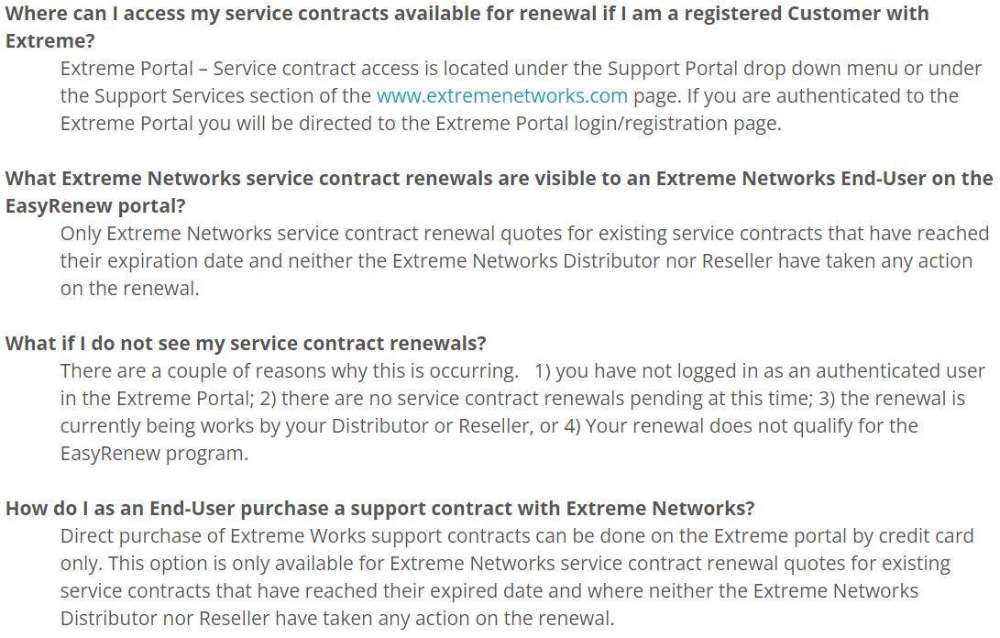Data contains of FAQ and there answers from the source <https://extremeportal.force.com/extrarticledetail?an=000093044&q=FAQ>

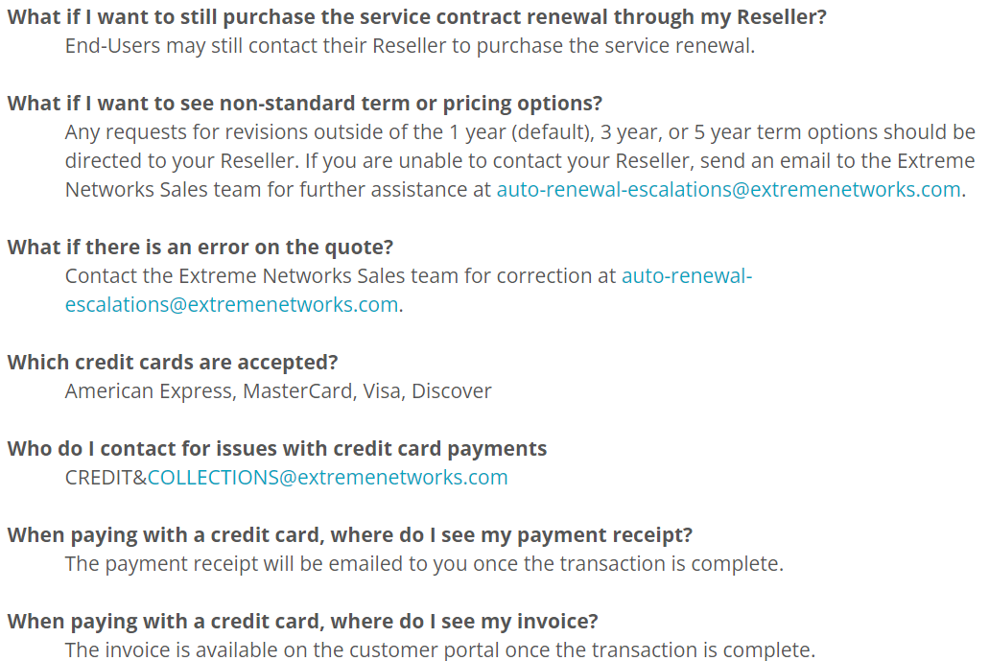

**JSON FORMAT:**

Above data is converted into json format for giving input to the model for generating utterances

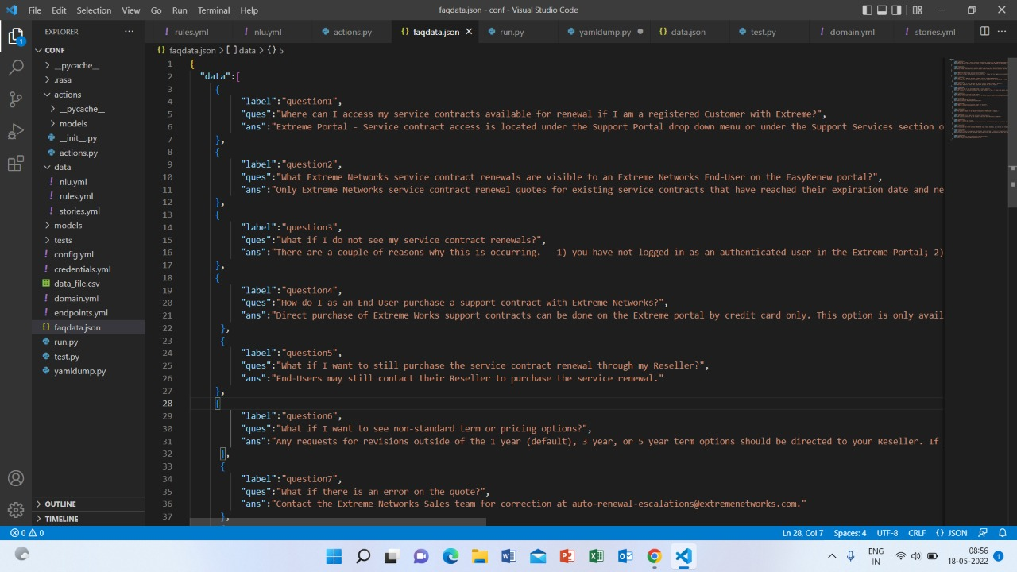

**Generation of Utterances:**

For automatic generation of utterances, T5 pre-trained model is used.

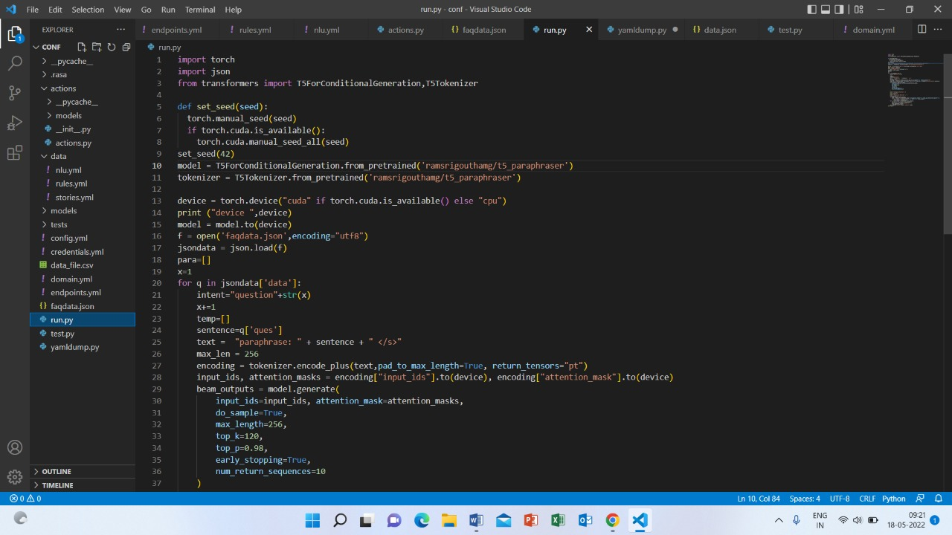

**Generated Utterances:**

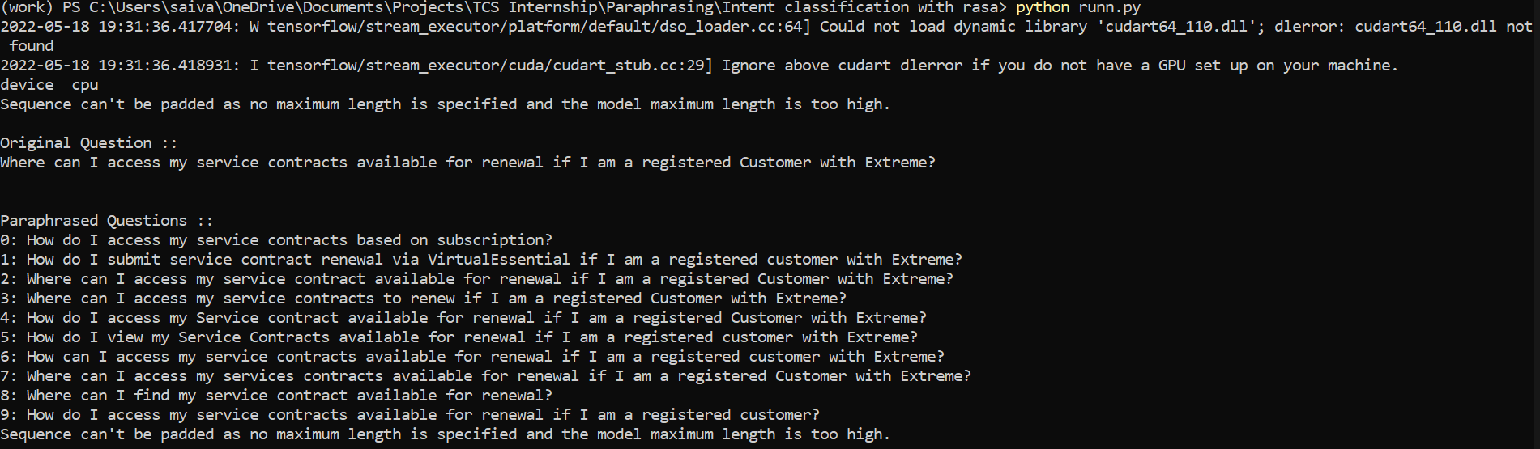

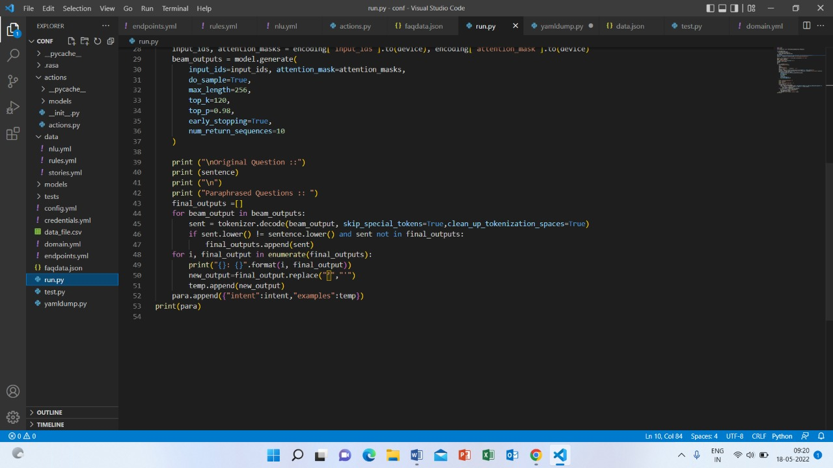

The above script represents generating paraphrases for each question from json data and appending the paraphrased sentences into variable “para”.

**Training RASA Model**

For training the RASA-NLU model, the data in para is converted into yml file.

The below is a python script for converting the data into yml format.

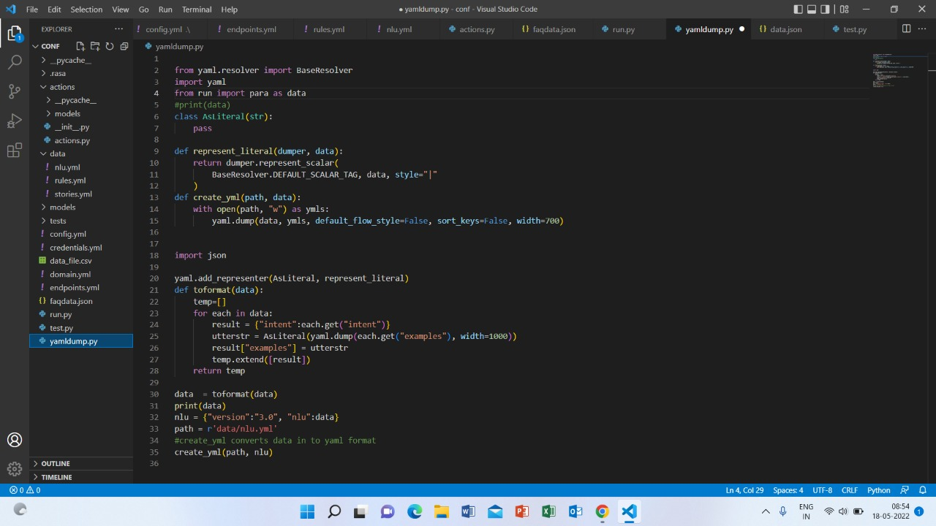

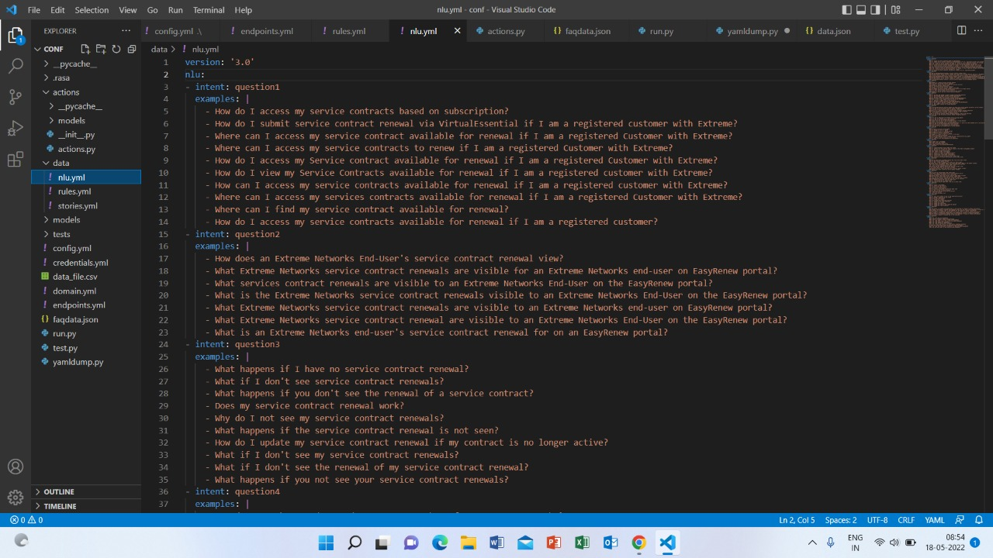

**Training model:**

After conversion of data into yml format, it is used to train the rasa model

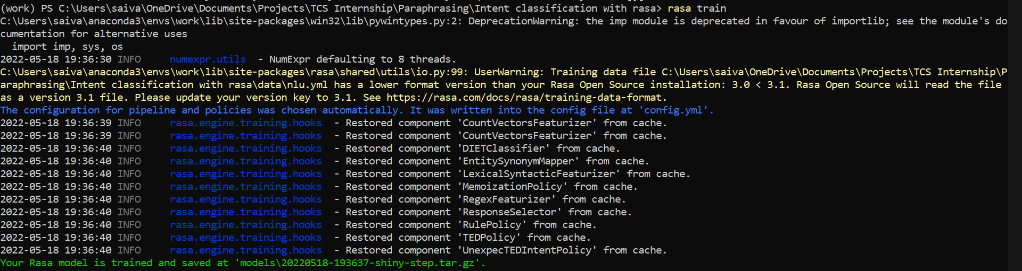

Testing Automation:

The original question is taken as input for testing and the responses consist of confidence scores and intent classification.

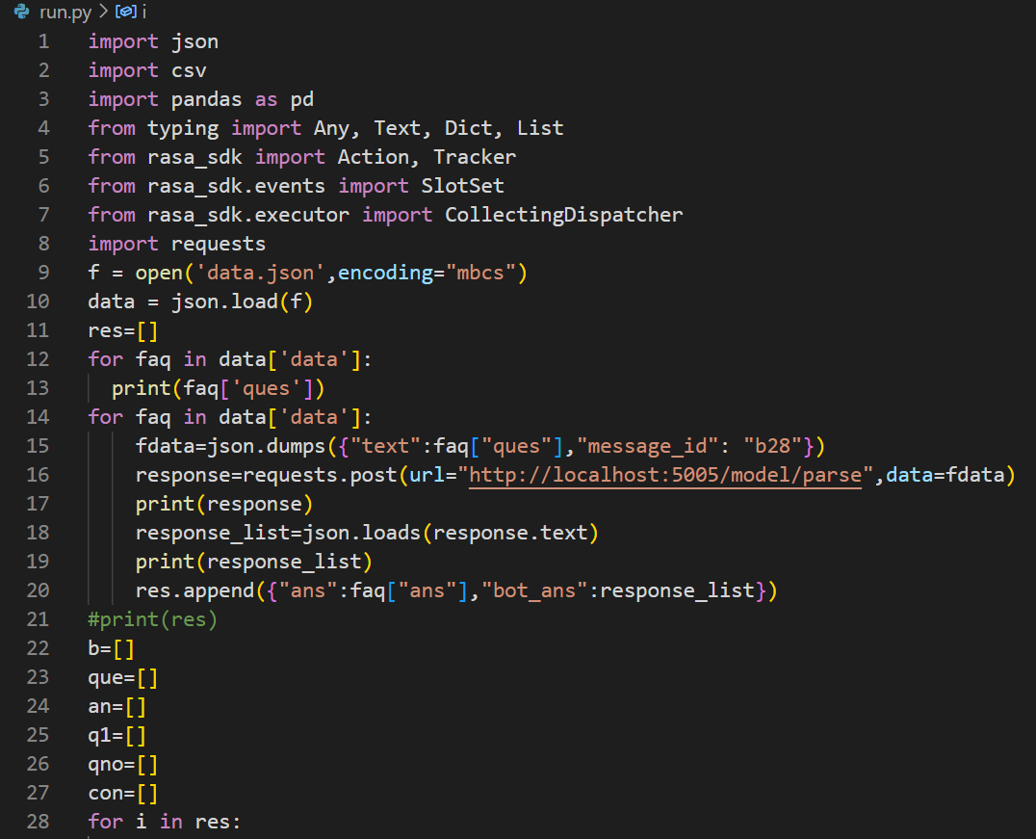The results obtained from run.py are stored in “res” variable and it is converted into csv file.

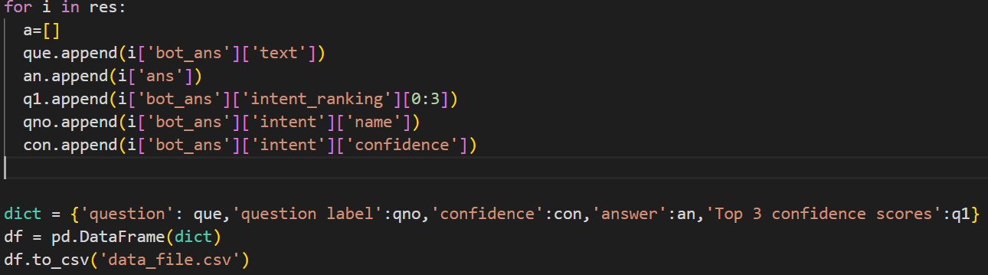

The below csv file is the results from run.py

