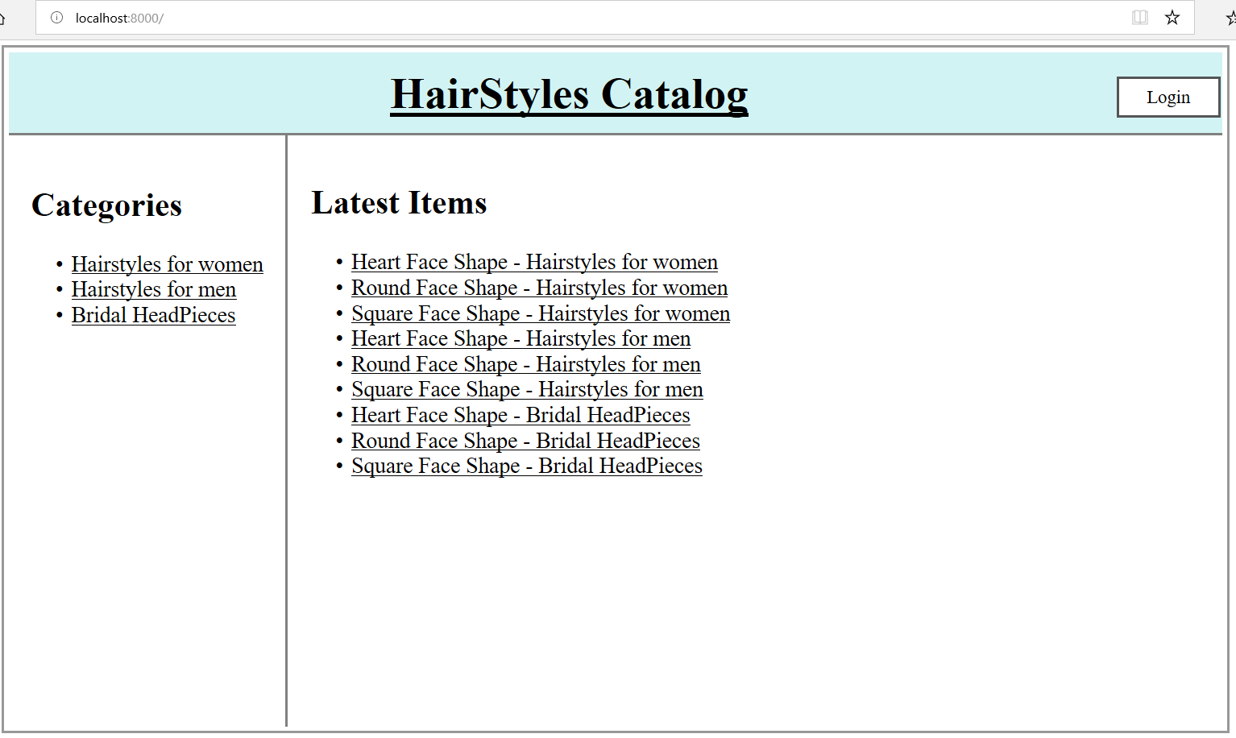
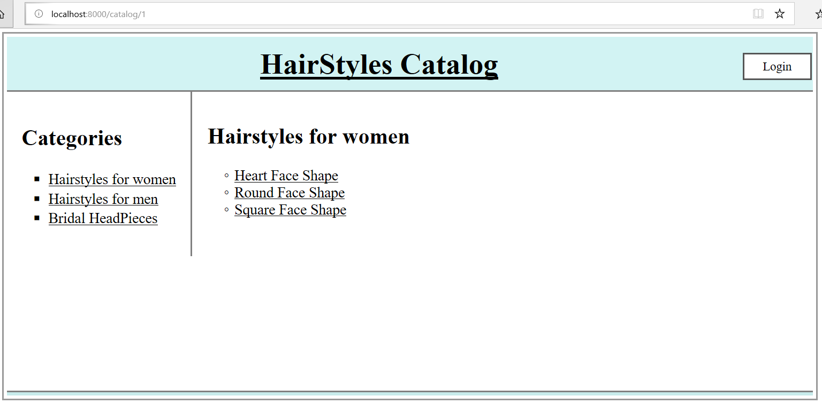
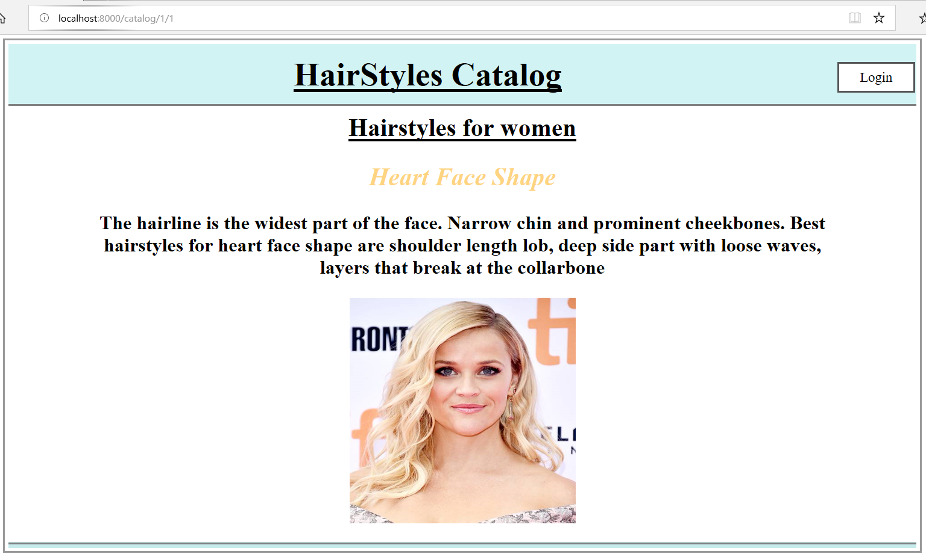
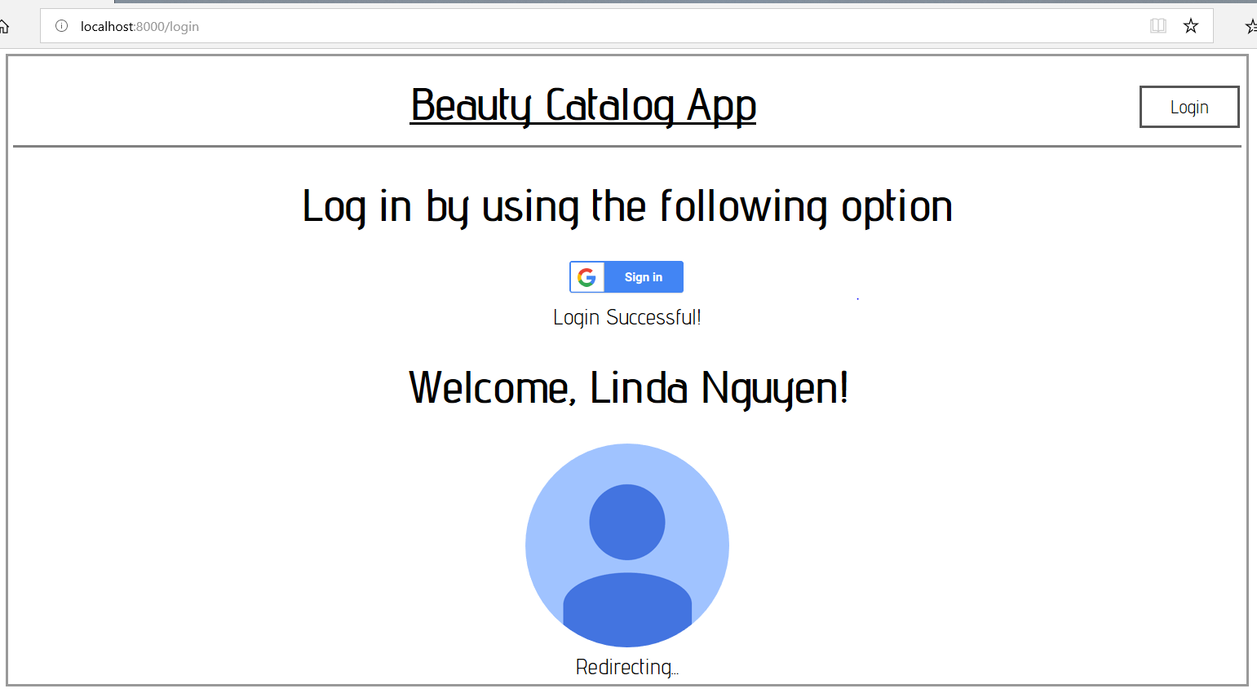
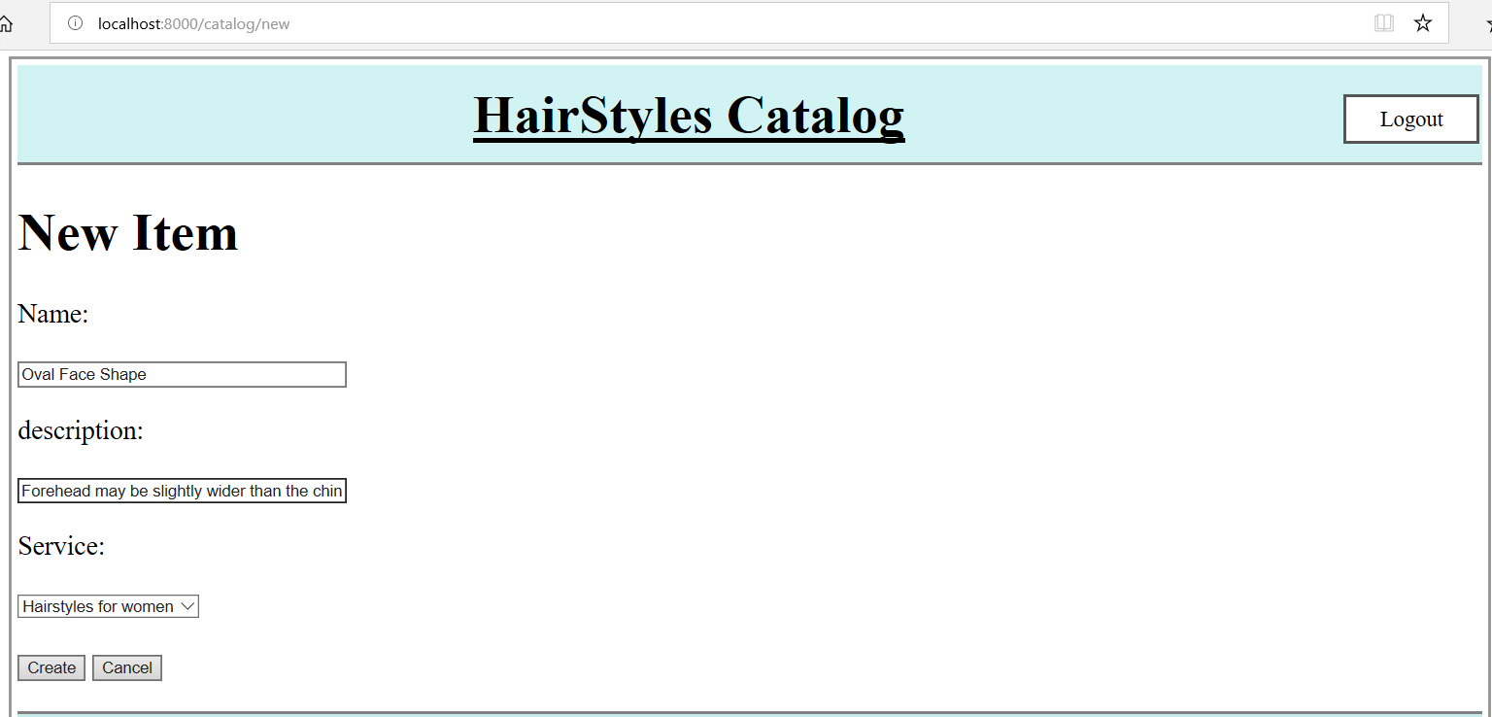
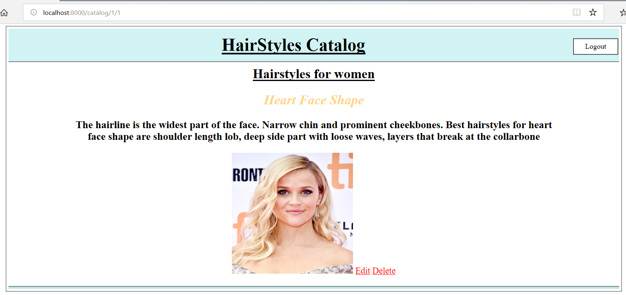
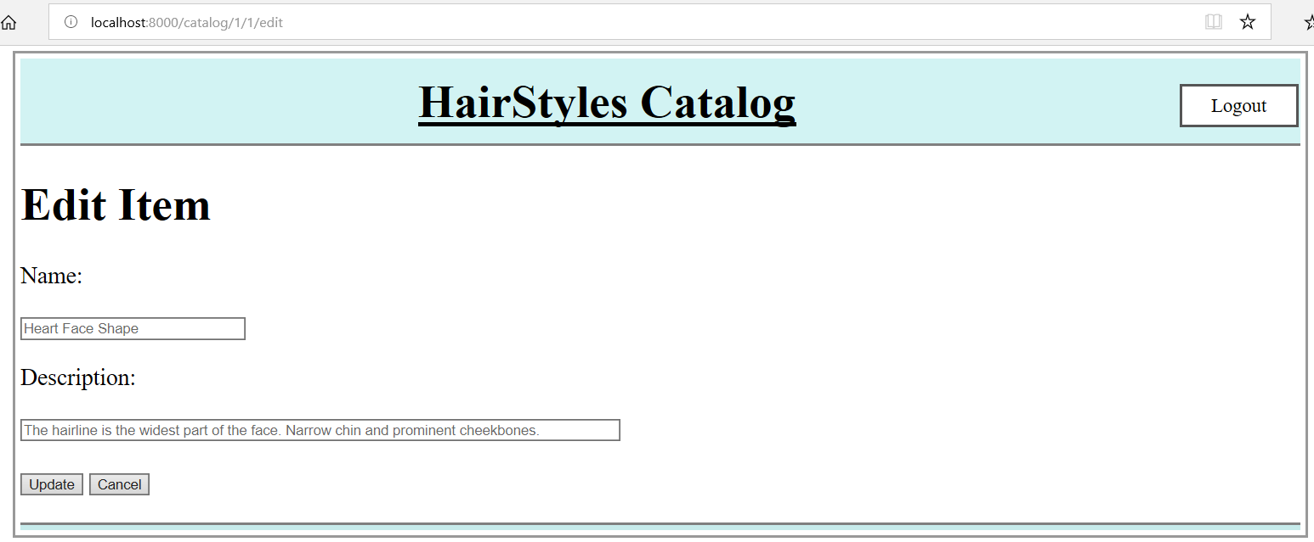
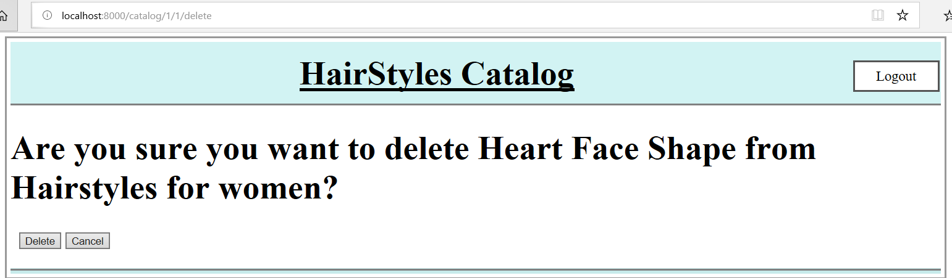
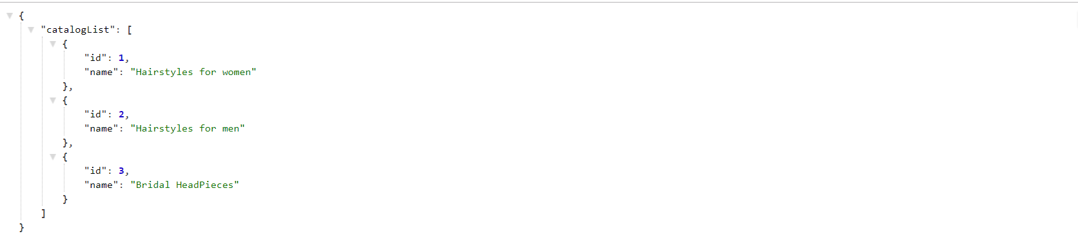
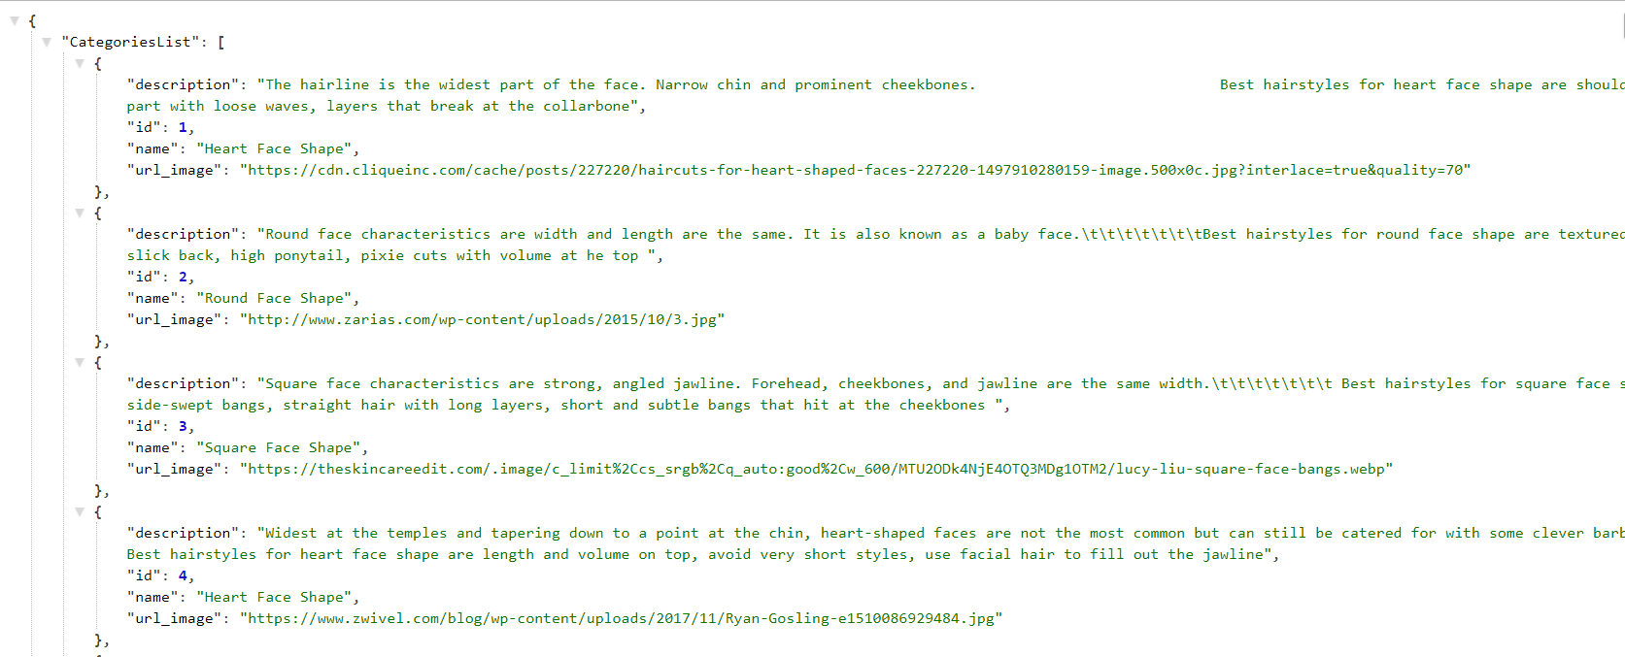
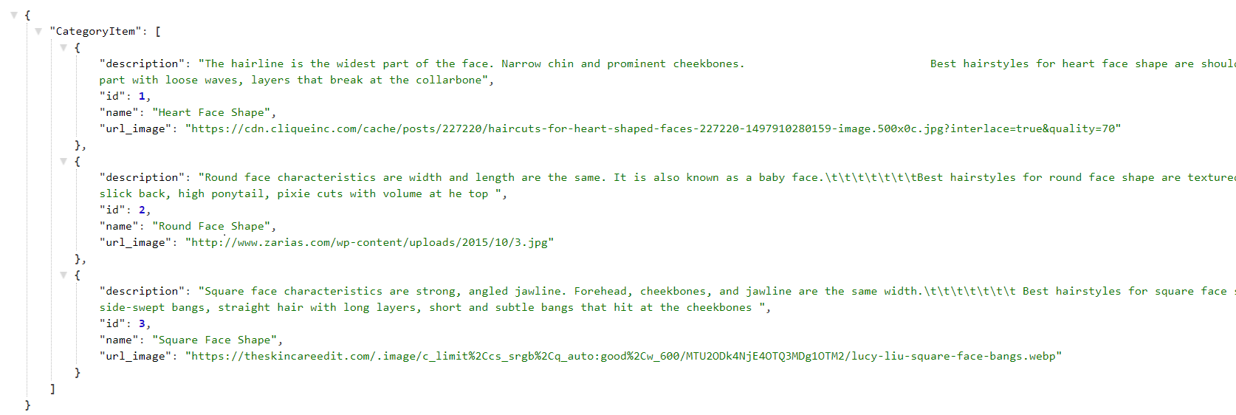
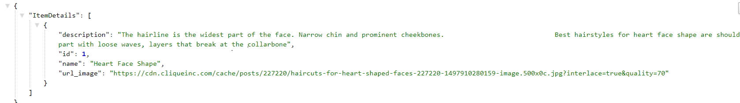
Item Catalog project

The Item Catalog project consists of developing an application that provides a list of items within a variety of categories, as well as provide a user registration and authentication system.

1. The homepage displays all current categories along with the latest added
http://localhost:8000

2. Selecting a specific category shows you all the items available for that category.
http://localhost:8000/catalog/1

3.Selecting a specific item shows you specific information of that item
http://localhost:8000/catalog/1/1

4. After logging in, a user has the ability to add, update, or delete item info.

http://localhost:8000/ (logged in)

5. Add item
http://localhost:8000/catalog/new

6.Display specific information of that item with Edit and Delete button

http://localhost:8000/catalog/1/1 (logged in)

7. Edit item
http://localhost:8000/catalog/new (logged in)

8. Delete item
http://localhost:8000/catalog/1/1/delete (logged in)

The application provides a JSON endpoint :

1.Returns JSON of all catalog
http://localhost:8000/catalog/JSON

2. Returns JSON of all categories in catalog
http://localhost:8000/catalog/categories/JSON

3. Returns JSON of selected category in catalog
http://localhost:8000/catalog/1/JSON

4. Returns JSON of selected item in catalog http://localhost:8000/catalog/1/1/JSON

