

COMPUTER SCIENCE

LAB REPORT SUBMISSION COVER PAGE

Comp Sci 353

Fall 2019

Student Name: Tswjfwmeng Vang
Declaration of originality:
I declare that all sentences, results and data mentioned in this report are from my own work. All work derived from other authors have been listed in the references. I understand that failure to do this is considered plagiarism and will be penalized.
Note that collaboration and discussions in conducting the experiments are allowed but copying and any act of cheating in the report, results and data are strictly prohibited

Student signature: Tswjfwmeng Vang

Experiment title: 7.1 & 7.2 exercises
……………………………………………………………………….
Experiment Date: Oct. 16 2019
Date Submitted: Oct. 16 2019
Lab Instructor Name: Professor Ahsan Verified:………………….

In this lab, we followed the exercises from the Seafarth’s text. I used EBE to run and debug the code.

In exercise 7.1, the goal was to add up the bits from a byte. I did that by assigning 2 variables in the segment .data section. The first variable was set as a DB with a binary value of 01100101 (101 in decimal). The second variable was set as a DB with a value of 0 in decimal. I will be using the second variable for keeping track of how many bits (1’s). In the main method, the first instruction is to move the value of my first variable into the register rax. I originally wanted to use register al but I kept getting an error so I decided to just use the 64 bit register instead. The block of code that follows the first instruction is repeated 8 times through out the program due to the instructions from the book to explicitly not use a loop. In the block of code, I used bt to search through the rax register starting from 0. Then, whatever the carry flag value is, I set it in register dl. From there, I moved the value of dl into my second variable. I would add to my second variable every time this block of code was rewritten. In the end, there were a total of 4 bits (1’s) in 01100101 binary.

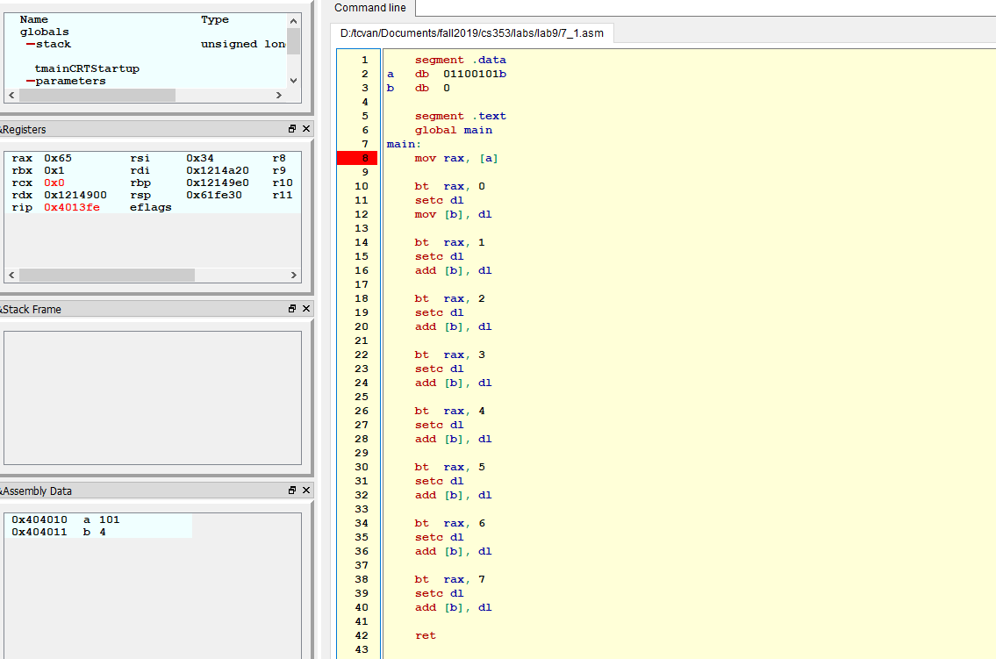
In exercise 7.2, the goal was to swap 2 values from 2 variables. I did this by using the xor keyword. First, I made 2 variables in the setgment .data portion and assigned them values of 10 and 5 respectively. In the main method, I moved those values into registers al and bl. The reasoning for chooing al and bl was because I wanted to choose the least amount registers to use. Since the values of 10 and 5 in decimal could fit in both of those registers, I decided to just use them instead of, for example, rax, a 64 bit register. The important part is as follows:
xor al, bl
xor bl, al
xor al, bl
mov [a], al
mov [b], bl

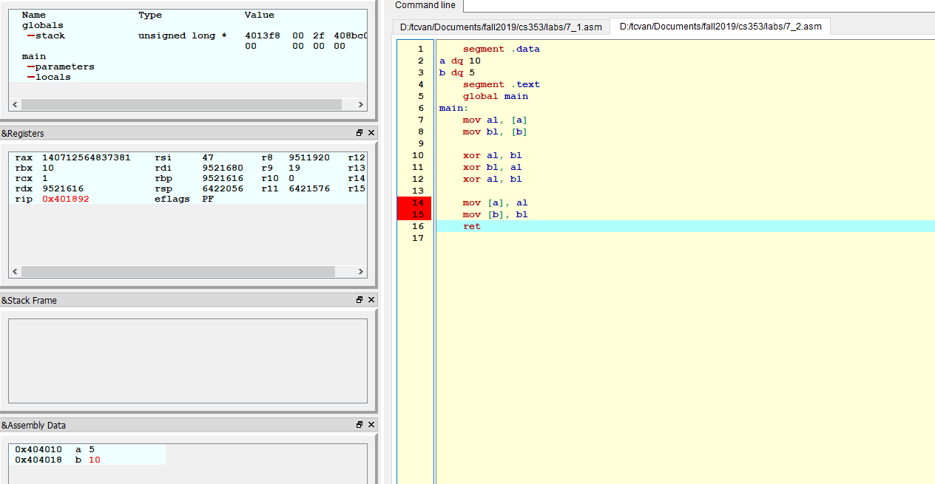
At the end of this code, we can observe that the 2 variables that I made at the beginning now have swapped values.

