In this lab we are continuing our half adder and creating a full adder circuit. We used 2 XOR gates, 2 AND gates, and 2 NOR gates. We used 2 NOR gates to act as the last OR gate in a full adder. Also, if we were to use an INVERTER with an NOR gate, we would have to use a transistor and we didn’t want to add that extra step.
The motivation for this lab was to get comfortable understanding basic circuits such as the half adder and full adder. A full adder is a continuation from a half adder and therefore putting together a full adder was good practice for getting used to circuits. From the instructions given to us, we were supposed to use a combination of gates that would result as the last OR gate in the full adder. Using the help from Professor Ahsan, we concluded that we should use 2 NOR gates.
Since we already had a half adder on our bread board, all we needed to do was add the other half of the adder. Each chip has multiple gates, so, instead of finding 2 more chips, we used the adjacent gates from our previous half adder instead. Doing this saved us space and time. At first, it was a little difficult for us to understand how to connect the half adder to the full adder. Also, the carry in and carry out was slightly confusing.
We eventually started to take on the lab slowly by figuring out which gates are supposed to be connected in the diagram. We followed the first XOR and that led us to 1 of the inputs for the second XOR. We followed that the second input for the second XOR, and that led us to the CARRY IN that is also branched off to the second AND gate. We finished off the second XOR gate by connecting its output to ground. By then the first and second AND gates were ready to connect its output to the OR (nor x2) gate. We connected the inputs to the first NOR gate. The second NOR gate needed to take 2 inputs, so we branched off the output from the first NOR gate to introduce 2 inputs for the second NOR gate (diagram provided below).
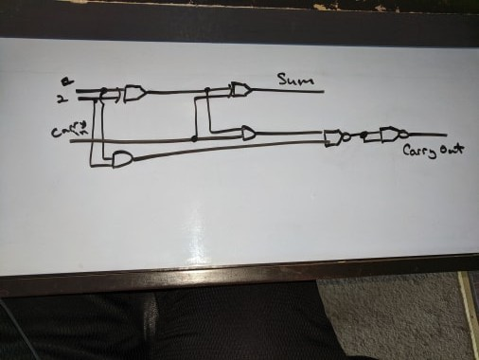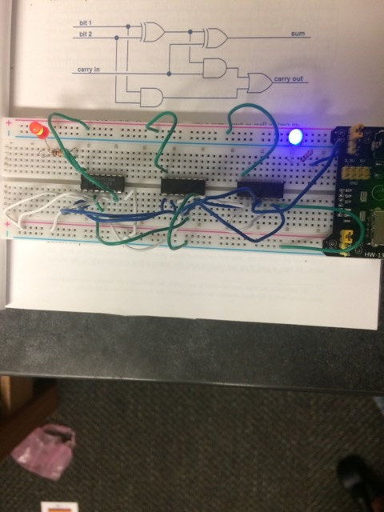
A | B | Carry In | Sum | Carry Out
0 | 0 | 0 | 0 | 0
0 | 0 | 1 | 0 | 1
0 | 1 | 0 | 0 | 1
0 | 1 | 1 | 1 | 0
1 | 0 | 0 | 0 | 1
1 | 0 | 1 | 1 | 0
1 | 1 | 0 | 1 | 0
1 | 1 | 1 | 1 | 1
Some complications such as wire management and power management occurred during the lab. Kevin was the one to figure out that we weren’t supplying power through each chip, and therefore, our initial full adder wasn’t working properly. Kevin’s solution properly fixed our full adder.
In conclusion, this lab was dedicated to learn about how to create a full adder on our bread boards. We were stressed to know about how to manipulate our gates to create functions such as: creating a block that will act as a new pre-determined gate, basic connectivity, and reusable resources. When creating the full adder, we were able to limit ourselves on how much resources we needed, like, gates, and wires. In this lab, we saw how the full adder is an extension of the half adder in a practical manner.

