Tswjfwmeng Vang
Professor Ahsan
CS353

Homework 1
2.2:
Google Pixel: 5 volts at 3 amps or 9 volts at 2 amps

2.3:
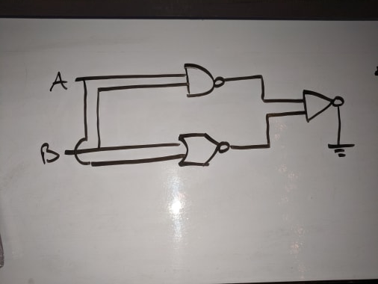

2.4:

A | B | And (1) | XOR(1) | C in | And (2) | XOR (2) // Sum | OR // C out
0 | 0 | 0 | 0 | 0 | 0 | 0 | 0
0 | 0 | 0 | 0 | 1 | 0 | 1 | 0
0 | 1 | 0 | 1 | 0 | 0 | 1 | 0
0 | 1 | 0 | 1 | 1 | 1 | 0 | 1
1 | 0 | 0 | 1 | 0 | 0 | 1 | 0
1 | 0 | 0 | 1 | 1 | 1 | 0 | 1
1 | 1 | 1 | 0 | 0 | 0 | 0 | 1
1 | 1 | 1 | 0 | 1 | 0 | 1 | 1

2.8:
7 maximum output bits
2.11:
When using only 2 inputs, nor gates don’t have many possibilities to keep electricity flowing. One of four combinations will keep electricity flowing when using 1 nor gate with 2 inputs. I can imagine that using an extra nor gate will come in handy is when both inputs will be logical 0 and having the output be logical 1. The opposite idea can be done too-- keeping the flow of electricity from happening. Since only one of four combinations result in logical 1, that means three of four combinations result in logical 0. Taking advantage of the nature of the nor gate, you can keep electricity from flowing throughout the circuit much easier.

