Tswjfwmeng Vang

Computer Architecture

Lab

November 5, 2019

I made the 4 variables and I put them in registers [rax, rbx, rcx, rdx] and then using register *rax* to hold the sum of the variables.

In this first photo, you can see that rax is initially 175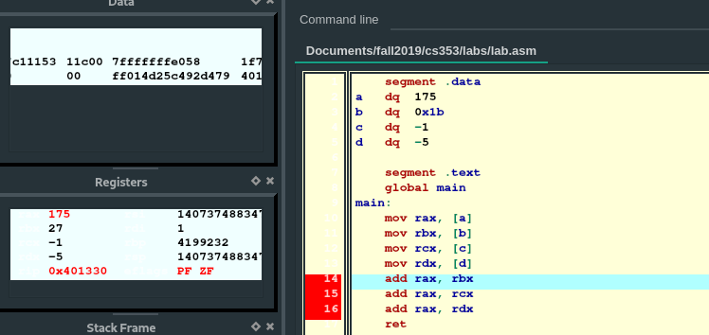

In the next photo, you can see that *rax* has changed its value to 202 (175 + 27).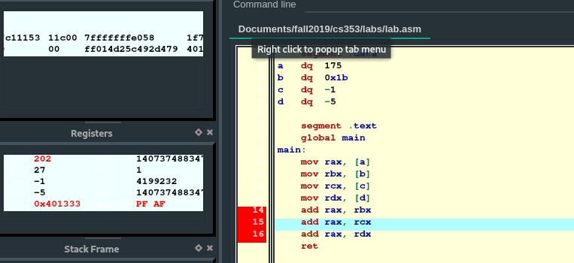

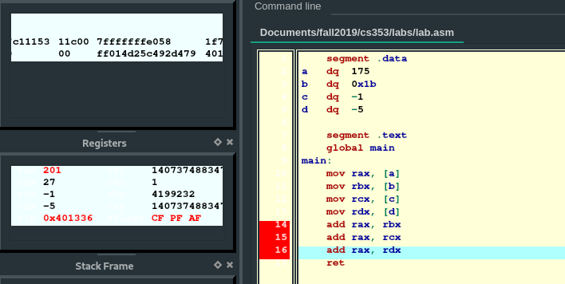

In this photo, you can see that *rax* is now 201 (202 + -1).

In this photo, you can see that *rax* is now 196 (201 + -5).