Software Requirements Specification for Sakai TOEIC

Prepared by

Nguyễn Hữu Phúc

Võ Trần Huy Thông

Đỗ Đức Duy

Phạm Cao Nam Hải

Nguyễn Đinh Nhật Minh

December 20, 2018

**Table of Contents**

1. Introduction 2

1.1 Purpose 3

1.2 Definitions, Acronyms and Abbreviations 3

2. High Requirements 4

2.1 User case 4

2.2 Toeic exam 4

2.3 Forced 4

2.4 Design and Implementation Constraints 6

2.5 User Documentation 6

3. Funtional Requirement 6

3.1 Module 7

3.1.1 Sign up 7

3.1.2 Sign in 7

3.1.3 List of users 8

3.1.4 Account Personal Information 9

3.1.5 Search field 9

3.2.6 Language field 10

4. Nonfunctional Requirement 11

4.1 Accessbility 11

4.2 Volume 11

4.3 Precision 11

4.4 Performance 12

4.5 Compatibility 12

4.6 Maintainability 12

4.7 Safety 12

4.8 Portability 12

5. System Constraint 12

5.1 Database 12

5.2 Device 12

5.3 Programming Language 12

# Introduction

## Purpose

We need to develop the system to help users learn, practice TOEIC exam and organize TOEIC exam. Users can be individuals or organizations

## Definitions, Acronyms and Abbreviations

|  |  |  |
| --- | --- | --- |
| **#** | **Abbreviations/T**  **erms** | **Explanation** |
| 1 | SRS | Software Requirement Specification |
| 2 | BR | Business Rule |
| 3 | SC | Screen |
| 4 | UC | Use Case |
| 5 | CRUD | Create/Read/Update/Delete a record in database |

# High Requirement.

## Use case

-User group represents the organization.

+These people can go to the system, register an account or use a social network account like Google, Facebook, and Twitter to log in and enter some additional information.

+ The system will automatically grant these people 1000 coins worth using for 30 days.

+ Users can use coins to create sites to manage materials for their courses.

+ Each Site will be priced by Admin. For example 500 coins / 1 Site.

+ Users can invite many others (available accounts in the system or no account) to take the TOEIC exam.

+Each time a person enters the exam and finishes the test, the Site Manager's Coin number will be added 10 coins (this value can be configured by the Admin).

+ For the contestant, he / she will be awarded an additional Coin by the number of points that can be taken.

+ Users of the organization can manage the account list of members of their organization. It is possible to create many TOEIC test questions and email notifications for members to review, discuss and test.

- Personal user group.

+ Users of individuals can also register an account and perform the Open Site function as the user organizes.

+ However, the amount of Coin granted from the beginning will be 500.

+ The whole TOEIC test entry function is the same as the user organization.

## Toeic Exam

- This system supports the TOEIC test with 2 Listening and Reading skills.

(Refer to the popular TOEIC test standard in the world and in Vietnam in the last 3 years).

## Forced

- The system can be deployed regardless of the operating system. Focus deployment on Windows and Linux CentOS.

- The response time of the system is fast enough for the user to test: Response Time is within a fair average compared to current TOEIC test sites.

- The number of concurrent users can join the same test at the same time: 5000 people.

- The figures shown above can be changed during system operation.

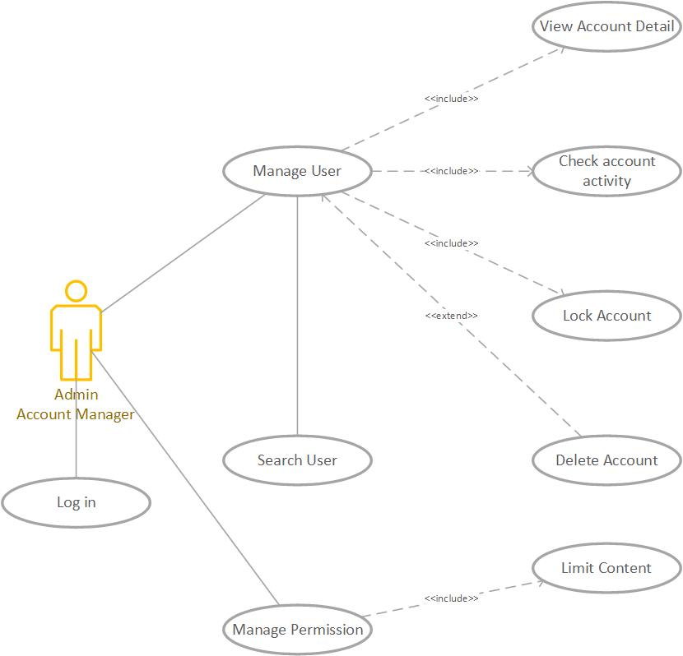

Diagram 1: Admin and Account Manager Permission

**Notes: Admin and account manager can access all function**

### User Description

|  |  |  |
| --- | --- | --- |
| **#** | **User Permission** | **Definition** |
| 1 | Admin |  |
| 2 | Account Manager |  |
| 3 | Guest |  |

### Use Case Description

|  |  |  |  |
| --- | --- | --- | --- |
| **#** | **ID** | **Name** | **Brief Description** |
| 1 | UC01 | Sign Up | User can create account to use the translate function |
| 2 | UC02 | Sign In | User can Login when they create account success |
| 3 | UC03 | List of user | Account Manager can see and manage the user account |
| 4 | UC04 | Account personal information | User can see and change their personal information |
| 5 | UC05 | Search field | User can enter the words or sentences to find the meaning |
| 6 | UC06 | Description section | User can see the word they enter and the meaning of that one |
| 7 | UC07 | Audio | User can hear the sound of that word |
| 8 | UC08 | View History | User can see the words they enter all the times |

### Use Case & User Permission Mapping

|  |  |  |  |  |
| --- | --- | --- | --- | --- |
| **Use Case** | **Use Case Name** | **Admin** | **Account Manager** | **Guest** |
| UC01 | Sign Up | X | X | X |
| UC02 | Sign In | X | X | X |
| UC03 | List of user | X | X |  |
| UC04 | Account personal information | X | X | X |
| UC05 | Search field | X | X | X |
| UC06 | Language field | X | X | X |
| UC07 | View History | X | X | X |
| UC08 | Upload Volcabulary | X | X | X |

## Design and Implementation Constraints

Được làm bởi team không có chính sách doanh nghiệp và pháp lý.

Program Được viết bằng ngôn ngữ java and(or) something có thể chạy được trên nền tảng web và thiết bị di động.

Bảo mật: phải tạo user và accept bởi admin để cung cấp quyền sử dụng

## User Documentation

Tài liệu bao gồm file hướng dẫn sử dụng có thể download trực tuyến hoặc đính kèm cùng phần mềm. Có thể contact qua địa chỉ email của team or sđt,....

Định dạng tài liệu: file .pdf, .docx.

# FUNCTIONAL REQUIREMENT

## Module 01

### UC01: Sign Up

|  |  |  |  |  |  |
| --- | --- | --- | --- | --- | --- |
| **ID** | **Name** | **Account** | **Trigger** | **Pre-condition** | **Post condition** |
| UC01 | Sign Up | Admin/Account Manager/Guest | User press the Sign Up button |  | Move to Sign Up form |

Activities

|  |  |  |  |
| --- | --- | --- | --- |
| **User** | | **System** | |
| Main flow: Sign Up Success | | | |
| 1 | User press sign up button. (SC01) |  | |
|  |  | 2 | Move to the Sign Up forms. (SC02) |
| 3 | User enter name, email, password and tick the box I agree. |  |  |
|  |  | 4 | Validate the field and the check the password. |

**System Messages**

|  |  |
| --- | --- |
| MS01 | Please enter your name. |
| MS02 | Please enter your email. |
| MS03 | Please enter your password. |
| MS04 | The password is not matched. |
| MS05 | Cannot create account when the check box I agree is missing. |

### UC02: Sign In

|  |  |  |  |  |  |
| --- | --- | --- | --- | --- | --- |
| **ID** | **Name** | **Account** | **Trigger** | **Pre-condition** | **Post condition** |
| UC02 | Sign In | Admin/Account Manager/Guest | User press the Sign In button |  | Move to homepage |

**Activities**

|  |  |  |  |
| --- | --- | --- | --- |
| **User** | | **System** | |
| Main flow: Sign In Success | | | |
| 1 | User press sign in button (SC02) |  | |
|  |  | 2 | Move to the Sign In forms (SC03) |
| 3 | User enter their email, password |  |  |
|  |  | 4 | Validate the field and the check the password. |

**System Messages**

|  |  |
| --- | --- |
| MS06 | Please enter your email This notification will appear when user let the email field is empty |
| MS07 | Please enter your password  This notification will appear when user let the password field is empty |
| MS08 | The password is not matched  This notification will appear when 2 password from input isn’t same |

### UC03: List of users

|  |  |  |  |  |  |
| --- | --- | --- | --- | --- | --- |
| **ID** | **Name** | **Account** | **Trigger** | **Pre-condition** | **Post condition** |
| UC03 | List of users | Admin/Account Manager | Admin/Account Manager press the icon user button |  | Move to List of users |

**Activities**

|  |  |  |  |
| --- | --- | --- | --- |
| **User** | | **System** | |
| Main flow: Move to List of User successful | | | |
| 1 | User press the icon (SC04) |  | |
|  |  | 2 | Show the list of users (SC05) |
| 3 | Admin/Account manager can lock or set the permission of account |  |  |

System Messages

|  |  |
| --- | --- |
| MS11 | Set up complete Admin/Account manager set the user permission successful |
| MS12 | Access denied Account isn’t admin or account manager can’t access when Admin/Account manager lock that one |

### UC04: Account Personal Information

|  |  |  |  |  |  |
| --- | --- | --- | --- | --- | --- |
| **ID** | **Name** | **Account** | **Trigger** | **Pre-condition** | **Post condition** |
| UC04 | Account Personal Information | Admin/Account Manager/Guest | User press the Account detail |  | Move to personal information page |

Activities

|  |  |  |  |
| --- | --- | --- | --- |
| **User** | | **System** | |
| Main flow: Sign Up Success | | | |
| 1 | User press personal information detail(SC06) |  | |
|  |  | 2 | Move to the personal information page (SC07) |
| 3 | User enter their new name, email, password. |  |  |
|  |  | 4 | Validate the field and the check the password by request their password again. |
| 5 | User enter the password to confirm |  |  |
|  |  | 6 | Notice when user type successful or not |

System Messages

|  |  |
| --- | --- |
| MS13 | Password is not match this message will appear when 2 password from user are not match |

### UC05: Search field

|  |  |  |  |  |  |
| --- | --- | --- | --- | --- | --- |
| **ID** | **Name** | **Account** | **Trigger** | **Pre-condition** | **Post condition** |
| UC05 | Search field | Admin/Account Manager/Guest | Admin/Account Manager/Guest enter any word or sentences and press search button. |  | Find the specific word to translate. |

Activities

|  |  |  |  |
| --- | --- | --- | --- |
| **User** | | **System** | |
| Main flow: Search successful | | | |
| 1 | User enter the words. |  | |
|  |  | 2 | Check this is words or not Check this is sentences or not. |
| 3 | Translate from English to Vietnamese or vice versa. |  |  |

System Messages

|  |  |
| --- | --- |
| MS11 | This is not the words The word or sentence that user entered contain the special characters. |

### UC06: Language field

|  |  |  |  |  |  |
| --- | --- | --- | --- | --- | --- |
| **ID** | **Name** | **Account** | **Trigger** | **Pre-condition** | **Post condition** |
| UC06 | Language field | Admin/Account Manager/Guest |  |  | Translate a word or a sentence from English to Vietnamese or vice versa |

Activities

|  |  |  |  |
| --- | --- | --- | --- |
| **User** | | **System** | |
| Main flow: Search successful | | | |
| 1 | Enter a word which don’t have any special characters. |  |  |
|  |  | 2 | Translate this word from English to Vietnamese when user enter the word to search correct. |

### UC07: View History

|  |  |  |  |  |  |
| --- | --- | --- | --- | --- | --- |
| **ID** | **Name** | **Account** | **Trigger** | **Pre-condition** | **Post condition** |
| UC07 | View History | Admin/Account Manager/Guest | Admin/Account Manager/Guest click the view history button |  | See the word they looked up |

Activities

|  |  |  |  |
| --- | --- | --- | --- |
| **User** | | **System** | |
| Main flow: View History page | | | |
|  |  | 1 | Show the user the word history list |

### UC08: Learning English

|  |  |  |  |  |  |
| --- | --- | --- | --- | --- | --- |
| **ID** | **Name** | **Account** | **Trigger** | **Pre-condition** | **Post condition** |
| UC07 | Targer another Activitives in app to | Admin/Account Manager/Guest | Admin/Account Manager/Guest click another activitives in app. |  | See the activitives they want to do next. |

Activities

|  |  |  |  |
| --- | --- | --- | --- |
| **User** | | **System** | |
| Main flow: View Another Activitives in Main Layout | | | |
|  |  | 1 | Show the user another activitives that they want to see next. |

# Nonfunctional Requirements

## Accessbility

User enter 1 character and show the list of the words that have that character.

User can use their voice to fill the word automatically.

## Volume

Number of user can access at least 100 peoples.

## Precision

The word must be translated when the words or sentenced have uppercases in any location.

The word received from user’s voice must be filled corect.

Audio must be spoken correct depends on the description.

## Performance

The word that user look up show the result under 5s.

The web application is responsive.

## Compatibility

The application must run on web browser.

The application run on windows 7 or higher.

## Maintainability

The software is divided into several small modules so it is easy to upgrade and maintain.

All functions can be possibly colliped.

Add more functions when needed.

## Safety

The account management system will check the account activity when the bad behavior appear (pollitic, system security,…).

System will check the virus inside the file or link when upload.

## Portability

The application run on device with any hardware:

* PC or laptop with minimum CPU core 2 duo, 2GB of rams or modern one.

# System Constraint

## Database

The application translate the word by query through firebase or MySQL.

## Device

The application run only on destop or laptop.

## Programming Language

Can write with the scripting language(HTML/CSS,JavaScript,PHP,...) or high level language (C/C++, python,java,...).

use modules through the command (unclude "../file.php";) in php.