Practice Questions for Final on Wed May 6 12:30-2:30 PM on Moodle

1)

In the mass-spring system shown above, the masses m₁, m₂ and m₃ are .8, .6
and .5, the spring constants k₁, k₂, k₃ and k₄ are 4.3, 5.1, 4.6 and 5.4, and x₁, x₂ and x₃ are the displacements of m₁, m₂ and m₃ from their equilibrium positions.

Write a MATLAB program as follows:

1) t will go from 0 to 8 sec in steps of .001 sec.

2) Calculate the displacements and velocities of the masses for each
value of t. Use 1e-7 as the accuracy factors, .7, .2 and .4 as the
initial values of x₁, x₂ and x₃ , and 0 as the initial values of the
velocities.

3) Plot x₁, x₂ and x₃ versus t using the colors blue, red and green and
the t axis in black.

4) In a separate figure, plot the velocities v₁, v₂ and v₃ versus t using
the colors blue, red and green and the t axis in black.

Just write the figure statements and the plot statements. Do not write any
other statements for the graphs.

This program has a function defined in a separate MATLAB file. Name this
function prog1f.

Write both the main program and the function.

Equations

The answer is on the next page.
Problem 1 Answer

Before writing the program for Problem 1, convert each 2nd order differential equation into 2 1st order differential equations:

Then Write the Program for Problem 1:

% main program
t=0 : .001 : 8;
u0 = [.7 0 .2 0 .4 0];
options = odeset('AbsTol', 1e-7, 'RelTol', 1e-7);
[t u] = ode45('prog1f', t, u0, options);
line1x = [0 8];
line1y = [0 0];
figure(1);
plot(t,u(:,1),'b',t,u(:,3),'r',t,u(:,5),'g',line1x,line1y,'k');
figure(2);
plot(t,u(:,2),'b',t,u(:,4),'r',t,u(:,6),'g',line1x,line1y,'k');

The function for Problem 1 is on the next page.

Problem 1 Function

% function prog1f
function f = prog1f(t,uf)
m1 = .8;
m2 = .6;
m3 = .5;
k1 = 4.3;
k2 = 5.1;
k3 = 4.6;
k4 = 5.4;
x1 = uf(1);
v1 = uf(2);
x2 = uf(3);
v2 = uf(4);
x3 = uf(5);
v3 = uf(6);
f = zeros(6,1);
f(1) = v1;
f(2) = 1/m1*( -k1*x1 + k2*(x2-x1) );
f(3) = v2;
f(4) = 1/m2*( -k2*(x2-x1) + k3*(x3-x2) );
f(5) = v3;
f(6) = 1/m3*( -k3*(x3-x2) - k4*x3 );

2)

In the mass-spring system shown above, the masses m₁, m₂ and m₃ are .8, .6
and .5, the spring constants k₁, k₂, k₃ and k₄ are 4.3, 5.1, 4.6 and 5.4, and x₁, x₂ and x₃ are the displacements of m₁, m₂ and m₃ from their equilibrium positions.

Write a MATLAB program as follows:

1) t will go from 0 to 8 sec in steps of .001 sec.

2) For each of the 3 natural frequencies, plot x₁, x₂ and x₃ versus t using
the colors blue, red and green and the t axis in black (there will be 3
figures). Only Figure 3 is shown below, but the program must plot all 3
figures (Figures 1-3) and the title of each figure must have a different
figure number. The horizontal and vertical axes of all 3 figures should
look like the ones on Figure 3.

Equations

Figure 3 is on the next page.

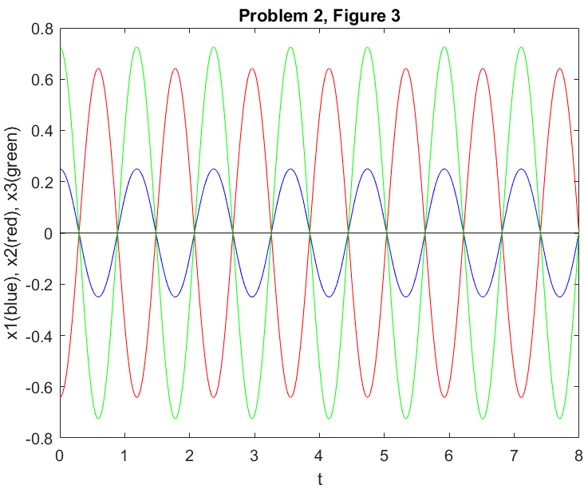

The answer is on the next page.

Problem 2 Answer

Do These Steps Before Writing the Program for Problem 2:

1) Rearrange the right sides of the equations by collecting the terms that
multiply x₁, x₂ and x₃:

2) Divide both sides of the equations by the masses:

3) Define the matrix A that contains the coefficients of x₁, x₂ and x₃ in the
equations. The first column of the matrix A contains the coefficients of x₁,
the second column contains the coefficients of x₂, etc. The first equation
gives the first row of the matrix A, the second equation gives the second
row, etc. If x₁, x₂ or x₃ does not appear in an equation, its coefficient
is 0 on the row of the matrix.

A = [ -(k1+k2)/m1 k2/m1 0
k2/m2 -(k2+k3)/m2 k3/m2
0 k3/m3 -(k3+k4)/m3 ]

Then Write the Program for Problem 2:

m1 = .8;
m2 = .6;
m3 = .5;
k1 = 4.3;
k2 = 5.1;
k3 = 4.6;
k4 = 5.4;
A = [ -(k1+k2)/m1 k2/m1 0
k2/m2 -(k2+k3)/m2 k3/m2
0 k3/m3 -(k3+k4)/m3 ];
A = -A;
[eigvec eigval] = eig(A);
t = 0:.001:8;
line1x = [0 8];
line1y = [0 0];
titles(1,:) = 'Problem 2, Figure 1';
titles(2,:) = 'Problem 2, Figure 2';
titles(3,:) = 'Problem 2, Figure 3';
for(k=1:3)
w = sqrt(eigval(k,k));
c1 = eigvec(1,k);
c2 = eigvec(2,k);
c3 = eigvec(3,k);
x1 = c1*cos(w*t);
x2 = c2*cos(w*t);
x3 = c3*cos(w*t);
figure(k);
plot(t,x1,'b',t,x2,'r',t,x3,'g',line1x,line1y,'k');
axis([0 8 -.8 .8]);
set(gca,'xtick',0:8);
set(gca,'ytick',-.8:.2:.8);
xlabel('t');
ylabel('x1(blue), x2(red), x3(green)');
title(titles(k,:));
end

3) Write a MATLAB program to calculate and print the following integral:

Use 1e-7 as the accuracy factor. The output of this program should look like this:

I=454.36167

Answer

a=4;
b=8;
accuracy=1e-7;
f=@(x) sqrt(2*x.^4+3*x).*cos(5*x).*log((4*x.^3+7*x)./(x.^2+1))./ ...
(x.^2.*sin((3*x+1)./(2*x)).*exp(-(5*x.^3+2*x)./(6*x.^2+2)));
I=quad(f,a,b,accuracy);
fprintf('I=%.5f\n',I);

4)

The thin flat sheet shown above has density

Write a MATLAB program to calculate and print the mass of the thin flat sheet. Use 1e-8 as the accuracy factors. The output of this program should look like this:

mass=38721.48074

Answer

a = 2;
b = 4;
g = @(x) x.^2.*(x-2).^3./(x.^2 + 3*x + 4);
h = @(x) ((x+1).^2 + 3)./(1 + (x-1).*sin(pi/4*(x-2)));
f=@(x,y) y.^2.*cos(x+y)./(x+2*y+1) + y.^3.*exp((2*x+3*y)./(x+y+1));
mass = quad2d(f,a,b,g,h,'RelTol',1e-8,'AbsTol',1e-8);
fprintf('mass=%.5f\n',mass);

5)

A solid is bounded in the x and y directions by the region shown above and
is bounded below and above in the z direction by the planes z=8 and z=x+y+2.
The density of the solid is given by

Write a MATLAB program to calculate and print the mass of the solid. Use 1e-4
as the accuracy factor. The output of this program should look like this:

mass=7523.429

Answer

global accuracy;
a = 2;
b = 4;
accuracy = 1e-4;
g = @(x) ((x-2)^4 + 3*x + 12)/(x+4);
h = @(x) 9 - sqrt(1 + (x-2)^3);
v = @(x,y) 8;
w = @(x,y) x + y + 2;
f=@(z,x,y) z.^3.*cos(x+y+z)./(2*x+3*z+2) + z.^2.*log(y*sqrt(z+y^3));
mass = quad('middle',a,b,accuracy,[],'inner',g,h,f,v,w);
fprintf('mass=%.3f \n',mass);
6) Write a MATLAB program as follows:

a) Read a data file (prog6.dat) that has 8 lines, where each line contains
a value of x and a value of y (data point).
b) For each data point from the second one to the second to last one, fit a second
order polynomial to that data point and the data point on either side of it
(fit the second order polynomial to three data points). Plot these fitted
second order polynomials using the colors red, blue, green, black, magenta and
cyan and the data points as black circles, all in the same graph.

The graph should look like this:

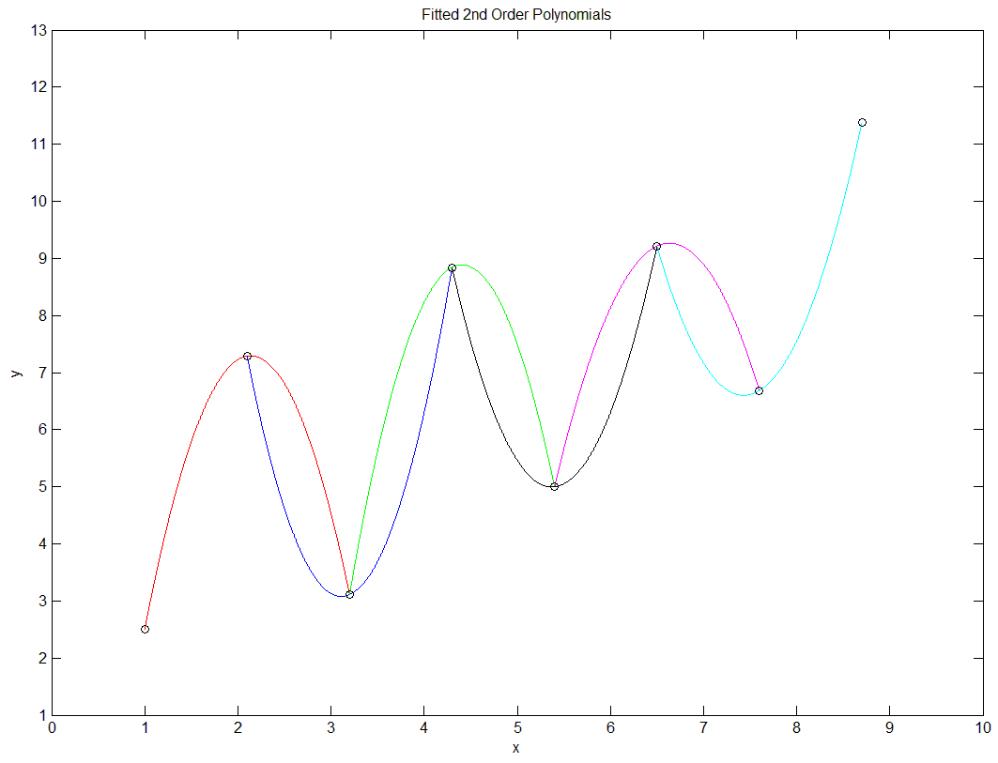
Answer

[xd yd] = textread('prog6.dat');
n = length(xd);
color = ['k','r','b','g','k','m','c','k'];
hold on;
box on;
for(k = 2:n-1)
xd3 = [xd(k-1) xd(k) xd(k+1)];
yd3 = [yd(k-1) yd(k) yd(k+1)];
c2 = polyfit(xd3,yd3,2);
x = xd(k-1):.001:xd(k+1);
y2 = polyval(c2,x);
plot(x,y2,color(k),xd,yd,'ko');
axis([0 10 1 13]);
set(gca,'xtick',0:10);
set(gca,'ytick',1:13);
xlabel('x');
ylabel('y');
title('Fitted 2nd Order Polynomials');
end
7) Write a MATLAB program as follows:

a) Read a data file (prog7.dat) that has 8 lines, where each line contains
a value of x and a value of y (data point).
b) For each data point from the third one to the third to last one, fit a fourth
order polynomial to that data point and the two data points on either side of
it (fit the fourth order polynomial to five data points). Plot these fitted
fourth order polynomials using the colors blue, green, black and magenta and
the data points as black circles, all in the same graph.

The graph should look like this:

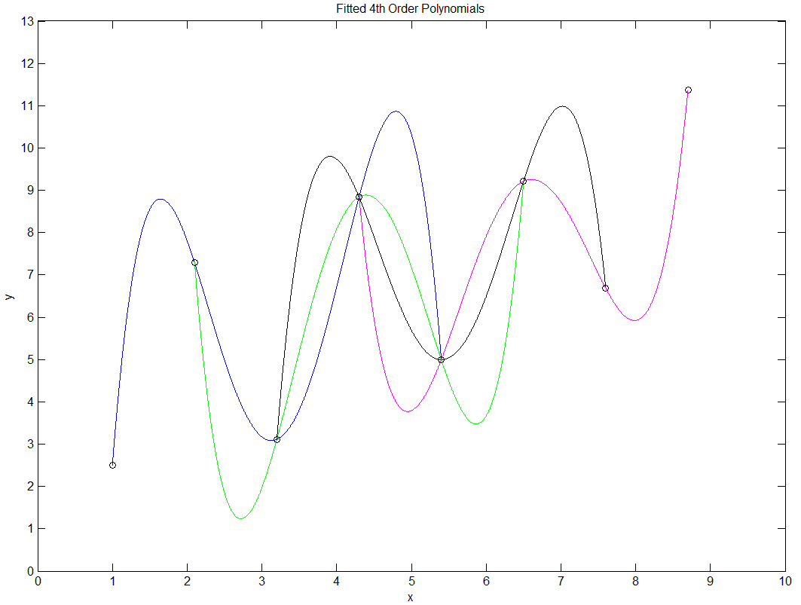

Answer

[xd yd] = textread('prog7.dat');
n = length(xd);
color = ['k','k','b','g','k','m','k','k'];
hold on;
box on;
for(k = 3:n-2)
xd5 = [xd(k-2) xd(k-1) xd(k) xd(k+1) xd(k+2)];
yd5 = [yd(k-2) yd(k-1) yd(k) yd(k+1) yd(k+2)];
c4 = polyfit(xd5,yd5,4);
x = xd(k-2):.001:xd(k+2);
y4 = polyval(c4,x);
plot(x,y4,color(k),xd,yd,'ko');
axis([0 10 0 13]);
set(gca,'xtick',0:10);
set(gca,'ytick',0:13);
xlabel('x');
ylabel('y');
title('Fitted 4th Order Polynomials');
end
8) Write a MATLAB program as follows:

1) Read a data file (prog8.dat) that has values of x and y (data points).

2) For each data point from the third one to the third to last one, do
the following:

a) Fit a second order polynomial to that data point and the data point
on either side of it (fit the second order polynomial to three data
points).

b) Fit a fourth order polynomial to that data point and the two data
points on either side of it (fit the fourth order polynomial to
five data points).

c) Use the fitted second order and fourth order polynomials to calculate
numerical values for the first and second derivatives at that data point.
Use the variables der2 and der4 for the first derivative obtained from the
fitted second and fourth order polynomials, respectively, and use the
variables secder2 and secder4 for the second derivative obtained from the
fitted second and fourth order polynomials, respectively.

d) Print the x coordinate of the data point and the numerical
derivatives obtained from the fitted polynomials.

The output of this program should look like this:

x=-2.0 der2=0.518 der4= 0.538 secder2= 7.786 secder4= 10.348
x=-0.9 der2=0.567 der4= 0.612 secder2=-7.697 secder4=-10.237
x= 0.2 der2=0.345 der4= 0.319 secder2= 7.293 secder4= 9.768
x= 1.3 der2=0.279 der4= 0.197 secder2=-7.413 secder4= -9.939
x= 2.4 der2=0.705 der4= 0.751 secder2= 8.188 secder4= 10.830
x= 3.5 der2=0.858 der4= 0.998 secder2=-7.911 secder4=-10.466
x= 4.6 der2=0.169 der4=-0.046 secder2= 6.658 secder4= 8.891
x= 5.7 der2=0.766 der4= 0.829 secder2=-5.572 secder4= -7.553

Answer

[xd yd] = textread('prog8.dat');
n = length(xd);
for(k = 3:n-2)
xd3 = [xd(k-1) xd(k) xd(k+1)];
yd3 = [yd(k-1) yd(k) yd(k+1)];
xd5 = [xd(k-2) xd(k-1) xd(k) xd(k+1) xd(k+2)];
yd5 = [yd(k-2) yd(k-1) yd(k) yd(k+1) yd(k+2)];
c2 = polyfit(xd3,yd3,2);
c4 = polyfit(xd5,yd5,4);
cder2 = polyder(c2);
der2 = polyval(cder2,xd(k));
csecder2 = polyder(cder2);
secder2 = polyval(csecder2,xd(k));
cder4 = polyder(c4);
der4 = polyval(cder4,xd(k));
csecder4 = polyder(cder4);
secder4 = polyval(csecder4,xd(k));
fprintf('x=%4.1f der2=%5.3f der4=%6.3f secder2=%6.3f secder4=%7.3f\n',...
xd(k),der2,der4,secder2,secder4);
end

9) Consider the following Poisson Equation for u(x,y) for 0 ≤ x ≤ 1 and
0 ≤ y ≤ 1 :

with the following Dirichlet boundary conditions:

u(x,0) = gbottom(x) = 1-x² , u(x,1) = gtop(x) = 4(1-x²)

u(0,y) = gleft(y) = 1+y² , u(1,y) = gright(y) = 0

NOTE: There will be 4 functions, named gbottom(x), gtop(x), gleft(y) and
gright(y), that give the boundary conditions on the bottom (y=0),
top (y=1), left (x=0) and right (x=1) sides of the square.

Write a MATLAB program as follows:

1) Use the 5-point scheme to calculate numerical values for the unknown u
for 0 < x < 1 and 0 < y < 1 . Divide both the x interval [0, 1] and the
y interval [0, 1] into 25 equal subdivisions (there will be 26 equally
spaced grid points in both the x and y intervals). Use 1e-8 as the
accuracy factor. The main program will call a function named poisson
that solves the Poisson Equation for the unknown u and returns it to the
main program. The first line of poisson is:

function u=poisson(f,gbottom,gtop,gleft,gright,n,L,accuracy)

where n is the number of grid points in both the x and y intervals, and
L is the length of both the x and y intervals.

2) Plot u versus x and y for 0 ≤ x ≤ 1 and 0 ≤ y ≤ 1 . u will be a surface
in 3-dimensional space. Use the MATLAB function surf to plot u. Do not
write any other statements for the graph except the surf statement.

There are two parts to this problem:

a) Write the main program.
b) Write the function poisson.

Problem 9 Part a Answer

% main program
L=1;
n=26;
accuracy=1e-8;
f=@(x,y) -2*(x^2+y^2);
gbottom=@(x) 1-x^2;
gtop=@(x) 4*(1-x^2);
gleft=@(y) 1+y^2;
gright=@(y) 0;
u=poisson(f,gbottom,gtop,gleft,gright,n,L,accuracy);
h=L/(n-1);
x=0:h:L;
y=0:h:L;
surf(x,y,u');
Problem 9 Part b Answer

Before writing the function poisson, obtain the equation to be iterated by
doing the following:

1) Approximate the second order partial derivatives in the Poisson Equation
by the 3-point second order central difference formula, using the point
with indices i,j as the central point:

where u_{i,j} = u(i,j) , f_{i,j} = f(x_{i},y_{j}) , and h is the stepsize in both the
x and y intervals.

2) Solve the equation for u_{i,j} :
Then write the function poisson:

% function poisson
function u=poisson(f,gbottom,gtop,gleft,gright,n,L,accuracy)
h=L/(n-1);
u=zeros(n,n);
for(i=1:n)
u(i,1)=gbottom((i-1)*h);
u(i,n)=gtop((i-1)*h);
end
for(j=1:n)
u(1,j)=gleft((j-1)*h);
u(n,j)=gright((j-1)*h);
end
max_diff = 1;
while(max_diff >= accuracy)
max_diff = 0;
for(i = 2:n-1)
for(j = 2:n-1)
uij_old = u(i,j);
u(i,j) = (u(i-1,j)+u(i+1,j)+u(i,j-1)+u(i,j+1) ...
-h^2*f((i-1)*h,(j-1)*h))/4;
diff = abs(u(i,j)-uij_old);
if(diff > max_diff)
max_diff = diff;
end
end
end
end

10) Consider the following Poisson equation for u(x,y) for 0 ≤ x ≤ 2 and
0 ≤ y ≤ 1 :

with the following Dirichlet boundary conditions:

u(x,0) = gbottom(x) = 1-x² , u(x,1) = gtop(x) = 4(1-x²)

u(0,y) = gleft(y) = 1+y² , u(2,y) = gright(y) = 2

NOTE: The x and y intervals have different lengths in this problem (the
length of the x interval is 2 and the length of the y interval is 1).
Use the variables Lx and Ly for the lengths of the x and y intervals,
nx and ny for the number of grid points in the x and y intervals
(the number of grid points is different in the x and y intervals),
and hx and hy for the stepsizes in the x and y intervals
(the stepsize is different in the x and y intervals).

NOTE: There will be 4 functions, named gbottom(x), gtop(x), gleft(y) and
gright(y), that give the boundary conditions on the bottom (y=0),
top (y=1), left (x=0) and right (x=2) sides of the rectangle.

Write a MATLAB program as follows:

1) Use the 5-point scheme to calculate numerical values for the unknown u
for 0 < x < 2 and 0 < y < 1 . Divide the x interval [0, 2] into 52 equal
subdivisions (there will be 53 equally spaced grid points in the x
direction), and divide the y interval [0, 1] into 20 equal subdivisions
(there will be 21 equally spaced grid points in the y direction).
Use 1e-8 as the accuracy factor. The main program will call a function
named poisson2 that solves the Poisson Equation for the unknown u and
returns it to the main program. The first line of poisson2 is:

function u = poisson2(f,gbottom,gtop,gleft,gright,nx,ny,Lx,Ly,accuracy)

where f(x,y) is the function on the right of the equals sign in the
Poisson Equation, accuracy is the accuracy factor, and the other
parameters of poisson2 are defined above.

2) Plot u versus x and y for 0 ≤ x ≤ 2 and 0 ≤ y ≤ 1 . u will be a surface
in 3-dimensional space. Use the MATLAB function surf to plot u. Do not
write any other statements for the graph except the surf statement.

There are two parts to this problem:

a) Write the main program.

b) Write the function poisson2.

Problem 10 Part a Answer

% main program
Lx = 2;
Ly = 1;
nx = 53;
ny = 21;
accuracy = 1e-8;
f=@(x,y) -2*(x^2+y^2);
gbottom=@(x) 1-x^2;
gtop=@(x) 4*(1-x^2);
gleft=@(y) 1+y^2;
gright=@(y) 2;
u = poisson2(f,gbottom,gtop,gleft,gright,nx,ny,Lx,Ly,accuracy);
hx = Lx/(nx-1);
hy = Ly/(ny-1);
x = 0:hx:Lx;
y = 0:hy:Ly;
surf(x,y,u');

Problem 10 Part b Answer

% function poisson2
function u = poisson2(f,gbottom,gtop,gleft,gright,nx,ny,Lx,Ly,accuracy)
hx = Lx/(nx-1);
hy = Ly/(ny-1);
u = zeros(nx,ny);
for(i = 1:nx)
u(i,1) = gbottom((i-1)*hx);
u(i,ny) = gtop((i-1)*hx);
end
for(j = 1:ny)
u(1,j) = gleft((j-1)*hy);
u(nx,j) = gright((j-1)*hy);
end
max_diff = 1;
while(max_diff >= accuracy)
max_diff = 0;
for(i = 2:nx-1)
for(j = 2:ny-1)
uij_old = u(i,j);
u(i,j) = ( hy^2*(u(i-1,j)+u(i+1,j)) + hx^2*(u(i,j-1)+u(i,j+1)) ...
-hx^2*hy^2*f((i-1)*hx,(j-1)*hy) ) / (2*(hx^2+hy^2));
diff = abs(u(i,j)-uij_old);
if(diff > max_diff)
max_diff = diff;
end
end
end
end

11) Consider the following One-Dimensional Heat Equation for u(x,t) for
0 ≤ x ≤ 1 and 0 ≤ t ≤ .2:
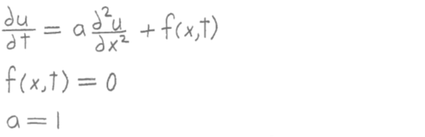

with the following initial conditions:

u(x,0) = u0(x) = sin(πx)

and the following boundary conditions:

u(0,t) = gleft(t) = 0

u(1,t) = gright(t) = 0

Write a MATLAB program as follows:

1) Use the explicit full discretization scheme to calculate numerical
values for the unknown u(x,t) for 0 < x < 1 and 0 < t ≤ .2 . Divide the
x interval [0, 1] into 12 equal subdivisions and the t interval [0, .2]
into 96 equal subdivisions (there will be 13 equally spaced grid points
in the x interval and 97 equally spaced grid points in the t interval).
Use the variables L for the length of the x interval, T for the length
of the t interval, nx and nt for the number of grid points in the x and
t intervals, and hx and ht for the stepsizes in the x and t intervals.
The main program will call a function named heat1 that solves the
One-Dimensional Heat Equation for the unknown u and returns it to the
main program. The first line of heat1 is:

function u = heat1(f, u0, gleft, gright, a, nx, nt, L, T)

2) Plot u versus x and t for 0 ≤ x ≤ 1 and 0 ≤ t ≤ .2 . u will be a surface
in 3-dimensional space. Use the MATLAB function surf to plot u. Do not
write any other statements for the graph except the surf statement.

There are two parts to this problem:

a) Write the main program.

b) Write the function heat1.

Problem 11 Part a Answer

% main program
L = 1;
T = .2;
a = 1;
f = @(x,t) 0;
u0 = @(x) sin(pi*x);
gleft = @(t) 0;
gright = @(t) 0;
nx = 13;
nt = 97;
u = heat1(f, u0, gleft, gright, a, nx, nt, L, T);
hx = L/(nx-1);
ht = T/(nt-1);
x = 0 : hx : L;
t = 0 : ht : T;
surf(x, t, u');

The answer to Problem 11 Part b is on the next page.

Problem 11 Part b Answer

Before writing the function heat1, obtain the equation to be used in the
explicit scheme by doing the following:

1) In the One-Dimensional Heat Equation, approximate the first order
partial derivative by the 2-point first order forward difference
formula and approximate the second order partial derivative by the
3-point second order central difference formula, using the point with
indices i,k-1 as the central point:

where u_{i,k} = u(i,k) , f_{i,k-1} = f(x_{i},t_{k-1}) , and h_{x} and h_{t} are the
stepsizes in the x and t intervals.

2) Solve the equation for u_{i,k} :

Then write the function heat1:

% function heat1
function u = heat1(f, u0, gleft, gright, a, nx, nt, L, T)
hx = L/(nx-1);
ht = T/(nt-1);
u = zeros(nx, nt);
for(i = 1 : nx)
u(i,1) = u0( (i-1)*hx );
end
for(k = 2 : nt)
u(1,k) = gleft( (k-1)*ht );
u(nx,k) = gright( (k-1)*ht );
end
for(k = 2 : nt)
for(i = 2 : nx-1)
u(i,k) = ht*a/hx^2*( u(i-1,k-1) - 2*u(i,k-1) + u(i+1,k-1) ) ...
+ ht * f( (i-1)*hx, (k-2)*ht ) + u(i,k-1);
end
end

12) Consider the following 2 Dimensional heat equation for u(x,y,t)
for 0 ≤ x ≤ 2, 0 ≤ y ≤ .6, and 0 ≤ t ≤ .2:

With the following initial conditions:

and the following Dirichlet boundary conditions:

NOTE: The x and y intervals have different lengths in this problem (the
length of the x interval is 2 and the length of the y interval is .6).
Use the variables Lx and Ly for the lengths of the x and y intervals,
nx and ny for the number of grid points in the x and y intervals
(the number of grid points is different in the x and y intervals),
and hx and hy for the stepsizes in the x and y intervals
(the stepsize is different in the x and y intervals). Use the
variable T for the size of the t interval and the variables nt and
ht for the number of grid points and the stepsize in the t interval.

There will be 4 functions, named gbottom, gtop, gleft and gright,
that give the boundary conditions on the bottom (y=0), top (y=.6),
left (x=0) and right (x=2) sides of the rectangle, respectively.

Write a MATLAB program as follows:

1) Use the explicit full discretization scheme to calculate numerical values
for the unknown u(x,y,t) for 0 < x < 2, 0 < y < .6 and 0 < t ≤ .2 .
Divide the x interval [0, 2] into 52 equal subdivisions (there will be 53
equally spaced grid points in the x direction), divide the y interval
[0, .6] into 20 equal subdivisions (there will be 21 equally spaced grid
points in the y direction), and divide the t interval [0, .2]
into 192 equal subdivisions (there will be 193 equally spaced grid points
in the t direction).
The main program will call a function named heat2 that solves the
Two-Dimensional Heat Equation for the unknown u and returns it to the
main program. The first line of heat2 is:

function u = heat2(f,u0,gbottom,gtop,gleft,gright,a,nx,ny,nt,Lx,Ly,T)

2) Plot u versus x and y for the t index k = 7 . u will be a surface
in 3-dimensional space. Use the MATLAB function surf to plot u. Do not
write any other statements for the graph except the surf statement.

There are two parts to this problem:

a) Write the main program.

b) Write the function heat2.

Problem 12 Part a Answer

% main program
Lx = 2;
Ly = .6;
T = .2;
a = 4/pi^2;
f = @(x,y,t) -8/pi^2*sin(pi*x)*cos(pi*y)*exp(t);
u0 = @(x,y) sin(pi/2*x)*sin(pi*y) + x*y + 2*x*(1-y);
gbottom = @(x,t) 2*x*cos(pi*t);
gtop = @(x,t) x*cos(pi*t);
gleft = @(y,t) 0;
gright = @(y,t) ( 2*y + 4*(1-y) )*cos(pi*t) ;
nx = 53;
ny = 21;
nt = 193;
u = heat2(f,u0,gbottom,gtop,gleft,gright,a,nx,ny,nt,Lx,Ly,T);
hx = Lx/(nx-1);
hy = Ly/(ny-1);
x = 0:hx:Lx;
y = 0:hy:Ly;
u2 = u(:,:,7);
surf(x,y,u2');
Problem 12 Part b Answer

% function heat2
function u = heat2(f,u0,gbottom,gtop,gleft,gright,a,nx,ny,nt,Lx,Ly,T)
hx=Lx/(nx-1);
hy=Ly/(ny-1);
ht=T/(nt-1);
u=zeros(nx,ny,nt);
for(i=1:nx)
for(j=1:ny)
u(i,j,1)=u0((i-1)*hx,(j-1)*hy);
end
end
for(k=2:nt)
for(i = 1:nx)
u(i,1,k) = gbottom((i-1)*hx,(k-1)*ht);
u(i,ny,k) = gtop((i-1)*hx,(k-1)*ht);
end
for(j = 1:ny)
u(1,j,k) = gleft((j-1)*hy,(k-1)*ht);
u(nx,j,k) = gright((j-1)*hy,(k-1)*ht);
end
end
for(k=2:nt)
for(i=2:nx-1)
for(j=2:ny-1)
u(i,j,k) = ht*a/hx^2*(u(i-1,j,k-1)-2*u(i,j,k-1)+u(i+1,j,k-1)) ...
+ ht*a/hy^2*(u(i,j-1,k-1)-2*u(i,j,k-1)+u(i,j+1,k-1)) ...
+ ht*f((i-1)*hx,(j-1)*hy,(k-2)*ht) + u(i,j,k-1);
end
end
end

13) Consider the following One-Dimensional Wave Equation for u(x,t) for
0 ≤ x ≤ 2π and 0 ≤ t ≤ 6:

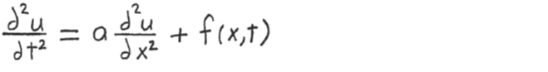

with the following initial conditions at t=0:

u(x,0) = u0(x) = sin(x/2),

v(x,0) = v0(x) = -sin(x/2)

and the following boundary conditions:

u(0,t) = gleft(t) = sin(π/6*t)

u(2π,t) = gright(t) = sin(π/12*t)

Write a MATLAB program as follows:

1) Use the explicit full discretization scheme to calculate numerical values
for the unknown u(x,t) for 0 < x < 2π and 0 < t ≤ 6 . Divide the x
interval [0, 2π] into 20 equal subdivisions and the t interval [0, 6]
into 30 equal subdivisions (there will be 21 equally spaced grid points
in the x interval and 31 equally spaced grid points in the t interval).
Use the variables L and T for the lengths of the x and t intervals,
nx and nt for the number of grid points in the x and t intervals, and
hx and ht for the stepsizes in the x and t intervals.
The main program will call a function named wave1 that solves the
One-Dimensional Wave Equation for the unknown u and returns it to the
main program. The first line of wave1 is:

function u = wave1(f,u0,v0,gleft,gright,a,nx,nt,L,T)

2) Plot u versus x and t for 0 ≤ x ≤ 2π and 0 ≤ t ≤ 6 . u will be a surface
in 3-dimensional space. Use the MATLAB function surf to plot u. Do not
write any other statements for the graph except the surf statement.

There are two parts to this problem:

a) Write the main program.

b) Write the function wave1.

Problem 13 Part a Answer

% main program
L = 2*pi;
T = 6;
a = 1/(4*pi^2);
f = @(x,t) 2*exp(-t/2)*sin(x/2);
u0 = @(x) sin(x/2);
v0 = @(x) -sin(x/2);
gleft = @(t) sin(pi/6*t);
gright = @(t) sin(pi/12*t);
nx = 21;
nt = 31;
u = wave1(f,u0,v0,gleft,gright,a,nx,nt,L,T);
hx = L/(nx-1);
ht = T/(nt-1);
x = 0:hx:L;
t = 0:ht:T;
surf(x,t,u');

The answer to Problem 13 Part b is on the next page.

Problem 13 Part b Answer

Before writing the function wave1, obtain the equation to be used in the
explicit scheme by doing the following:

1) Approximate the second order partial derivatives in the One-Dimensional
Wave Equation by the 3-point second order central difference formula,
using the point with indices i,k-1 as the central point:

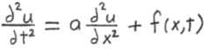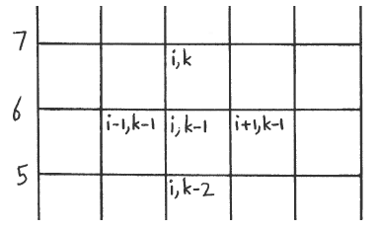

where u_{i,k} = u(i,k) , f_{i,k-1} = f(x_{i},t_{k-1}) , and h_{x} and h_{t} are the stepsizes
in the x and t intervals.

2) Solve the equation for u_{i,k} :

NOTE: This equation can be used only for k ≥ 3 . It cannot be used
for k = 2 because when k = 2, the term u_{i,k-2} becomes u_{i,0} which
is undefined because the second index cannot be less than 1
(1 corresponds to t=0; if the second index were less than 1,
it would correspond to a negative time).

3) In order to obtain an equation that can be used when k = 2, do the
following:

3a) The velocity v is the first derivative of u with respect to time:

3b) Approximate the first order partial derivative in the above equation
by the 2-point backward difference formula, using the point with
indices i,k-1 as the central point:

where v_{i,k-1} = v(x_{i},t_{k-1}).

3c) Solve this equation for u_{i,k-2} :

3d) Substitute this equation for u_{i,k-2} into the equation in step 2 above:

Use the above equation for k = 2 in which case v_{i,k-1} becomes v_{i,1} which
is given by the initial velocity v0 since t₁ = 0:

v_{i,1} = v(x_{i},t₁) = v(x_{i},0) = v0(x_{i}) .

Then write the function wave1:

% function wave1
function u = wave1(f,u0,v0,gleft,gright,a,nx,nt,L,T)
hx = L/(nx-1);
ht = T/(nt-1);
u = zeros(nx,nt);
for(i = 1:nx)
u(i,1) = u0((i-1)*hx);
end
for(k = 2:nt)
u(1,k) = gleft((k-1)*ht);
u(nx,k) = gright((k-1)*ht);
end
k = 2;
for(i = 2:nx-1)
u(i,k) = ht^2*a/hx^2*(u(i-1,k-1) - 2*u(i,k-1) + u(i+1,k-1)) ...
+ ht^2*f((i-1)*hx,(k-2)*ht) + u(i,k-1) + ht*v0((i-1)*hx);
end
for(k = 3:nt)
for(i = 2:nx-1)
u(i,k) = ht^2*a/hx^2*(u(i-1,k-1) - 2*u(i,k-1) + u(i+1,k-1)) ...
+ ht^2*f((i-1)*hx,(k-2)*ht) + 2*u(i,k-1) - u(i,k-2);
end
end

