Sample 5a

The angular velocity ω of a particle moving in a circle is 3 rad/s at t=0.
The differential equation for ω is

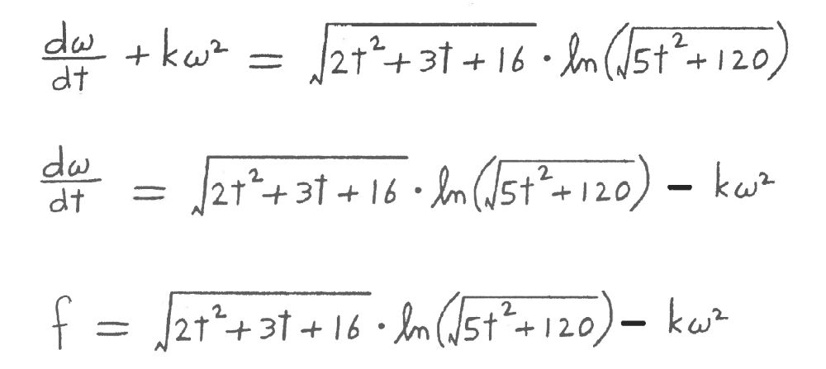

where k=.0547 .

Write a MATLAB program to do the following:

1) t will go from 0 to 4 sec in steps of .001 sec .

2) Calculate ω for each value of t. Use 1e-7 as the accuracy factors.

3) Plot ω versus t in blue. The graph should look like the one on the
attached sheet.

