## Sample 11

**Consider the following One-Dimensional Heat Equation for u(x,t) for 0 ≤ x ≤ 1**

**and 0 ≤ t ≤ .2:**

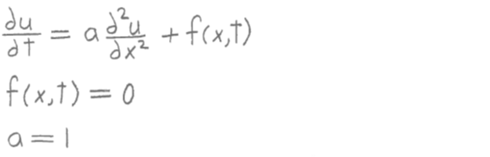

**with the following initial conditions:**

**u(x,0) = u0(x) = sin(x)**

**and the following boundary conditions:**

**u(0,t) = gleft(t) = 0**

**u(1,t) = gright(t) = 0**

**Write a MATLAB program as follows:**

**1) Use the explicit full discretization scheme to calculate numerical values**

**for the unknown u(x,t) for 0 < x < 1 and 0 < t ≤ .2 . Divide the x**

**interval [0, 1] into 12 equal subdivisions and the t interval [0, .2]**

**into 96 equal subdivisions (there will be 13 equally spaced grid points**

**in the x interval and 97 equally spaced grid points in the t interval).**

**Use the variables L for the length of the x interval, T for the size of**

**the t interval, nx and nt for the number of grid points in the x and t**

**intervals, and hx and ht for the stepsizes in the x and t intervals.**

**The main program will call a function named heat1 that solves the**

**One-Dimensional Heat Equation for the unknown u and returns it to the**

**main program. The first line of heat1 is:**

**function u = heat1(f, u0, gleft, gright, a, nx, nt, L, T)**

**2) Plot u versus x and t for 0 ≤ x ≤ 1 and 0 ≤ t ≤ .2 . u will be a surface**

**in 3-dimensional space. Use the MATLAB function surf to plot u.**

**The graph should look like the one on the attached sheet.**