**Derivation of the formula for ui,k**

**One-Dimensional Heat Equation**

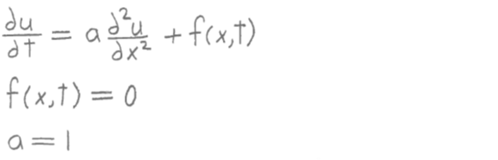

**Before writing the function heat1, obtain the equation to be used in the**

**explicit scheme by doing the following:**

**1) In the One-Dimensional Heat Equation, approximate the first order**

**partial derivative by the 2-point first order forward difference**

**formula and approximate the second order partial derivative by the**

**3-point second order central difference formula, using the point with**

**indices i,k-1 as the central point:**



**where ui,k = u(i,k) , fi,k-1 = f(xi,tk-1) , and hx and ht are the**

**stepsizes in the x and t intervals.**

**2) Solve the equation for ui,k :**

