## Sample 12

**Consider the following One-Dimensional Wave Equation for u(x,t) for 0 ≤ x ≤ 2 and 0 ≤ t ≤ 6:**

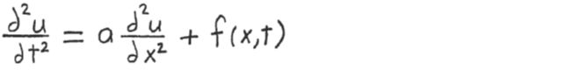





**with the following initial conditions at t=0:**

**u(x,0) = u0(x) = sin(x/2),**

**v(x,0) = v0(x) = -sin(x/2)**

**and the following boundary conditions:**

**u(0,t) = gleft(t) = sin(/6*t)**

**u(2,t) = gright(t) = sin(/12*t)**

**Write a MATLAB program as follows:**

**1) Use the explicit full discretization scheme to calculate numerical values**

**for the unknown u(x,t) for 0 < x < 2 and 0 < t ≤ 6 . Divide the x**

**interval [0, 2] into 20 equal subdivisions and the t interval [0, 6]**

**into 30 equal subdivisions (there will be 21 equally spaced grid points**

**in the x interval and 31 equally spaced grid points in the t interval).**

**Use the variables L and T for the lengths of the x and t intervals,**

**nx and nt for the number of grid points in the x and t intervals, and**

**hx and ht for the stepsizes in the x and t intervals.**

**The main program will call a function named wave1 that solves the**

**One-Dimensional Wave Equation for the unknown u and returns it to the**

**main program. The first line of wave1 is:**

**function u = wave1(f,u0,v0,gleft,gright,a,nx,nt,L,T)**

**2) Plot u versus x and t for 0 ≤ x ≤ 2 and 0 ≤ t ≤ 6 . u will be a surface**

**in 3-dimensional space. Use the MATLAB function surf to plot u.**

**The graph should look like the one on the attached sheet.**