**Derivation of Equation for ui,k in Sample 12**

**One-Dimensional Wave Equation for u(x,t)**



**Before writing the function wave1, obtain the equation to be used in the**

**explicit scheme by doing the following:**

**1) Approximate the second order partial derivatives in the One-Dimensional**

**Wave Equation by the 3-point second order central difference formula,**

**using the point with indices i,k-1 as the central point:**

 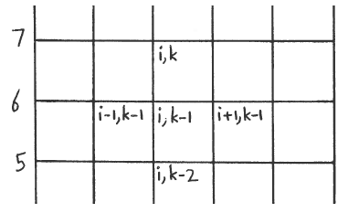



**where ui,k = u(i,k) , fi,k-1 = f(xi,tk-1) , and hx and ht are the stepsizes**

**in the x and t intervals.**

**2) Solve the equation for ui,k :**



**NOTE: This equation can be used only for k ≥ 3 . It cannot be used**

**for k = 2 because when k = 2, the term ui,k-2 becomes ui,0 which**

**is undefined because the second index cannot be less than 1**

**(1 corresponds to t=0; if the second index were less than 1,**

**it would correspond to a negative time).**

**3) In order to obtain an equation that can be used when k = 2, do the**

**following:**

**3a) The velocity v is the first derivative of u with respect to time:**



**3b) Approximate the first order partial derivative in the above equation**

**by the 2-point backward difference formula, using the point with**

**indices i,k-1 as the central point:**



**where vi,k-1 = v(xi,tk-1).**

**3c) Solve this equation for ui,k-2 :**



**3d) Substitute this equation for ui,k-2 into the equation in step 2 above:**



**Use the above equation for k = 2 in which case vi,k-1 becomes vi,1 which**

**is given by the initial velocity v0 since t1 = 0:**

**vi,1 = v(xi,t1) = v(xi,0) = v0(xi) .**