**Sample 6a Steps**

**Convert the second order equation for x:**



**into two first order equations by doing steps a-e below:**

**a) Rearrange the second order equation to get the term containing the second**

**derivative by itself on the left:**

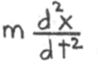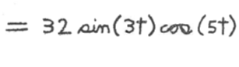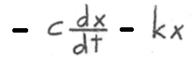

**b) Define the first derivative of x to be the velocity v of the mass:**



**c) Substitute this into the second derivative of x. When this substitution is**

**done, the second derivative of x becomes the first derivative of v:**



**d) Then substitute this into the term that contains the second derivative of x**

**in the equation in part a, and also substitute the equation in part b into**

**the term that contains the the first derivative of x. When these two**

**substitutions are done, the second order equation in part a becomes the**

**following first order equation:**



**e) Then in order to get the first derivative by itself on the left in the**

**above equation, divide both sides of the equation by m:**



**Steps a-e above have converted the second order equation for x in the statement of the probleminto the two first order equations given in steps b and e, where the equation in step b is the first order equation for x and the equation in step e is the first order equation for for v.**