PostgreSQL Administration Lab Manual

Check if postgres instance is running?

ps -ef | grep postgres

The output should look like, and you should see a very big line.

[postgres@lab01 ~]$ ps -ef | grep postgres
root 51600 3208 0 19:45 pts/1 00:00:00 su - postgres
postgres 51601 51600 0 19:45 pts/1 00:00:00 -bash
postgres 51680 1 0 19:46 ? 00:00:00 /usr/local/pgsql/bin/postgres -D /u01/pgsql/16
postgres 51681 51680 0 19:46 ? 00:00:00 postgres: checkpointer
postgres 51682 51680 0 19:46 ? 00:00:00 postgres: background writer
postgres 51684 51680 0 19:46 ? 00:00:00 postgres: walwriter
postgres 51685 51680 0 19:46 ? 00:00:00 postgres: autovacuum launcher
postgres 51686 51680 0 19:46 ? 00:00:00 postgres: logical replication launcher
postgres 51689 51601 0 19:46 pts/1 00:00:00 ps -ef
postgres 51690 51601 0 19:46 pts/1 00:00:00 grep --color=auto postgres
[postgres@lab01 ~]$

From here /usr/local/pgsql/bin/postgres -D /u01/pgsql/16

Installation location - /usr/local/pgsql/bin
Database files location - D /u01/pgsql/16

To login to database

/usr/local/pgsql/bin/psql
[or]
/usr/pgsql-16/bin/psql

To stop postgres

/usr/local/pgsql/bin/pg_ctl stop -D /u01/pgsql/16

There are 3 modes in stopping the cluster. They are
Shutdown modes are:
smart quit after all clients have disconnected
fast quit directly, with proper shutdown (default)
immediate quit without complete shutdown; will lead to recovery on restart

To start postgres

/usr/local/pgsql/bin/pg_ctl start -D /u01/pgsql/16

If home location is /usr/pgsql-16, then to stop/start use

/usr/pgsql-16/bin/pg_ctl stop -D /u01/pgsql/16
/usr/pgsql-16/bin/pg_ctl start -D /u01/pgsql/16

Module 3 – Terminate a user connection

Identify the pid

postgres=#
postgres=# select pid, query from pg_stat_activity;
pid | query
-------+------------------------------------------
51685 |
51686 |
51913 | select pid, query from pg_stat_activity;
52017 | select *, pg_sleep(1000) from emp;
51682 |
51681 |
51684 |
(7 rows)

To cancel the backend

postgres=# select pg_cancel_backend('52017');
pg_cancel_backend
-------------------
t
(1 row)

2023-12-29 20:00:00.983 IST [52017] ERROR: canceling statement due to user request
2023-12-29 20:00:00.983 IST [52017] STATEMENT: select *, pg_sleep(1000) from emp;
postgres=#

To terminate the backend

postgres=# select pg_terminate_backend('52017');
2023-12-29 20:00:17.664 IST [52017] FATAL: terminating connection due to administrator command
2023-12-29 20:00:17.664 IST [52017] STATEMENT: select *, pg_sleep(1000) from emp;
pg_terminate_backend
----------------------
t
(1 row)

Two parameters that control idle sessions are

idle_in_transaction_session_timeout
idle_session_timeout

PostgreSQL Installation
Lab Exercise – 1: source code installation [optional]

1. Download software from internet
wget https://ftp.postgresql.org/pub/source/v16.1/postgresql-16.1.tar.gz

2. Extract the software
tar -xf postgresql-16.1.tar.gz

pre-requisites

Package | Check if it is there | What should be there | If not there
make | make --version | >3.80 | dnf install make
gcc | rpm -qa | grep gcc | gcc-* | dnf install gcc
readline | rpm -qa | grep readline | readline, readline-devel | dnf install readline*
zlib | rpm -qa | grep zlib | zlib, zlib-devel | dnf install zlib*
libicu | Rpm -qa | grep libicu | Libicu, libicu-devel | dnf install libicu-devel

Switch to extracted location and install the software

cd postgresql-16.1/

./configure #check whether pre-requisites met or not?
make #compile all C programs
make install #run c programs

cd contrib/ #switch to contrib folder to install contrib module
make #compile all C programs
make install #run c programs

Prepare your data directory

useradd postgres #add user to do postgres activities
passwd postgres #give password
mkdir -p /u01 #create main directory
chown -R postgres:postgres /u01 #make postgres as owner
su - postgres #switch
mkdir -p /u01/pgsql/16 #prepare data directory
Initialize, start and login to the database cluster

/usr/local/pgsql/bin/initdb -D /u01/pgsql/16 #initialize
/usr/local/pgsql/bin/pg_ctl -D /u01/pgsql/16 start #start
/usr/local/pgsql/bin/psql #login
create extension pg_buffercache; #create extension after login

Lab Exercise – 2-1

In this lab exercise you can practice installing PostgreSQL on Cent OS 8

- Connect to your Linux machine as root

- Use useradd command to create a _minnew user, create /u01 and make postgres as owner

useradd postgres
passwd postgres
mkdir -p /u01
chown -R postgres:postgres /u01

- Install the repository RPM:

dnf install -y https://download.postgresql.org/pub/repos/yum/reporpms/EL-8-x86_64/pgdg-redhat-repo-latest.noarch.rpm

- Disable the built-in PostgreSQL module:

dnf -qy module disable postgresql

- Install PostgreSQL:

dnf install -y postgresql16-server postgresql16-contrib

- Create a database cluster and start the cluster using services:

/usr/pgsql-16/bin/postgresql-16-setup initdb

- Enable autostart for PostgreSQL service:

systemctl enable postgresql-16

- Start PostgreSQL Service:

systemctl start postgresql-16

- Check status of PostgreSQL Service

systemctl status postgresql-16

Lab Exercise – 2-2*

Choose the custom location for data directory for installing PostgreSQL cluster.

- Install the repository RPM:

dnf install -y https://download.postgresql.org/pub/repos/yum/reporpms/EL-8-x86_64/pgdg-redhat-repo-latest.noarch.rpm

- Disable the built-in PostgreSQL module:

dnf -qy module disable postgresql

- Install PostgreSQL:
dnf install -y postgresql16-server postgresql16-contrib

- Decide the database directory:

#as root user, if you haven’t performed it Lab Exercise 1
mkdir -p /u01
chown -R postgres:postgres /u01

su - postgres
mkdir -p /u01/pgsql/15

- Initialize, start and login to the cluster

/usr/pgsql-16/bin/initdb -D /u01/pgsql/16
/usr/pgsql-16/bin/pg_ctl -D /u01/pgsql/16 start
/usr/pgsql-16/bin/psql

- Install pg_buffercache extension

Create extension pg_buffercache;

Lab Exercise - 3

RPM Installation method.

- Download required rpms

Browse
https://download.postgresql.org/pub/repos/yum/16/redhat/rhel-8-x86_64/

wget https://download.postgresql.org/pub/repos/yum/16/redhat/rhel-8-x86_64/postgresql16-libs-16.1-4PGDG.rhel8.x86_64.rpm

wget https://download.postgresql.org/pub/repos/yum/16/redhat/rhel-8-x86_64/postgresql16-16.1-4PGDG.rhel8.x86_64.rpm

wget https://download.postgresql.org/pub/repos/yum/16/redhat/rhel-8-x86_64/postgresql16-server-16.1-4PGDG.rhel8.x86_64.rpm

wget https://download.postgresql.org/pub/repos/yum/16/redhat/rhel-8-x86_64/postgresql16-contrib-16.1-4PGDG.rhel8.x86_64.rpm

- Install the RPMs

rpm -ivh <.rpm>

rpm -ivh postgresql16-libs-16.1-4PGDG.rhel8.x86_64.rpm
rpm -ivh postgresql16-16.1-4PGDG.rhel8.x86_64.rpm
rpm -ivh postgresql16-server-16.1-4PGDG.rhel8.x86_64.rpm
rpm -ivh postgresql16-contrib-16.1-4PGDG.rhel8.x86_64.rpm

- Decide the database directory:

su - postgres
mkdir -p /u01/pgsql/16

- Initialize, start and login to the cluster

/usr/pgsql-16/bin/initdb -D /u01/pgsql/16
/usr/pgsql-16/bin/pg_ctl -D /u01/pgsql/16 start
/usr/pgsql-16/bin/psql

- Install pg_buffercache extension

Create extension pg_buffercache;

Lab Exercise – 4 [optional]

- Add postgres user to sudoers file

chmod 650 /etc/sudoers

cat /etc/sudoers
## Allow root to run any commands anywhere
root ALL=(ALL) ALL
postgres ALL=(ALL) ALL

- Install required RPMs (required for postgresql15-devel module)

yum install epel-release
dnf --enablerepo=powertools install perl-IPC-Run -y
dnf install postgresql15-devel

- Install few prerequisites (During few extensions installation)

yum install libzstd-devel
yum install libzstd
yum install readline* -y
yum install zlib* -y
yum install openssl* -y
yum install lz4-devel -y
yum install perl-devel -y

- Passwordless connectivity between two machines (During backup and recovery)

ssh-keygen -t rsa
ssh postgres@192.168.110.204 mkdir -p .ssh
cat .ssh/id_rsa.pub | ssh postgres@192.168.110.204 'cat >> .ssh/authorized_keys'
ssh postgres@192.168.110.204 "chmod 700 .ssh; chmod 640 .ssh/authorized_keys"
ssh postgres@192.168.110.204

ssh-keygen -t rsa
ssh postgres@192.168.110.148 mkdir -p .ssh
cat .ssh/id_rsa.pub | ssh postgres@192.168.110.148 'cat >> .ssh/authorized_keys'
ssh postgres@192.168.110.148 "chmod 700 .ssh; chmod 640 .ssh/authorized_keys"
ssh postgres@192.168.110.148

- Running multiple servers/clusters/same version/different version

Initialize new cluster and modify port number before starting up
change the port number in postgresql.conf file

port=5444

- same version client/server

[postgres@lab01 15]$ /usr/pgsql-15/bin/psql
psql (15.4)
Type "help" for help.

postgres=# \q

- lower version client on server

[postgres@lab01 15]$ /usr/pgsql-14/bin/psql
psql (14.9, server 15.4)
WARNING: psql major version 14, server major version 15.
Some psql features might not work.
Type "help" for help.

postgres=# \q

- higher version client on server

[postgres@lab01 15]$ /u
u01/ usr/
[postgres@lab01 15]$ /usr/local/pgsql/bin/psql
psql (16.0, server 15.4)
Type "help" for help.

- Setting up bash profile

[postgres@lab01 ~]$ cat .bash_profile
# .bash_profile

# Get the aliases and functions
if [ -f ~/.bashrc ]; then
. ~/.bashrc
fi

PHOME=/usr/pgsql-16
PATH=$PHOME/bin:$PATH

# User specific environment and startup programs

- Custom location for data directory for root approach

# install postgresql
dnf install postgresql15-server

# Edit configuration file
[root@lab01 system]# cat /lib/systemd/system/postgresql-15.service | grep Environment
# Note: avoid inserting whitespace in these Environment= lines, or you may
Environment=PGDATA=/u01/pgsql/15/
Environment=PG_OOM_ADJUST_FILE=/proc/self/oom_score_adj
Environment=PG_OOM_ADJUST_VALUE=0
[root@lab01 system]#

# Reload the service
systemctl daemon-reload

# initialize the database and enable automatic start:

sudo /usr/pgsql-15/bin/postgresql-15-setup initdb
sudo systemctl enable postgresql-15
sudo systemctl start postgresql-15

- Uninstallation

#root approach
dnf remove postgresql16*

#source code approach
Cd /root/postgresql-16.1/contrib
Make clean

Cd /root/postgresql-16.1
Make clean

Module 4 – Post Installation steps

Setting Environmental Variables
Add the following two lines in /home/postgres/.bash_profile and do
. .bash_profile

POSTGRES_HOME=/usr/local/pgsql; export POSTGRES_HOME
PATH=$POSTGRES_HOME/bin:$PATH; export PATH

EXAMPLE BASH PROFILE FOR v14 Installation

[postgres@lab01 ~]$ cat .bash_profile
# .bash_profile

# Get the aliases and functions
if [ -f ~/.bashrc ]; then
. ~/.bashrc
fi

# User specific environment and startup programs
PHOME=/usr/pgsql-16
PATH=$PHOME/bin:$PATH:$HOME/.local/bin:$HOME/bin

export PATH

psql Environment Var iables

Command- Line Opt ion Environment Var iable Meaning
-d <dbname> PGDATABASE Name of database to connect to
-h <host> PGHOST Name of host to connect to
-p <port> PGPORT Por t number to connect to
-U <user> PGUSER PostgreSQL Username

Post PostgreSQL Installation steps

- Change password.

[postgres@lab01 ~]$ /usr/local/pgsql/bin/psql
psql (16.1)
Type "help" for help.

postgres=#

postgres=# \password
Enter new password:
Enter it again:
postgres=#

- Enable external connectivity

- Edit postgresql.conf file with

listen_addresses = '*' # (change requires restart)

- Edit pg_hba.conf with

host all all 0.0.0.0/0 md5 #reload

- Restart the cluster with below command.

pg_ctl restart -D /u01/pgsql/16

- Enable 5432 port or disable firewall

firewall-cmd --zone=public --add-port=5432/tcp --permanent
firewall-cmd –reload

[or]

Systemctl stop firewalld

- Use pgtune to set parameters.

- Login to the below website
- https://pgtune.leopard.in.ua/#/
- Enter your operating system resource details and get parameter details
- Make changes in postgresql.conf file.
- Restart the cluster

Setting PostgreSQL parameters
Most people will directly change settings in postgresql.conf silently, assuming that this is the place to change PostgreSQL configuration parameters. However, this is not the only place you can use. The purpose of this blog is to show you which other options you have and how you can use these features to make your database configuration better.
For the sake of simplicity, I will use an easy configuration parameter to demonstrate how PostgreSQL operates

postgres=# show work_mem;
work_mem
----------
40MB
(1 row)

postgres=#

The first thing you have to learn is how to figure out where configuration parameters actually come from. To do that, take a look at the pg_settings view:

SELECT * FROM pg_settings WHERE name = 'work_mem';

postgresql.conf allows to include files. The idea is to give users the chance to break up postgresql.conf into smaller chunks.
What are the various ways you can change the value?
postgresql.conf and included files

The rule here is simple: If your parameter is used inside a configuration file more than once, the LAST entry is going to be taken. In general, a parameter should only be in a config file once, but in case an error happens, you can be sure that the last entry is the one that counts.

Understanding ALTER SYSTEM

After the builtin settings, after taking what there is in postgresql.conf and after taking those include files into account, PostgreSQL will take a look at postgresql.auto.conf. The main question is: What is postgresql.auto.conf? It happens quite frequently, that administrators don’t have full access to the system (e.g. no SSH access). In this case superusers can take advantage of ALTER SYSTEM, which allows you to change PostgreSQL parameters using plain SQL. Here is how it works:

If you run ALTER SYSTEM, the database will made changes to postgresql.auto.conf:
These values will have precedence over postgresql.conf.
Using pg_ctl
you might only want to set it during maintenance mode. Maybe you want to start PostgreSQL on a different port to manually, while fixing a problem, to lock out users. In this case you can pass parameters via pg_ctl directly:

Using ALTER DATABASE SET …
In 80% of cases it is totally enough to either take the built-ins, postgresql.conf, or postgresql.auto.conf. Using -o is already quite rare. However, there is a lot more. Sometimes you want your configuration to be way finer grained. What if a parameter should only be used inside a specific database? Here is how it works:

ALTER USER … SET …
So far changes have been made to postgresql.conf, postgresql.auto.conf, on startup as well as on a per-database level. However, how about specific users? To do that, consider ALTER USER … SET …:

ALTER USER … IN DATABASE … test …
But what if this is still not fine-grained enough? What if you only want to set a value for a user inside a transaction? PostgreSQL can even do that:

Changing PostgreSQL parameter at the session level
Sometimes hardwiring configuration settings is still not flexible enough. In PostgreSQL configuration, parameters can even be changed on a per session level. But be careful: This seemingly simple feature is highly sophisticated. The important thing to consider, is that in PostgreSQL everything is transaction. This includes PostgreSQL configuration parameters, as you can see in the next example:

Assigning parameters to functions
After this introduction, there is a final feature I want to share: Parameters can be assigned to functions.

1. Postgresql.conf
work_mem=1MB

2. Postgresql.auto.conf
work_mem=2MB

3. Command Line Options
work_mem=3MB

pg_ctl start -o "-c work_mem='3MB'"

4. All Roles
work_mem=4MB

alter role all set work_mem='4MB';

5. Database
work_mem=5MB

alter database postgres set work_mem='5MB';

6. Role
work_mem=6MB

alter role digoal set work_mem='6MB';

7. Session (Client Parameter)
work_mem=7MB

set work_mem ='7MB';

8. Transaction
work_mem=8MB

postgres=# begin;
BEGIN
postgres=# set local work_mem='8MB';
SET

9. Function
The parameter is valid in the function. After the function is called, the other parameter value of the highest priority is used.
work_mem=9MB

postgres=# create or replace function f_test() returns void as $$
declare
res text;
begin
show work_mem into res;
raise notice '%', res;
end;
$$ language plpgsql strict set work_mem='9MB';
CREATE FUNCTION

postgres=# select f_test();
NOTICE: 9MB
f_test
--------

(1 row)

Which parameter needs restart?

postgres=# select distinct context from pg_settings;
context
-------------------
Postmaster #Need restart
superuser-backend #Only super user can change
user #Any super user can change with SET
internal #Can only be changed with rebuild
backend #session level reset
sighup #reload
superuser #Only super user can change with SET

(7 rows)

Example.,

select name, setting,context from pg_settings order by context;
name | setting | context
------------------------------------+--------------------------
post_auth_delay | 0 | backend (POSTGRESQL.CONF)
block_size | 8192 | internal (CAN’T DO)
listen_addresses | * | postmaster (RESTART)
log_checkpoints | off | sighup (RELOAD)
log_lock_waits | off | superuser (SET)
log_connections | off | superuser-backend
work_mem | 4096 | user (SET)

View the configurations:
postgres=# select * from pg_db_role_setting;
setdatabase | setrole | setconfig
-------------+---------+------------------
1 | 0 | {work_mem=1MB}
14174 | 0 | {work_mem=10MB}
14174 | 10 | {work_mem=400MB}
(3 rows)
Reset the parameters:
postgres=# alter system reset all;
ALTER SYSTEM

postgres=# alter role postgres reset all;
ALTER ROLE

postgres=# alter database postgres reset all;
ALTER DATABASE

postgres=# alter user postgres in database postgres reset all;
ALTER ROLE

How do you enable alert logging and what are the mandatory parameters?

Set the following parameters in postgresql.conf

log_destination = 'stderr'
logging_collector = on
log_directory = 'log'
log_filename = 'postgresql-%d-%m-%Y.log'

log_line_prefix = '%t [%p]: [%l-1] user=%u,db=%d,app=%a,client=%h '
log_checkpoints = on
log_connections = on
log_disconnections = on

log_lock_waits = on
log_temp_files = 0
log_autovacuum_min_duration = 0
log_error_verbosity = default
log_statement = off
lc_messages='C'

Restart the cluster.

Confirm the changes.

postgres=# show logging_collector
postgres-# ;
logging_collector
-------------------
on
(1 row)

postgres=#

Download sample database

wget https://edu.postgrespro.com/demo-small-en.zip
unzip demo-small-en.zip
psql -f demo-small-en-20170815.sql

Module 4 - psql Tool - Command Line Interfaces

Working with tools

<toolname> --help

Lab Exercise – 1

NOTE: ALL PRACTICE LABS OF MODULE 3 & 4 MUST BE DONE PRIOR TO THIS LAB EXERCISE

  - Connect to database using psql. Type the following command:
psql -h <ip address> -p 5432 -U postgres -d postgres
then type the
postgres password.

  - List all databases.
Type the following command:
\l

  - Switch to the demo database. Type the following command:
\c demo

  - List all the tables
Type the following command
\dt+

  - Describe the tickets table including description. Type the following command: \d tickets

  - List all schemas. Type the following command: \dn

  - List all tablespaces. Type the following command: \db

  - Execute an SQL statement, to save the output to a file.
Type the following command:
\o seats.txt
SELECT * FROM seats;
\o

  - Do the same thing, just saving data, not the column headers. Type the following command:
\t
\o customer_data.txt SELECT * FROM customers;
\o
\t

  - Turn on the expanded table formatting mode. Type the following command:
\x
SELECT * FROM dept;
\x

  - Lists tables, views, and sequences with their associated access privileges.
Type the following command: \dp
  - View the current working directory. Type \! pwd

Exit psql. Type \q

Module 5 – Database Clusters Lab Exercise – 1
- A new website is to be developed for an online music store
  - Create a new cluster with data directory /u01/pgsql/data and ownership of
postgres user
  - Start your cluster
  - Reload your cluster with pg_ctl utility and using pg_reload_conf()
function
  - Stop your cluster with fast mode

Note: Answer of this Lab Exercise is given assuming PATH variable is set in .bash_profile or can be set using export PATH=/usr/pgsql- 16/bin:$PATH

Answer - Lab Exercise-1
- Login as postgres user and in a terminal window and create directory
mkdir -p /u01/pgsql/data

- Create and initialize the cluster. Type the following command:
initdb -D /u01/pgsql/data

- Change the port.
Type
vi /edbdata/postgresql.conf, then click the <INSERT> key

- Change the port to 5433 . Uncomment the parameter and set the port
port = 5433

- Save and close the file. Type <ESC>:wq <Enter>

- Start the cluster.

Type pg_ctl -D /u01/pgsql/data start

- Reload the cluster.
Type the following command:
pg_ctl -D /u01/pgsql/data reload
or connect using psql –p 5433 -U postgres -d postgres and type the following command:
SELECT pg_reload_conf();

- Stop the cluster.
Type the following command:
pg_ctl -D /u01/pgsql/data –mf stop

Module 6 - Configuration Lab Exercise - 1
- You are working as DBA. It is recommended to keep a backup copy of postgresql.conf file before making any changes. Make necessary changes in server parameter file for following settings:
  - Allow up to 200 connected users
  - Reserve 10 connection slots for DBA
  - Set the idle_session_timeout to 10 seconds

Answer Lab Exercise -1
Open a terminal window. Type su – postgres

- Create a copy of config file. Type the following command:
cp /u01/pgsql/16/postgresql.conf
~/postgresql.conf.backup

Open the postgresql.conf file.Type
vi /u01/pgsql/16/postgresql.conf

then click the <INSERT> key.
- Make following Changes:
  - max_connections = 200 (remember to uncomment the line)
  - superuser_reserved_connections = 10 (remember to uncomment the line)
  - idle_session_timeout = 10s (remember to uncomment the line)

- Save the file and close. Type <ESC>:wq <Enter>

- Restart database cluster to implement the changes.

pg_ctl -D /u01/pgsql/16 restart

Lab Exercise – 2

- Working as a DBA is a challenging job and to track down certain activities on the database server logging has to be implemented. Go through the server parameters that control logging and implement the following
  - Save all the error message in a file inside the log folder in your cluster data directory (e.g. /u01/pgsql/16)
  - Log all queries which are taking more than 5 seconds to execute, and their time
  - Log the users who are connecting to the database cluster
  - Make the above changes and verify them

Answer Lab Exercise – 2
- Open a terminal and login as the postgres user. Type
su – postgres then the password.

- Open the postgresql.conf file. Type
vi /u01/pgsql/16/postgresql.conf

- Make following changes:
  - log_directory = 'log'
  - log_min_duration_statement = 5s
  - log_connections = on

- Save the file and close. Type
<Esc>:wq <Enter>

- Reload postgres cluster to implement the changes. Type
pg_ctl -D /u01/pgsql/16 reload

- Verify the changes by connecting to a database in your database cluster.
Type psql -p 5432 -U postgres -d postgres

  - Type the following command:
SHOW log_connections;
SHOW log_min_duration_statement; SHOW log_directory;

Exit psql type \q

Lab Exercise – 3

- Perform the following changes recommended by a senior DBA and verify them. Set:
  - Shared buffer to 256MB
  - Effective cache size to 512MB
  - Maintenance memory to 64MB
  - Temporary memory to 8MB

Answer Lab Exercise - 3

Open a terminal and logon as the postgres user. Type
su - postgres then the password.

Open the postgresql conf file. Type
vi /u01/pgsql/16/postgresql.conf

then type <i> to go into insert mode

- Make following Changes:
  - shared_buffers = 256MB
  - maintenance_work_mem = 64MB
  - effective_cache_size = 512MB
  - work_mem = 8MB

Save the file and close. Type
<ESC>:wq <Enter>

- Restart postgres cluster to implement the changes. Type the following command:
pg_ctl -D /u01/pgsql/16 restart

Lab Exercise - 4
- Vacuuming is an important maintenance activity and needs to be properly configured. Change the following autovacuum parameters on the production server. Set:
  - Autovacuum workers to 6
  - Autovacuum threshold to 100
  - Autovacuum scale factor to 0.3
  - Auto analyze threshold to 100
  - Autovacuum cost limit to 100

Answer Lab Exercise - 4

Open a terminal and logon as the posgres user.
Type
su - postgres then the password.

Open the postgresql conf file. Type <i> to go into insert mode
vi /u01/pgsql/16/postgresql.conf

- Make following Changes:
  - autovacuum_max_workers = 6
  - autovacuum_vacuum_threshold = 100
  - autovacuum_vacuum_scale_factor = 0.3
  - autovacuum_analyze_threshold = 100
  - autovacuum_vacuum_cost_limit = 100

- Save the file and close. Type <ESC>:wq <Enter>

- Reload postgres cluster to implement the changes. Type
pg_ctl -D /u01/pgsql/16 reload

Module 7 - Data Dictionary Lab Exercise - 1
- You are working with different schemas in a database. Write a query to find the list of schemas currently in your search path.

Answer Lab Exercise - 1
Open a terminal and login as the postgres user. Type
su - postgres then the password.

Login with psql

  - Write a query to find the list of schemas currently in your search path. Type
SHOW search_path;
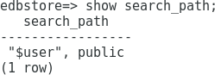

Exit psql type \q

Lab Exercise - 2
- You need to determine the names and definitions of all the views in your schema. Create a report that retrieves view information - the view name and definition text.

Answer Lab Exercise - 2
Open a terminal and login as the postgres user. Type
su - postgres then the password.

Login with psql

  - Create a report that retrieves view information: the view name and definition text.
Type the following command:

SELECT * FROM pg_views WHERE schemaname='bookings';
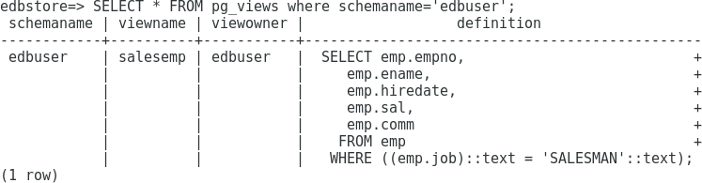

Exit psql type \q

Lab Exercise - 3
- Create report of all the users who are currently connected. The report must display total session time of all connected users.

- You found that a user has connected to the server for a very long time and have decided to gracefully kill its connection. Write a statement to perform this task.

Answer Lab Exercise - 3
Open 2 terminal windows

Login as the postgres user in first.
Type su - postgres then the password.

Login as the postgres user.
Type su - postgres then the password.

  - In first terminal, go to psql and create user

create user demo with password 'demo' superuser;
\c – demo
create table emp(id int,sal int);
insert into emp values(1,100);
select *, pg_sleep(100) from emp;

  - Create report of all the users who are currently connected. The report must display total session time of all connected users.
Type the following command:
SELECT usename,now()-backend_start AS "Total Connection Time", pid FROM pg_stat_activity;

demo=# SELECT usename,now()-backend_start AS "Total Connection Time", pid FROM pg_stat_activity;
usename | Total Connection Time | pid
----------+-----------------------+-------
| 00:33:39.866296 | 59395
postgres | 00:33:39.864779 | 59396
demo | 00:00:27.998908 | 61177
postgres | 00:07:28.792663 | 60806
| 00:33:39.870294 | 59392
| 00:33:39.870808 | 59391
| 00:33:39.865677 | 59394
(7 rows)

  - You found the the demo user has been connected to the server for too long. Gracefully kill demo connection. Write a statement to perform this task.
Type the following command:
SELECT pg_terminate_backend(61177);

demo=# SELECT pg_terminate_backend(61177);
pg_terminate_backend
----------------------
t
(1 row)

  - Run the user connection report again. Type the following command:
SELECT usename,now()-backend_start AS "Total Connection Time", pid FROM pg_stat_activity;

demo=# SELECT usename,now()-backend_start AS "Total Connection Time", pid FROM pg_stat_activity;
usename | Total Connection Time | pid
----------+-----------------------+-------
| 00:37:05.730189 | 59395
postgres | 00:37:05.728672 | 59396
postgres | 00:10:54.656556 | 60806
| 00:37:05.734187 | 59392
| 00:37:05.734701 | 59391
| 00:37:05.72957 | 59394
(6 rows)

Exit psql type \q.

Lab Exercise - 4
- Write a query to display the name and size of all the databases in your cluster. Size must be displayed using a meaningful unit.

Answer Lab Exercise - 4
Open a terminal and login as the postgres user. Type
su - postgres then the password.

Go to psql and

Write a query to display name and size of all the databases in your cluster. Size must be displayed using a meaningful unit.

Type the following command:

SELECT datname, pg_size_pretty(pg_database_size(datname)) AS size from pg_database;

demo=# SELECT datname, pg_size_pretty(pg_database_size(datname)) AS size from pg_database;
datname | size
-----------+---------
postgres | 7700 kB
demo | 281 MB
template1 | 7764 kB
template0 | 7537 kB
(4 rows)

demo=#
Exit psql type \q

Benchmarking (pgbench)

How to initialize tables with pgbench

pgbench -i -s 5 postgres

[postgres@postgres01 ~]$ pgbench -i -s 5 postgres
creating tables...
100000 of 500000 tuples (20%) done (elapsed 0.16 s, remaining 0.65 s)
200000 of 500000 tuples (40%) done (elapsed 0.39 s, remaining 0.59 s)
300000 of 500000 tuples (60%) done (elapsed 0.57 s, remaining 0.38 s)
400000 of 500000 tuples (80%) done (elapsed 0.77 s, remaining 0.19 s)
500000 of 500000 tuples (100%) done (elapsed 1.10 s, remaining 0.00 s)
vacuum...
set primary keys...
done.

How to benchmark with pgbench with 20 clients doing 100 transactions each on postgresql database.

pgbench -c 20 -t 100 postgres

[postgres@postgres01 ~]$ pgbench -c 20 -t 100 postgres
starting vacuum...end.
transaction type: <builtin: TPC-B (sort of)>
scaling factor: 5
query mode: simple
number of clients: 20
number of threads: 1
number of transactions per client: 100
number of transactions actually processed: 2000/2000
latency average = 45.096 ms
tps = 443.500071 (including connections establishing)
tps = 444.016123 (excluding connections establishing)

Few other example.,

/usr/pgsql-16/bin/pgbench -c 10 -T 5 postgres -R 10 -n -P 1
/usr/pgsql-16/bin/pgbench -c 10 -T 5 postgres -R 10 -n -P 1
/usr/pgsql-16/bin/pgbench -c 10 -T 10 postgres -R 10 -n -P 1
Physical file design

Page Layout

https://postgreshelp.com/postgresql-page-layout/

Wal file
To switch wal file

postgres=# select pg_switch_wal();
pg_switch_wal
---------------
0/187C16B8
(1 row)

postgres=#

To view waldump
/usr/pgsql-16/bin/pg_waldump 000000010000000000000012
Control file
pg_controldata -D /u01/pgsql/16

Module 8 - Creating and Managing Databases

Lab Exercise - 1
- Design database for a banking project.
  - Create hdfc_user user with password ‘hdfc_user’.
  - Create an hdfc_user schema which can be used by user hdfc_user.
  - Login as the hdfc_user user, create a table emp and check whether that table belongs to the hdfc_user schema or not.

Answer Lab Exercise - 1

Connect postgres database using psql utility:

psql postgres postgres
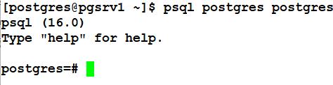

- Create a user hdfc_user with the password lion. Type the following command:
CREATE USER hdfc_user Password 'hdfc_user';

- Create database hdfc_db with owner hdfc_user
create database hdfc_db with owner hdfc_user;

- Connect to hdfc_db as hdfc_user and Create the schema hdfc_user.
Type the following command:
CREATE SCHEMA hdfc_user;

- Create a table emp. Type the following command:
CREATE table emp(id int, sal int);

Review the tables in the schema. Type \d emp

- Quit
\q

Lab Exercise – 2 – Create read-only user

grant connect on database hdfc_db to hdfc_read;
grant usage on schema hdfc_user to hdfc_read;
grant select on emp to hdfc_read;
grant select on all tables in schema hdfc_user to hdfc_read;
alter default privileges in schema hdfc_user grant select on tables to hdfc_read;

hdfc_db=> grant connect on database hdfc_db to hdfc_read;
GRANT
hdfc_db=> grant usage on schema hdfc_user to hdfc_read;
GRANT
hdfc_db=> grant select on emp to hdfc_read;
GRANT
hdfc_db=> grant select on all tables in schema hdfc_user to hdfc_read;
GRANT
hdfc_db=> alter default privileges in schema hdfc_user grant select on tables to hdfc_read;
ALTER DEFAULT PRIVILEGES
hdfc_db=>

Lab Exercise – 2 – Create two roles and assign privileges appropriately

- Create two roles
hdfc_dba, hdfc_dev
- Assign below privileges
hdfc_dba -> all privileges on your hdfc_user tables
hdfc_dev -> read only privileges on your hdfc_user tables
- create 4 users
hdfc_dba1,hdfc_dba2, hdfc_dev1, hdfc_dev2
- Assign hdfc_dba role to hdfc_dba1,hdfc_dba2
- Assign hdfc_dev role to hdfc_dev1,hdfc_dev2
- Audit their activity.

postgres=# create role hdfc_dba;
CREATE ROLE
postgres=# create role hdfc_dev;
CREATE ROLE
postgres=# \q
[postgres@lab01 15]$ psql -U hdfc_user -d hdfc_db
psql (15.5)
Type "help" for help.

hdfc_db=> grant connect on database hdfc_db to hdfc_dev;
GRANT
hdfc_db=> grant usage on schema hdfc_user to hdfc_dev;
GRANT
hdfc_db=> grant select on all tables in schema hdfc_user to hdfc_dev;
GRANT
hdfc_db=>
hdfc_db=> grant connect on database hdfc_db to hdfc_dba;
GRANT
hdfc_db=> grant usage on schema hdfc_user to hdfc_dba;
GRANT
hdfc_db=> grant all on all tables in schema hdfc_user to hdfc_dba;
GRANT
hdfc_db=>
hdfc_db=>\q

[postgres@lab01 15]$ psql
psql (15.5)
Type "help" for help.

postgres=# create user hdfc_dev1 with password 'hdfc_dev1';
CREATE ROLE
postgres=# create user hdfc_dev2 with password 'hdfc_dev2';
CREATE ROLE
postgres=# create user hdfc_dba1 with password 'hdfc_dba1';
CREATE ROLE
postgres=# create user hdfc_dba2 with password 'hdfc_dba2';
CREATE ROLE
postgres=#
postgres=# grant hdfc_dba to hdfc_dba1;
GRANT ROLE
postgres=# grant hdfc_dba to hdfc_dba2;
GRANT ROLE
postgres=# grant hdfc_dev to hdfc_dev1;
GRANT ROLE
postgres=# grant hdfc_dev to hdfc_dev2;
GRANT ROLE
postgres=# alter user hdfc_dev1 set log_statement='all';
ALTER ROLE
postgres=# alter user hdfc_dev2 set log_statement='all';
ALTER ROLE
postgres=# alter user hdfc_dba1 set log_statement='all';
ALTER ROLE
postgres=# alter user hdfc_dba2 set log_statement='all';
ALTER ROLE
postgres=#
postgres=# alter user hdfc_dev1 set search_path=hdfc_user;
ALTER ROLE
postgres=# alter user hdfc_dev2 set search_path=hdfc_user;
ALTER ROLE
postgres=# alter user hdfc_dba1 set search_path=hdfc_user;
ALTER ROLE
postgres=# alter user hdfc_dba2 set search_path=hdfc_user;
ALTER ROLE
postgres=#

Module 10 – Monitoring and Admin Tools Lab Exercise - 1
- Open pgAdmin 4 and connect to the default PostgreSQL database cluster
  - Create a user named pguser
  - Create a database named pgdb owned by pguser
  - After creating the pgdb database change its connection limit to 4
  - Create a schema named pguser inside the pgdb database
  - The schema owner should be pguser

Answer Lab Exercise - 1 Lab Exercise - 1
- PgAdmin 4 on Windows can be installed first

- Open PgAdmin 4 and connect to the default Postgres database cluster

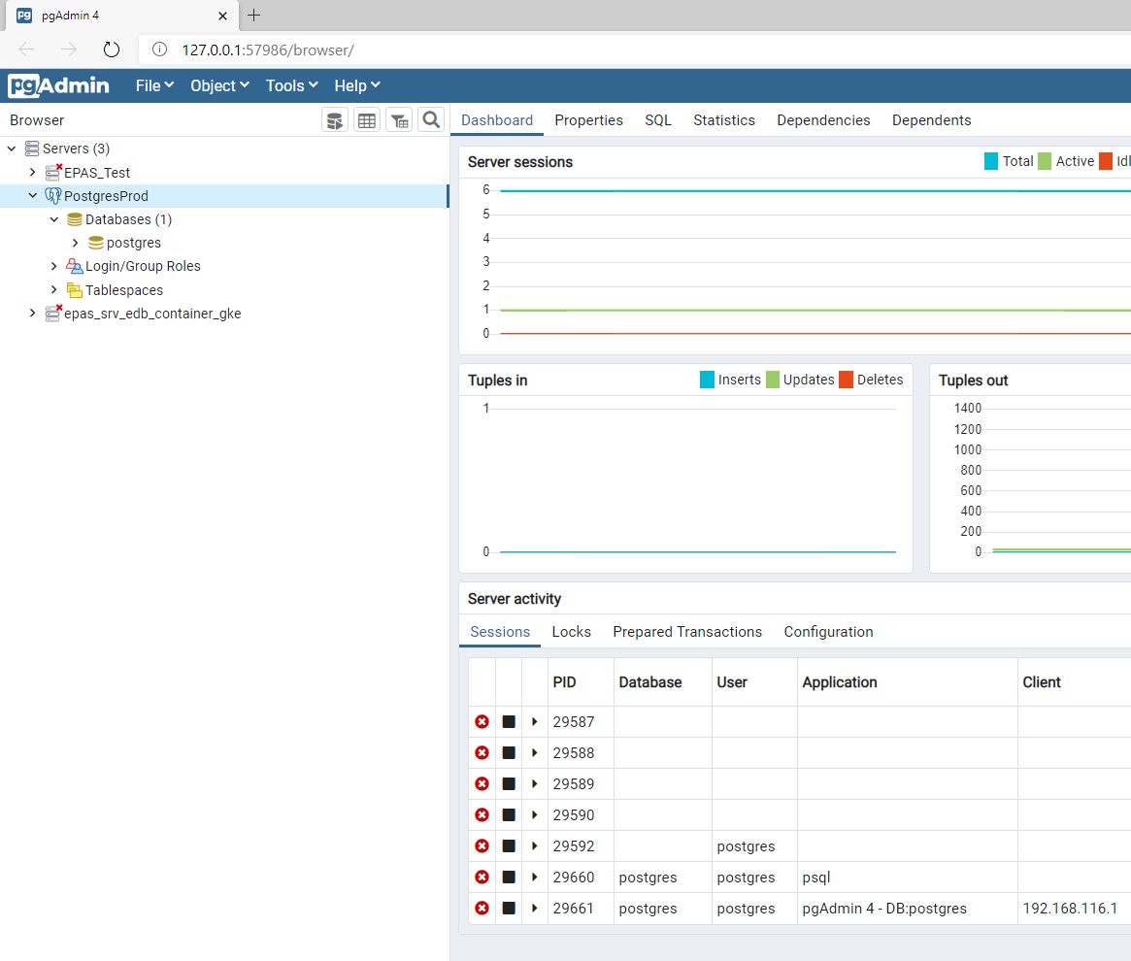

- Create user pguser
  - Right click on Login/Group Roles and choose Create:Login/Group Roles.

  - Enter Role Name type pguser.
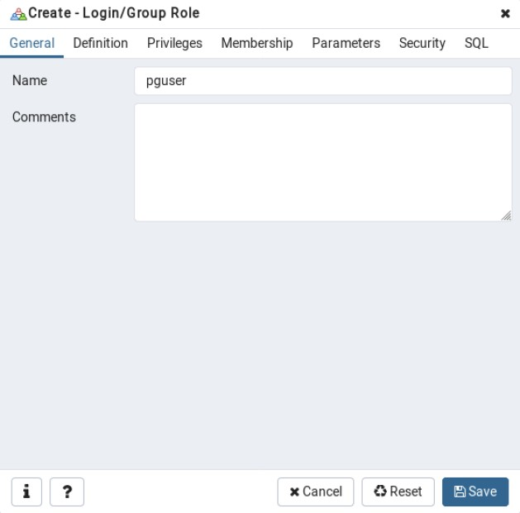

  - Click the Definition tab and enter a password for pguser.
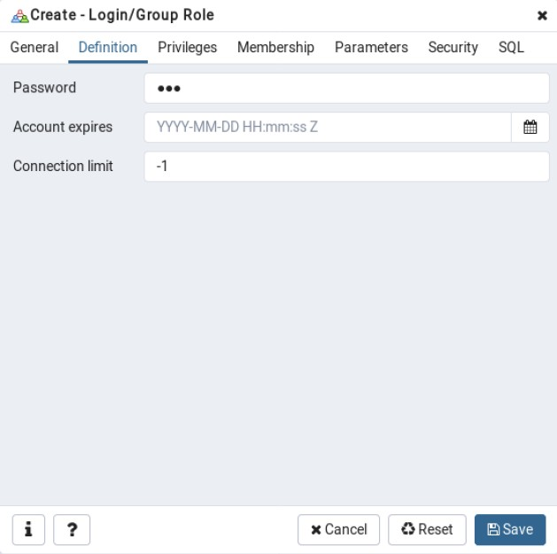

  - Click the Privileges tab and set Can login to Yes then click Save.
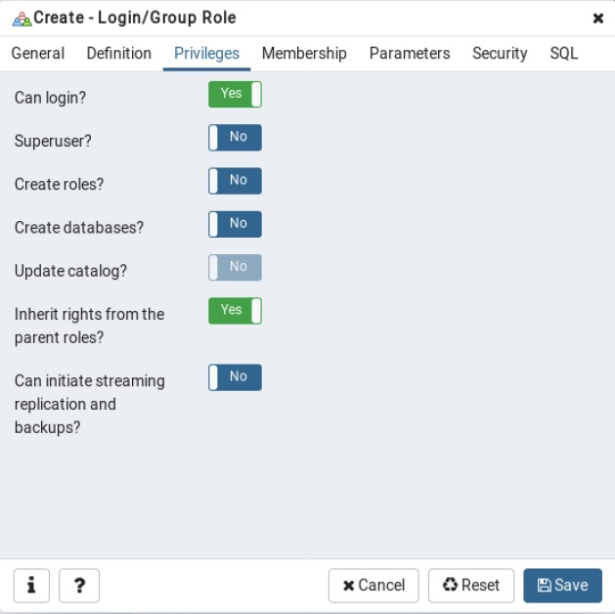

- Create a database called pgdb owned by pguser.
  - Right click Databases and choose Create: Database.

  - Enter the database name type pgdb.

  - Set the owner to be pguser and click Save.
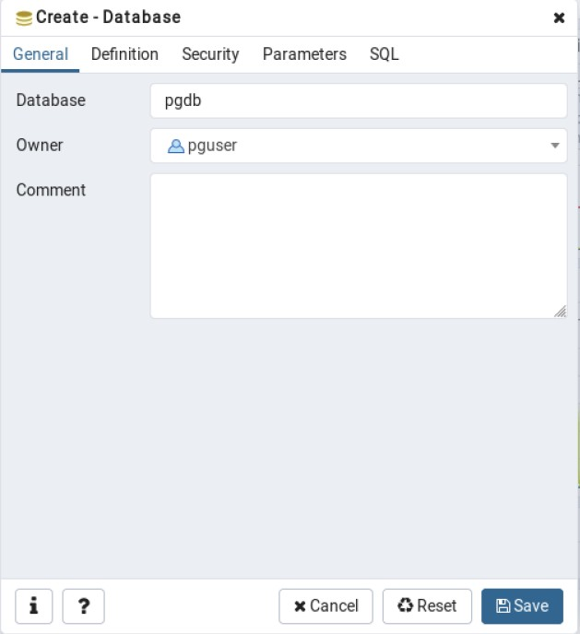

- Change the database connection limit to 4.
  - Right Click pgdb database and click Properties.

  - Click Definition tab change the Connection Limit to 4 then click

Save.
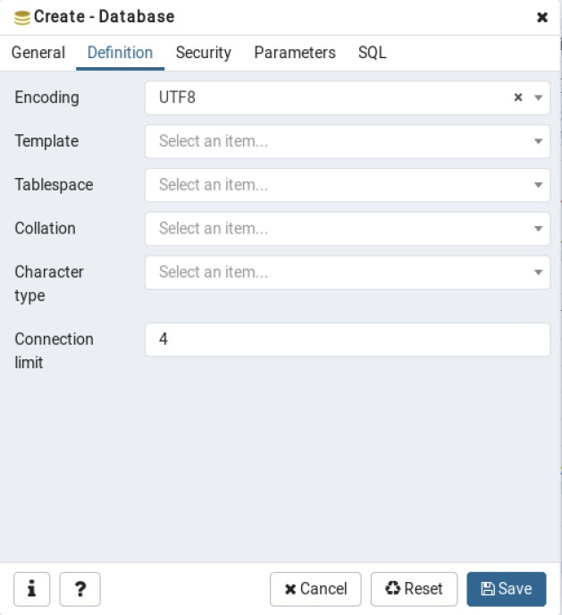

- Create a schema in the pgdb database called pguser. Set the owner to be pguser.
  - Right Click Schemas under pgdb database and click Create:

Schema

  - Enter the Schema Name as pguser and enter the Owner as
pguser,
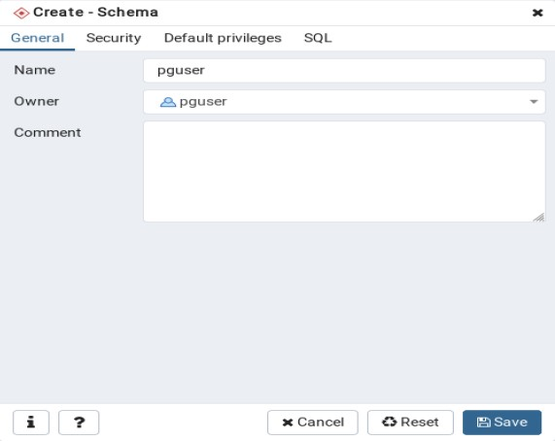

  - Click the Security tab then under Grantee choose pguser.
Under Privileges check All and With Grant Option. Then click Save.
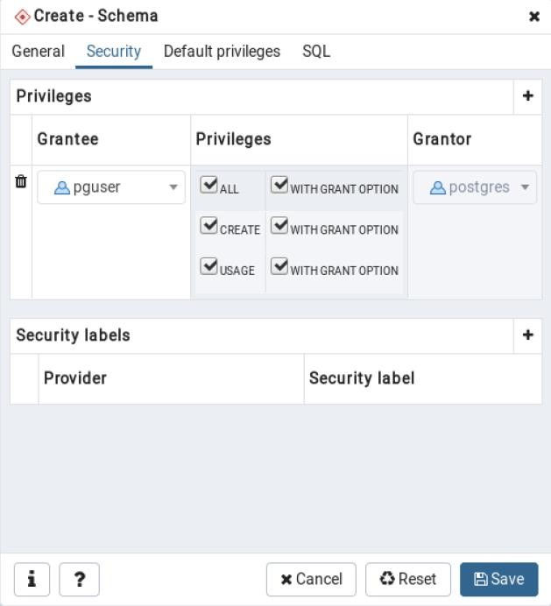

Lab Exercise - 2
- You have created the pgdb database with the pguser schema. Create following objects in the pguser schema:
  - Table - Teams with columns TeamID, TeamName, TeamRatings
  - Sequence - seq_teamid start value - 1 increment by 1
  - Columns - Change the default value for the TeamID column to seq_teamid
  - Constraint - TeamRatings must be between 1 and 10
  - Index - Primary Key TeamID
  - View - Display all teams in ascending order of their ratings. Name the view as vw_top_teams

Answer Lab Exercise - 2
- Open PgAdmin 4. Expland Databases. Go to pgdb then to Schemas and to pguser, created in the last exercise.

- Create the Teams Table.
  - Right click Tables and click Create: Table.
  - Enter Table name Teams and set the Owner to be pguser.
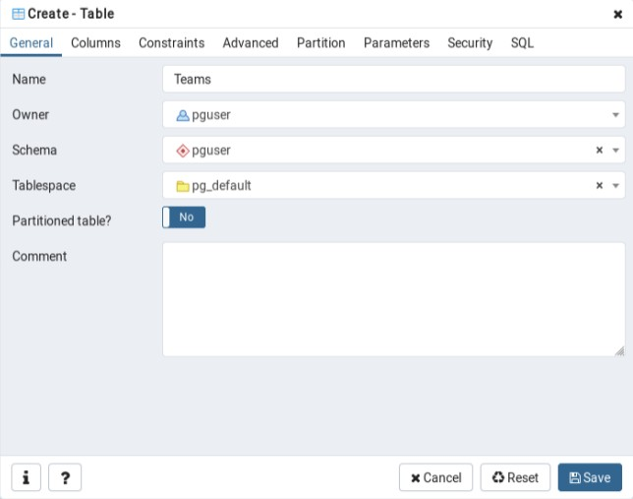

  - Click Columns tab and enter the following column names and data types then click Save. For each new column click the add button in the right corner.
    - TeamID, numeric
    - TeamName, character varying

    - TeamRatings, numeric
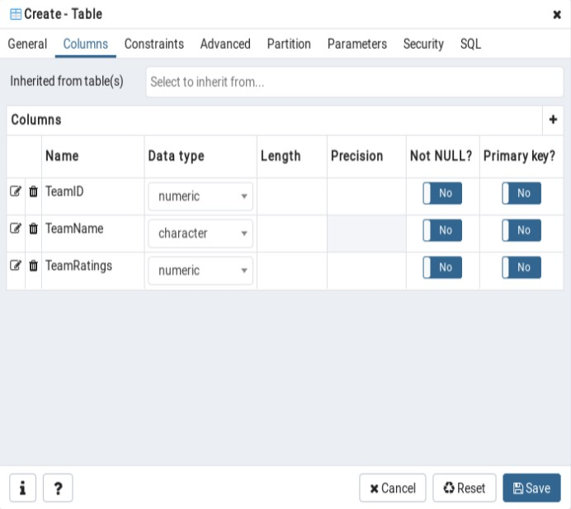

- Create a Sequence seq_teamid with a start value of 1 and increment by 1
  - Right click in Sequences and click Create: Sequence.
  - Enter Sequence Name seq_teamid and set the Owner to be
pguser.
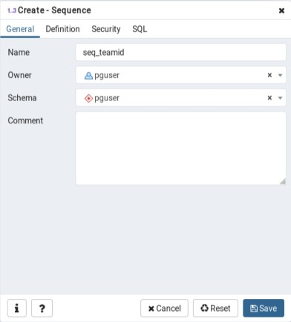

  - Click on Definition tab and enter the Increment to be 1 and the Start
to be 1 then click Save.
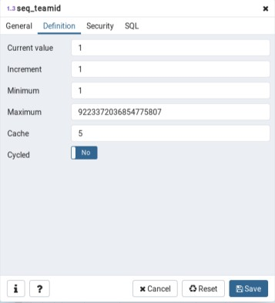

- Change default value for TeamID column to be seq_teamid.
  - Expand the Teams table and click onto columns. Right click the
teamid column and choose Properties.

  - Click Constraints tab and set the Default value to be seq_teamid type nextval('pguser.seq_teamid') then click Save.
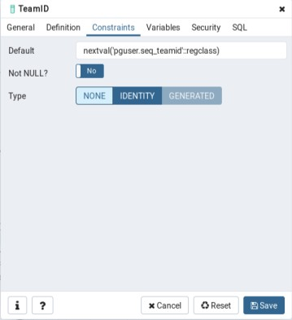

- Set the constraint for TeamRatings to be between 1 and 10.
  - Right click on Constraints in the teams table.

  - Go to Create: Check

  - Click on the Definitions tab and type "TeamRatings" between 1 and 10 then click Save.

NOTE: You may skip the name as it will be assigned by DB Server.

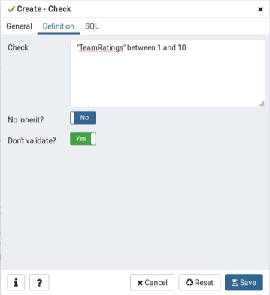

- Set the Index Primary Key to be TeamID.
  - Right click Constraints and choose Create: Primary Key.
  - Go to the Definitions tab and choose the column TeamID from column drop down list then click Save.
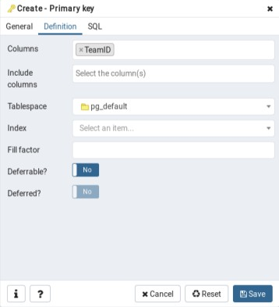

- Create a view that will display all teams in ascending order of their ratings.
Name the view as vw_top_teams
  - Right click on Views in the pguser Schema and click Create: View

  - Enter the name vw_top_teams and set Owner as pguser.
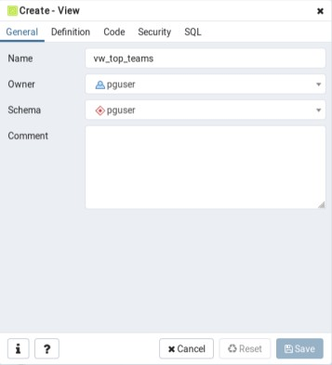

  - Click the Code tab and Type
SELECT "TeamName", "TeamRatings" FROM pguser."Teams" ORDER BY "TeamRatings" asc and then click Save.
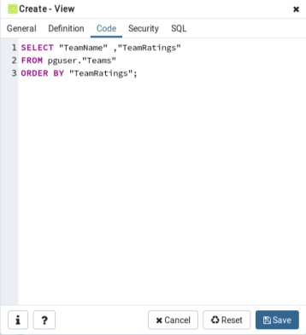

Lab Exercise – 3

- View all rows in the Teams table.

- Using the Edit data window you just opened in the previous step, insert the following rows into the Teams table:

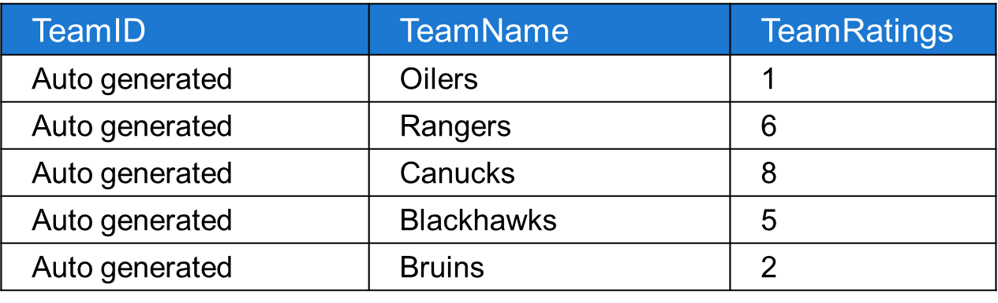

Answer Lab Exercise - 3
  - View all the rows in the teams table. Right click the Teams table. Choose
View Data then choose View All Rows.

  - In the Data Output window from previous step insert the above rows to the
Teams table.
    - Double click each row TeamName and enter the value, then double click TeamRatings and enter the value.
    - Click the Save button.

    - Repeat until all 5 rows are loaded.
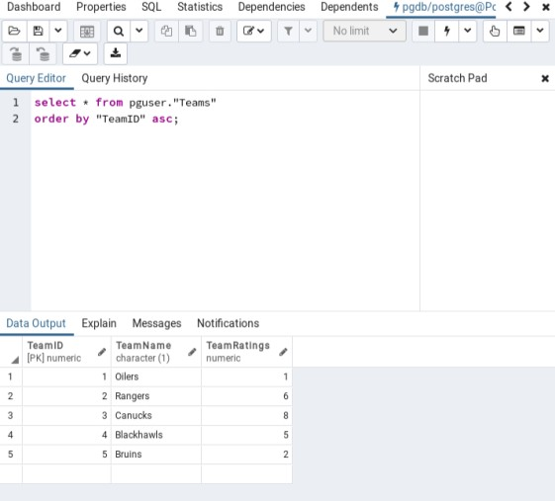

  - Click Save and close the window.

Lab Exercise - 4
- Connect to the pgdb database using the query tool.
- Using the graphical query builder retrieve all the rows present in the Teams table.
- Using the graphical query builder retrieve all the rows present in view
vw_top_teams.

Answer Lab Exercise - 4
  - Go to Tools and choose Query Tool.

  - In the SQL Editor Type
SELECT * FROM "Teams";

  - Click the Execute Query button.

  - In the SQL Editor Type
SELECT * FROM vw_top_teams;

  - Click the Execute Query button.
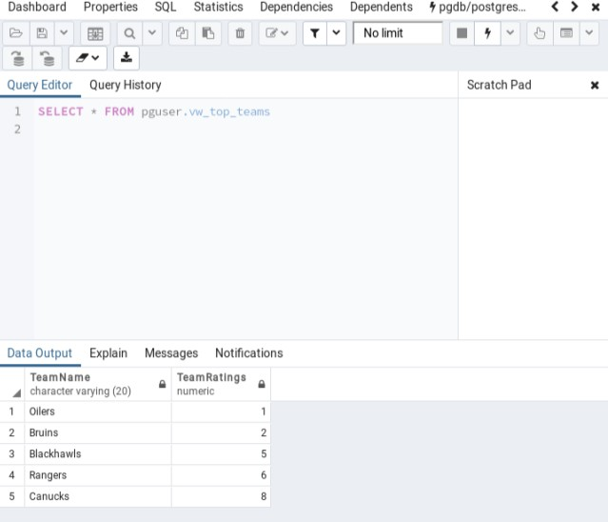

  - Go to the File Menu and choose Exit. Click No to save changes message.

Module 12 – Logical replication

Take logical backup

Pg_dump – Export database/tables/schemas
pg_dump -U hdfc_user -d hdfc_db -t emp > emp.sql #export

psql -U hdfc_user -d hdfc_db < emp.sql #import
(or)
psql -U hdfc_user -d hdfc_db -f emp.sql #import

#compressed, cannot read
pg_dump -U hdfc_user -d hdfc_db -t emp -Fc -f emp.bkp (-Z 9)

#o/s tar
pg_dump -U hdfc_user -d hdfc_db -t emp -Ft -f emp.tar

#read/edit your backup piece
pg_dump -U hdfc_user -d hdfc_db -t emp -Fp -f emp.backup
#parallelism
pg_dump -U hdfc_user -d hdfc_db -t emp -Fd -f emp (-j 4)
Pg_restore – Import

pg_restore -U hdfc_user -d hdfc_db dbbackup.bkp
pg_restore -U hdfc_user -d hdfc_db -t emp dbbackup.bkp #restore a single table

Module 12 – Physical replication

Backup and Recovery
--------------------
1. Enable archivelogging.
2. Backup and Restore in same machine
3. Backup and Restore in different machine
4. Backup and Restore in different machine + apply archivelogs
5. Backup and Restore in different machine + apply archivelogs + until my fav archive
6. Backup and Restore in different machine + apply archivelogs + wait for next archive to come
7. Backup and Restore in different machine + apply archivelogs + start streaming wals
8. Backup and Restore in different machine + apply archivelogs + start synchronous streaming wals
9. Switchover and Failover

- Enable archivelogging.

archive_mode = on
archive_command = 'cp %p /u01/archives/%f'

- Enable wal log hints

wal_log_hints = on

- Backup and Restore in same machine

/usr/pgsql-15/bin/pg_basebackup -D /u01/pgsql/15

- Backup and Restore in different machine

/usr/pgsql-16/bin/pg_basebackup -D /u01/pgsql/16 -Ft --checkpoint=fast -P -h 192.168.110.174

cd /u01/pgsql/15
tar -xf base.tar
mv pg_wal.tar pg_wal
cd pg_wal
tar -xf pg_wal.tar
rm -rf pg_wal.tar
cd ../
rm -rf base.tar

/usr/pgsql-15/bin/pg_ctl start -D /u01/pgsql/15

- Backup and Restore in different machine + apply archivelogs

#Restore backup and do following
touch recovery.signal
restore_command = 'scp 192.168.110.174:/u01/archivelogs/%f %p' #postgresql.conf

- Backup and Restore in different machine + apply archivelogs + until my fav archive

#Restore backup and do following

touch recovery.signal
restore_command = 'scp 192.168.110.174:/u01/archivelogs/%f %p' #postgresql.conf
recovery_target_lsn='0/198FB4A0'

- Backup and Restore in different machine + apply archivelogs + wait for next archive to come

touch standby.signal
restore_command = 'scp 192.168.110.174:/u01/archivelogs/%f %p' #postgresql.conf

- Backup and Restore in different machine + apply archivelogs + start streaming wals

touch standby.signal
restore_command = 'scp 192.168.110.174:/u01/archivelogs/%f %p' #postgresql.conf
primary_conninfo ='user=postgres password=postgres host=192.168.110.174'

- Backup and Restore in different machine + apply archivelogs + start synchronous streaming wals

#primary
synchrnonus_standby_names = '*'

touch standby.signal
restore_command = 'scp 192.168.110.174:/u01/archivelogs/%f %p' #postgresql.conf
primary_conninfo ='user=postgres password=postgres host=192.168.110.174 application_name=random'

9. Switchover and Failover

* STOP APPLICATION
* STOP ALL YOUR CRON JOBS
* CHECKPOINT

1. promote your standby
/usr/pgsql-15/bin/pg_ctl promote -D /u01/pgsql/15

2. Do rewind in primary
/usr/pgsql-15/bin/pg_rewind --target-pgdata=/u01/pgsql/15 --source-server="port=5432 host=192.168.47.182"

3. Set up replication #old primary

1) edit primary_connfinfo
2) touch standby.signal

Module 13 - Routine Maintenance Tasks Lab Exercise – 1
- While monitoring table statistics on the demo database, you found that some tables are not automatically maintained by autovacuum. You decided to perform manual maintenance on these tables. Write a SQL script to perform the following:
  - Reclaim obsolete row space from the aircrafts_data table.
  - Update statistics for airports_data and boarding_passes tables.
  - Mark all the obsolete rows in the tickets table for reuse.
- Execute the newly created maintenance script on edbstore database.

Answer Lab Exercise - 1
Open a terminal and login as the postgres user. Type
su - postgres then the postgres password.

- Write a SQL script to perform maintenance on the customers, emp, dept and orders tables.
Type the following command:
vi demo_mnts_script.sql to create the script.

Then type <i> to get into insert mode and enter the following maintenance commands:
VACUUM FULL aircrafts_data;
ANALYZE airports_data;
ANALYZE boarding_passes;
VACUUM tickets;

Save and close. Type
<ESC>:wq <ENTER>

- Run the script.
Type the following command:
psql -f demo_mnts_script.sql -d demo -U postgres
then enter the postgres password.

Module 14 - Moving Data Lab Exercise - 1

Extensions

pg_repack
dnf install pg_repack_15

postgres=# create extension pg_repack;
CREATE EXTENSION
postgres=#

/usr/pgsql-15/bin/pg_repack --help

[postgres@lab01 ~]$ /usr/pgsql-15/bin/pg_repack --all
INFO: repacking database "postgres"
INFO: repacking table "public.pgbench_accounts"
INFO: repacking table "public.pgbench_branches"
INFO: repacking table "public.pgbench_tellers"
INFO: repacking database "template1"
INFO: database "template1" skipped: pg_repack 1.4.8 is not installed in the database
[postgres@lab01 ~]$

[or]

[postgres@lab01 ~]$ /usr/pgsql-15/bin/pg_repack -d postgres
INFO: repacking table "public.pgbench_accounts"
INFO: repacking table "public.pgbench_branches"
INFO: repacking table "public.pgbench_tellers"
[postgres@lab01 ~]$

pg_top extension
--------------------
dnf install pg_top
https://blog.mclaughlinsoftware.com/2022/03/02/postgresql-cli-error/

pg_stat_statements
-------------------

shared_preload_libraries='pg_stat_statements'

postgres=# create extension pg_stat_statements;
CREATE EXTENSION
postgres=# \q

pg_stat_statements.max = 10000
pg_stat_statements.track = all
pg_stat_statements.track_utility = off
pg_stat_statements.save = on

Top 10 I/O-intensive queries

SELECT query, calls, total_exec_time, rows, 100.0 * shared_blks_hit /
nullif(shared_blks_hit + shared_blks_read, 0) AS hit_percent
FROM pg_stat_statements ORDER BY total_exec_time DESC LIMIT 5;

select userid::regrole, dbid, query
from pg_stat_statements
order by (blk_read_time+blk_write_time)/calls desc
limit 10;

Reset
-----
select pg_stat_statements_reset();

pgpool
------
-> Ensure PostgreSQL software installed

dnf install https://download.postgresql.org/pub/repos/yum/15/redhat/rhel-8-x86_64/pgpool-II-pg15-extensions-4.4.2-1.rhel8.x86_64.rpm

cp /etc/pgpool-II/pgpool.conf.sample /etc/pgpool-II/pgpool.conf
Edit the configuration file /etc/pgpool-II/pgpool.conf

listen_addresses = '*'
pcp_socket_dir = '/var/run/postgresql'
unix_socket_directories = '/var/run/postgresql'
allow_clear_text_frontend_auth = on
pool_passwd = ''

# - Backend Connection Settings -

backend_hostname0 = '192.168.110.171'
backend_port0 = 5432
backend_weight0 = 1
backend_data_directory0 = '/u01/pgsql/15'
backend_flag0 = 'ALLOW_TO_FAILOVER'
backend_application_name0 = 'server0'

backend_hostname1 = '192.168.110.172'
backend_port1 = 5432
backend_weight1 = 1
backend_data_directory1 = '/u01/pgsql/15'
backend_flag1 = 'ALLOW_TO_FAILOVER'
backend_application_name1 = 'server1'

sr_check_user = 'postgres'
sr_check_password = 'postgres'
sr_check_database = 'postgres'

health_check_period =1

health_check_user = 'postgres'
health_check_password = 'postgres'
health_check_database = 'postgres'

touch /etc/pgpool-II/pool_passwd

systemctl start pgpool-II

[postgres@v3 ~]$ export PGPASSWORD=postgres
[postgres@v3 ~]$ psql -U postgres -p 9999 postgres -c "show pool_nodes"

touch /etc/pgpool-II/pool_passwd

Upgrades

mkdir -p /u03/pgsql/customts

1. Stop both primary and standby
2. Initialize version 16 on primary (Do not initialize in standby, just create empty folder)

mkdir -p /u01/pgsql/16 #primary
/usr/pgsql-16/bin/initdb -D /u01/pgsql/16 #primary
mkdir -p /u01/pgsql/16 #standby

3. Ensure no instance is running in both machines
4. Upgrade with below command
/usr/pgsql-16/bin/pg_upgrade -d /u01/pgsql/15 -D /u01/pgsql/16 -b /usr/pgsql-15/bin -B /usr/pgsql-16/bin -k

5. Run the below command to make rsync
[postgres@lab02 pgsql]$ pwd
/u01/pgsql
[postgres@lab02 pgsql]$

rsync --archive --delete --hard-links --size-only --no-inc-recursive --verbose \
/u01/pgsql/15 \
/u01/pgsql/16 \
postgres@192.168.110.195:/u01/pgsql --dry-run

+++++

Create tablespace

mkdir -p /u01/custom #both primary and standby

#run below in primary
create tablespace ts location '/u01/custom';
create database ac tablespace ts;
/usr/pgsql-15/bin/pgbench -i -s 30 ac

stop both machines, no need to create any extra folders inside /u01/custom,
PG_16* will automatically gets created

/usr/pgsql-16/bin/pg_upgrade -d /u01/pgsql/15 -D /u01/pgsql/16 -b /usr/pgsql-15/bin -B /usr/pgsql-16/bin -k

#main directory upgrade
mkdir -p /u01/pgsql/16 #standby

rsync --archive --delete --hard-links --size-only --no-inc-recursive --verbose \
/u01/pgsql/15 \
/u01/pgsql/16 \
postgres@192.168.110.195:/u01/pgsql --dry-run

rsync --archive --delete --hard-links --size-only --no-inc-recursive --verbose \
/u01/custom/PG_15_202209061 \
/u01/custom/PG_16_202307071 \
postgres@192.168.110.195:/u01/custom --dry-run

++++

1. pg_upgrade

1. direct copy (no prior backup required)

- Time consuming
- Equal amount of disk space

2. link method (v15 folder gone)

- No time consuming
- If something goes wrong, you might need to restore v15 database.

3. When you have custom tablespaces.

- If its copy, careful while removing old tablespace.

4. when you have standby

- What if your primary has custom tablespace?
- upgrade

5. when you have extensions

6. what if you have logical replication in place.

2. pg_dump

3. logical replication (near zero)

1. change wal_level=logical (n1)

2. initialize and start cluster in standby(n2)

3. take metadata backup
/usr/pgsql-15/bin/pg_dump -U postgres -d demo -s > metaonly.sql

4. import metadata in (n2) after creating required database
psql -f metaonly.sql

5. set up publication (n1)
demo=# create publication my_publication for all tables;
CREATE PUBLICATION
demo=#

6. set up subsription (n2)
CREATE SUBSCRIPTION my_subscription
CONNECTION 'host=192.168.110.198 port=5432 dbname=postgres' PUBLICATION my_publication;

