**Test Script Example + Template**

**1. Introduction and context setting *Time: ~3 minutes***

* *Introduce yourself, briefly explain your product, what your participant can expect from the meeting, and the goal of your research*

Hi, my name is [moderator’s name]. We are now working on a new app called [name of the product]. The app provides you with better tools to track your time and record hours related to your projects. I want to share our early design concepts with you and get your feedback.

The result of this test session will help us identify the problems in the current design and make improvements in our next iteration.

*\* Encourage your participant to be open and think out loud (you may have to do this more than once if you find that they are quiet or hesitant to share their true thoughts)*

Please share your thoughts and feedback with us openly. There is no right or wrong answer. Please think out loud while you are looking at various screen designs.

*\* Make sure that all the findings will remain confidential*

Any information that you provide will only be shared internally and is intended only to inform our designs.

*\* If you are audio or video recording and want to take photos to capture the type of environment they are in, ask for permission.*

Can I ask for your permission to record this interview and take photos?

**2. Background questions and establishing rapport *Time: ~3 minutes***

*\* Questions focused on the participant’s background and job position. They are not only informative, but also good for warming up the conversation*

Can you please tell us about your role and responsibilities?

Can you tell us about your timesheet entry?

**3. Introducing the scenario  *Time: ~15 Minutes***

*\* Give the participant a task that your design helps accomplish. Explain that this is a generic scenario and might not be exactly the way they work. It’s good to provide some explanation for the tasks such as the goal the user is accomplishing.*

Let’s imagine a scenario where you are a facility manager for [Company A]. You have to enter your working time separately depending on your working location. And, you have a timesheet app on your phone that allows you to do this.

*\* After you setup the scenario for the participant, make sure that they understood it. Begin with the first screen from your storyboard*

Start screen

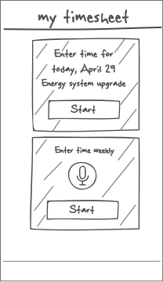

*Print your hand-sketches, and introduce one by one as the session goes.*

*If you are using our Research Tool, upload your sketches into the tool.*

Sample Questions

* What do you see on this screen?
* What do you expect each element to do?
* What do you think about the app pushing you the entries based on today’s date and current location?
* How would you proceed?

*\* You can write down the answers as you see fit or completely rely on your note-taker*

**4. Detailed questions about each task *Time: ~20 Minutes***

*\* Here, the participant is asked how they would go about doing specific tasks. These tasks are derived from your testing goals and elaborately written to help the participant feel in the shoes of the user. Remind them to think out loud. Instruct the user to treat the sketches as if it were a real app, “pressing” the buttons as they usually would (your job as interviewer is to change the screens accordingly)*

**Task 1**: You were working on Energy Systems upgrade in Building 7, and it took an extra hour, so you want to change the time entry from 2 hours to 3 hours. What will you do? Please walk us through.

Screens for modifying and confirming the time entry

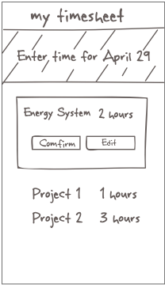 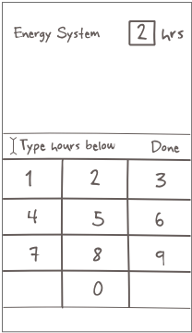 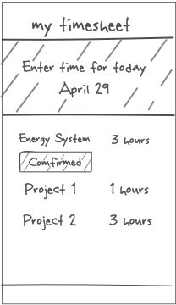

Sample Questions *\* not to be asked for each single screen but as you see fit*

* What do you see on this screen?
* What do you think the CONFIRM and EDIT buttons are for?
* What do you do now? What do you expect to see next?
* How was the experience completing this task?

*\* If the participant is struggling, assist them with probing questions*

* What are you trying to do now?
* How would you expect to complete this task?
* What if I told you that you need to tap on a button here?

*\* If participant still can’t figure out how to proceed, move them forward by telling them what to do. Ask them why this is not intuitive for them, so you know what to address in the next iteration.*

* Actually, if you click EDIT, you’d end up in the Editing screen

**Task 2:** It is the end of the week. You need to leave the office now because you are already late for a personal appointment. But, you need to make sure the weekly time entry is complete. What will you do?

Weekly time entry flow

 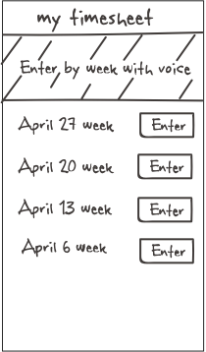 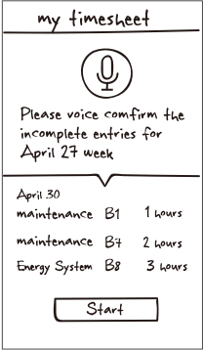

Sample Questions

*\* If you are introducing a new feature, you can try to understand the participant’s stance on it with detailed questions in addition to the purely screen related questions listed above*

* Did you notice the label “Enter by week with voice?” What did that mean to you?
* Is entering time with voice something that would be useful for you? If so, how?
* Any thoughts on confirming entries with voice?

**5. Wrapping up the test *Time: ~7 minutes***

*\* Capture the participant’s final thoughts, what they liked the best and least*

* It seems that we have covered everything. Thank you very much for agreeing to talk to us. What do you think of this solution overall?
* What do you like most? Why?
* If you could change one thing, what would you change? Why?

*\* Giving a small gift (usually a popular retailer gift card) would be a very nice gesture for your participant*

* Here, we have a small thank you gift for you.

*\* Ask if they have anything else to add. Participants may mention something valuable even at the end. Don’t be afraid to stay silent for a bit to allow them to think*

* Would you like to add anything else? Any last thoughts?

*\* Close with a thank you statement*

* Again, thank you very much for your time – we really appreciate it.