-- TASK - 7 :
-- 1. Create and select the database and
-- 2. Core tables
-- Users who write reviews
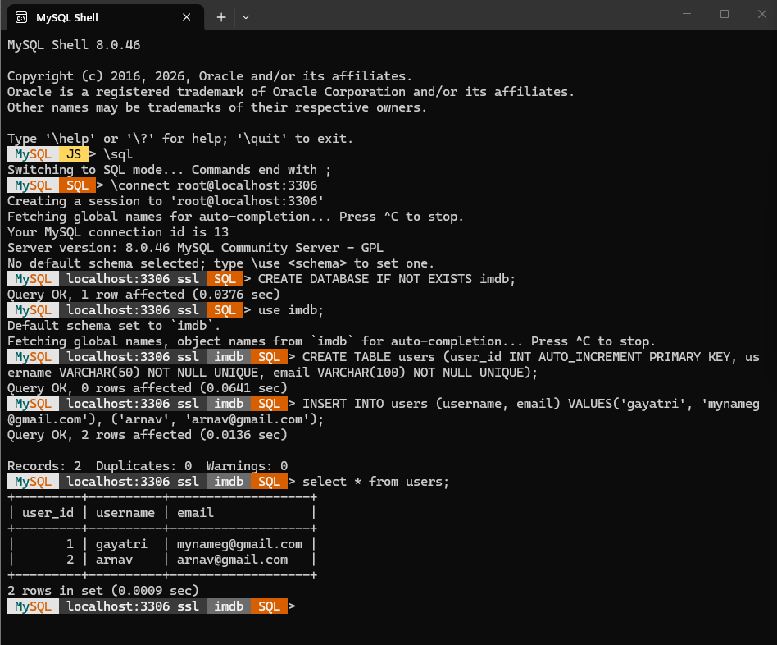
-- Movies
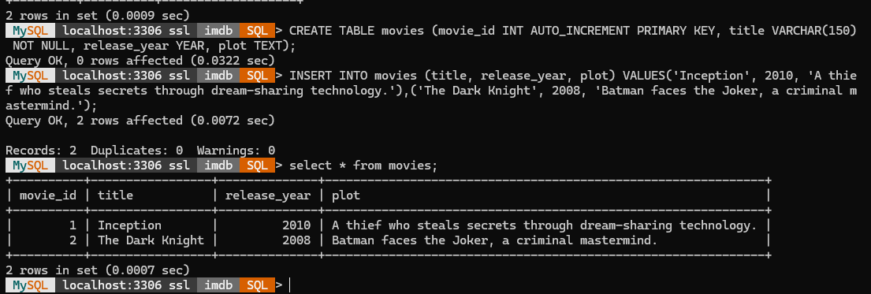

-- Genres (Action, Drama, Comedy, etc.)
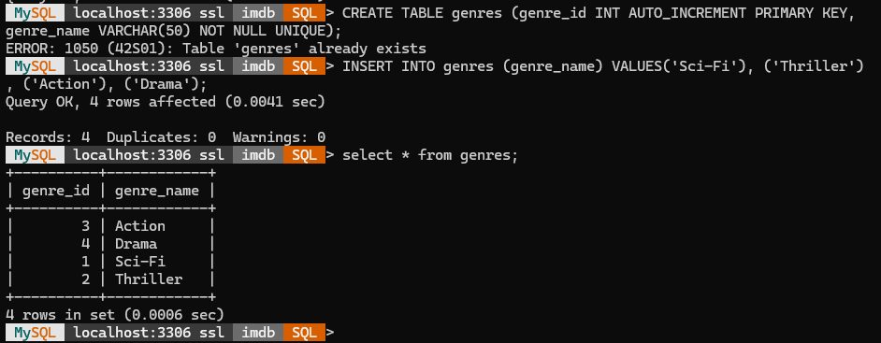
-- Artists (actors, directors, etc.)
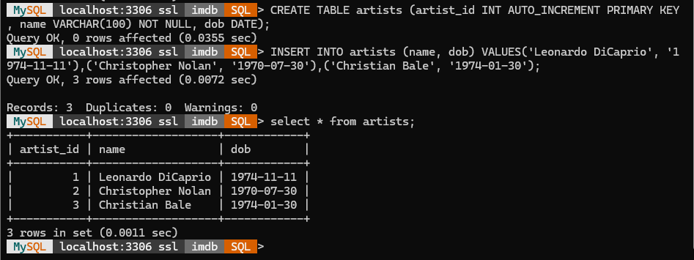
-- Skills an artist can have (Acting, Directing, Singing, Stunt, etc.)
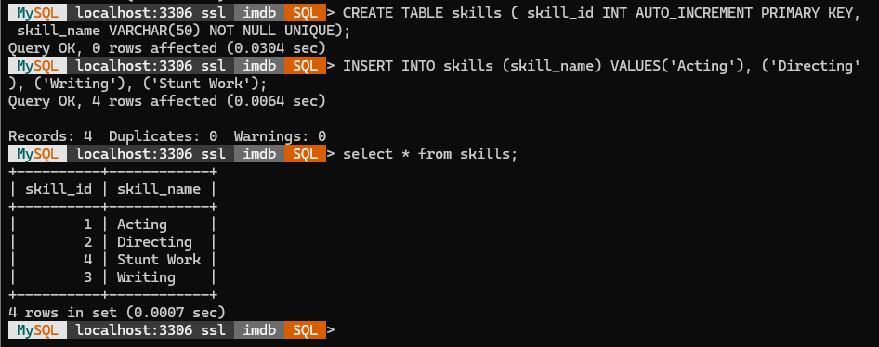

-- Roles an artist can play in a movie (Actor, Director, Producer, Writer)
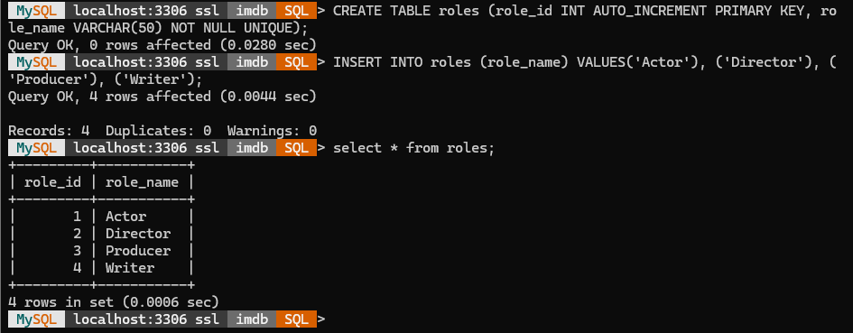
-- 3. Requirement 1 : Movie can have multiple media (Video or Image)
-- One movie -> many media rows (one-to-many, FK on the "many" side)
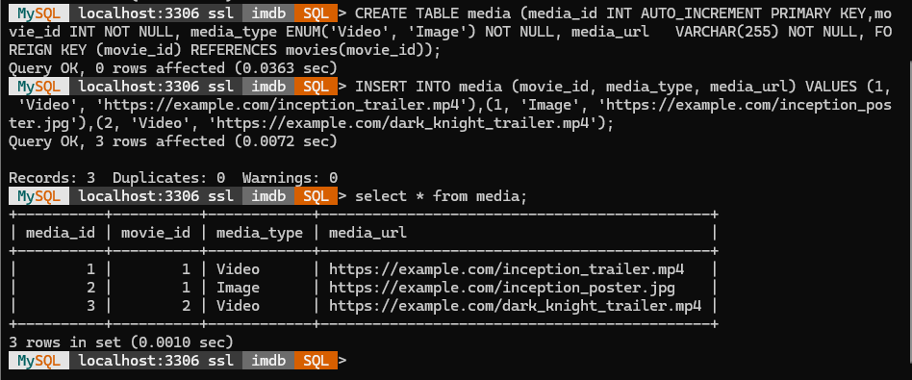
-- 4. Requirement 2 : Movie can belong to multiple genres
-- Many-to-many -> needs a junction table with a composite PK
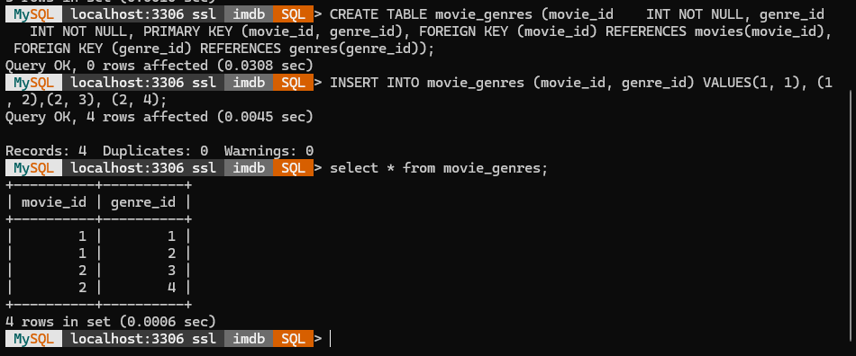
-- 5. Requirement 3 : Movie can have multiple reviews,
-- and each review belongs to one user
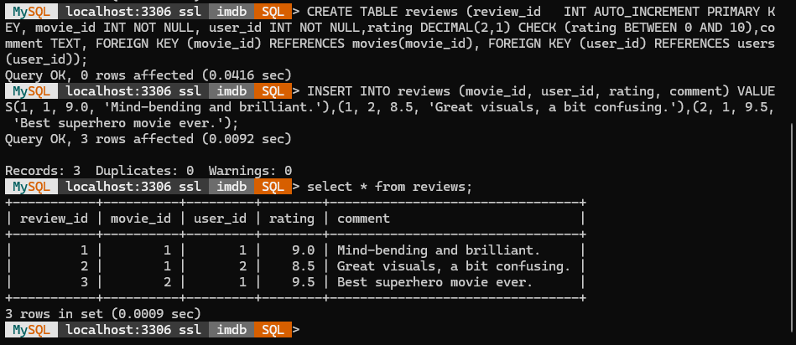
-- 6. Requirement 4 : Artist can have multiple skills
-- Many-to-many -> junction table
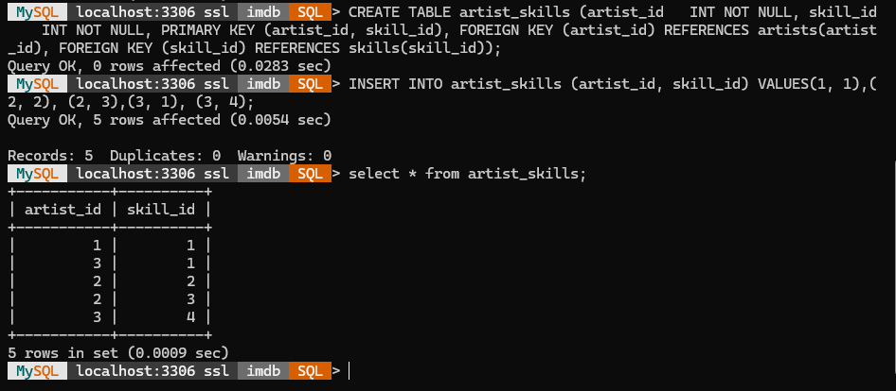

-- 7. Requirement 5 : Artist can perform multiple roles in a single film
-- Junction table between movies, artists and roles.
-- Composite PK includes role_id so the same artist can appear
-- on the same movie more than once, as long as the role differs.
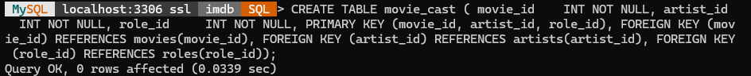
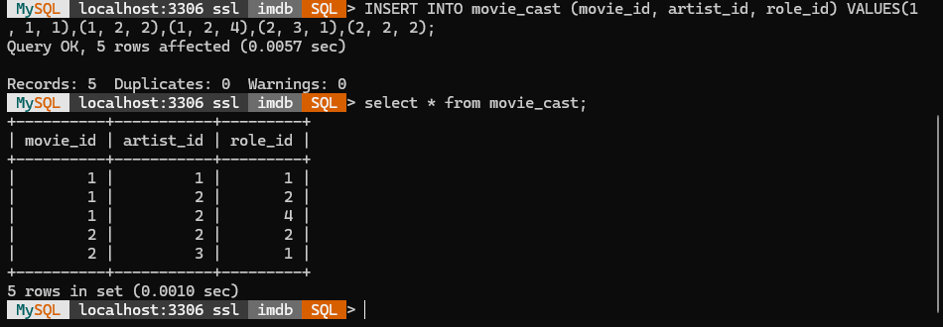
_________________________________________________________________________________
-- 1) All media for a movie
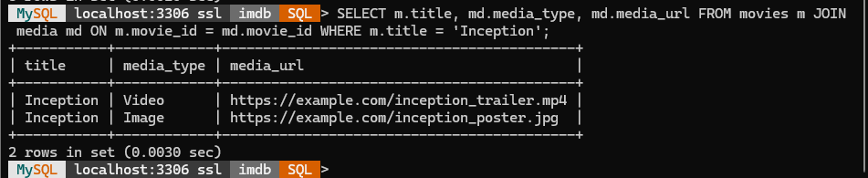
-- 2) All genres for a movie
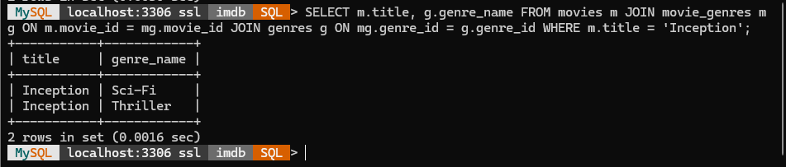
-- 3) All reviews for a movie with the reviewing user
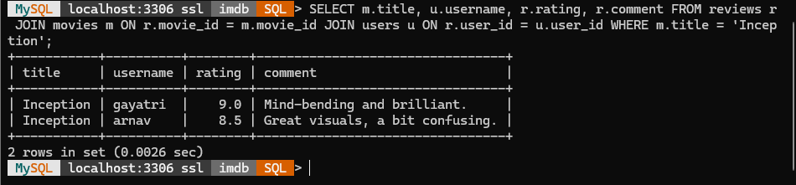
-- 4) All skills for an artist
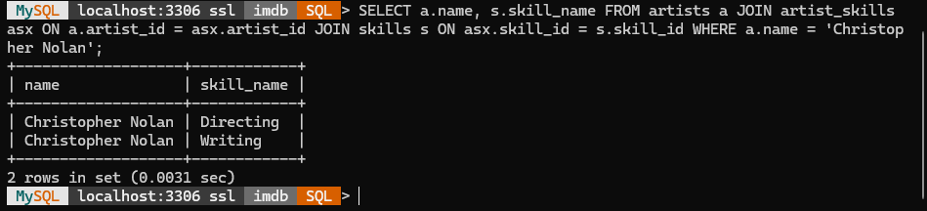
-- 5) All roles an artist performed in one specific film
