安装git的其中一步出错
命令：sudo apt update
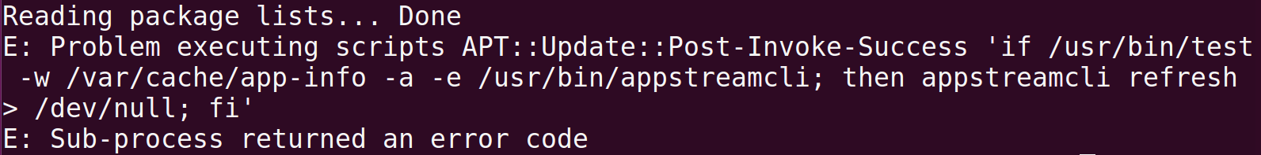

git commit
-a:Tell the command to automatically stage files that have been modified and deleted, but new files you have not told Git about are not affected
告诉命令自动暂存已修改和删除的文件，但是没有告诉Git的新文件不受影响

