**nEbO**

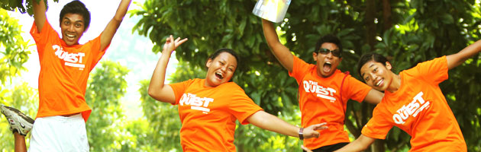

**About Us**

**Power of Youth**  
  
nEbO was launched on 7 July 2007 to bridge the gap between youths aged 12 to 21 and the Labour Movement. As nEbO aims to create a community of Work-Ready, World-Ready and Life-Ready youths, members are given the opportunity to hone their leadership skills and develop their potential. Activists take on leadership roles in nEbO, initiating, planning and leading events for other members, creating a vibrant community powered by youth, for youth.

**Membership**

**nEbO Plus! Card**  
Discover an astounding variety of lifestyle privileges that gives you more reasons to play! Maximize your dollars and embrace the spirit of freedom with the nEbO Plus! card which entitles you to both nEbO and NTUC Plus! membership programme benefits and privileges! Endless excitement and experience, yours to own.

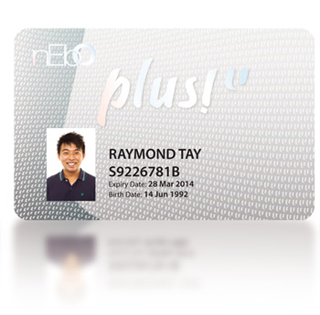

**Privileges & Benefits include:**  
   
**• Cathay Cineplexes**  
- $7 per movie ticket for sessions from Mon – Fri before 6 pm, excluding eve of PH & PH  
- $9.50 per movie ticket for sessions after 6pm on Fri and all day on Sat, Sun, eve of PH & PH  
- FREE popcorn (promo size worth $4.50) for every ticket purchased, capped at 4 popcorns per card, per member  
  
**• Party World KTV**  
- 20% off total bill from Sun - Thu and on Fri (until 6pm), excluding eve of PH and PH  
- 1-for-1 drinks from Sun - Thu (after 6pm), excluding eve of PH and PH  
  
**• Wild Wild Wet**  
- Exclusive discount  
  
**• Zone X**  
- Free nEbO MIP TaPZ Card  
  
**• Orchid Bowl**  
- Special rate per game (U.P. up to $4.50 during peak)  
  
**• Costa Sands Resort**  
- Exclusive rates on chalet booking  
  
**• nEbO Hub @ AMK Hub**  
- Exclusive discount on movie room booking  
  
**• Colosseum**  
- Special LAN gaming & party room rates from Mon-Thu (excluding membership specials)  
- Enjoy Colosseum membership at a special rate of $8/pax (U.P. $16)  
  
**• Lifestyle**  
- Exclusive discounts and backstage passes to concerts  
- Free entry to selected nEbO parties & events  
- Birthday treats  
  
**• LinkPoints**  
- Earn loyalty points at participating merchant outlets  
  
& many more! Check out [nEbO's Privileges & Benefits](http://www.nebo.sg/site/PrivilegesandBenefits.aspx) & [www.PowerOfU.sg](http://www.powerofu.sg/) to see the full line-up.

[**Sign up now!**](http://www.ascentis.com.sg/nebo_cso/signup/appform.aspx)

**How to reach us**

[www.nEbO.sg](http://www.nebo.sg/)  
[www.facebook.com/nEbO.sg](http://www.facebook.com/nEbO.sg)  
   
**nEbOmation @ E!hub**  
(Level 4, Downtown East)  
1 Pasir Ris Close,  
Singapore519599  
Tel: (65) 6582 3585 / 6582 3984  
   
**nEbO Hub @ AMK Hub**  
53 Ang Mo Kio Ave 3,  
#04-02  
Singapore569933  
Tel: (65) 6582 3510

**U Sports**



**About Us**

**Bringing together a community of sports enthusiast**  
  
U Sports was set up to engage sports enthusiasts and their families and friends. It provides a comprehensive and packed calendar of sports-related events and activities. Those who have a common passion for sports can come together and actively nurture new friendships. Initiatives such as the various sports interest groups and mass events, leagues and competitions such as the U Games, the iconic inter-union, multi-sport tournament are also in place to encourage sustained participation among members. U Sports aims to increase outreach and create opportunities for union members to enhance interaction and forge a community built on strong ties of friendship and a fervour for sports.

**Interest Groups**  
  
There are 17 sports interest groups which you can choose to join:  
1.     Soccer  
2.     Bowling  
3.     Softball  
4.     Run  
5.     Golf  
6.     Cycling  
7.     Adventure  
8.     Basketball  
9.     Combat  
10.   Cuesports  
11.   Fitness  
12.   Floorball  
13.   Tennis  
14.   Touch Rugby  
15.   Water Sports  
16.   Woodball  
17.   Roller sports (new)

**How to reach us**

1 Pasir Ris Close,  
Singapore 519599  
Tel: (65) 6582 3459  
Email: [info@usports.com.sg](mailto:info@usports.com.sg)  
Fax: (65) 6581 3326  
Homepage: [www.usports.sg](http://www.usports.sg/)  
Facebook: [www.facebook.com/usports](http://www.facebook.com/usports)

**U Live**



**About Us**

**A Lifestyle Community for Active Agers**  
  
Launched in July 2009, U Live is an exclusive platform to reach out to active agers 55 years and above. This vibrant community is all about staying connected with family and friends through numerous activities and living an active lifestyle. The tagline "The Good Life" further signifies the new chapter in the lives of our active agers, where they can look forward to many more productive and purposeful years ahead, enjoying a happy and healthy life with emphasis on social, intellectual, physical, vocational, emotional and spiritual wellness.  
   
Through various Work, Live and Play initiatives like re-employment schemes, cause-centric programmes, and age-specific interest groups and privileges, U Live hopes to encourage active agers to remain employed, enriched and engaged. In addition to new work opportunities and exciting lifestyle and life skill activities, U Live also allows our active agers to maintain their association with the Labour Movement.

**Interest Groups**  
  
To promote a healthy, enriching and balanced lifestyle, various interest groups are in place for our active agers to cater to their interests and hobbies as well as to broaden their social circles. Presently, there are 20 interest groups to choose from. Here are some of the groups that are well received by our members.  
   
**• Brisk Walking Club**  
Enjoy the sunshine while you pace your way to fitness and health.  
   
**• Crazy Boots**  
Put on your dancing boots and line dance your way to an energetic tempo and a healthier you!  
   
**• Eco Club**  
Be part of our award-winning gardening club and let your green fingers create magic.  
   
**• Golden Bowl**  
Pick up bowling tips, blaze the lanes and improve your game while you strike a bond with our bowlers.  
   
**• Golden Eye**  
Learn new techniques and capture stunning images at our photography workshops & outings.  
   
**• Gourmet Club**  
Enjoy culinary delights and mouth-watering delicacies with makan kakis.  
   
**• Green Swingers Team**  
Have a tee time and putt a birdie while networking with fellow golfing enthusiasts.  
   
**• Just Travel**  
Let the world be your oyster and discover new experiences as you travel with us!  
   
**• Mind Gamers Club**  
Keep an active mind while having fun through various brain fitness games and challenges.  
   
**• Music Makers Club**  
Learn the art of strumming from our ukulele players and experience making music together to the tunes of evergreen oldies.  
   
**• Woodball Warriors**  
Play like the Royals did in this easy-to-learn lawn game and enjoy this fitness activity amongst the company of friends.

**How to reach us**

1 Pasir Ris Close, Singapore 519599  
[www.ulive.sg](http://www.ulive.sg/)  
[www.facebook.com/ulive.sg](http://www.facebook.com/ulive.sg)  
   
**For Communities and Events**  
Email: [events@ulive.com.sg](mailto:events@ulive.com.sg)  
Tel: 6582 3605  
   
**For Membership Matters**  
Email: [membership@ntuc.org.sg](mailto:membership@ntuc.org.sg)  
Tel: 6213 8000

**my golf kaki**

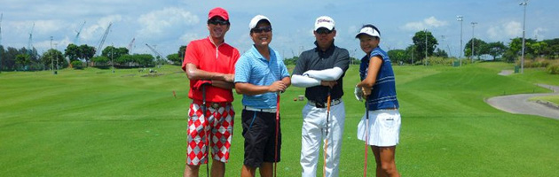

**About Us**

**You’ll never have to walk the fairways alone again**  
  
Set up especially for union members, my golf kaki is a vibrant club established with the objective of building a sustainable golfing community with shared values and interests. As an associate member of the Singapore Golf Association (SGA), my golf kaki offers issuance and maintenance of handicap index. As part of our one-stop service, the club also offers golf insurance, preferential rates at local and overseas golf courses, merchant discounts and other exciting benefits for members.

**Membership**

**Our perks at a glance**  
   
**Maintenance of Handicap Index**  
Benefit from handicap maintenance for as low as $160 per annum!  
   
**Golf Insurance**  
Celebrate and spend up to $500 when you achieve a Hole-in-One at any golf course worldwide!  
   
**Concessionary Green Fees**  
Enjoy attractive green fees from as low as $36 at Orchid Country Club. Other concessions are also available at selected local and foreign golf courses.  
   
**Activities and Programmes**  
Look out for the monthly medals and members’ nights.  
   
**Special Rates for Proficiency Certification**  
Obtain Proficiency Certification with up to 50% savings with appointed golf academies.  
   
**Retail Discounts**  
Shop at MST Golf and get an instant 25% discount on purchase of golfing merchandise.  
  
[**Make me a member!**](http://www.mygolfkaki.com/MembershipRegistration.aspx)

**How to reach us**

80 Rhu Cross #01-02, Singapore 437437  
Tel: (65) 6342 5188  
Email: [contact@mygolfkaki.com](mailto:contact@mygolfkaki.com)  
[www.mygolfkaki.com](http://www.mygolfkaki.com/)  
[www.facebook.com/mygolfkaki](http://www.facebook.com/mygolfkaki)  
   
**Branch**  
1 Orchid Club Road #02-01/#02-05, Orchid Country Club  
Singapore 769162  
Tel: (65) 6483 8313