**Wild Wild Wet**



**About Us**

**Get wet and splashy in the East**  
  
Opened in 2004, Wild Wild Wet is Singapore’s first water park. We promise you a day of thrills and spills for the whole family. Situated at Downtown East, it remains one of the most popular family attractions in Singapore by NTUC Club. From adrenalin-pumping rides to relaxing and gentle ones, visitors are guaranteed a fun-filled day while they beat the heat.

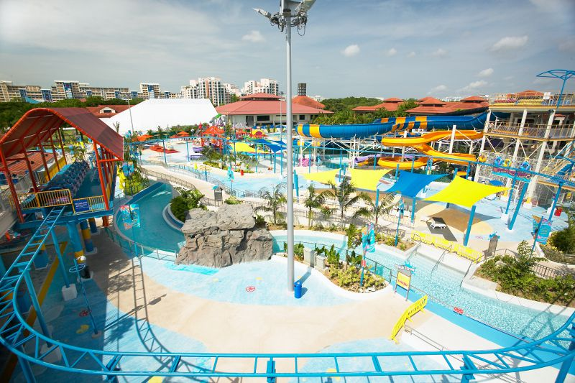

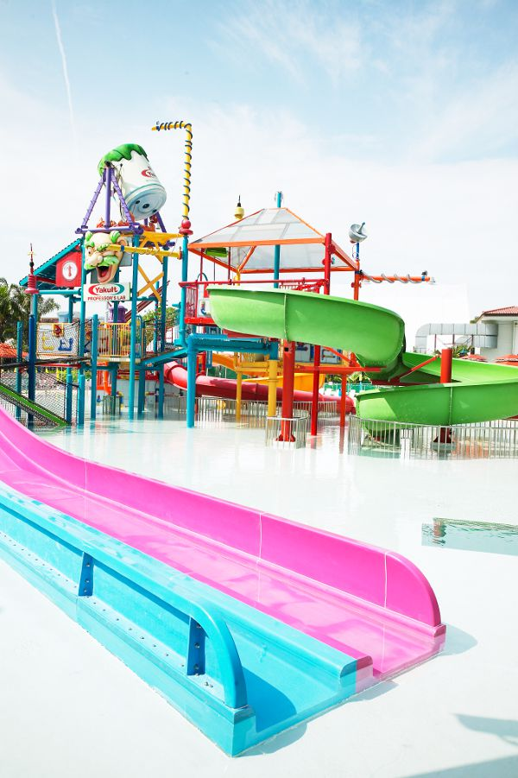

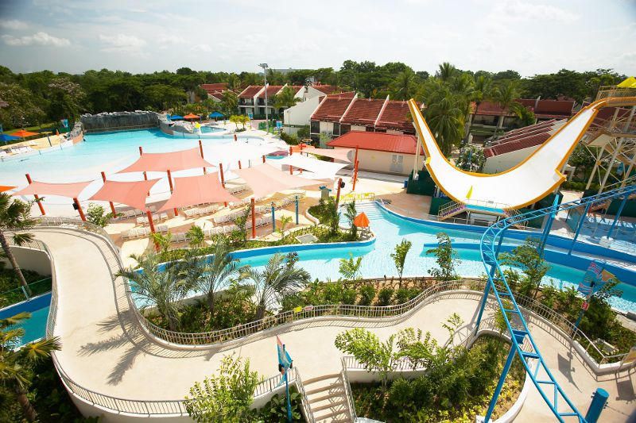

**Ticketing Information**

|  | **Admission** |
| --- | --- |
| Adult (12 years old & above) | $16.00 |
| Child (aged 3 - 11 years old) | $11.00 |
| Family (2 adults and 2 children) | $44.00 |
| nEbO | $11.50 |
| Senior Citizen (aged 55 years old & above) | Free admission |
| Locker Rental (Coin Operated) | $1.00 - $3.00 |

***Terms & Conditions***

* NTUC Plus! & Plus! Card holders
  + Present NTUC Plus! or Plus! card at admission to enjoy offer
  + NTUC Plus! or Plus! card member must be present during ticket purchase
  + NTUC Plus! or Plus! card member can purchase a maximum of 4 tickets for accompanying guests
  + Temporary NTUC Plus! or Plus!card/receipt will not be entitled to LinkPoints scheme (issuance / redemption)
  + Park may be closed for Corporate / private events and admission will be denied
  + Not valid for Corporate and/or Travel Agent Sales.
  + The promotion is not valid with other promotions, events, discounts and vouchers.
  + The management reserves the right to amend the terms and conditions without any prior notice.

nEbO Plus! card holders

* + nEbO member can purchase a maximum of 1 additional tickets for an accompanying guest
  + Additional tickets will be priced at $11.50 + 525 LinkPoints each and applicable for instant redemption
  + Present nEbO Plus! card at admission to enjoy offer
  + nEbO member must be present during ticket purchase
  + Temporary nEbO card/receipt will not be entitled to LinkPoints scheme (issuance / redemption)
  + Park may be closed for Corporate / private events and admission will be denied
  + Not valid for Corporate and/or Travel Agent Sales.
  + The promotion is not valid with other promotions, events, discounts and vouchers.
  + The management reserves the right to amend the terms and conditions without any prior notice

**Operating Hours**

Mon, Wed – Fri: 1pm – 7pm  
Sat, Sun, Gazetted School & Public Holidays: 10am – 7pm

**How to reach us**

1 Pasir Ris Close,  
Singapore519599  
Dial : (65) 6581 9128  
[www.wildwildwet.com](http://www.wildwildwet.com)   
[www.facebook.com/wildwildwet](http://www.facebook.com/wildwildwet)

**Marina Bay Golf Course**



**About Us**

**More than just a good game of golf**  
  
Marina Bay Golf Course is Singapore’s only 18-hole public golf course and one of Asia’s best public golf courses. Located strategically in the heart of town, the course offers golfers great accessibility and a picturesque view of the city skyline, be it day or night.

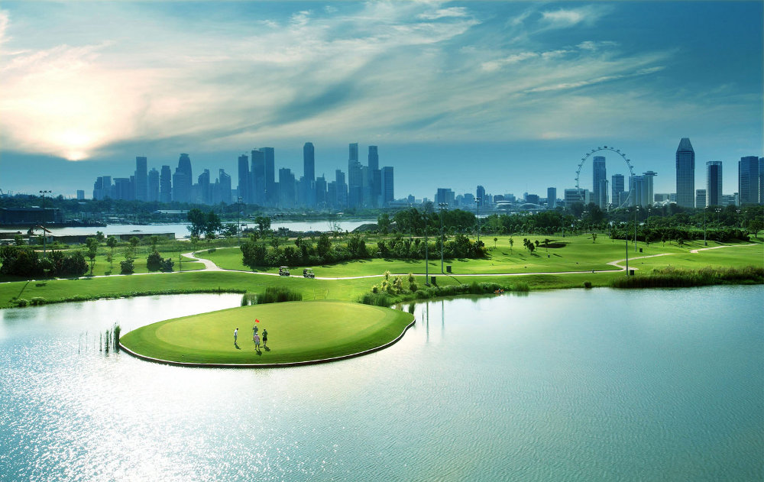  
  
**Key facilities & services**  
  
**Practice Facilities**  
Amateur golfers can practice at putting greens, chipping green and practice bunker. Charges may apply for the use of these facilities.  
  
**The Canopy Café**  
Relax and enjoy a light snack while enjoying a bird’s eye view of the golf course. The café serves a variety of local and western food so you’d be spoilt for choices.  
  
**MST Golf**  
This retail store offers a myriad of golfing products, from equipment to accessories and apparel. Rental of clubs and shoes is also available.  
  
**StarGolf Academy**  
The academy offers various training programmes to suit all levels as well as customised training modules for golfers with specific goals. Lessons are conducted by experienced golf professionals who are recognised by the Singapore Professional Golfers’Association (SPGA).

**Charges**

Please note that all rates are on a per golfer per round basis. Golf charges include green fees, buggy, GPS, shower and locker fees.

|  |
| --- |
|  |
| |  |  |  |  | | --- | --- | --- | --- | | **Golfing Charges** | **Singaporeans & PRs** | **MGK\*** | **Visitors** | | **18-holes Weekdays** | $75 | $95 | $115 | | **18-holes Weekends** | $120 | $160 | $200 | | **9-holes Weekdays** | $52.50 | $67.50 | $82.50 | | **9-holes Weekends** | $72.50 | $87.50 | $102.50 | |

|  |
| --- |
| * Applicable to Employment Pass / Work Permit / Dependent Pass holders who are also my golf kaki Ordinary / Junior / Senior members. At point of payment and registration, my golf kaki membership card(s) must be presented to enjoy the discounted golfing rates. In addition, all other terms and conditions regarding tee time bookings, handicap requirements etc shall apply. For more information on my golf kaki, please visit [**http://www.mygolfkaki.com**](http://www.mygolfkaki.com)/. |
|  |
| |  |  | | --- | --- | | **Evening Golf Lighting Charges** | | | **18-hole** | $11 (From 3.32pm to 4.28pm) | |
|  |
| |  |  | | --- | --- | | **Night Golf Lighting Charges** | | | **18-hole** | $22 (From 4.36pm to 5.56pm) | | **9-hole** | $11 (From 6.30pm to 7.50pm) | |
|  |
| |  |  | | --- | --- | | **Non-refundable Advance booking fees** | | | **0 - 5 days** | $0 | | **6 - 10 days** | $10 | | **11 - 15 days** | $20 | |
|  |
| All rates are subjected to prevailing 10% service charge and GST. Weekdays refer to Mondays through to Fridays, excluding public holiday(s) which fall on a weekday. Weekends refer to Saturdays, Sundays and Public Holidays. |

**How to reach us**

80 Rhu Cross #01-01  
Singapore437437  
Tel: (65) 6345 7788  
Email: [enquiry@mbgc.com.sg](mailto:enquiry@mbgc.com.sg)  
[www.mbgc.com.sg](http://www.mbgc.com.sg/)  
[www.facebook.com/marinabaygolfcourse](http://www.facebook.com/marinabaygolfcourse)

**my golf kaki academy**

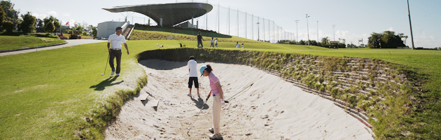

**About Us**

My Golf Kaki Academy aims to be a leader in the golf traching field by adopting a holistic approach to deliver affordable and high quality programmes to all in Singapore. Located in Orchid Country Club and Tanglin Public Golf Course (from 2012 onwards), the Academy offers comprehensive training and development programmes which impart golf skills and knowledge within a positive learning environment. All programs are endorsed under the Sports Education Programme (SEP) for 2012/2013.

To make lessons engaging for the students, the Academy employs a variety of swing analysis aids such as V1 Golf and Swinguru, a new type of digital golf learning and teaching experience. Lessons are conducted by qualified and experienced Class A members of Singapore Professional Golfers Association. All coaches are also certified standard first aiders and recognised under the National Coaching Accreditation Programme by Singapore Sports Council.

Students of my golf kaki Academy have access to a conducive training room and a range of golfing facilities at Orchid Country Club. Access to training facilities at Marina Bay Golf Course and Tanglin Public Golf Course is also available.

Click [here](http://203.92.95.87/GolfAcademy/Image_Repository/Pdf/brochure.pdf) for my golf kaki Academy brochure.