**Downtown East**

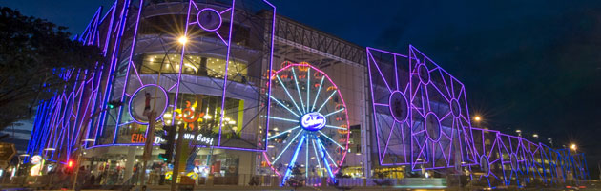

**About Us**

**Go East!**  
  
A one-stop leisure and lifestyle destination, Downtown East is also a choice venue for NTUC members and Singaporeans to enjoy a wide array of entertainment options at affordable prices.  
   
From a humble beginning as just NTUC Pasir Ris Resort, it was re-developed in 2000 to become Downtown East, Singapore’s lifestyle and recreational hub. Today, it is home to Costa Sands Resort and the popular water park, Wild Wild Wet. The entertainment and leisure centre E!hub opened in 2008 and added a cinema, Orchid Bowl and lots more to the colourful landscape.  
   
 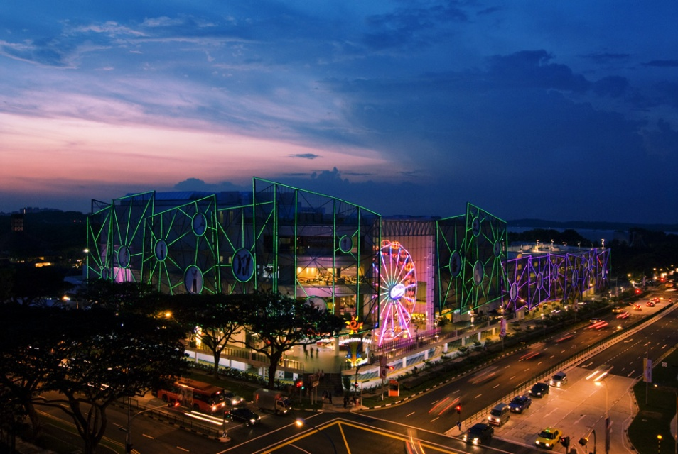



Costa Sands Resort (Downtown East)

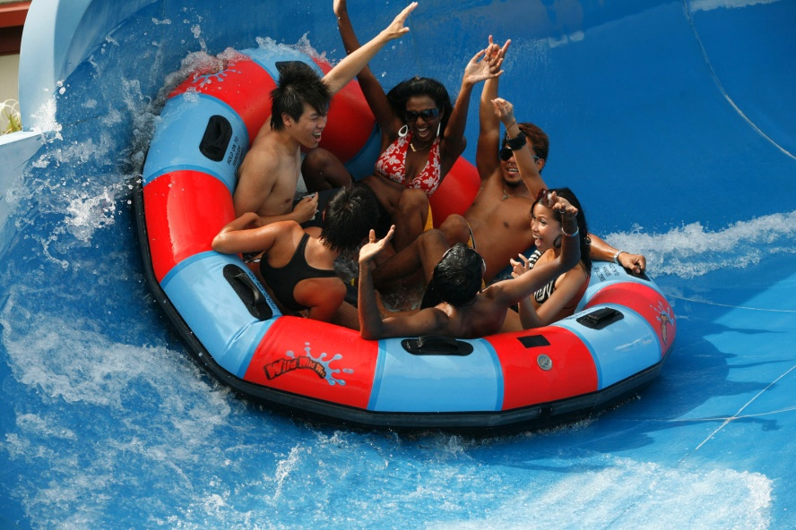

Wild Wild Wet



Dining at Downtown East

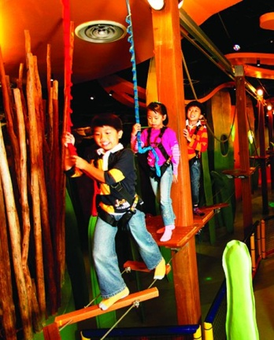

eXplorerkid

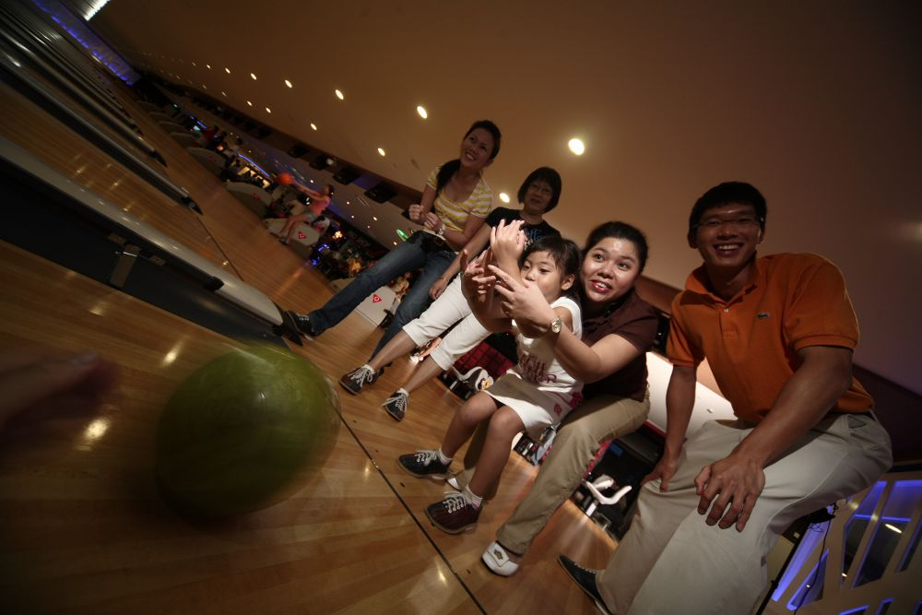

Orchid Bowl

**How to reach us**

1 Pasir Ris Close,  
Singapore519599  
Dial : (65) 6589 1688  
[www.downtowneast.com.sg](http://www.ntucclub.com/)  
[www.facebook.com/downtowneast](http://www.facebook.com/downtowneast)  
[www.youtube.com/wowdowntowneast](http://www.youtube.com/wowdowntowneast)

**Costa Sands Resort**

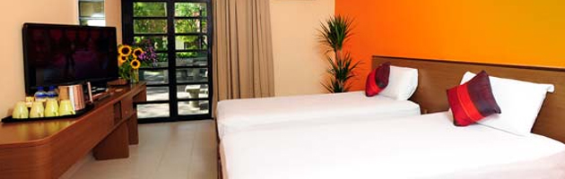

**About Us**

**The place to be for a staycation or vacation**  
  
Costa Sands Resort manages three local resorts in Downtown East, Pasir Ris and Sentosa. Holidaymakers who desire to relax in a sanctuary beyond Singapore can look to Banyu Biru, Nirwana Gardens (Bintan, Indonesia) for the comfort and delight of a tropical paradise.

**How to reach us**

[www.costasands.com.sg](http://www.costasands.com.sg/)  
[www.facebook.com/costasandsresort](http://www.facebook.com/costasandsresort)  
Email: [resvn@costasands.com.sg](mailto:resvn@costasands.com.sg)  
   
**Corporate Sales Office**  
1 Pasir Ris Close  
Singapore 519599  
Tel: (65) 6589 1666  
Fax: (65) 6582 5332  
Email: [corpsales@ntucclub.com.sg](mailto:corpsales@ntucclub.com.sg)  
 

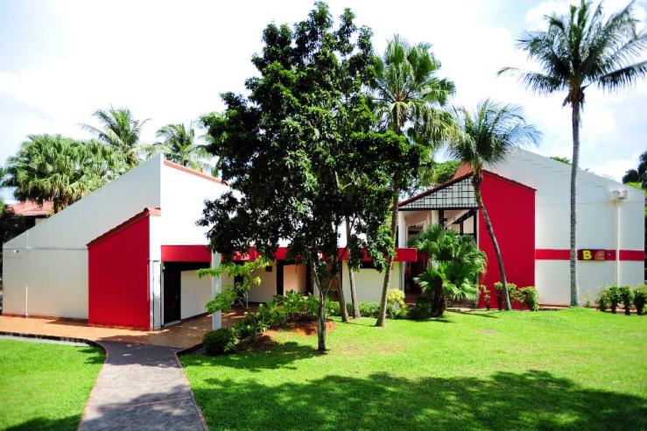

**Costa Sands Resort**  
**(Downtown East)**  
1 Pasir Ris Close,  
Singapore 519599  
Tel (24 hrs): (65) 6582 3322  
Fax: (65) 6582 9535

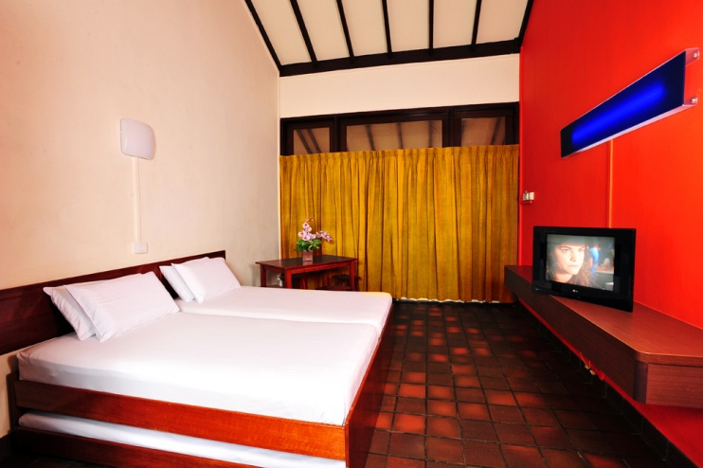

**Costa Sands Resort (Pasir Ris)**  
159M Jalan Loyang Besar,  
PasirRis Park  
Singapore 509404  
Tel (24 hrs): (65) 6582 2537  
Fax: (65) 6582 2098

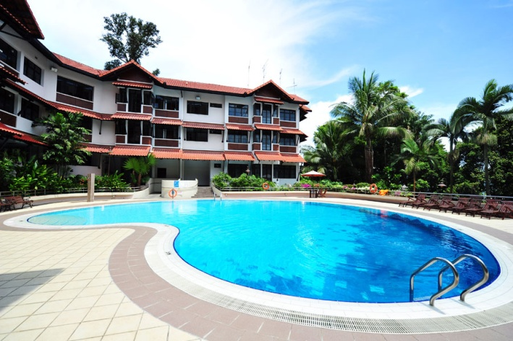

**Costa Sands Resort (Sentosa)**  
30 Imbiah Walk, Sentosa,  
Singapore 099537  
Tel (24 hrs): (65) 6275 1034  
Fax: (65) 6275 1074

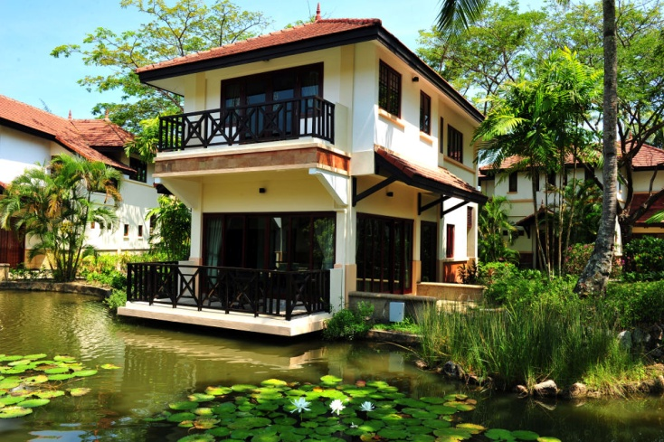

**Banyu Biru @ Nirwana Gardens**  
Nirwana Gardens, Jalan Panglima Pantar,  
Lagoi 29155, Bintan Resorts, Indonesia  
Tel: (65) 6589 1865  
c/o Costa Sands Resort  
(Downtown East)

**eXplorerkid**

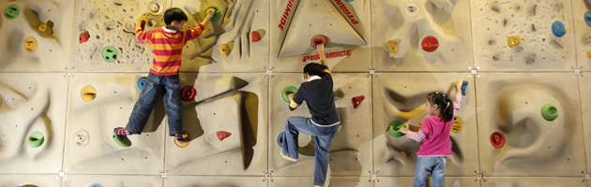

**About Us**

**Learn and explore the world with little ones on-board**  
  
eXplorerkid is a family-friendly club for families with children aged 12 and younger. We operate the largest Indoor Playground in Singapore, eXplorerkid @ E!hub, in Downtown East. There are fun and challenging play stations for kids, and relaxation facilities for accompanying parents and guardians.

At eXplorerkid, we encourage learning through exploration. To transport our young to a fantasy world of learning and discovery, the eXplorerkid Indoor Children Playground is a highly-tactile playground designed around a mystical forest theme. As the children explore the eXplorerkid Indoor Playground's Mystical Forest, they are exposed to fun-play obstacles and educational elements.

Besides the Indoor Playground, eXplorerkid offers the following products and services: Membership, School Field Trips, Themed Birthday Parties, Events, Activities and a retail Fun Shop.

**Admission and Play Rates**

Charges for children under 12 vary accordingly to the playtime. NTUC and eXplorerkid members enjoy attractive year-round discounts in play rates.

The full-day and per-hour play rates cover playtime at the standard play stations. There are two play stations (Adventure Highlands and Ball‘O’City) that charge separate playtime fees.

Any expenses incurred at the adult-only facilities are charged accordingly.

Socks must be worn at all times by all visitors in eXplorerkid Indoor Playground. Shoes are to be deposited at the Shoe Store before entering the Playground. Visitors are encouraged to bring their own socks or they can buy a pair for $2.50 at the entrance.

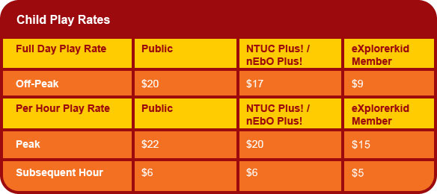

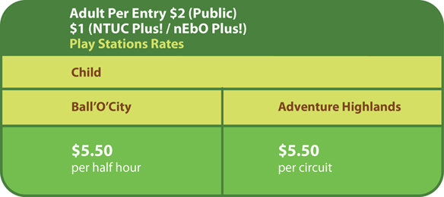

**Operating Hours**   
  
*Off-peak days:  
Monday to Thursday, open from 12 noon to 10 pm.

**Peak days:  
Friday to Sunday Eve of Public Holidays, Public Holidays, Gazetted School Holidays, PSLE Marking Days open from 10 am to 10 pm.  
  
  
**How to reach us**

[www.explorerkid.com](http://www.explorerkid.com/)  
[www.facebook.com/explorerkid](http://www.facebook.com/explorerkid)  
   
**eXplorerkid @ E!hub, Downtown East**  
1 Pasir Ris Close  
E!hub @ Downtown East  
Level 3  
Singapore519599  
Tel: (65) 6589 1668  
   
**eXplorerkid @ AMK Hub**  
53 Ang Mo Kio Ave 3  
AMK Hub #04-02  
Singapore569933  
Tel: (65) 6582 3326

**Orchid Bowl**

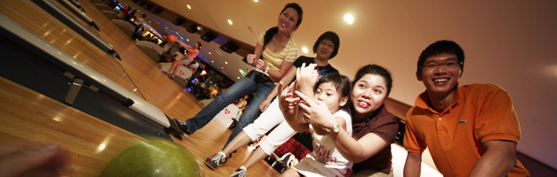

**About Us**

**The coolest bowling centres for everybody**  
  
Orchid Bowl is one of the largest bowling operators in Singapore with five leisure bowling centres at The Chevrons, Safra Tampines, Safra Yishun, Orchid Country Club and E!hub, Downtown East.  
  
It is also the first bowling operator in the region to be equipped with the latest bowling system, Switch – a high-tech system used in over 30 countries like Switzerland, Italy, Spain, Germany and the United Kingdom. All 140 lanes in Orchid Bowl’s five centres boast lanes, furniture and equipment, designed by renowned car designer Pininfarina, who counts Ferrari and Maserati as his clients.  
  
A centralised lane reservation system has also been installed, with the capability to allow bowlers to track their scores across all Orchid Bowl’s centres and work out their bowling statistics over a chosen period.

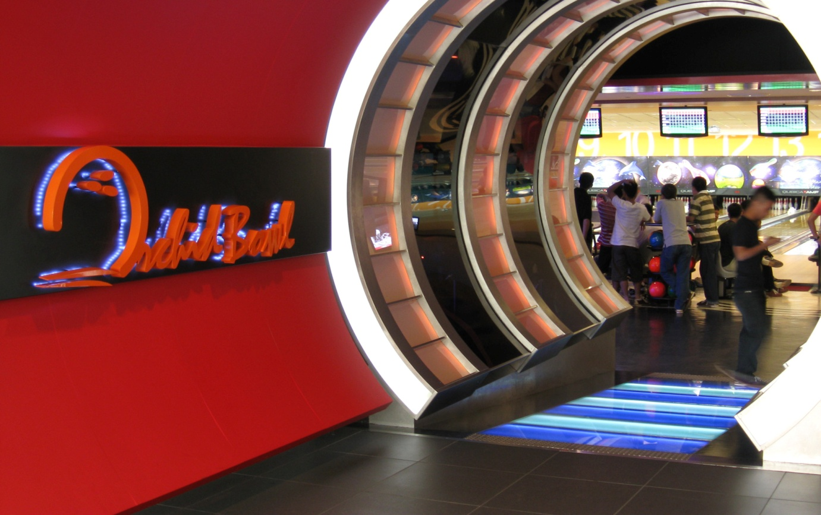

**Orchid Bowl @ Orchid Country Club**  
Located in Yishun, this 36-lane outlet is one of the largest bowling centres in Singapore, and the preferred choice for corporate events.  
   
**Orchid Bowl @ Safra Yishun Country Club**  
Surrounded by lush greenery, this is a place where families and friends can relax, dine and enjoy great bowling fun at this 24-lane outfit.  
   
**Orchid Bowl @ Safra Tampines**  
Right in the heart of a sporting hub, this outlet with 24 lanes is popular with sports enthusiasts, leisure fun-seekers and tertiary youths who are looking for a bowling good time in the east.  
   
**Orchid Bowl @ THE CHEVRONS**  
A vibrant and relaxing environment for the Chevron club members and the public to unwind and interact, this 24-lane outlet at Boon Lay sees mainly families and youngsters.  
   
**Orchid Bowl @ E!hub**  
Located at Downtown East and a trendy choice with both youths and families, this 32-lane bowling centre comes with the first-in-Singapore miniature bowling!  
  
  
**How to reach us**

Email [cs@orchidbowl.com.sg](mailto:cs@orchidbowl.com.sg)  
[www.orchidbowl.com.sg](http://www.orchidbowl.com.sg/)  
[www.facebook.com/orchidbowl](http://www.facebook.com/orchidbowl)  
   
**SAFRA Yishun Country Club**  
60 Yishun Avenue4  
SAFRA Yishun Country Club #02-V2  
Singapore769027  
Tel: (65) 6759 9739  
Fax: (65) 6754 7798  
Email: [ob_sy@orchidbowl.com.sg](mailto:ob_sy@orchidbowl.com.sg)  
   
**SAFRA Tampines**  
1A Tampines Street 92  
SAFRA Tampines #03-01  
Singapore528882  
Tel: (65) 6783 6001  
Fax: (65) 6783 6630  
Email: [ob_st@orchidbowl.com.sg](mailto:ob_st@orchidbowl.com.sg)  
   
**THE CHEVRONS**  
48 Boon Lay Way  
The Chevrons #04-01  
Singapore609961  
Tel: (65) 6795 5900  
Fax: (65) 6795 5902  
Email: [ob_tc@orchidbowl.com.sg](mailto:ob_tc@orchidbowl.com.sg)  
   
**E!hub**  
1 Pasir Ris Close  
#01-111 E!hub Downtown East  
Singapore519599  
Tel: (65) 6583 1622  
Fax: (65) 6583 2611  
Email: [ob_ehub@orchidbowl.com.sg](mailto:ob_ehub@orchidbowl.com.sg)  
   
**Orchid Country Club**  
1 Orchid Club Road  
Orchid Country Club #02-37  
Singapore769162  
Tel: (65) 6759 4448  
Fax: (65) 6759 6811  
Email: [ob_occ@orchidbowl.com.sg](mailto:ob_occ@orchidbowl.com.sg)