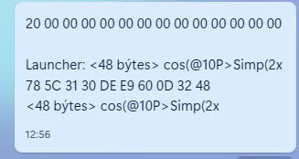
Shift 11 pages 1 lines
Vô quickcpy max (E9E0)
`DA 7B 31 31 21 30 C0 EA 30 30 30 30 C8 3D 32 31
DE 3D 32 30 DA 7B 31 31 21 30 E0 EA 30 30 30 30
C8 3D 32 31 DE 3D 32 30 DA 7B 31 31 21 30 00 EB
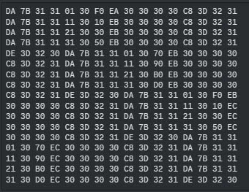
30 30 30 30 C8 3D 32 31 DE 3D 32 30 DA 7B 31 31 21 30 spell 4 page
20 EB 30 30 30 30 C8 3D 32 31 DE 3D 32 30 DA 7B
31 31 21 30 40 EB 30 30 30 30 C8 3D 32 31 DE 3D
32 30 DA 7B 31 31 21 30 60 EB 30 30 30 30 C8 3D
32 31 DE 3D 32 30 DA 7B 31 31 21 30 80 EB 30 30
30 30 C8 3D 32 31 DE 3D 32 30 DA 7B 31 31 21 30
A0 EB 30 30 30 30 C8 3D 32 31 DE 3D 32 30 DA 7B
31 31 21 30 C0 EB 30 30 30 30 C8 3D 32 31 DE 3D
32 30 DA 7B 31 31 21 30 E0 EB 30 30 30 30 C8 3D
32 31 DE 3D 32 30 DA 7B 31 31 21 30 00 EC 30 30
30 30 C8 3D 32 31 DE 3D 32 30 00 00 00 00 00 00
20 20 20 20 20 20 20 31 30 20 20 20 20 20 20 20
20 00 00 00 00 00 00 00 00 00 00 00 00 00 00 00
20 20 20 20 20 20 20 20 39 20 20 20 20 20 20 20
20 00 00 00 00 00 00 00 00 00 00 00 00 00 00 00
20 20 20 20 20 20 20 20 38 20 20 20 20 20 20 20
20 00 00 00 00 00 00 00 00 00 00 00 00 00 00 00
20 20 20 20 20 20 20 20 37 20 20 20 20 20 20 20
20 00 00 00 00 00 00 00 00 00 00 00 00 00 00 00
20 20 20 20 20 20 20 20 36 20 20 20 20 20 20 20
20 00 00 00 00 00 00 00 00 00 00 00 00 00 00 00
20 20 20 20 20 20 20 20 35 20 20 20 20 20 20 20
20 00 00 00 00 00 00 00 00 00 00 00 00 00 00 00
20 20 20 20 20 20 20 20 34 20 20 20 20 20 20 20
20 00 00 00 00 00 00 00 00 00 00 00 00 00 00 00
20 20 20 20 20 20 20 20 33 20 20 20 20 20 20 20
20 00 00 00 00 00 00 00 00 00 00 00 00 00 00 00
20 20 20 20 20 20 20 20 32 20 20 20 20 20 20 20

