Enterprise Integration Pattern explains many ways of communicating messages apart from what JMS proposed (PointToPoint and PublishSubscribe).

<http://www.enterpriseintegrationpatterns.com/patterns/messaging/SimpleMessagingIntro.html>

**Request/Reply communication:** This approach makes producer to consumer as synchronous. It can be done for both PointToPoint and PublishSubscribe.

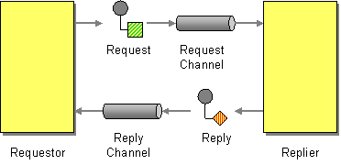

**Send a pair of *Request-Reply* messages, each on its own channel.**

**Code for Request/Reply Communication**

[**http://activemq.apache.org/how-should-i-implement-request-response-with-jms.html**](http://activemq.apache.org/how-should-i-implement-request-response-with-jms.html)

There are two standard patterns in JMS for correlating request and response messages. These patterns are particularly used in synchronous request response messaging.

The two patterns are called:

* MessageID Pattern
* CorrelationID Pattern

MessageID pattern

In the MessageID pattern the service consumer (the party who initiates the request or invokes the service) must provide a unique MessageID and a JMS destination where the service consumer expects the response. This response destination is set in the JMS header property: ‘JMSReplyTo’

The Service provider will copy the MessageID it received in the request to the CorrelationID of the response message and send the response to the JMS destination provided by the service consumer in the JMSReplyTo property.

Graphically this can be viewed as:

[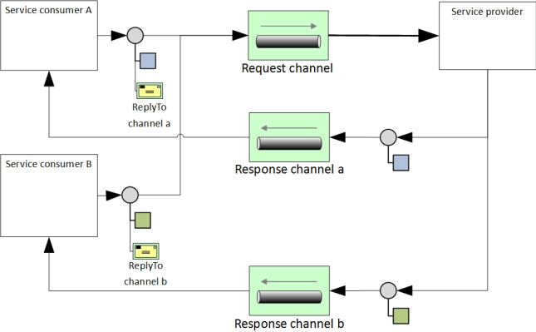](https://pgaemers.files.wordpress.com/2014/10/ems-patterns-1.jpg)

CorrelationID pattern

In the CorrelationID pattern the service consumer must provide a unique CorrelationID. The service provider will copy the CorrelationID it received into the CorrelationID of the response message. All response messages will go to the same response destination.

[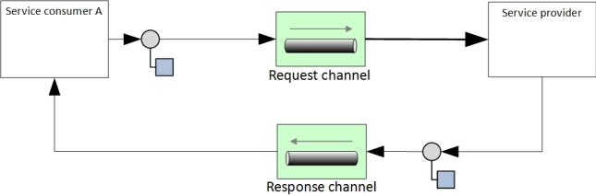](https://pgaemers.files.wordpress.com/2014/10/ems-patterns-2.jpg)