1) If I am going to make a cloning for a Object (i.e) calling object.clone().
Then Class should implements Cloneable (Marker Interface), otherwise
CloningNotSupportedException will be thrown
2) Clone method can or cannot be overriden.
3) If the class has only String and primitives. then implementing Clonable alone is enough.
We dont have to override Clone method. On seeing the Clonable interface,
JVM will do the work.
4) If we want deep copy, implement Cloneable and override Clone method
a) In Clone method. Create copy of current object.
b) Set all the values from this.
c) Return copied object.

package com.rbs.aol;

public class CloningShallow {

int rollno;
String name;

CloningShallow() {

}
CloningShallow(int rollno, String name) {
this.rollno = rollno;
this.name = name;
}

public static void main(String args[]) {
try {
CloningShallow s1 = new CloningShallow(101, "Prabhu");
CloningShallow s2 = (CloningShallow) s1.clone();
System.out.println(s1.rollno + " " + s1.name);
System.out.println(s2.rollno + " " + s2.name);
s2.name="King";
System.out.println(s1.rollno + " " + s1.name);
System.out.println(s2.rollno + " " + s2.name);

} catch (CloneNotSupportedException c) {
c.printStackTrace();
}

}
}
java.lang.CloneNotSupportedException: com.rbs.aol.CloningShallow
at java.lang.Object.clone(Native Method)
at com.rbs.aol.CloningShallow.main(CloningShallow.java:20)

package com.rbs.aol;

public class CloningShallow implements Cloneable {

int rollno;
String name;

CloningShallow() {

}
CloningShallow(int rollno, String name) {
this.rollno = rollno;
this.name = name;
}

public static void main(String args[]) {
try {
CloningShallow s1 = new CloningShallow(101, "Gold");
CloningShallow s2 = (CloningShallow) s1.clone();
System.out.println(s1.rollno + " " + s1.name);
System.out.println(s2.rollno + " " + s2.name);
s2.name="King";
System.out.println(s1.rollno + " " + s1.name);
System.out.println(s2.rollno + " " + s2.name);

} catch (CloneNotSupportedException c) {
c.printStackTrace();
}

}
}
Output
101 Gold
101 Gold
101 Gold
101 King

package com.rbs.aol;

/**
How to Run this class
1) comment clone method. Check that both original and copied values are modified, after modifying the copied object.
Because both original and copied points to same object
2) uncomment clone method. Values will be differ (i.e) both have individual objects.
So modifying the copied object dont make changes on original object

**/
public class CloningDeep implements Cloneable {

CloningShallow shallow;
String name;

public static void main(String[] args) throws CloneNotSupportedException {
CloningShallow s1 = new CloningShallow(101, "Gold");
CloningDeep deep = new CloningDeep();
deep.name = "Prabhu";
deep.shallow = s1;
CloningDeep deep2 = (CloningDeep)deep.clone();

System.out.println("oringal: " + deep.shallow.name);
System.out.println("copied: " + deep2.shallow.name);
/*System.out.println(deep.name);
System.out.println(deep2.name);*/

//Modifying the copied object
System.out.println("=== Modifying the Copied Object ===");
deep2.shallow.name = "King";
//deep2.name = "King";
System.out.println("oringal: " + deep.shallow.name);
System.out.println("copied: " + deep2.shallow.name);
/*System.out.println(deep.name);
System.out.println(deep2.name);*/

}
public Object clone() throws CloneNotSupportedException {
CloningShallow shallow = new CloningShallow();
shallow.rollno = this.shallow.rollno;
shallow.name = this.shallow.name;
CloningDeep deep = new CloningDeep();
deep.shallow = shallow;
return deep;
}

}

Original State of Object
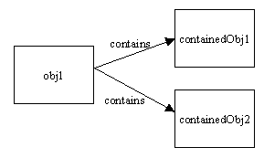
Shallow Cloning: Default in java. If we give object. Clone()
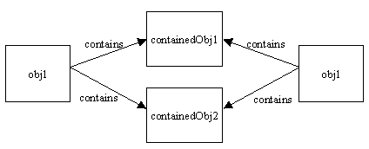
Deep Cloning
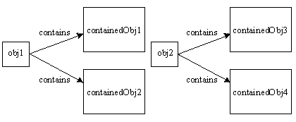

Cloning can also be implemented by Serialization. But it doesn’t make sense or Serialiation is not meant for cloning purpose. It is like storing and retrieving object from to byteArray. Kind of overthink and nonsense way of doing in alternate way.

