Generics is applied to which part of class? class, instance variable and method
public class GenericsType<T> {

private T t;

public T get(){
return this.t;
}

public void set(T t1){
this.t=t1;
}

public static void main(String args[]){
GenericsType<String> type = new GenericsType<>();
type.set("Pankaj"); //valid

GenericsType type1 = new GenericsType(); //raw type
type1.set("Pankaj"); //valid
type1.set(10); //valid and autoboxing support
}
}
When we don’t provide type, the type becomes Object and hence it’s allowing both String and Integer objects

What are Upper and Lower bounds, Unbound in Generics ? Where to choose one
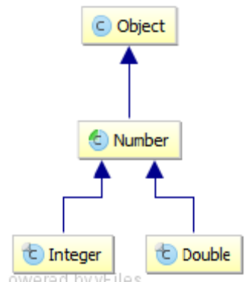
Upper Bounded Wildcards
Upper bounded wildcard restricts the unknown type to be a specific type or subtype of that type.
For example, If we want to write a method that accepts List<Number> and its subtypes i.e. List<Double> and List<Integer>, etc then we can use Upper bounded wildcard.
public static void process(List<? extends Number> list) { /* ... */ }

Lower Bounded Wildcards
Lower bounded wildcard restricts the unknown type to be a specific type or super type of that type.
For Example, If you want to write a method that puts Integer objects into a list. To maximize flexibility, you may like the method to work on List<Integer>, List<Number>, but not List<Double> - anything that can hold Integer values.
public static void addNumbers(List<? super Integer> list) {/*.....*/}
Unbounder WildCards
List <? extends Object> list or List<?> list
In the above any object can be passed to list.

