When should I use NIO over IO?
1) If you need to manage thousands of open connections simultaneously, each only send a little data, for instance a chat server, implementing the server in NIO is probably an advantage.
2) if you need to keep a lot of open connections to other computers, e.g. in a P2P network, using a single thread to manage all of your outbound connections might be an advantage. This one thread, multiple connections design is illustrated in this diagram

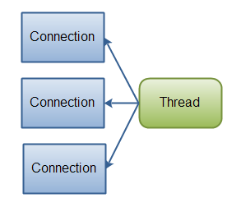

If you have fewer connections with very high bandwidth, sending a lot of data at a time, perhaps a classic IO server implementation might be the best fit. This diagram illustrates a classic IO server design:
Java IO: A classic IO server design - one connection handled by one thread.
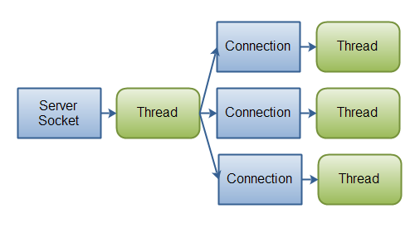

IO | NIO
Stream oriented | Buffer oriented
Blocking IO | Non blocking IO

Buffer Oriented : Java NIO's buffer oriented approach is slightly different. Data is read into a buffer from which it is later processed. You can move forth and back in the buffer as you need to. This gives you a bit more flexibility during processing. However, you also need to check if the buffer contains all the data you need in order to fully process it.

Non-Blocking IO : Java IO's various streams are blocking. That means, that when a thread invokes a read() or write(), that thread is blocked until there is some data to read, or the data is fully written. The thread can do nothing else in the meantime.
NIO Reading : Java NIO's non-blocking mode enables a thread to request reading data from a channel, and only get what is currently available, or nothing at all, if no data is currently available. Rather than remain blocked until data becomes available for reading, the thread can go on with something else.

NIO Writing : The same is true for non-blocking writing. A thread can request that some data be written to a channel, but not wait for it to be fully written. The thread can then go on and do something else in the mean time.

Advantage : a single thread ( Using Selector) can now manage multiple channels of input and output.

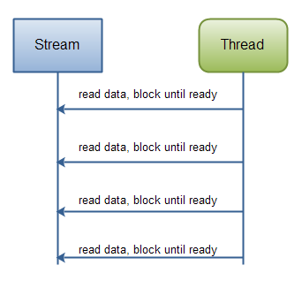
Java IO: Reading data from a blocking stream.

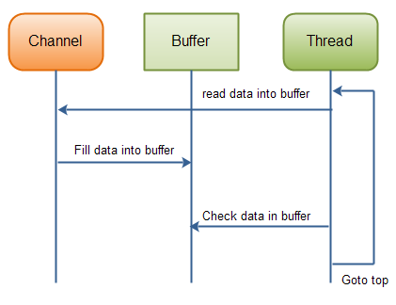
Java NIO: Reading data from a channel until all needed data is in buffer.

FileChannel:
FileChannel cannot run in non-blocking mode. Because The regular/standard OS supports File read/write only in blocking mode which cannot be overriden by JavaAPI.
But using FileChannel, reading/writing big data is quite fast. Since FileChannel is tuned using Buffers. Also forward/reverse on Buffer is another best operation.
Verify AsynchronousFileChannel

