Problem : If a class has instance variable and there are 2 threads running, any threads can access the instance variable at the same time and hence the concurrency issue

Solution : 1) synchronize it so that only 1 can use at a time

Problem : 2 threads wants its own local variable, so that it can be modified by only that threads which is created on specific object.

Solution : Put the variable inside thread.

Problem : 2 threads wants its own local variable “plus” initial value has to be populated from main method.

Solution : Go for ThreadLocal

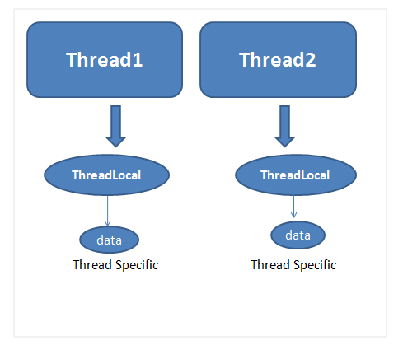

The Internals of ThreadLocal and How it Works(ThreadLocalSample in eclipse)
ThreadLocal is implemented by having a Map (a ThreadLocalMap) as field (with WeakReference entry) within each Thread instance.
As a rule of thumb, always clean up/reset your threadlocal after you have finished your “unit of operation”! Even though the current code might be simple enough to bypass the cleanups, it might be adapted and integrated into servlets/thread pooling later on! After all, cleaning up responsibly is always appreciated both in the realms of programming and real life.

