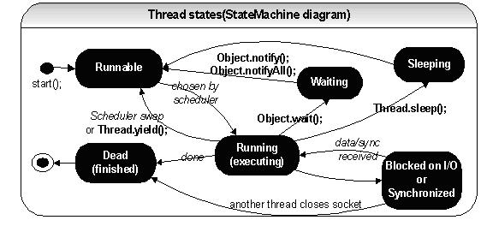

Thread will go to Blocking state when
- under synchronized method unable to get lock…
- when IO is executed and data is not feeded.

Other thread not runnable state

- scheduler decides to give priority to other thread
- yield() (deprecated)is called. Allow equal priority of other thread to run
- suspend() (deprecated)is called.. only resume() can take the thread again to Runnable state
- when sleep called
- when wait callled

