BlockingQueue came under the principal of Producer-Consumer, where multiple threads can write data to queue and multiple threads can read data from queue. So during such a time, the queue should be accessible by many threads without collision or any issue.

A blocking queue is a queue that blocks
1) when you try to dequeue an item from queue and the queue is empty, 2) when you try to enqueue items to queue and the queue is already full.

A thread trying to dequeue from an empty queue is blocked until some other thread inserts an item into the queue.

A thread trying to enqueue an item in a full queue is blocked until some other thread consumes the data in queue or clearing the queue completely.

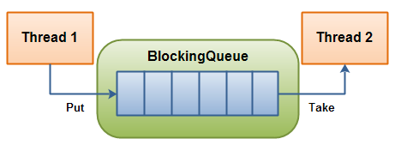

ArrayBlockingQueue
ArrayBlockingQueue is a bounded, blocking queue that stores the elements internally in an array. That it is bounded means that it cannot store unlimited amounts of elements.

BlockingQueue queue = new ArrayBlockingQueue(1024);
queue.put("1");
Object object = queue.take();
LinkedBlockingQueue
An optionally-bounded blocking queue based on linked nodes. The capacity, if unspecified, is equal to Integer.MAX_VALUE. (2³¹-1)
