JMS is not a protocol. It is a specification. Many MOM vendors implement this specification and provide API for messaging. JMS implementations are vendor specific.

From the producer side to queue message is always fire and forget. No acknowledgement or synchronous or asynchronous message is received by producer.
From the queue to consumer side, client and QM can or cannot send acknowledgement by synchronous or asynchronous way to queue. This is to intimate queue that message can be removed from queue because it is consumed successfully. This concept is called reliability mechanism.
There is no possibility of synchronous communication from producer to consumer

What is Message Broker?: A message broker is the one who manages queues. A Queue Manager is called Message Broker.
Task done by message broker are
- Route a message to several destinations, using rules that act on the contents of one or more of the fields in the message or message header.
- Store a message, or part of a message, in a database.
- Transform (Modify) the contents of a message; for example, by adding data extracted from a database.
- Monitoring, Logging.
- When a message expires, message will be saved on DB or dead letter queue. Broker retrieves the message after certain time from a database, place it on queue again.

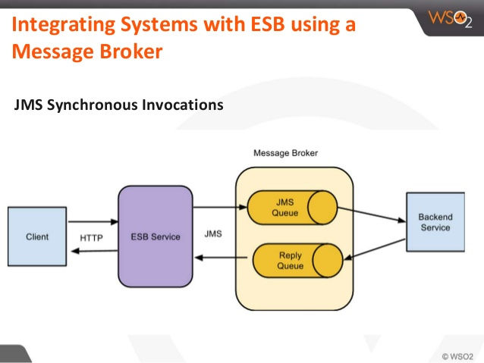
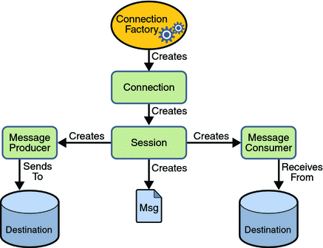 MessageToSend are byteMessage, textmessage etc…

Similar example would be JDBC connection…(provide ipaddress of DB, Load driver, get connection, statement etc… )

So underlying protocol/security(HTTP or SOAP) is also vendor specific

The most common messaging models are:
Publish-Subscribe Messaging
Point-To-Point Messaging (Ex: Logging)

Point-To-Point Messaging: The acknowledgement is not mandate. If mandate messages from queue will be deleted only after getting acknowledgement. It is part of reliability.
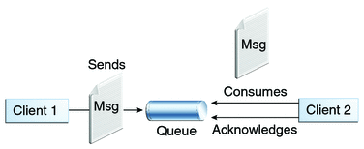
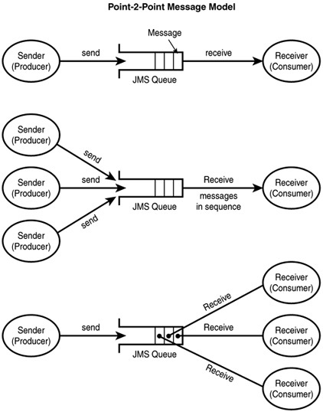

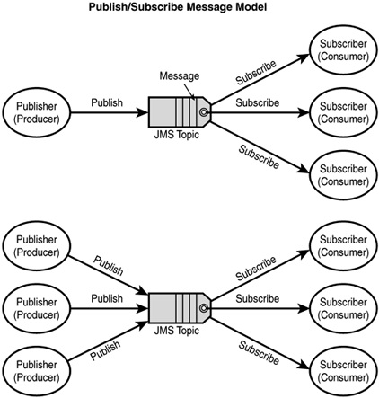

What is MessageSelector?: When a producer places 2 different types of messages on a queue, the consumer will understand the message intended for them only by reading MessageSelector Ex Scenario: In an trading application, both buy and sell messages are placed on the same queue.

Reliability Mechanisms: This specifies how message is reliable between Queue and Consumer.
- Controlling message acknowledgment: You can specify various levels of control over message acknowledgment.
- Specifying message persistence: You can specify that messages are persistent, meaning they must not be lost in the event of a provider failure.
- Setting message priority levels: You can set various priority levels for messages, which can affect the order in which the messages are delivered.
- Allowing messages to expire: You can specify an expiration time for messages so they will not be delivered if they are obsolete.
- Creating temporary destinations: You can create temporary destinations that last only for the duration of the connection in which they are created.

