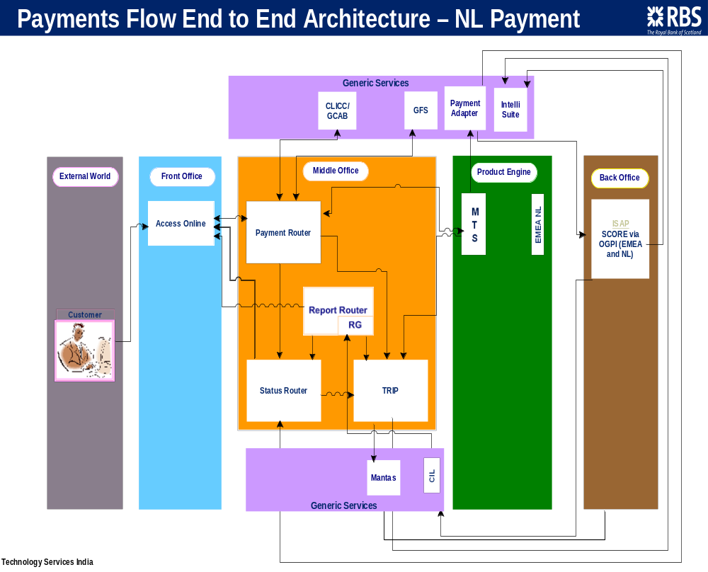

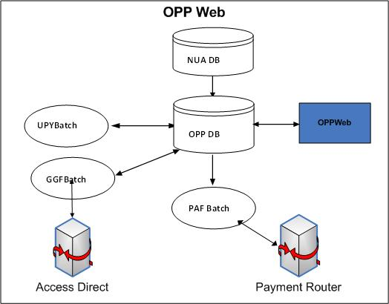
- OPPWeb Initiating payment of different types and it gets stored in OPPDB .
- Once the payment is authorized and released PAFBatch sends payments to payment router gateway to mid office.
- OPPWeb initiates the bulk payments by uploading different formats of industry standard format files through OPPWeb..
- If a Bulk payment is initiated through OPP Web
UPYBatch parses and enriches these uploaded files and stores all payments in OPPDB.
- GGFBatch parse the fusion format files and sends payment information to Access Direct (AD).

