Association
1) Strong Association : Class A has Class B as field
2) Weak Association : Class A has a method which takes Class B as argument or
Class A has a method which returns Class B.
3) Shared Association
4) Not-Shared Association
Aggregation (Shared Association)
The aggregation link used to stress the point that ClassA is not the exclusive container of ClassB, as in fact ClassB has another container.
The association link can replace the aggregation link in every situation, while aggregation cannot replace association in situations were there is only a ‘weak link’ between the classes, i.e. ClassA has method/s that contain parameter of ClassB but ClassA doesn’t hold reference to ClassB instance.

Martin Fowler suggest that the aggregation link should not be used at all because it has no added value and it disturb consistency..
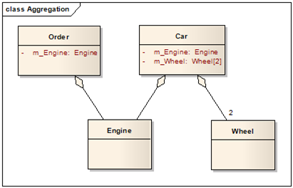

Composition(Not-Shared Association)
In cases where in addition to the part-of relationship between ClassA and ClassB - there’s a strong life cycle dependency between the two, meaning that when ClassA is deleted then ClassB is also deleted as a result, we should be more specific and use the composition link instead of the aggregation link or the association link.
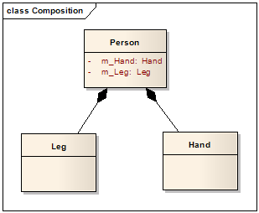

- Caching of database objects inside your program is a perfect candidate for Composition, an object in cache shall be destroyed (evicted) as soon as the related entity is deleted from database.
- On the other hand, Ducks(component part) swimming in a Pond(aggregate object) is an example of Aggregation where there is a weaker relationship among the two.

Composition Example1
Consider a simple example of a LinkedList class. A LinkedList is made up of Nodes. Here LinkedList class is the owning object Nodes. When it is destroyed , all the Nodes contained in it are wiped off. If a Node object is deleted from the list, the LinkedList object will still exist.
Composition is implemented such that an object contains another object.
class LinkedList {

Node head;
int size;
}
This is composition.
Composition Example2
In the below example the departments parts are destroyed as soon as composite object is destroyed.
public class Organization {
private final List<Department> departments;

public Organization() {
departments = new ArrayList<>();
departments.add(new Department("Finance"));
departments.add(new Department("HR"));
departments.add(new Department("Technical"));
}
}

class Department {
private final String name;

Department(String name) {
this.name = name;
}
}

Aggregation Example
In the below example members are not destroyed when Team object is destroyed. Member can exists on its own.
public class Team {
private final List<Member> members;

public Team(List<Member> members) {
this.members = members;
}
}

class Member {
private final String name;

Member(String name) {
this.name = name;
}
}

