Why Hystrix
Hystrix is a library designed to do place a long-running, blocking calls in a separate thread.

Features of Hystrix
- Hystrix is a fancy wrapper around a ThreadpoolExecutor. Also It does a lot more
- It provides circuit breaker pattern by isolating network calls to specific threadpools, providing ability to throttle(choke, limit) calls, fast fail and fallbacks

Hystrix Execution Patterns
A Hystrix command can be executed in 3 ways.
- Use .execute(): pure synchronous call. You call the method and continue your program once the result has arrived. Your program's total execution time is the sum both calls. The main flow of your program is very linear.
- Use .queue(): receive a Future immediately for both commands. Both service calls are executed in parallel. Then use .get() to retrieve the results. These calls with block until the result is there. Your total execution time is faster than before: your execution time will be the length of the longest service call. Use this when you i.e. want to combine the results of the two services. The main flow of your program is still linear, although both calls are executed in parallel.
- Use .subscribe(): receive a Observable immediately for both commands. Both service calls are executed in parallel. Then use .subscribe() to register a call-back to act on the result once it is available. This is very useful if you don't want to combine the results and want to react independently on the results of service A and B once they arrive. The main flow of your program is no linear, but reactive: the flow of the program will continue inside the callback for each command.

The following are equivalent to each other:
String s1 = new CommandHelloWorld("World").execute();
String s2 = new CommandHelloWorld("World").queue().get();
String s3 = new CommandHelloWorld("World").observe();

HystrixCommand: This class a has a method run(), which we need to override
HystrixObservableCommand: This class a has a method construct(), which we need to override

When we need Fallback Scenario and when not?
- Fallback – Not suitable when a command performs a write operation
  - If your Hystrix command is designed to do a write operation rather than to return a value, there isn’t much point in implementing a fallback. If the write fails, you probably want the failure to propagate back to the caller.
- Fallback is suitable when doing a batch systems/offline compute
  - If your Hystrix command is filling up a cache, or generating a report, or doing any sort of offline computation, it’s usually more appropriate to propagate the error back to the caller who can then retry the command later, rather than to send the caller a silently-degraded response.
- Whether or not your command has a fallback, all of the usual Hystrix state and circuit-breaker state/metrics are updated to indicate the command failure.

Primary + Secondary with Fallback
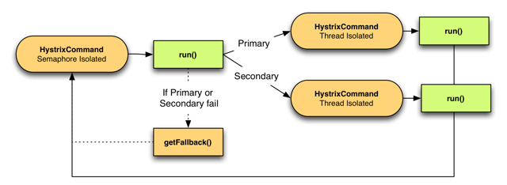
Hystrix Terminologies:
- Command Group: A command group is a logical grouping of command. Ex: Command Group Key is Reporting. 2 commands can get report from 2 different systems.
- Command Name: A command name is, by default derived from class name Or you can set explicitly by “.andCommandKey(HystrixCommandKey.Factory.asKey("HelloWorld"))”
- Command Setter: You can place a “Command Group Name” and “Command Name” inside an Command Setter for easier reference.
- Thread Pool: Here is a simple example when a thread pool is needed.
  - two commands used to access Video metadata
  - group name is “VideoMetadata”
  - command A goes against resource #1
  - command B goes against resource #2
  - If command A becomes latent and saturates its thread-pool it should not prevent command B from executing requests since they each hit different back-end resources.
  - Thus, we logically want these commands grouped together but want them isolated differently and would use HystrixThreadPoolKey to give each of them a different thread-pool.

  - “ .andThreadPoolKey(HystrixThreadPoolKey.Factory.asKey("getVideo1")))”;

