THE TITLE GOES HERE WITH CAPITAL LETTER

Auther’s Name^{1,a)}, Auther’s Name² and Auther’s Name^{3,b)}

¹Replace this text with an author’s affiliation (use complete addresses). Note the use of superscript “a)” to indicate the author’s e-mail address. Use b), c), etc. to indicate e-mail addresses for more than 1 author.
²Additional affiliations should be indicated by superscript numbers 2, 3, etc. as shown above.
³You would list an author’s second affiliation here.

Abstract
Each paper must include and abstract. Begin the abstract with the word “Abstract” followed by a period in bold 15 point TH sarabunPSK font. Type the abstract clearly using Word or WordPerfect software. Please prepare the abstract in English and use TH SarabunPSK font (format 15 or 15-point). The abstract text should not exceed 300 words and the keywords number should not exceed 5.

Keywords: Keywords 1, Keywords 2 (no more than 5 words)

First, Second and Third Headings
Apart from prepositions and articles, all words in first, second and third headings should have their initial letters in uppercase (heading with Each Initial Letter Capitalized). Prepositions are words like “for,” “from,” “with,” “in,” “off,” and articles include words such as “an,” “a,” “the.”

Page Layout
Use 176 x 250 mm paper size (W x H mm) and adjust the margins as follows: Margins of 3 cm for top and 2 cm for bottom; Margins of 3 cm for the left side and 2 cm for the right side. The text is to be single spaced.

________________________________________________
^{a)}Corresponding author: Your name
Email: your@emailaddress.xxx
Formatting the Title
The title is set in bold 16-point TH sarabun PSK font, justified. The letter of the title should be capitalised and should be centred.

Formatting Author Names and Author Affiliations
The style for the names is First Names, typed in 12-point TH sarabun PSK font, then Last Name, typed in 14-point font, with a comma after all except the last author, which is separated by “and”.
Affiliations of authors should be typed in 9-point TH sarabun PSK font. They should be preceded by a numerical superscript corresponding to the same superscript after the name of the author concerned. Please ensure that affiliations are as full and complete as possible and include the country.

Formatting the text
The text of your paper should be formatted as follows:
- 15-point TH sarabun PSK font.
- The text should be set to single line spacing.
- Paragraphs should be justified.

Figures and tables
Figures and tables, as originals of good quality and well contrasted, are to be in their final form, ready for reproduction, pasted in the appropriate place in the text. Try to ensure that the size of the text in your figures is approximately the same size as the main text (15 point). Try to ensure that lines are no thinner than 0.25 point.
Captions should be typed in 15-point font. They should be flush left above the tables and 0.25 cm indent left beneath the figures.
Place the figure as close as possible after the point where it is first referenced in the text. If there is a large number of figures and tables it might be necessary to place some before their text citation.
For example:
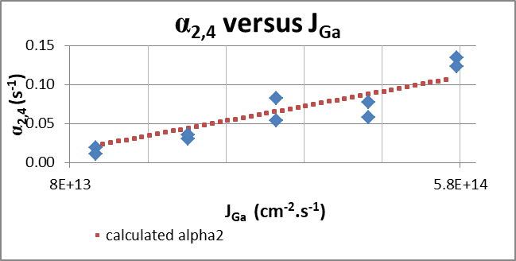
(a)

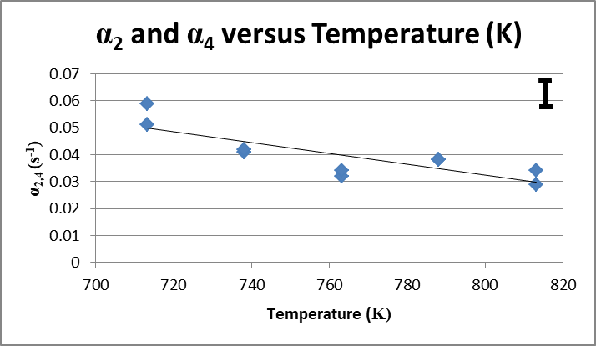
(b)

Fig. 1 The text “Fig. 1,” which labels the caption, should be bold and have initial letters in uppercase. If figures have more than one part, each part should be labeled (a), (b), etc.

Table 1 Caption of the table 1. Above the figure
Indium Fraction x | Group III Growth Rates ( | As₄ Flux Multiplication Factors | Substrate Temperatures
0.006 | 0.20, 0.40, 0.6, 0.8 and 1.00 | 1, 2, 3, 4 and 5 | 440, 465, 490, 515 and 540

Colour Illustrations
You are free to use colour illustrations of the proceedings but any print version will be printed in black and white unless special arrangements have been made with the conference organiser. Please check whether or not this is the case. If the print version will be black and white only, you should check your figure captions carefully and remove any reference to colour in the illustration and text. In addition, some colour figures will degrade or suffer loss of information when converted to black and white, and this should be taken into account when preparing them.

Equations and Mathematics
Equations should be centred and should be numbered with the number on the right-hand side.

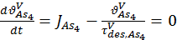 (1)

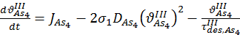 (2)

References
References should be cited in the text by placing only the first author’s name and year in brackets for example: (A. Loykaew et al. 2013). A complete reference should provide enough information to locate the article. References to printed journal articles should typically contain:
• The authors, in the form: initials of the last names followed by first name (only the first letter capitalized with full stops after the initials) with a comma after all except the last author, which is separated by comma + “&”
• The year of publication (in brackets).
• The title (the first letter of the title should be capitalised with the rest in lower case),
• The journal title (italic type),
• The volume number (italic type),
• The article number or the page numbers,
Here are some examples:
Loykaew, A., Usher, B. F., Jones, R. T., & Pigram, P. J. (2013). A novel sample structure for the measurement of Indium segregation profiles in GaAs/ InGaAs/GaAs heterostructures. International Journal of Applied Physics and Mathematics, 3(3), 191-197.
Foxon, C. T., & Joyce, B. A. (1975). Interaction kinetics of As₄ and Ga on {100} GaAs surfaces using a modulated molecular beam technique. Surface Science, 50, 434-450.

